Ketaki Mahajan

A – 2 / 16014022050

Tutorial 1: Correlation & Regression (19 / 01 / 2024)

**Q1.**

**Draw scatter diagram and determine the coefficient of correlation for the following data:**

|  |  |  |  |  |  |  |  |  |
| --- | --- | --- | --- | --- | --- | --- | --- | --- |
| **X** | 62 | 64 | 65 | 69 | 70 | 71 | 72 | 74 |
| **Y** | 126 | 125 | 139 | 145 | 165 | 152 | 180 | 208 |

**Code –**

x = c(62, 64, 65, 69, 70, 71, 72, 74)

y = c(126, 125, 139, 145, 165, 152, 180, 208)

r = cor(x,y)

plot(x, y, main = " Q1 - Scatter Diagram | 16014022050", xlab = "x", ylab = "y")

cat("coefficient of correlation is", r)

paste("name & roll no.", "ketaki mahajan, 16014022050")

**Output –**

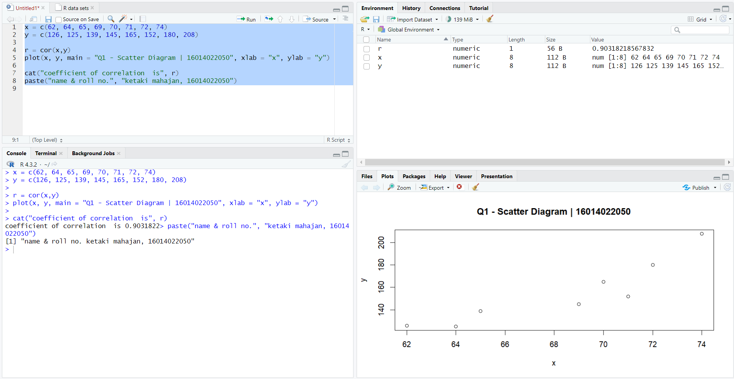

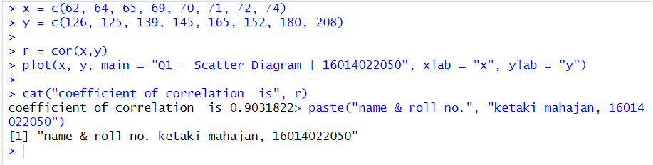

**Q2.**

**Obtain the equation of the line of y on x.**

**Estimate y when x is 73.**

**Plot equation of regression line of y on x.**

|  |  |  |  |  |  |  |
| --- | --- | --- | --- | --- | --- | --- |
| **X** | 70 | 72 | 74 | 76 | 78 | 80 |
| **Y** | 163 | 170 | 179 | 188 | 196 | 220 |

**Code –**

x = c(70, 72, 74, 76, 78, 80)

y = c(163, 170, 179, 188, 196, 220)

r1 = lm(y ~ x) # Regression of y on x

co = coef(r1) # Coefficients (a, b) in the equation y = a + b*x

mco = matrix(co) # Column matrix of coefficients (a, b)

a = mco[1, 1]

cat("Constant term a is", a)

b = mco[2, 1]

cat("Value of b is", b)

# Estimated values of y

esty = fitted(r1)

cat("Estimated values of y are", esty)

# Estimate y for x = 73

x1 = 73

ey = a + b * x1

cat("Estimated value of y when x = 73 is", ey)

plot (x, y, main = "Q2 – Regression Line Y on X | 16014022050", pch = "+") # Plots points corresponding to x and given value of y (+)

points(x, esty, pch = "*") # Plots points corresponding to x and it’s estimated value of y (*)

lines(x, y, col = "green") # Plots line corresponding to x and given value of y (+) using green colour

lines(x, esty, col = "red") # Plots line between x and estimated value of y (*) using red colour

paste("name & roll no.", "ketaki mahajan, 16014022050")

**Output –**

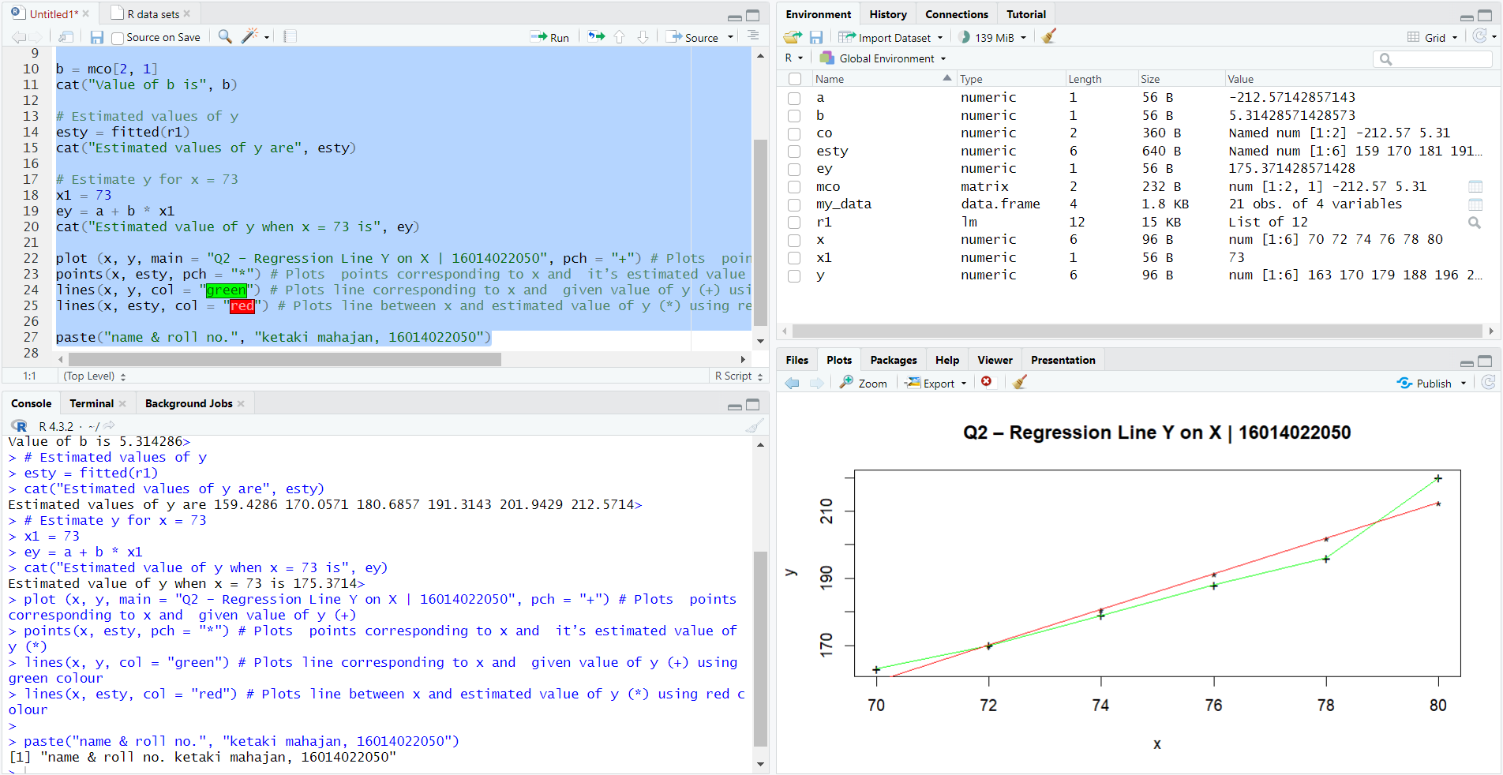

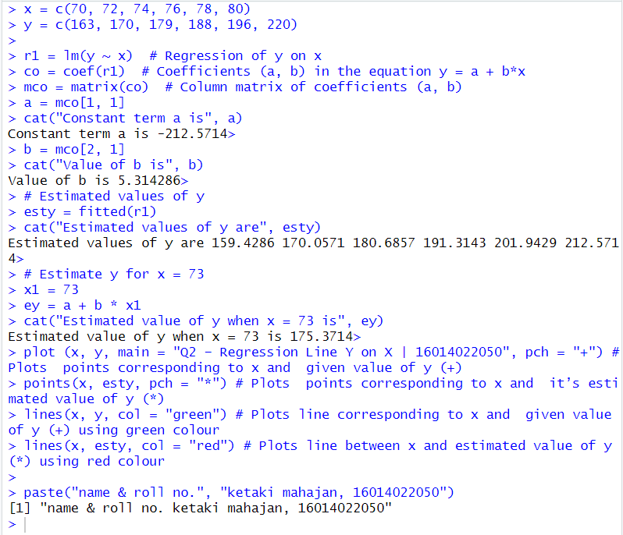

**Q3.**

**Find the equations of lines of regression of x on y for the following data.**

**Estimate x when y is 70.**

**Plot line of regression of x on y.**

|  |  |  |  |  |  |  |  |  |
| --- | --- | --- | --- | --- | --- | --- | --- | --- |
| **X** | 65 | 66 | 67 | 67 | 68 | 69 | 70 | 72 |
| **Y** | 67 | 68 | 65 | 66 | 72 | 72 | 69 | 71 |

**Code –**

x = c(65, 66, 67, 67, 68, 69, 70, 72)

y = c(67, 68, 65, 66, 72, 72, 69, 71)

r1 = lm(x ~ y) # Regression of x on y

co = coef(r1) # Coefficients (a, b) in the equation x = a + b*y

mco = matrix(co) # Column matrix of coefficients (a, b)

a = mco[1, 1]

cat("Constant term a is", a)

b = mco[2, 1]

cat("Value of b is", b)

# Estimated values of x

estx = fitted(r1)

cat("Estimated values of x are", estx)

# Estimate x for y = 70

y1 = 70

ex = a + b * y1

cat("Estimated value of X is when y = 70 is", ex)

plot(x, y, main = “Q3 – Regression Line X on Y | 16014022050”, pch = "+") # Scatter plot of original data

points(estx, y, pch = "*") # Plots points corresponding to x and it’s estimated value of y(*)

lines(x, y , col = "green") # Plots line corresponding to x and given value of y (+) using green colour

lines(estx, y , col = "red")# Plots line between y and estimated value of x (*) using red colour

paste("Name & Roll no.: Ketaki Mahajan, 16014022050")

**Output –**

