Ketaki Mahajan

A – 2 / 16014022050

Tutorial 4: Probability Distribution (16 / 02 / 2024)

1. **If X is Binomial Distribution B(n, p), where n = 20, p = 0.65. Write R-program to evaluate and print the following -**
   1. **P(X = 5)**
   2. **P(X ≤ 16)**
   3. **P(X ≥ 7)**

**Code –**

a = dbinom(5, 20, 0.65)

b = pbinom(16, 20, 0.65)

c = 1 - pbinom(7, 20, 0.65)

cat("P(X = 5) = ", a)

cat("P(X ≤ 16) = ", b)

cat("P(X ≥ 7) = ", c)

cat("Name & Roll No.: ", "Ketaki Mahajan, 16014022050")

**Output –**

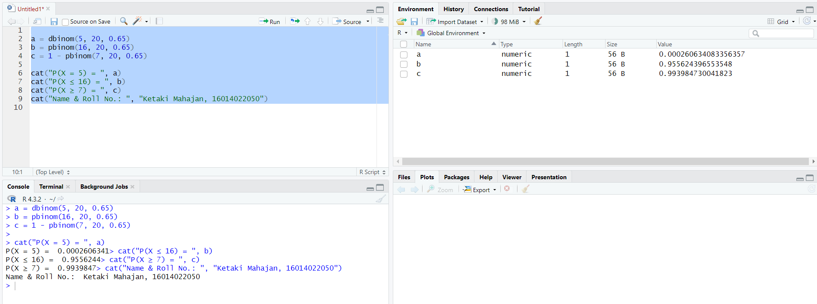

1. **If X is Poisson Distribution with mean 0.05, write R-program to evaluate and print the following -**
   1. **P(X = 10)**
   2. **P(X ≤ 5)**
   3. **P(12 ≤ X ≤ 25)**

**Code –**

m = 0.05

a = dpois(10, m)

b = ppois(5, m)

c = ppois(25, m) - ppois(11, m)

cat("P(X = 10) = ", a)

cat("P(X ≤ 5) = ", b)

cat("P(12 ≤ X ≤ 25) = ", c)

cat("Name & Roll No.: ", "Ketaki Mahajan, 16014022050"

**Output –**

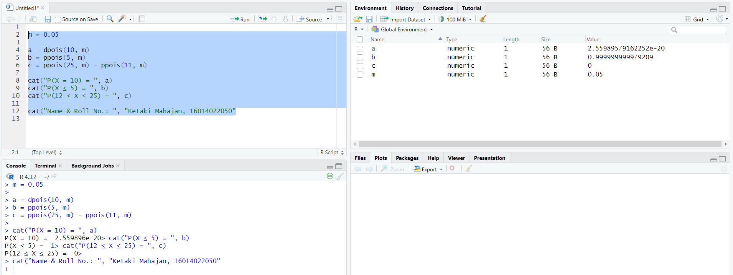

1. **If X is Uniform Distribution over the range (1, 35), write R-program to evaluate and print the following -** 
   1. **P(X < 17.6)**
   2. **P(X > 19.2)**
   3. **P(21.5 < X < 33.9)**

**Code –**

a = punif(17.6, 1, 35)

b = 1 - punif(19.2, 1, 35)

c = punif(33.9, 1, 35) - punif(21.5, 1, 35)

cat("P(X < 17.6) = ",a)

cat("P(X > 19.9) = ",b)

cat("P(21.5 < X < 33.9) = ",c)

cat("Name & Roll No.: ", "Ketaki Mahajan, 16014022050")

**Output –**

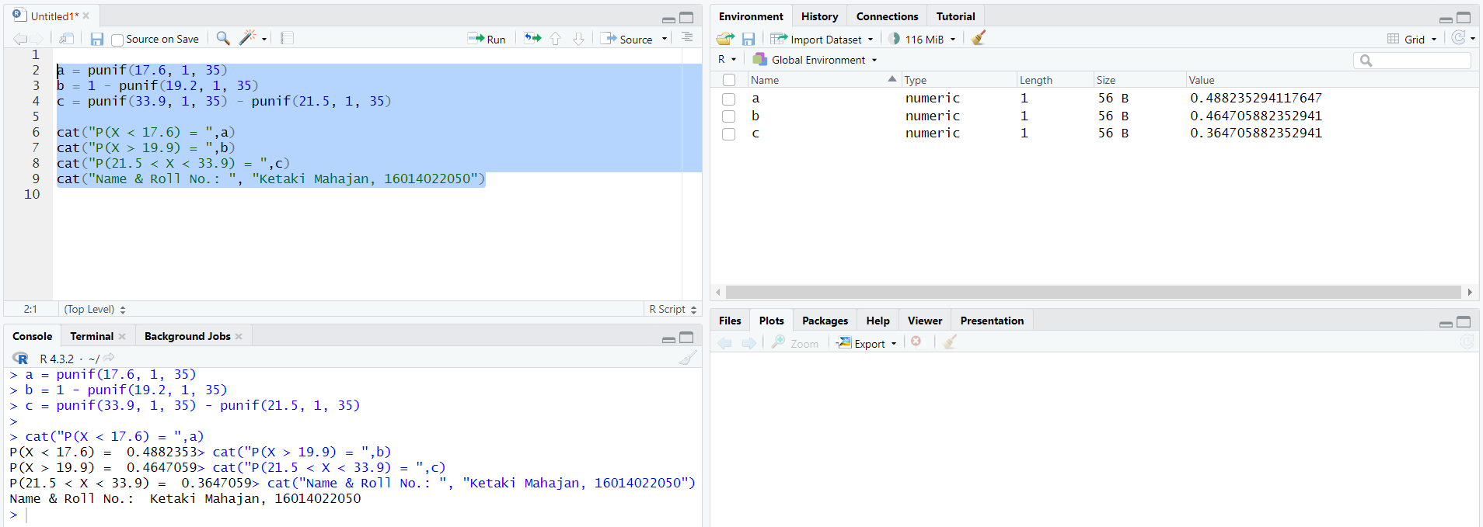

1. **If X is Exponential Distribution with mean 60, write R-program to evaluate and print the following -**
   1. **P(X < 45)**
   2. **P(X > 50)**
   3. **P(5 < X < 75)**
   4. **Find value of k such that P(X < k) = 0.7**

**Code –**

pa = 1/60

a = pexp(45, pa)

b = 1 - pexp(50, pa)

c = pexp(75, pa) - pexp(5, pa)

k = qexp(0.7, pa)

cat("P(X < 45) = ", a)

cat("P(X > 50) = ", b)

cat("P(5 < X < 75) = ",c)

cat("The value of k is ",k)

cat("Name & Roll No.: ", "Ketaki Mahajan, 16014022050")

**Output –**

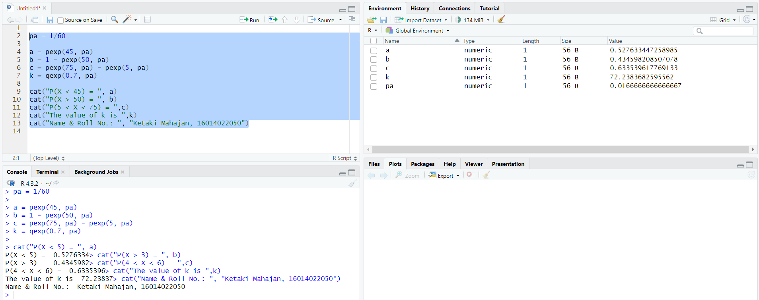

1. **If X is Normal Distribution with mean 20 and standard deviation 5, write R-program to evaluate and print the following -**
   1. **P(X < 28)**
   2. **P(X > 15)**
   3. **P(10 < X < 35)**
   4. **Find value of k1 such that P(X < k1) = 0.3**
   5. **Find value of k2 such that P(X > k2) = 0.04**

**Code –**

a = pnorm(28, 20, 5)

b = 1 - pnorm(15, 20, 5)

c = pnorm(35, 20, 5) - pnorm(10, 20, 5)

k1 = qnorm(0.3, 20, 5)

k2 = qnorm(0.04, 20, 5)

cat("P(X < 28) = ", a)

cat("P(X > 15) = ", b)

cat("P(10 < X < 35) = ", c)

cat("Value of k1 such that P(X < k1) = 0.3 is ", k1)

cat("Value of k2 such that P(X > k2) = 0.04 is ", k2)

cat("Name & Roll No.: ", "Ketaki Mahajan, 16014022050")

**Output –**

