Ketaki Mahajan

A – 2 / 16014022050

Tutorial 6: Sampling using R (15 / 03 / 2024)

1. **Test the significance of the difference between the means of two normal population with the same standard deviation from the following data –**

|  |  |  |  |
| --- | --- | --- | --- |
|  | **Size** | **Mean** | **Standard Deviation** |
| **Sample 1** | 1000 | 25 | 5 |
| **Sample 2** | 2000 | 23 | 7 |

**Code –**

sm1 = 25 # mean for sample 1

sm2 = 23 # mean for sample 2

sd1 = 5 # standard deviation of sample 1

sd2 = 7 # standard deviation of sample 2

n1 = 1000 # size of sample 1

n2 = 2000 # size of sample 2

zcal= abs((sm1-sm2)/sqrt((sd1^2/n2)+(sd2^2/n1)))

cat("absolute value of z-calculated is ", zcal)

cat("name & rollno.: ","ketaki mahajan & 16014022050")

**R-studio Output –**

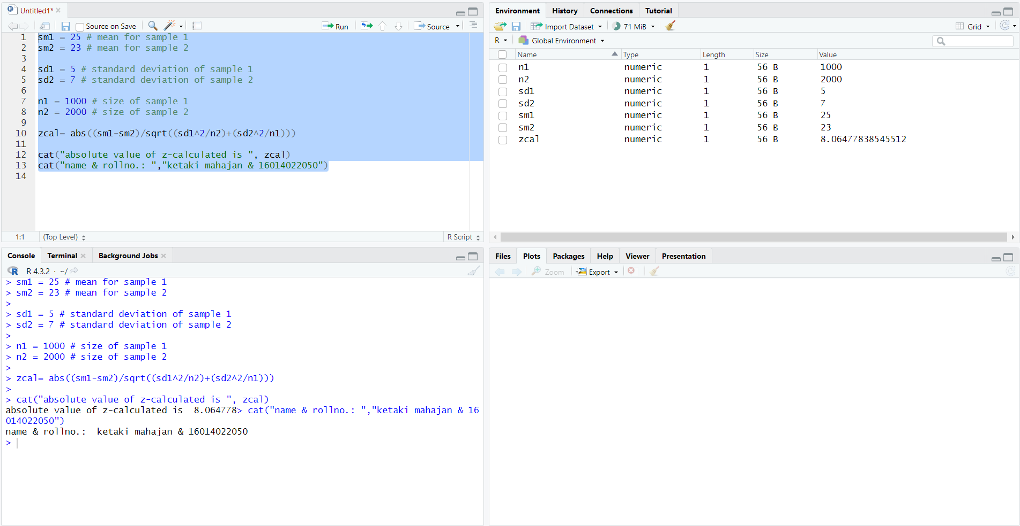

**Steps of Hypothesis Testing –**

* **Ho :**
* **Ha :**  (Nature of the test is two tailed)
* LOS is 5%
* Table value of $Z_{α}$ is: 1.96
* Calculated value of Z: $Z_{cal}=\frac{{\overline{x}}_{1}- {\overline{x}}_{2}}{\sqrt{\frac{s_{1}^{2}}{n_{2}}+\frac{s_{2}^{2}}{n_{1}}}}=$ 8.064778
* Since, $Z_{cal}$ > $Z_{α}$, we **reject** the null hypothesis.
* Hence, to conclude, we can say that the **difference between the population means is significant**.

1. **The weights of eight randomly selected athletes are recorded in kilograms:**

**70, 75, 78, 80, 82, 85, 87, 90.**

**The weights of twelve randomly selected basketball players are recorded in kilograms:**

**72, 74, 76, 78, 79, 80, 82, 83, 84, 85, 87, 88.**

**Can it be concluded that basketball players, on average, weigh more than athletes?**

**Code –**

# athletes weights (sample 1)

x1 <- c(70, 75, 78, 80, 82, 85, 87, 90)

# basketball player weigths (sample 2)

x2 <- c(72, 74, 76, 78, 79, 80, 82, 83, 84, 85, 87, 88)

sm1 = mean (x1) # mean for sample 1

sm2 = mean (x2) # mean for sample 2

sd1 = sd(x1) # standard deviation of sample 1

sd2 = sd(x2) # standard deviation of sample 2

n1 = 8 # size of sample 1

n2 = 12 # size of sample 2

tcal = abs((sm1-sm2)/sqrt(((n1*sd1^2+n2*sd2^2)/(n1+n2-2))*((1/n1)+(1/n2))))

cat("absolute value of t-calculated is ", tcal)

cat("name & rollno.: ","ketaki mahajan & 16014022050")

**R-Studio Output –**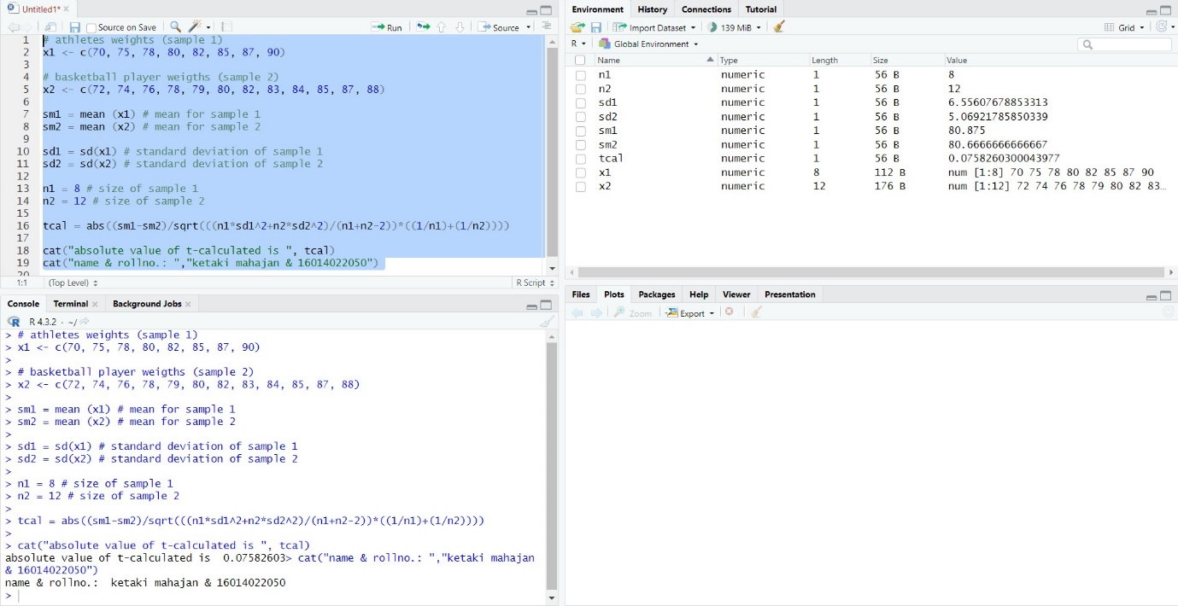

**Steps of Hypothesis Testing –**

* **Ho :**
* **Ha :**  (Nature of the test is one tailed)
* LOS is assumed as 5%
* DOF = 8 + 12 – 2 = 18
* Table value of $t_{α}$ is: 1.7341
* Calculated value of t: $t_{cal}=\frac{{\overline{x}}_{1}- {\overline{x}}_{2}}{\sqrt{\frac{n_{1}s_{1}^{2}+n_{2}s_{2}^{2}}{n_{1}+n_{2}-2}} ×\sqrt{\frac{1}{n_{1}}+\frac{1}{n_{2}}}}$ = 0.07582603
* Since, $t_{cal}$ < $t_{α}$, we **accept** the null hypothesis.
* Hence, to conclude, there is **no evidence** that says basketball players, on average, weigh more than athletes.

1. **A random sample of 300 observations has a mean of 15.5 kg. Can it be a random sample from a population whose mean is 16 kg and variance are 20 kg?**

**Code –**

pm = 16 # population mean

sm = 15.5 # sample mean

sd = sqrt(20) # standard deviation of sample or population

n = 300 # size of sample

zcal = abs((sm-pm)/(sd/sqrt(n)))

cat("absolute value of z-calculated is ",zcal)

cat("name & rollno.: ", "ketaki mahajan & 16014022050")

**R-Studio Output –**

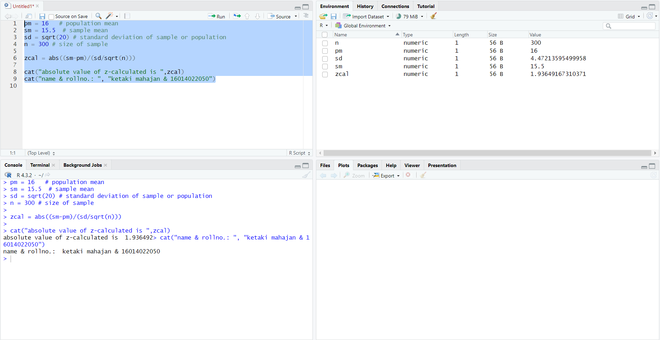

**Steps of Hypothesis Testing –**

* **Ho :**
* **Ha :**  (Nature of the test is two tailed)
* LOS is 5%
* Table value of $Z_{α}$ is: 1.96
* Calculated value of Z: $Z_{cal}= \frac{\overline{x}-μ}{σ/{\sqrt{n}}}=$ 1.936492
* Since $Z_{cal}$ < $Z_{α}$, we **accept** the null hypothesis.
* Hence, to conclude, we can say that the **sample is drawn from a population** with mean 16.