**Name: Ketaki Mahajan**

**Batch: A – 3**

**Roll Number: 16014022050**

**Question 1:**

Draw the graph of the following function and its Fourier series (with n = 100 and n = 50).

$f\left(x\right)=x-x^{2}$, $0 ≤x ≤2π$

**Code (n = 50) -**

clear; clc;

L = %pi;

x = 0:0.01:2*L;

f = x - x.^2; *// define function f(x)*

a0 = (1/(2*L)) * inttrap(x, f); *// calculate a0*

for n = 1:50

f1 = f .* cos(%pi * n * x / L);

a(n) = (1/L) * inttrap(x, f1); *// define Fourier constant a(n)*

end

for n = 1:50

f2 = f .* sin(%pi * n * x / L);

b(n) = (1/L) * inttrap(x, f2); *// define Fourier constant b(n)*

end

subplot(2, 1, 1);

plot(x, f);

title('Original Function');

u = 0; y = 0;

for n = 1:50

u = a(n) * cos(%pi * n * x / L) + b(n) * sin(%pi * n * x / L);

y = y + u;

end

fs = y + a0;

subplot(2, 1, 2);

plot(x, fs);

title('Ketaki Mahajan 16014022050 Question 1 if n=50','fontsize',5);

**Output (n = 50) -**

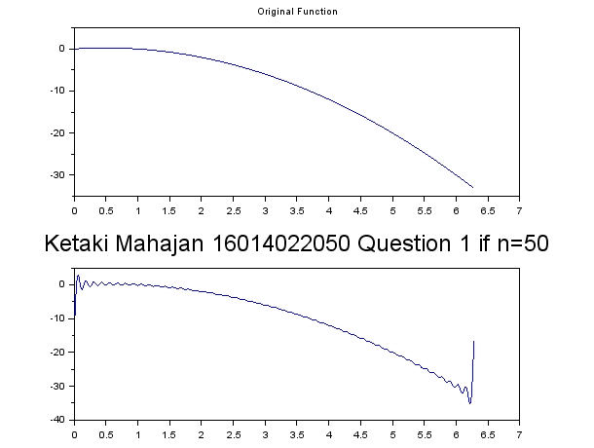

**Code (n = 100) -**

clear; clc;

L = %pi;

x = 0:0.01:2*L;

f = x - x.^2; *// define function f(x)*

a0 = (1/(2*L)) * inttrap(x, f); *// calculate a0*

for n = 1:100

f1 = f .* cos(%pi * n * x / L);

a(n) = (1/L) * inttrap(x, f1); *// define Fourier constant a(n)*

end

for n = 1:100

f2 = f .* sin(%pi * n * x / L);

b(n) = (1/L) * inttrap(x, f2); *// define Fourier constant b(n)*

end

subplot(2, 1, 1);

plot(x, f);

title('Original Function');

u = 0; y = 0;

for n = 1:100

u = a(n) * cos(%pi * n * x / L) + b(n) * sin(%pi * n * x / L);

y = y + u;

end

fs = y + a0;

subplot(2, 1, 2);

plot(x, fs);

title('Ketaki Mahajan 16014022050 Question 1 if n=100','fontsize',5);

**Output (n = 100) -**

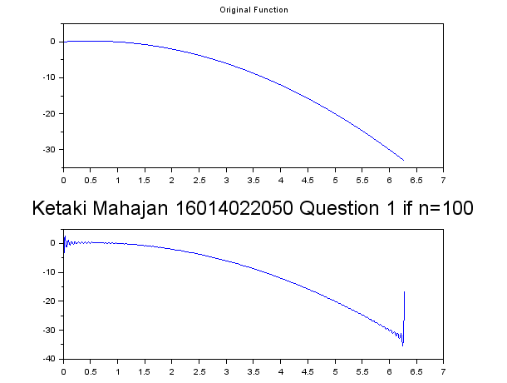

**Question 2:**

Draw the graph of the following function and its Fourier series (with n = 20 and n = 5).

$f\left(x\right)=\cos\left(x\right)$, $-π ≤x ≤ π$

**Code (n = 5) -**

clear; clc;

L = %pi;

x = -L:0.01:L;

f = cos(x); *// define function f(x)*

a0 = (1/(2*L)) * inttrap(x, f); *// calculate a0*

for n = 1:5

f1 = f .* cos(%pi * n * x * (1/L));

a(n) = (1/L) * inttrap(x, f1); *// define Fourier constant a(n)*

end

for n = 1:5

f2 = f .* sin(%pi * n * x * (1/L));

b(n) = (1/L) * inttrap(x, f2); *// define Fourier constant b(n)*

end

subplot(2, 1, 1);

plot(x, f);

title('Original Function');

u = 0; y = 0;

for n = 1:5

u = a(n) * cos(%pi * n * x * (1/L)) + b(n) * sin(%pi * n * x * (1/L));

y = y + u;

end

fs = y + a0;

subplot(2, 1, 2);

plot(x, fs);

title('Ketaki Mahajan 16014022050 Question 2 if n=5','fontsize',5);

**Output (n = 5) -**

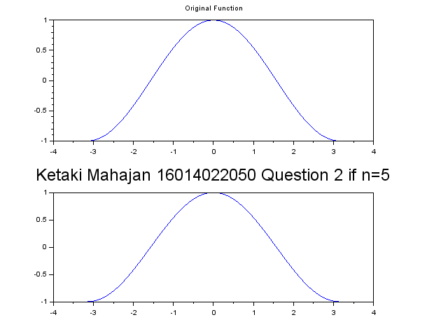

**Code (n = 20) -**

clear; clc;

L = %pi;

x = -L:0.01:L;

f = cos(x); *// define function f(x)*

a0 = (1/(2*L)) * inttrap(x, f); *// calculate a0*

for n = 1:20

f1 = f .* cos(%pi * n * x * (1/L));

a(n) = (1/L) * inttrap(x, f1); *// define Fourier constant a(n)*

end

for n = 1:20

f2 = f .* sin(%pi * n * x * (1/L));

b(n) = (1/L) * inttrap(x, f2); *// define Fourier constant b(n)*

end

subplot(2, 1, 1);

plot(x, f);

title('Original Function');

u = 0; y = 0;

for n = 1:20

u = a(n) * cos(%pi * n * x * (1/L)) + b(n) * sin(%pi * n * x * (1/L));

y = y + u;

end

fs = y + a0;

subplot(2, 1, 2);

plot(x, fs);

title('Ketaki Mahajan 16014022050 Question 2 if n=20','fontsize',5);

**Output (n = 20) -**

