**Question 1:**

Find out the mail servers of the following domain :

Ibm.com

Wipro.com

Ans-

* Ibm.com –

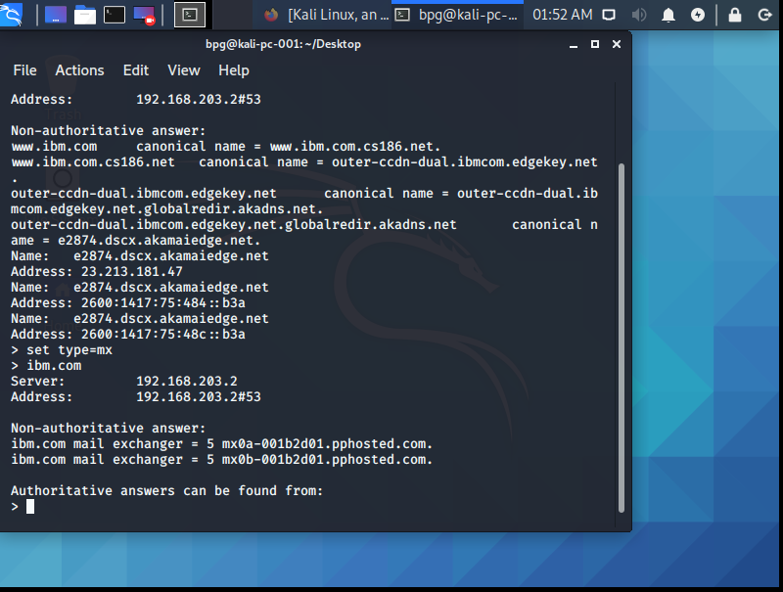

* Wipro.com

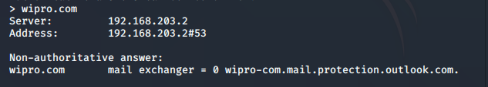

**Question 2:**

Find the locations, where these email servers are hosted.

Ans –

Ibm.com – USA

Wipro.com – India

**Question 3:**

Scan and find out port numbers open 203.163.246.23

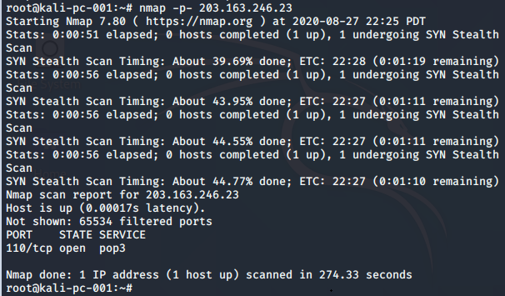

**Question 4:**

Install nessus in a VM and scan your laptop/desktop for CVE.

