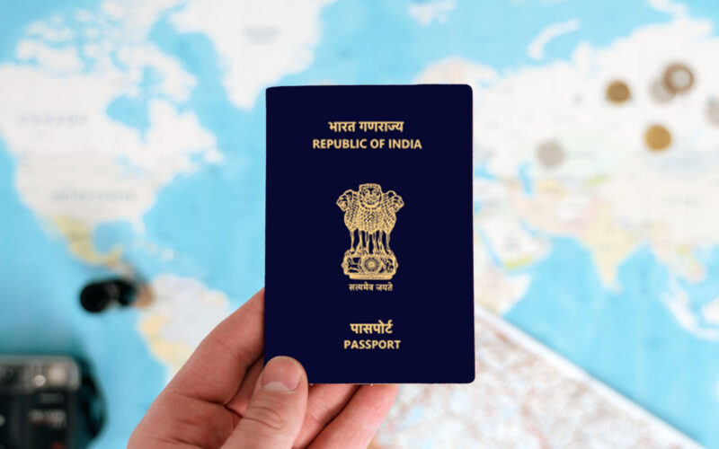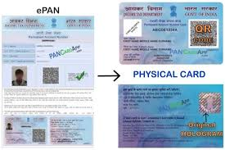

Passport
aniket@gmail.com
7057764142
1236 1456 7894
https://example.com/login-update
https://test-phish.example/reset
https://secure-example.net/verify-account
https://mail.example.org/security-alert

