
Cover illustration (decorative)
Healthcare Secure
Complete Student Handbook & Single Source of Truth
From first scaffold to current clinic app — architecture, Android, analytics, ABDM/SMS/multi-tenant, gynae decision support, debugging RCA, secrets, VPS deploy
Application version baseline: 0.1.0 (+ Unreleased features documented herein)
Document edition: 26 July 2026 (includes Jul 24–26 gynae decision support + offline/vitals RCA)
Audience: students learning Android (Capacitor), FastAPI, and clinic workflows
SECURITY NOTICE: This document never contains real SECRET_KEY, SECRET_SALT, PINs, API keys, or production passwords. Use placeholders only.

Table of contents
- Part I — Foundations
- Part II — Learning paths (Android, patient analytics, backend)
- Part III — Chronological development (scratch → now)
- Part IV — System deep dive (how it works today)
- Part V — Issues, debugging strategies, and root cause analysis
- Part VI — Secrets, changing app behavior, and paid VPS deployment
- Part VII — Future enhancement plans
- Part VIII — Appendices (glossary, commands, file tree)
This Word document is the intended single source of truth. README.md in the repo is a short entry point that points here. CHANGELOG.md remains the SemVer history; annexes: docs/PLAY_STORE.md, docs/CLOUD_DEPLOY.md, docs/PRIVACY_POLICY.md, docs/ABDM_SMS_MULTI_TENANT.md.

Part I — Foundations

1. Problem statement
Small clinics often juggle paper prescriptions, scattered phone photos of lab reports, and WhatsApp forwards. That is hard to search, easy to lose, and risky for privacy. Healthcare Secure is a dual-root clinic application: a Python FastAPI backend that stores de-identified clinical encounters, and a Next.js + Capacitor frontend that runs in a browser or as an Android app on ordinary staff phones.
Significance for learners: you are not building a toy todo list — you are practicing identity minimization, role-based access, mobile packaging, and operational deploy thinking on a domain that cares about patient data.

2. Product constraints
- Non-technical staff UI — short labels, Hindi/English toggle, large tap targets.
- Roles: doctor (sign Rx), staff (vitals/notes), lab (results/uploads).
- Gynecology-oriented decision support (obstetric card, ANC alerts, case brief) is advisory only — never auto-orders or replaces clinical judgment.
- Phones are general devices carried everywhere — open app on mobile data and work (clinic PC is optional for day-to-day use).
- Security first: raw name/phone/MRN are HMAC-blinded before persistence; secrets stay out of git.

3. Security mindset for beginners
PHI (Protected / personal health information) includes clinical notes, vitals, labs, and documents. Even if you hash the patient’s phone, the visit notes remain sensitive. Blind IDs reduce the risk of a stolen database leaking a phone-number column — they do not make the whole dataset “anonymous.”
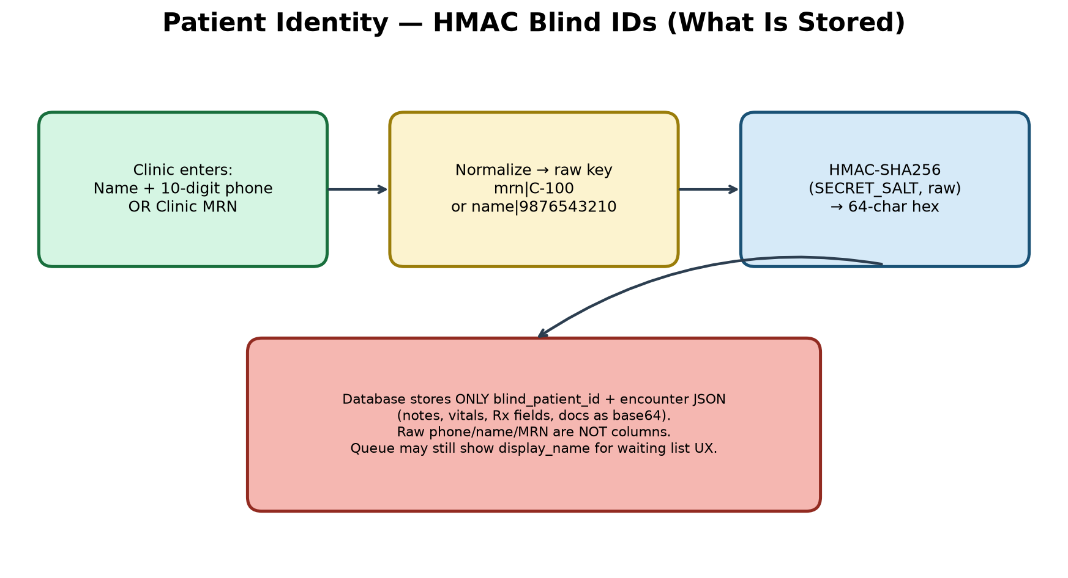
Figure: HMAC blind identity pipeline
- SECRET_SALT — used only for HMAC patient IDs. Changing it remaps history (plan carefully).
- SECRET_KEY — used for signed prescription download URLs.
- PINs — prefer pbkdf2$… hashes from scripts/hash_pin.py; lockout after failed attempts.
- TLS — phones on public 4G must use HTTPS with a publicly trusted certificate (Let’s Encrypt), not a self-signed LAN cert.

4. Tech stack glossary
Term | Plain meaning in this project
FastAPI | Python web framework for the clinic API
SQLAlchemy | ORM mapping Python classes to DB tables
SQLite / Postgres | Local file DB vs production server DB
Next.js App Router | React UI framework; we static-export for Capacitor
Capacitor | Wraps web UI in a native Android shell
Whisper | Speech-to-text (local faster-whisper or cloud)
Ollama / LLM | Parses transcript text into structured Rx JSON
HMAC | Keyed hash — same salt + input → same blind ID
nginx | Reverse proxy terminating TLS in Docker

5. Dual-root layout
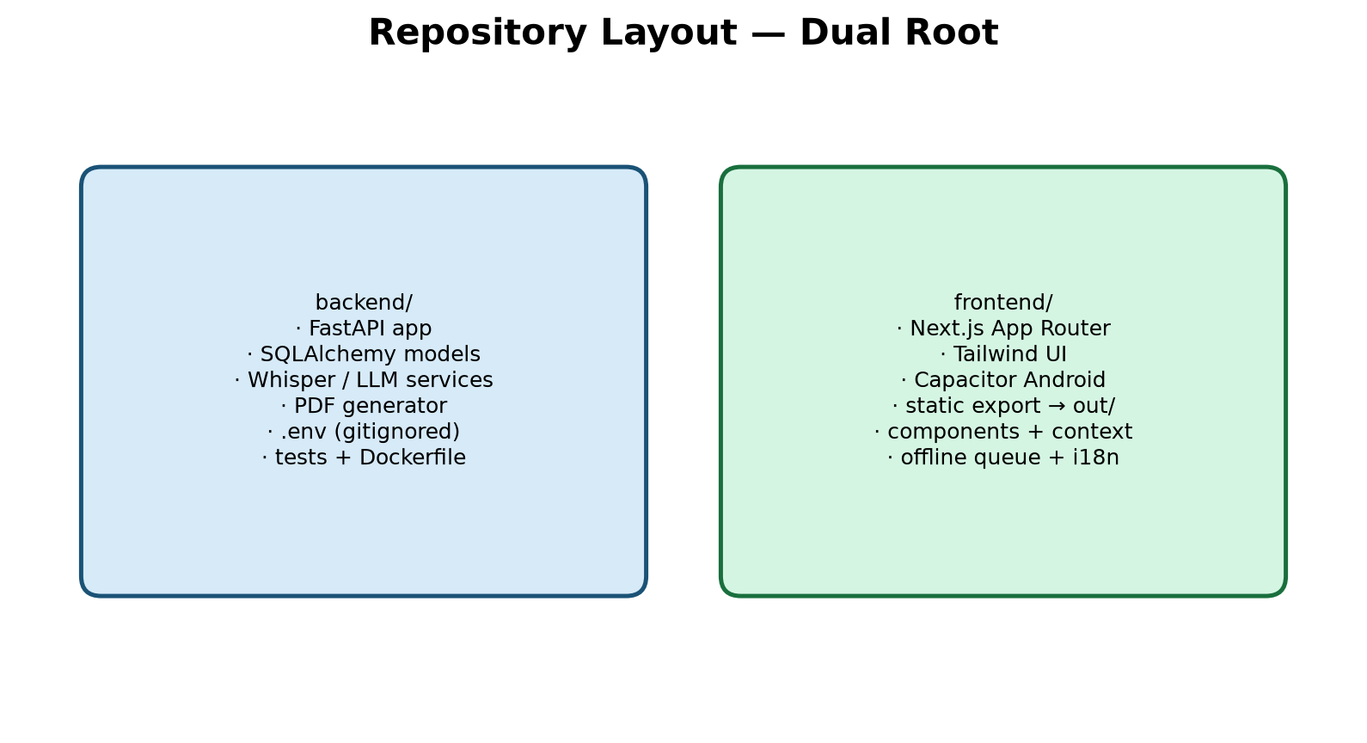
Figure: backend/ and frontend/ dual roots
Keeping API and UI in separate roots teaches a production habit: the phone never embeds the database; it only calls HTTPS endpoints. You can rebuild the Android app without touching Python, and scale the API independently later.

Part II — Learning paths

6. Android path (Capacitor)
The “Android app” is mostly your Next.js UI compiled to static files in frontend/out/, then synced into a native project with Capacitor. The WebView loads those files. Native plugins add microphone, share, and print behaviors.
- Set frontend/.env.local NEXT_PUBLIC_API_BASE_URL (optional default; runtime override exists).
- npm run mobile:build → next build + npx cap sync.
- npm run cap:open:android → Android Studio.
- Run on USB device; grant RECORD_AUDIO when prompted.
- On sign-in, set Clinic server address to your API (LAN or https://api.example).
Significance: static export (output: "export" in next.config) is required so there is no Node server on the phone. Default Capacitor builds allow cleartext HTTP for LAN learning. For cloud HTTPS production APKs set CAPACITOR_HTTPS=true before npm run mobile:build (see docs/PLAY_STORE.md). AGP 9.x needs proguard-android-optimize.txt — frontend/scripts/fix-agp-proguard.mjs runs during cap:sync / mobile:build.
Student tip: frontend/android/ is gitignored — each machine generates it with Capacitor. That surprises beginners who clone the repo and expect Android Studio files to appear automatically.

7. Patient analytics path (as implemented today)
Clinic Analytics is live under More (not a hospital BI warehouse). Staff/doctors see operational counts; lab sees a limited lab-results summary. On Visit, decision-support panels (case brief, ANC alerts, consult pack) sit above vitals for the locked patient.
- GET /api/v1/analytics/today — encounters, unique patients, queue waiting, vitals, labs, Rx signed.
- GET /api/v1/analytics/week — last 7 days by day.
- GET /api/v1/analytics/frequency — top medications and diagnoses (30d).
- POST /api/v1/analytics/vitals-trend — weight/BP/Hb (+ pulse/SpO2/temp) over visits; merges lab Hb into the series; returns ANC rule alerts; optional gestational-age X-axis from LMP.
- GET /api/v1/analytics/export.csv — de-identified CSV (doctor only); blind-id prefix only.
- GET /api/v1/history/case-summary — consolidated obstetric + vitals deltas + labs + docs + scan cadence + soft alerts (decision support).
- POST /api/v1/history/consult-pack — LLM or rule-fallback “today’s consult” checklist.
- POST /api/v1/history/rx-hints — soft pre-sign medication conflict hints.
- POST /api/v1/history/documents/{id}/analyze — extract USG/report findings into structured JSON.
- Patient timeline, activity audit, waiting queue (Open → lock patient), structured lab + HL7 ORU.
Student rule: never export raw phone/name columns. Temperature may be entered in °C or °F (stored as °F). Neonatal vitals bands apply when age is under ~28 days. LLM/consult output is decision support only — confirm before acting.

8. Backend path
Request flow: HTTP → FastAPI router (app/api/v1/endpoints/*) → service (app/services/*) → SQLAlchemy model → database. Settings load from backend/.env via pydantic-settings (app/core/config.py). OpenAPI docs appear only when DEBUG=true.

Part III — Chronological development
This section is an engineering journal: each era shows goal, steps, significance, and how to verify. Dates refer to the July 2026 build history of this repository.

Era A — Scaffold (Day 0)
Goal: Create dual-root FastAPI + Next.js App Router + Tailwind TypeScript skeleton with CORS locked to localhost and env-driven config.
Development steps:
- backend/app/main.py with /health
- backend/app/core/config.py + .env.example
- frontend app router layout/page + Tailwind
Significance: Teaches separation of API and UI and “no secrets in code.”
How to verify: curl http://127.0.0.1:8000/health ; npm run dev on :3000

Era B — Config & frontend versioning fixes
Goal: Make uvicorn and Next actually start on the developer machine.
Development steps:
- Fix CSV list env parsing with NoDecode
- Restore Next.js 15 after accidental downgrade to Next 9
Significance: First real RCA lessons (see Part V).
How to verify: Uvicorn starts; Next shows the dashboard shell

Era C — Blind identity + clinical records
Goal: Store encounters keyed by HMAC blind_patient_id, never raw phone columns.
Development steps:
- app/services/security.py
- app/models/record.py ClinicalRecord
- SECRET_SALT in settings
Significance: Core privacy architecture of the product.
How to verify: Tokenize endpoint returns shape mrn|… or name|phone without persisting raw IDs as columns

Era D — Voice → transcript → LLM → PDF
Goal: Doctor dictates; system produces a signed prescription PDF and history row.
Development steps:
- Whisper transcription service
- LLM parser (Ollama default)
- fpdf2 letterhead PDF
- Frontend VoiceRecorder + EncounterWorkspace
Significance: End-to-end clinical value; introduces AI ops (CPU Whisper, Ollama).
How to verify: Record short clip → parse → write PDF

Era E — Mic Permissions-Policy bug
Goal: Browser recording failed with NotAllowedError despite user gesture.
Development steps:
- next.config Permissions-Policy microphone=(self)
Significance: Security headers can break features — always test mic after header changes.
How to verify: Record button captures audio on localhost

Era F — Mobile / LAN
Goal: Run on Android over clinic Wi-Fi.
Development steps:
- Capacitor config + mobile:build
- uvicorn --host 0.0.0.0
- CORS + PUBLIC_API_BASE_URL for LAN IP
Significance: Bridges web skills into Android packaging.
How to verify: Phone browser or APK reaches API

Era G — Roles, vitals, simplified UI
Goal: Staff enter vitals; lab uploads; doctor signs.
Development steps:
- doctor/staff/lab roles
- vitals validation (°F)
- simplified non-tech copy
Significance: Clinic realism beyond a single-doctor demo.
How to verify: Staff PIN can save vitals; lab cannot sign Rx

Era H — Reliability (P1)
Goal: Survive API restarts; stop baking LAN IP into every APK rebuild.
Development steps:
- Runtime clinic server URL
- Durable clinic_sessions
- PIN hash + lockout
- activity log, pytest CI, SQLite backup scripts
Significance: Moves from prototype to operable clinic tool.
How to verify: Restart API; session still valid; change URL without rebuild

Era I — Enhancements (P2/P3 + later stubs)
Goal: MRN identity, structured lab, print-first Rx, queue, i18n, offline queue, Docker/TLS, AAB docs, ABHA/HL7/pediatric stubs.
Development steps:
- queue.py, integrations.py, LabResultsForm, WaitingQueue
- docker-compose.yml + nginx
- docs/PLAY_STORE.md
Significance: Broadens clinic ops and prepares cloud hosting.
How to verify: Add queue entry; enter lab panel; docker compose builds

Era J — Ops, analytics, hardening (22 Jul 2026)
Goal: Keep the API responsive on phones; ship clinic analytics; harden production defaults.
Development steps:
- WHISPER_PRELOAD=false by default; warm Whisper in background if enabled
- scripts/watch_api.cmd health watchdog
- Phone first-run blocks localhost (needsClinicUrlSetup)
- ClinicAnalytics UI + /analytics/today|week|frequency|vitals-trend|export.csv
- Attachments on disk (content_path); TrustedHost + unlock rate-limit
- °C/°F preference; neonatal vitals; HL7 MSA ACK; CAPACITOR_HTTPS; PRIVACY_POLICY.md
- AGP ProGuard fix script (proguard-android-optimize.txt)
Significance: Turns “LAN demo that hangs” into an operable daily clinic tool.
How to verify: curl /health answers in <1s; phone unlocks with LAN IP; analytics panel loads

Era K — ABDM, SMS appointments, multi-tenant (22–23 Jul 2026)
Goal: National-ready ABHA OTP flow (sandbox/mock), appointment SMS, multi-clinic isolation.
Development steps:
- abdm_client.py + /integrations/abha/otp/* + callback; ABDM_MOCK OTP 123456
- appointments API + SMS_PROVIDER=console|msg91|twilio; encrypted phones
- CLINICS + clinic_id on users/sessions/records/queue/appointments
- docs/ABDM_SMS_MULTI_TENANT.md
Significance: Moves beyond single-clinic POC toward multi-site and ABDM-capable installs.
How to verify: Book appointment (console SMS log); ABDM_MOCK link; two clinics cannot see each other’s records

Era L — OPD shell, gynae decision support, demo seed (24–26 Jul 2026)
Goal: Ship a multi-tab clinic shell and pregnancy-aware decision support without inventing diagnoses.
Development steps:
- Clinic routes: Today / Patient / Visit / Records / Labs / More + ClinicNav bottom bar
- Obstetric profile (LMP/EDD/GPLA/blood group/Rh/high-risk) + LockedPatientChip GA
- Hemoglobin on vitals; pregnancy-aware weight/BP/Hb charts (GA X-axis when LMP set)
- Case brief UI + GET /history/case-summary; ANC BP/Hb/weight alerts (anc_alerts.py)
- Merge lab Hb into vitals-trend; ANC scan cadence checklist (NT / anomaly / growth)
- POST /history/consult-pack (LLM + rule fallback); POST /history/rx-hints before sign
- POST /history/documents/{id}/analyze for USG/report findings; Analyze on attachments
- Waiting List Open → lock patient; Google Calendar / .ics; day-before SMS remind script
- scripts/seed_demo.cmd — eight showcase patients covering alerts, cadence, Rx hints
- Offline queue: only queue network/5xx failures; drop 400/422 invalid jobs on sync
- Fix VitalsTrendCharts TS syntax (Python * keyword-only args broke mobile:build)
Significance: Turns the app into a teachable gynae OPD demo: charts, alerts, consult pack, and safe Rx hints.
How to verify: seed_demo --wipe; lock Ananya Reddy → Visit case brief shows alerts; Records → Analyze growth USG; npm run mobile:build succeeds

Current status snapshot
Area | Status
LAN clinic on PC + phone | Usable (set clinic URL; not localhost on phone)
Roles / PIN / durable sessions | Implemented
MRN / lab / queue / offline / i18n | Implemented
Clinic analytics + CSV export | Implemented
Attachments on disk | Implemented (legacy base64 still readable)
Docker Compose scaffold | Present; harden before public
Public India VPS phones-everywhere | Documented (CLOUD_DEPLOY.md); not auto-provisioned
ABHA / ABDM | OTP + link implemented; needs NHA credentials for live gateway (ABDM_MOCK for demo)
SMS appointments | Implemented (console/msg91/twilio); day-before remind script
Multi-tenant clinics | Implemented (CLINICS + clinic_id scoping)
OPD multi-tab shell | Implemented (Today / Patient / Visit / Records / Labs / More)
Obstetric profile + GA charts | Implemented (LMP/EDD/GPLA; Hb; pregnancy X-axis)
Case brief / ANC alerts / consult pack | Implemented (decision support only)
Rx pre-sign hints + USG analyze | Implemented (soft warnings; findings JSON)
Demo seed showcase | scripts/seed_demo.cmd (--wipe)
Play Store listing | AAB docs + PRIVACY_POLICY.md stub
Git remote push of Unreleased work | May still need auth/commit hygiene

Part IV — System deep dive
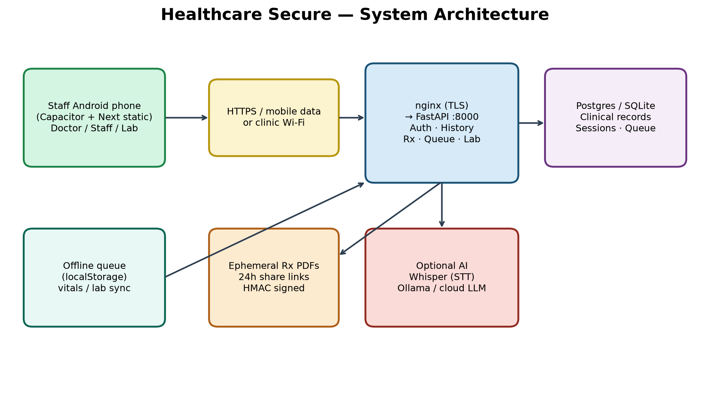
Figure: system architecture
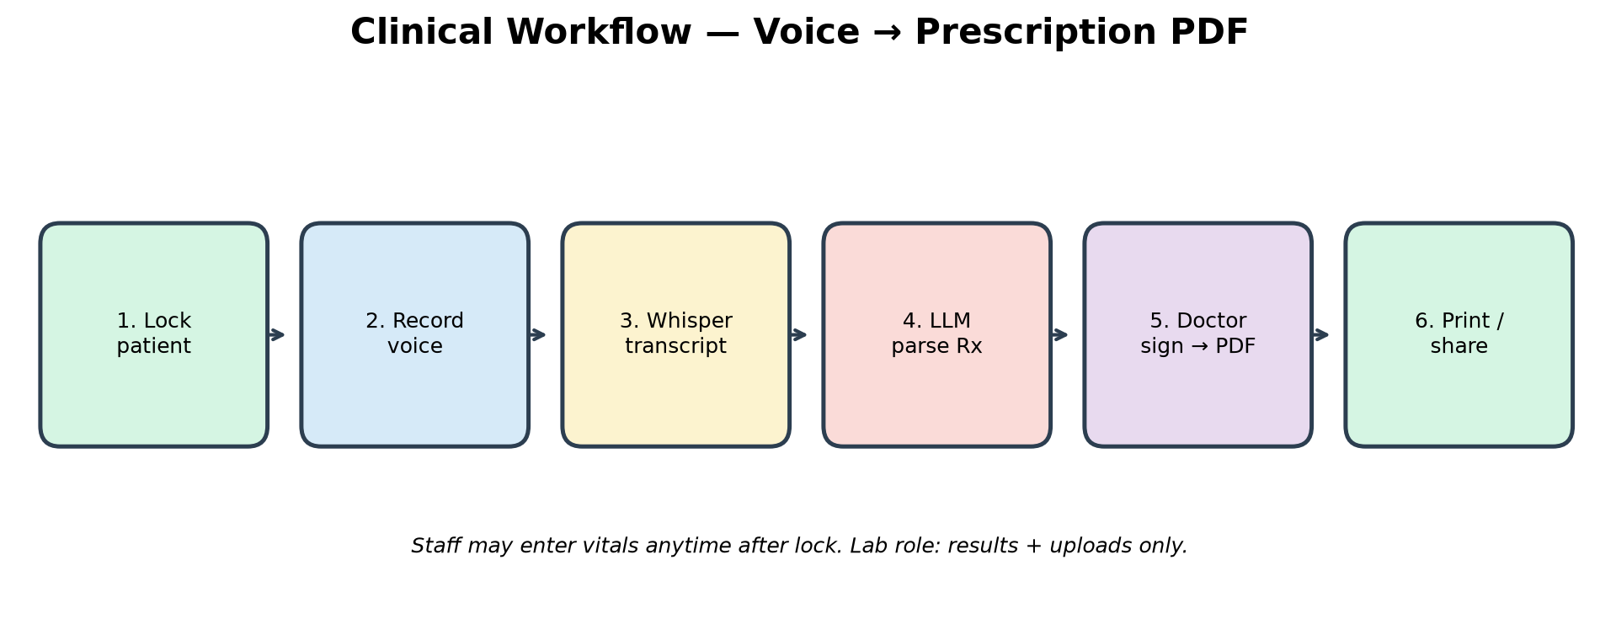
Figure: voice to prescription workflow
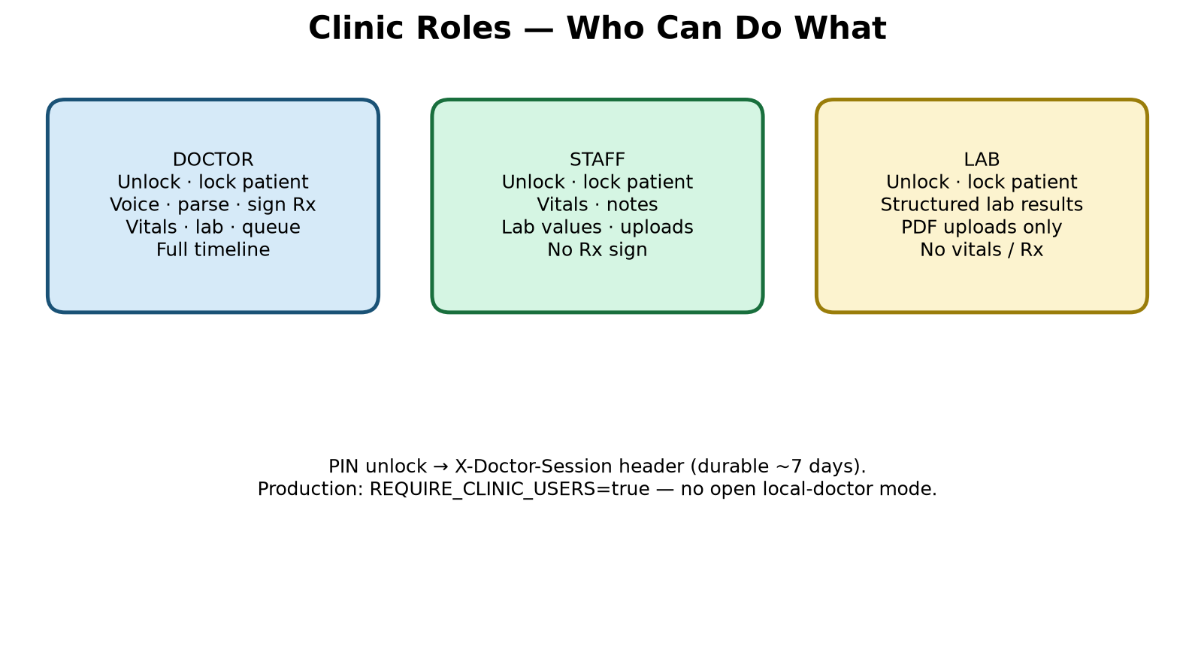
Figure: role capabilities

9. Data model (conceptual)
- clinical_records — id, clinic_id, blind_patient_id, created_at, encounter_data (JSON).
- clinic_sessions — durable unlock tokens (~7 days) including clinic_id.
- clinic_queue — today’s waiting list (clinic-scoped).
- appointments — scheduled visits; phone encrypted at rest; SMS status fields.
- encounter_data types: visit/prescription, vitals, document, lab_result, audit, abha_link, obstetric_profile.
- Document files live under backend/data/attachments/ (content_path); optional findings JSON after Analyze; legacy content_base64 still loads.
- Existing DBs gain clinic_id via soft ALTER on API startup (schema_migrate).

10. Identity rules
- Prefer clinic MRN when set → raw key mrn|{MRN} → HMAC.
- Else name + 10-digit Indian mobile → name|{digits}.
- Phone change remaps history for name|phone keys; MRN-keyed patients skip remap (records_moved=0).
- ABHA: local HMAC link always available; with ABDM credentials or ABDM_MOCK, use MOBILE_OTP then link with txn_id.
- Linking tokens from ABDM are stored as HMAC only — never cleartext ABHA in columns.
- Multi-clinic: every clinical read/write is filtered by the signed-in clinic_id.

11. API map (student overview)
Prefix | Purpose
/health | Liveness (must stay fast — do not block on Whisper load)
/api/v1/auth/* | Unlock / lock / me / status (users + clinics list)
/api/v1/history/* | Tokenize, search, vitals, docs, lab-results, obstetric-profile, case-summary, consult-pack, rx-hints, document analyze, change-phone
/api/v1/prescription/* | Transcribe, parse, write PDF, share-link, download
/api/v1/queue/* | Today’s waiting queue
/api/v1/appointments/* | Book / list / remind / cancel / patient-identity (+ SMS)
/api/v1/analytics/* | Today, week, frequency, vitals-trend (+ alerts/lab merge), export.csv
/api/v1/integrations/* | ABHA OTP/link/status, ABDM callback, HL7 ORU + MSA ACK

12. Frontend map
- app/(clinic)/* — Today / Patient / Visit / Records / Labs / More (bottom ClinicNav)
- DoctorGate — clinic picker, PIN, clinic server URL (blocks localhost on phone)
- PatientBar / PatientContext / LockedPatientChip — lock, MRN, GA chip, ABHA OTP + local link
- AppointmentScheduler (Google Calendar / .ics), ClinicAnalytics, WaitingQueue (Open → lock)
- ObstetricProfileForm, PatientCaseBrief (alerts, scan cadence, consult pack)
- VitalsForm (°C/°F + hemoglobin), PatientVitalsCharts / VitalsTrendCharts, LabResultsForm
- EncounterWorkspace (rx-hints before Sign), VoiceRecorder, PrescriptionShare
- PatientTimeline, PatientAttachments (Analyze), PatientAuditTrail, OfflineSyncBanner
- lib/offlineQueue.ts (drop 400/422), lib/i18n.tsx (EN/HI), lib/apiBase.ts, lib/doctorSession.ts, lib/obstetric.ts, lib/calendarExport.ts

13. Offline semantics
If vitals/lab POST fails due to network error or 5xx/408/429, items enqueue in localStorage (capped). Banner on Today offers Sync now; online event and page load also flush. Validation failures (HTTP 400/422) are NOT queued — they show the server error and are dropped from any stale queue on the next flush (see RCA-16). This is not a full offline EHR — prescriptions still need the API.

14. Environment surface (placeholders only)
Copy backend/.env.example → backend/.env. Example placeholder lines (DO NOT use these as real secrets):
- SECRET_KEY=CHANGE_ME_GENERATE_WITH_OPENSSL_RAND_HEX_32
- SECRET_SALT=CHANGE_ME_GENERATE_WITH_OPENSSL_RAND_HEX_32
- CLINIC_USERS=dr1|Dr Example|doctor|pbkdf2$… (hash via scripts/hash_pin.py)
- CLINICS=default|Main Clinic|Address| (optional multi-tenant)
- PUBLIC_API_BASE_URL=https://api.your-domain.example
- WHISPER_PROVIDER=local|openai|groq ; WHISPER_PRELOAD=false (keep /health fast)
- LLM_PROVIDER=ollama|openai|groq
- REQUIRE_CLINIC_USERS=true and APP_ENV=production on public hosts
- ABDM_MOCK=true (demo OTP 123456) or ABDM_CLIENT_ID / ABDM_CLIENT_SECRET
- SMS_PROVIDER=console|msg91|twilio
Critical student tip: backend/.env.example is a template with empty CLINIC_USERS. Real users live only in backend/.env (gitignored). Empty example lines do not mean the clinic has no staff accounts.

Part V — Issues, debugging, and RCA
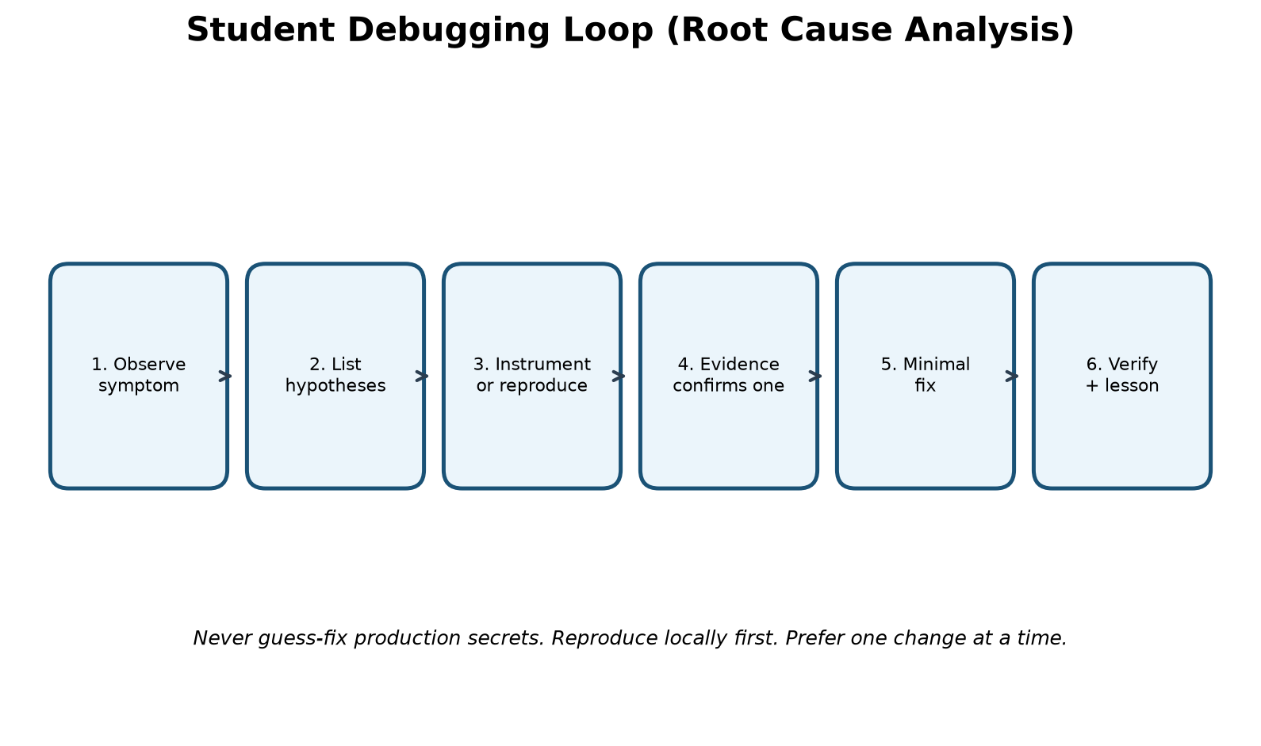
Figure: student debugging / RCA loop
General playbook: (1) write the symptom exactly, (2) list 3–5 hypotheses, (3) gather evidence (logs, curl, browser Network, adb logcat), (4) change one thing, (5) verify, (6) write the lesson. Avoid shotgun config edits.

RCA-1 — uvicorn SettingsError on ALLOWED_HOSTS / CORS_ORIGINS
Symptom: API refused to start; pydantic-settings error parsing allowed_hosts from .env.
Hypotheses considered: CSV vs JSON; wrong .env path; BOM; validator bug.
Debug strategy: Instrument config load; log raw env strings and whether JSON decode ran before validators.
Root cause: List[str] fields were JSON-decoded before field validators; CSV like localhost,127.0.0.1 failed.
Fix: Annotate fields with Annotated[..., NoDecode] so CSV reaches the splitter validator.
Lesson: Know your settings library’s decode order; .env UX should match how types are parsed.

RCA-2 — Next.js rejected next.config.ts / App Router broken
Symptom: Frontend would not start; config.ts unsupported.
Hypotheses considered: Wrong Next major; bad lockfile; React mismatch.
Debug strategy: Preflight script logged package.json declared vs installed Next version.
Root cause: next was pinned to ^9.3.3 (likely npm audit fix --force) while scaffold needed Next 15.
Fix: Restore next ^15 and reinstall; avoid audit --force without reading the major bump.
Lesson: Lockfiles and audit tooling can silently destroy a scaffold.

RCA-3 — Microphone NotAllowedError on Record
Symptom: Record failed even on localhost with user gesture.
Hypotheses considered: Permission denied UI; insecure context; AudioContext failure; Permissions-Policy.
Debug strategy: Log getUserMedia error name/message and document.permissions.
Root cause: next.config sent Permissions-Policy: microphone=() which blocks mic.
Fix: Change to microphone=(self).
Lesson: Security headers are feature switches — test mic/camera after every header change.

RCA-4 — Phone cannot reach API on Wi-Fi
Symptom: APK or phone browser times out / CORS errors.
Hypotheses considered: uvicorn bound to 127.0.0.1 only; firewall; wrong CORS; wrong PUBLIC_API_BASE_URL.
Debug strategy: From phone open http://LAN:8000/health; check Windows Firewall; inspect CORS preflight.
Root cause: API must listen on 0.0.0.0; CORS must include phone origin; share links need PUBLIC_API_BASE_URL.
Fix: Bind 0.0.0.0; update .env CORS and public base; allow ports 8000/3000.
Lesson: Mobile networking is part of full-stack work.

RCA-5 — Rebuilding APK for every LAN IP change
Symptom: Staff moved networks; app pointed at old IP.
Hypotheses considered: Build-time NEXT_PUBLIC_* baked in.
Debug strategy: Compare build env vs runtime needs.
Root cause: Static export baked the API URL at build time.
Fix: Runtime “Clinic server address” saved in localStorage (apiBase.ts).
Lesson: Prefer runtime config for environment-specific endpoints.

RCA-6 — Sessions vanished after API restart
Symptom: Doctors unlocked again after every uvicorn reload.
Hypotheses considered: In-memory session dict lost on process exit.
Debug strategy: Restart API and observe /auth/me.
Root cause: Sessions were not durable.
Fix: Persist clinic_sessions in SQLite/Postgres with expiry.
Lesson: Anything you care about across restarts belongs in a database.

RCA-7 — Open local-doctor mode risk
Symptom: Empty CLINIC_USERS allowed overly open access in some modes.
Hypotheses considered: Mis-set production flags.
Debug strategy: Hit /auth/status in production-like env.
Root cause: Convenience default unsafe when exposed publicly.
Fix: REQUIRE_CLINIC_USERS / APP_ENV=production blocks open mode.
Lesson: Defaults that help students can harm production — gate them.

RCA-8 — Whisper missing in Docker image
Symptom: Voice works on laptop venv but not in stock container.
Hypotheses considered: Image size vs dependency omission.
Debug strategy: Read Dockerfile vs requirements.txt.
Root cause: Dockerfile intentionally skips heavier Whisper deps.
Fix: Use WHISPER_PROVIDER=openai|groq on VPS, or enlarge image, or disable voice.
Lesson: Containers are deliberate subsets — document the tradeoff.

RCA-9 — Self-signed TLS vs phone trust on 4G
Symptom: HTTPS with clinic self-signed cert fails off LAN.
Hypotheses considered: Trust store; captive portals; wrong host.
Debug strategy: Compare behavior on clinic Wi-Fi vs mobile data.
Root cause: Self-signed certs are for LAN labs; public phones need Let’s Encrypt.
Fix: Public VPS + ACME certificates; point app at https://api.domain.
Lesson: Match certificate trust model to where phones roam.

RCA-10 — Collaboration / gitignore surprises
Symptom: Clone missing android/; cannot push; fear of committing .env.
Hypotheses considered: gitignore; remote auth; large Unreleased delta.
Debug strategy: git status; check remotes; confirm .env ignored.
Root cause: android/ and secrets are intentionally local; remote write access may be limited.
Fix: Document generate-android steps; never commit .env; push only with proper access.
Lesson: Onboarding docs prevent “empty clone” panic.

RCA-11 — Phone stuck on Loading… / “no profiles” (22 Jul 2026)
Symptom: APK opened, spinner never finished, or sign-in showed zero users even though CLINIC_USERS seemed set.
Hypotheses considered: API down; wrong clinic URL; empty users; CORS; hung uvicorn still listening on :8000.
Debug strategy: From PC: curl http://127.0.0.1:8000/health (must return quickly). From phone: open http://LAN:8000/health. Compare backend/.env CLINIC_USERS vs .env.example. Check DoctorGate Network call to /auth/status.
Root cause: Compound causes: (1) API process listening but not answering HTTP (often blocked in Whisper preload/startup); (2) phone clinic URL left as localhost (points at the phone itself); (3) confusion between empty .env.example and real .env users (dr1/nurse1/…). UI previously looked like “no profiles” when the auth fetch failed/hung.
Fix: Restart API with WHISPER_PRELOAD=false; set phone Clinic server address to http://192.168.x.x:8000 (not localhost); keep users in backend/.env; phone first-run now forces clinic URL setup; auth fetch timeout ~8s with clearer unreachable-server copy; optional scripts/watch_api.cmd.
Lesson: “Port is open” ≠ “HTTP works.” Always prove /health. Never use localhost as the clinic URL on a physical phone.

RCA-12 — Android release build fails on ProGuard (AGP 9.3)
Symptom: Gradle/Capacitor release or AAB build failed looking for proguard-android.txt.
Hypotheses considered: Wrong AGP; missing SDK file; third-party plugin path.
Debug strategy: Read Gradle error path; compare Android SDK/AGP version; search plugins for getDefaultProguardFile.
Root cause: AGP 9.x ships proguard-android-optimize.txt; older getDefaultProguardFile('proguard-android.txt') breaks.
Fix: Point app + @capacitor-community/file-opener at optimize file; run frontend/scripts/fix-agp-proguard.mjs from cap:sync / mobile:build so regenerated android/ stays fixed.
Lesson: Native toolchain versions drift — pin a fix script when Cap sync regenerates android/.

RCA-13 — Whisper preload freezes the API at startup
Symptom: /health hung or took minutes; phones could not unlock; voice later worked only after long wait.
Hypotheses considered: Model download; CPU thrash; uvicorn single worker blocked; firewall.
Debug strategy: Time curl /health right after start; watch CPU; read WHISPER_* settings.
Root cause: WHISPER_PRELOAD=true loaded faster-whisper during lifespan before accepting useful traffic.
Fix: Default WHISPER_PRELOAD=false; if true, warm model in a background task after startup; first transcribe may still be slow — that is preferred over a dead /auth/status.
Lesson: Never block readiness probes on optional heavy models.

RCA-14 — Empty CLINIC_USERS in .env.example misread as “no users”
Symptom: Developer opened .env.example, saw blank CLINIC_USERS, assumed auth was empty.
Hypotheses considered: Wrong file; parser bug; unset env in process.
Debug strategy: Open backend/.env (gitignored); GET /api/v1/auth/status; print list_public_users locally.
Root cause: Template vs secrets file mix-up — real clinic had dr1/nurse1/nurse2/lab1 in .env only.
Fix: Document the distinction in handbook/README; UI copy points at .env not .env.example.
Lesson: Teach two-file mental model: example = placeholders; .env = live secrets.

RCA-15 — Listen socket up but HTTP never answers
Symptom: netstat showed :8000 LISTENING; browsers and phones timed out; uvicorn log looked “started.”
Hypotheses considered: Stuck startup hook; deadlock; wrong bind; zombie reloader child.
Debug strategy: curl -m 3 /health; kill leftover uvicorn PIDs; restart clean; enable watch_api.cmd.
Root cause: Process accepted TCP but event loop/startup work prevented request handling (related to RCA-13).
Fix: Hard restart; WHISPER_PRELOAD=false; scripts/watch_api.cmd polls /health and restarts after failures.
Lesson: Operational watchdogs catch “half-alive” APIs that confuse mobile clients.

RCA-16 — Empty vitals 400 queued as “offline item(s) waiting to sync” (25 Jul 2026)
Symptom: Today tab showed “1 offline item(s) waiting to sync”; Sync now never cleared it; uvicorn logged POST /api/v1/history/vitals → 400 Bad Request.
Hypotheses considered: True offline; SECRET_SALT/tokenize fail; range validation; empty payload; UI treating all errors as offline.
Debug strategy: Instrument add_vitals_entry + VitalsForm: log which fields were filled, HTTP status, and whether enqueueOffline ran. Inspect localStorage healthcare_offline_queue. Reproduce empty Save.
Root cause: Client allowed (or re-synced) an empty vitals body. API correctly returned 400 (“Enter at least one vital or a diagnostic note”). VitalsForm catch-all treated every !ok response as offline and enqueued the same empty payload. flushOfflineQueue kept retrying 400s forever, so the Today banner never cleared.
Fix: Require at least one vital/note before POST; queue offline only for network/5xx/408/429; show server detail for 400/422; drop permanent failures on flush; auto-flush on Today mount.
Lesson: HTTP 400 is not “offline.” Never enqueue validation errors into a sync retry queue.

RCA-17 — mobile:build fails on Python-style `*` in TypeScript (25 Jul 2026)
Symptom: npm run mobile:build / next build: Unexpected token `*` in VitalsTrendCharts.tsx seriesFrom.
Hypotheses considered: SWC parser bug; wrong TS target; bad merge; accidental Python syntax in TS.
Debug strategy: Read the exact line from the webpack error; compare call sites vs signature.
Root cause: seriesFrom was declared with Python keyword-only syntax (`*, byGestation: boolean`) while call sites already passed an options object `{ byGestation }`. Valid Python, illegal TypeScript.
Fix: Change signature to `opts: { byGestation: boolean }` and destructure inside. Re-run mobile:build.
Lesson: Cross-language edits invite syntax bleed — always compile after mixing Python and TypeScript habits.

Part VI — Secrets, behavior changes, and paid VPS deploy
This part is intentionally in scope for the handbook: how to handle secrets safely (without publishing any), how to change application behavior deliberately, and how to deploy a paid India-region VPS so phones work everywhere on mobile data.

15. Secrets — committing and handling (no confidential values)
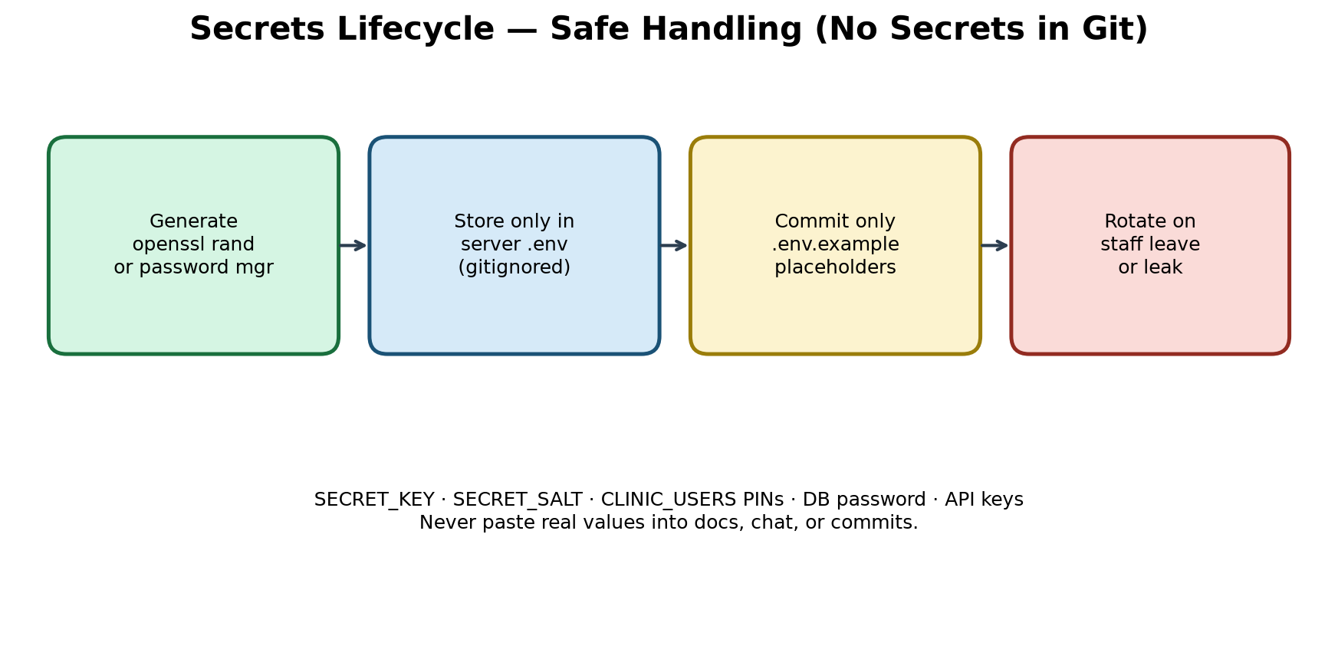
Figure: secrets lifecycle
What may be committed:
- .env.example with CHANGE_ME placeholders
- Documentation describing variable names and purpose
- hash_pin.py and instructions to generate pbkdf2$ hashes locally
What must NEVER be committed:
- backend/.env or frontend/.env.local with real values
- Real SECRET_KEY / SECRET_SALT / API keys / DB passwords
- Plaintext clinic PINs in git history
- TLS private keys (deploy/certs/*.key), Play signing keystores (*.jks), key.properties
Safe generation examples (run locally; do not paste outputs into chat/docs):
- openssl rand -hex 32 → candidate for SECRET_KEY or SECRET_SALT
- python scripts/hash_pin.py → pbkdf2$… for CLINIC_USERS
- Store production values in the VPS .env with chmod restricted to the deploy user
If a secret was accidentally committed: rotate it immediately (new salt remaps patient blinds — treat as an incident), remove from git history with a deliberate process, and invalidate old sessions.

16. Changing application behavior (safe practice)
“Changing behavior” means altering features, defaults, validation, or roles. Student-safe process:
- State the user-visible change in one sentence (e.g., “Staff can edit temperature unit”).
- Find the owning layer: UI component, API schema, service validation, or env default.
- Prefer config flags for environment differences (LAN vs cloud Whisper provider).
- Add or extend a pytest when touching auth, identity, or vitals validation.
- Update CHANGELOG [Unreleased] and this handbook’s “current status” when behavior ships.
- Never “fix” production by editing live DB rows for identity — use official change-phone/MRN flows.
Examples of behavior levers already in the app: WHISPER_PROVIDER, WHISPER_PRELOAD, LLM_PROVIDER, REQUIRE_CLINIC_USERS, CLINICS / multi-tenant CLINIC_USERS, ABDM_MOCK / ABDM_*, SMS_PROVIDER, CAPACITOR_HTTPS, vitals age_years and temperature_unit, clinic_mrn vs phone identity, role gates, obstetric LMP/EDD, ANC alert thresholds (code), offline queue permanent-failure drop list.

17. Paid VPS deployment (phones everywhere)
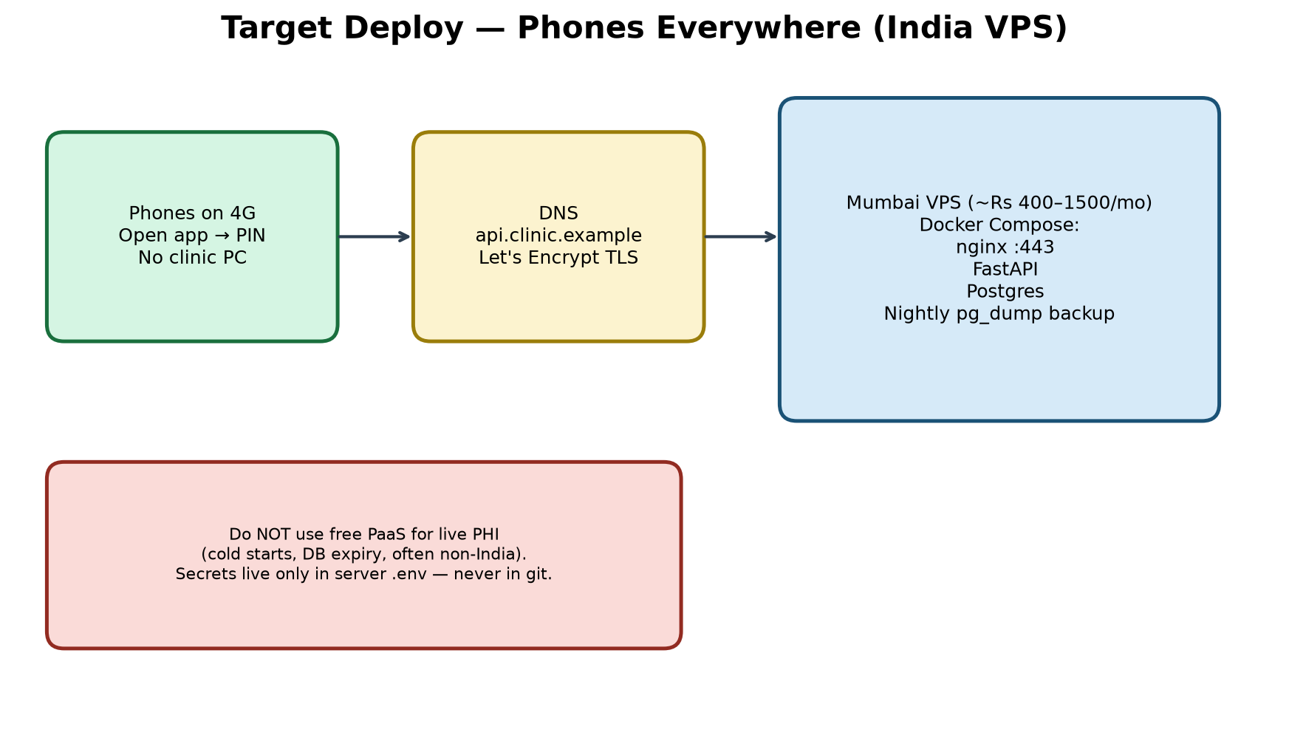
Figure: India VPS target topology
Recommendation: a small always-on VPS in an India region (e.g., Mumbai) costing roughly Rs 400–1,500/month for API + Postgres + TLS. Free PaaS with cold starts and expiring databases is unsuitable for live PHI.

17.1 Pre-deploy checklist
- Register a domain (example: api.yourclinic.example) — placeholder name only in this doc.
- Choose VPS size: 1–2 GB RAM to start; more if you run local Whisper/Ollama.
- Decide voice strategy: (A) cloud STT/LLM keys on server, (B) typed notes only, (C) larger box + local models.
- Prepare CLINIC_USERS with hashed PINs offline.
- Confirm gitignore covers .env, certs, keystores.

17.2 Provision and Docker
- Create VPS in India region; restrict SSH to your IP; open ports 80 and 443 only for the app.
- Install Docker Engine + Compose plugin.
- Copy release files (without .env) to the server; create .env on the server interactively.
- Set DATABASE_URL to Compose Postgres; APP_ENV=production; REQUIRE_CLINIC_USERS=true; PUBLIC_API_BASE_URL=https://api.yourclinic.example; strong DB password (not the compose default).
- Point DNS A record to the VPS public IP.
- Obtain Let’s Encrypt certificates (certbot) and mount them into nginx (replace self-signed LAN flow).
- docker compose up -d --build
- From a phone on mobile data (not clinic Wi-Fi): open https://api…/health then unlock with PIN.

17.3 Phone APK for cloud
- Build with HTTPS scheme: set CAPACITOR_HTTPS=true then npm run mobile:build (clears cleartext LAN mode — see capacitor.config.ts).
- On first run, enter https://api.yourclinic.example as Clinic server address (phones reject localhost).
- Attach privacy policy URL from docs/PRIVACY_POLICY.md before Play listing.
- npm run mobile:build; install APK; train PIN + patient lock. Play Store / signed AAB is optional — see docs/PLAY_STORE.md.

17.4 Backups and operations
- Schedule pg_dump (or scripts/backup_pg.cmd); SQLite backup scripts for laptop DBs.
- Store backups encrypted off-box; test restore quarterly.
- Monitor GET /health (scripts/watch_api.cmd on LAN; external uptime on VPS — no PHI in probes).
- Patch OS/Docker monthly; rotate PINs when staff leave.
- Expected monthly cost band: Rs ~400–900 (lean) to Rs ~1,000–2,500 (comfortable + STT usage).

17.5 What this handbook will not do
It will not create a cloud account for you, spend money, or print real secrets. You (or your instructor) provision the VPS; this document is the procedure and rationale.

Part VII — Future enhancement plans
Shipped items stay in Part III / current status. This table is what remains after Era J/K/L (analytics, disk attachments, OPD shell, obstetric/ANC decision support, consult pack, Rx hints).
Theme | Plan | Notes
Cloud India VPS go-live | Execute CLOUD_DEPLOY.md on a paid Mumbai VPS | Procedure exists; clinic must provision
Live ABDM (not mock) | NHA sandbox/prod client ID/secret + public callback | OTP client ready; care-context/HIU still out of scope
Richer HL7 / devices | MLLP framing, more segment types | ORU + MSA ACK already present
Pediatric growth charts UI | WHO/CDC growth curves by age | Neonatal bands + adult/pregnancy charts already present
MSG91 templates | DLT-approved SMS templates for India | console/msg91/twilio + day-before remind wired
Play Store publish | Signed AAB + hosted privacy URL | docs/PLAY_STORE.md + PRIVACY_POLICY.md
Per-clinic letterhead | Branding from CLINICS rows in PDF | clinic_id branding helper exists; PDF still mostly global CLINIC_*
Richer USG NLP | OCR + stronger LLM extract when Ollama unavailable | Heuristic + optional LLM analyze already ships

Part VIII — Appendices

A. Glossary
Term | Definition
Blind ID | HMAC hex of normalized patient key
MRN | Clinic medical record number identity key
ABHA / ABDM | Ayushman Bharat Health Account / Digital Mission APIs
HIP | Health Information Provider (clinic facility in ABDM)
OPD | Outpatient department / clinic day
ANC | Antenatal care (pregnancy follow-up)
LMP / EDD | Last menstrual period / estimated due date
GPLA | Gravida / Para / Abortions / Living children
Case brief | Decision-support summary for the locked patient (not a diagnosis)
STT | Speech-to-text
AAB | Android App Bundle for Play Store
DPDP | India Digital Personal Data Protection Act (compliance context)
RCA | Root cause analysis
clinic_id | Multi-tenant clinic key on sessions and records

B. Command cheat sheet (Windows)
- Backend venv: cd backend && python -m venv .venv && .\.venv\Scripts\pip install -r requirements.txt
- API: .\.venv\Scripts\uvicorn app.main:app --reload --host 0.0.0.0 --port 8000
- Prove API alive: curl -m 3 http://127.0.0.1:8000/health
- Watchdog: scripts\watch_api.cmd
- Demo seed: scripts\seed_demo.cmd [--wipe]
- Day-before SMS: scripts\remind_day_before.cmd
- Frontend: cd frontend && npm install && npm run dev
- Mobile (LAN): npm run mobile:build && npm run cap:open:android
- Mobile (HTTPS APK): set CAPACITOR_HTTPS=true && npm run mobile:build
- Tests: cd backend && .\.venv\Scripts\python -m pytest -q
- PIN hash: .\.venv\Scripts\python ..\scripts\hash_pin.py
- Docker: docker compose up --build
- Regenerate handbook diagrams: python docs/build_handbook_diagrams.py
- Rebuild this Word doc: python docs/build_handbook_docx.py

C. Annotated top-level tree
- backend/ — FastAPI API, models, services, tests, Dockerfile
- frontend/ — Next.js UI, Capacitor config, components
- deploy/ — nginx TLS config, cert generator (certs gitignored)
- docs/ — handbook (.docx), CLOUD_DEPLOY, PLAY_STORE, PRIVACY_POLICY, ABDM_SMS_MULTI_TENANT
- scripts/ — backup/restore, watch_api, seed_demo, remind_day_before, Ollama helpers, AAB, hash_pin
- docker-compose.yml — Postgres + API + nginx
- CHANGELOG.md — SemVer history

D. How to keep this handbook as the single source of truth
- When you ship a user-visible change, update CHANGELOG [Unreleased] and rebuild this .docx.
- Add new RCA entries when a non-obvious bug is fixed.
- Never paste production secrets into the handbook source or screenshots.
- Prefer editing docs/build_handbook_docx.py (or regenerating from an approved outline) over hand-editing the .docx forever.

E. Closing note for students
You now have one document that explains why the app exists, how it was built, how Android packaging fits, how patient identity, light analytics, and gynae decision support work, what broke and why, how to handle secrets, how to change behavior carefully, and how to host on a paid India VPS for phones used everywhere. Build small, verify often, and treat clinic data with respect.

