**Software Requirements Specification**

For

**Image Segmentation**

Prepared by

|  |  |  |
| --- | --- | --- |
| **Specialization** | **SAP ID** | **Name** |
| AIML | 500076426 | Jay Gupta |
| AIML | 500076502 | Gaurav Sharma |
| AIML | 500075381 | Dev Singh |
| AIML | 500075382 | Ketan Chawla |



Department of Informatics

School Of Computer Science

UNIVERSITY OF PETROLEUM & ENERGY STUDIES,

DEHRADUN- 248007. Uttarakhand

Table of Contents

|  |  |  |
| --- | --- | --- |
| **Topic** | | **Page No** |
| Table of Content | |  |
| Revision History | |  |
| 1 | Introduction |  |
|  | Purpose |  |
|  | Project Scope |  |
|  | Motivation |  |
|  | Methodology |  |
|  | References |  |
| 2 | Project Description |  |
|  | Reference Algorithm |  |
|  | Data structure |  |
|  | SWOT Analysis |  |
|  | Project Features |  |
|  | Design diagrams |  |
|  | Tools and Libraries |  |
| 3 | System Requirements |  |
|  | Hardware requirement |  |
|  | Software requirement |  |

**Revision History**

|  |  |  |  |
| --- | --- | --- | --- |
| **Date** | **Change** | **Reason for Changes** | **Mentor Signature** |
|  |  |  |  |
|  |  |  |  |
|  |  |  |  |
|  |  |  |  |

INTRODUCTION

Purpose

Image processing is something that has been very popular and widely used in last few decades and lots of research is still going on how to improve its performance further. As so many applications and working domains are highly dependent on it, its requirements is increasing day by day. Image segmentation is one of the core parts of image processing.

Image segmentation is the process of partitioning an image into different regions based on their features. This separates out the objects of interest from the rest of the image thereby makes the analysis of the image easier. Computer vision which is so popular nowadays and has made the systems performance as good as human at dealing with images, uses image segmentation. Image segmentation has lots of application in different areas, like it is used in the face recognition technology which is used in security systems, image segmentation is used in object detection, in the medical science as a way to locate and identify fractures, damaged tissues and cells and also used in search engines that offers image-based searches.

Project Scope:

Implementation of different image segmentation algorithms and comparing their results on grey scale images

Following algorithms will be implemented:

* Otsu (Thresholding based)
* K-Means (Clustering based)
* Sobel edge detector (Edge detection based)
* Region growing (region based)

Motivation

Image segmentation is an important image processing, and it seems everywhere if we want to analyze what inside the image. For example, if we seek to find if there is a chair or person inside an indoor image, we may need image segmentation to separate objects and analyze each object individually to check what it is. Image segmentation usually serves as the preprocessing before image pattern recognition, image feature extraction and image compression. Researches of it started around 1970, while there is still no robust solution, so we want to find the reason and see what we can do to improve it.

Methodology

In this project we use the iterative method to build our project. By using this approach, we built our project, test and review it and if we need some changes then we iterate the model again, test review it and after each iteration we will get a better model from the earlier.

References

1. There is a research paper in which there is comparison of region-based segmentation. In this paper there is a comparison of two segmentation algorithm i.e., region growing and region merging.

Title: Region growing and region merging segmentation

Link: <https://ieeexplore.ieee.org/abstract/document/628077/references#references>

1. There is a research paper in which there is comparison of every segmentation algorithm and find out how to combine these algorithms and use effectively.

Title: Image Segmentation Algorithms Overview

Link: <https://arxiv.org/abs/1707.02051>

1. There is a research paper in which there is a comparison of each and every algorithm and finding the complexity, segmentation effect, flaws and improvements scope in those segmentation algorithms and also find which image is suitable for which algorithm.

Title: The Comparative Research on Image Segmentation Algorithms

Link: <https://ieeexplore.ieee.org/abstract/document/4959132>

1. There is a research paper in which there is detail study of clustering segmentation.

Title: Clustering Techniques for Digital Image Segmentation

Link:[https://www.ijser.org/researchpaper/Clustering-Techniques-for-Digital-Image- Segmentation.pdf](https://www.ijser.org/researchpaper/Clustering-Techniques-for-Digital-Image-%20%20Segmentation.pdf)

PROJECT DESCRIPTION

Reference Algorithm

There are four algorithms used in this project

1. Otsu:

It is a thresholding-based image segmentation algorithm. It is used to divide an image into two regions based on their pixel values. In this algorithm first a histogram distribution of image pixel values is calculated then a threshold value T is selected such that it minimizes standard deviation within the regions. Finally, all pixel values less than or equal to T will form one region and greater than T the other region.

Output:

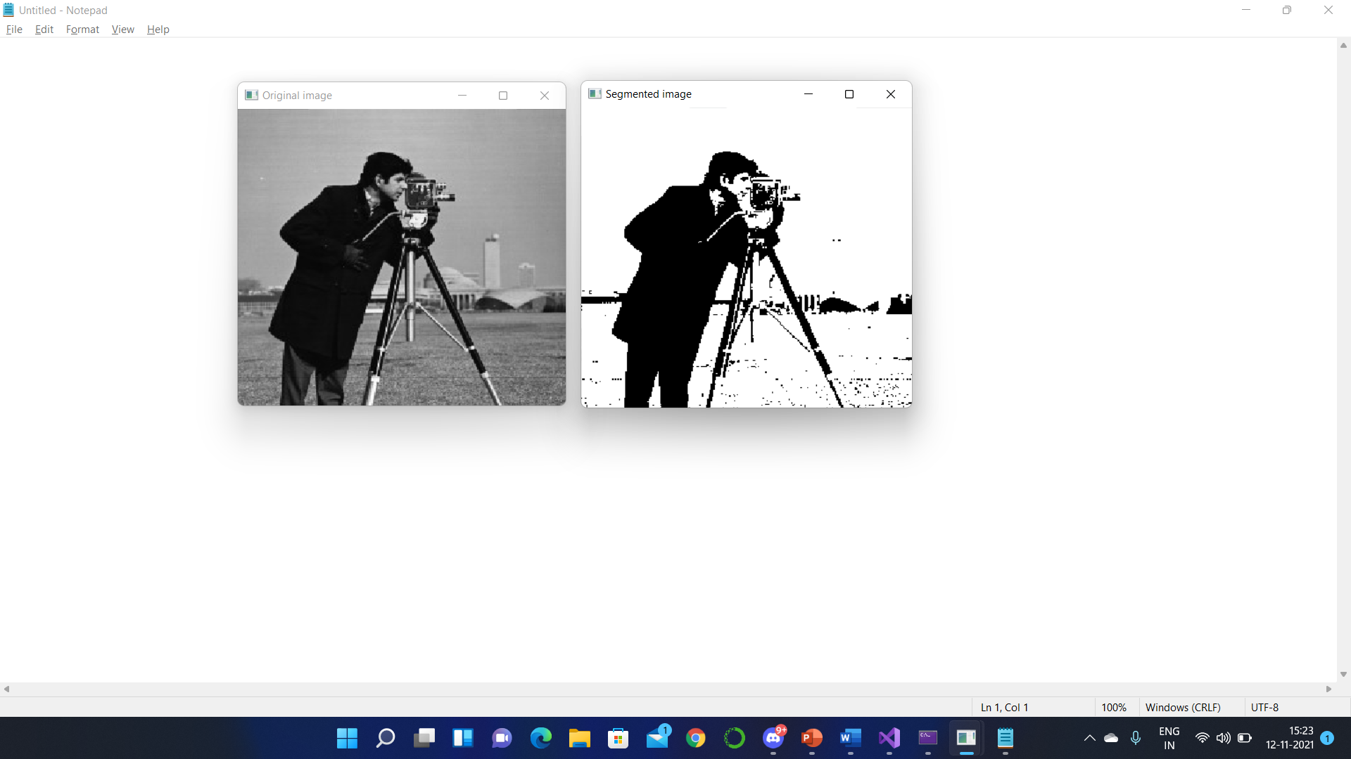

1. K-means

It's a clustering-based image segmentation algorithm. Here K is a hyper parameter, whose value is set before algorithm starts. First randomly K points of the image are selected as the initial centers. Then in each iteration Euclidean distance of all points is calculated from each of these centers and the point will be associated to the closest center. After that center are recalculated (by taking the mean value of the cluster) and the process is repeated until we get same clusters in two consecutive iterations. Finally, the clusters we get will form the segmented regions.

Output:

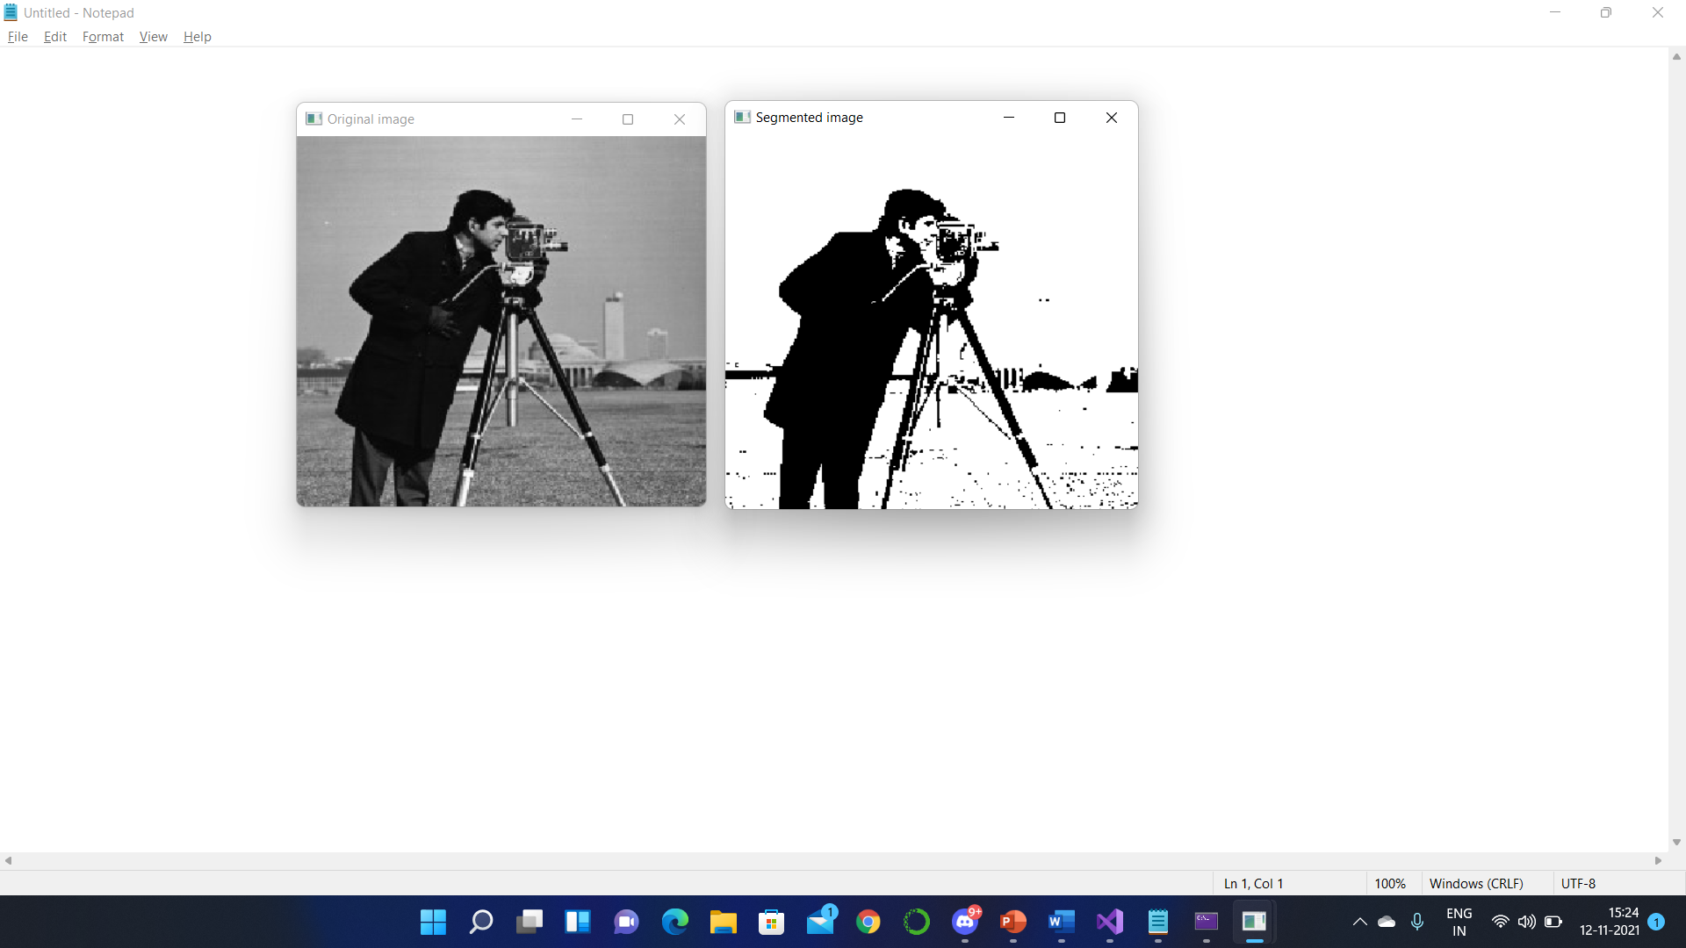

1. Sobel Edge detection

The Sobel method of edge detection for image segmentation finds edges using the Sobel approximation to the derivative. It precedes the edges at those points where the gradient is highest. The Sobel technique performs a 2-D spatial gradient quantity on an image and so highlights regions of high spatial frequency that correspond to edges. In general, it is used to find the estimated absolute gradient magnitude at each point in n input grayscale image.

Output:

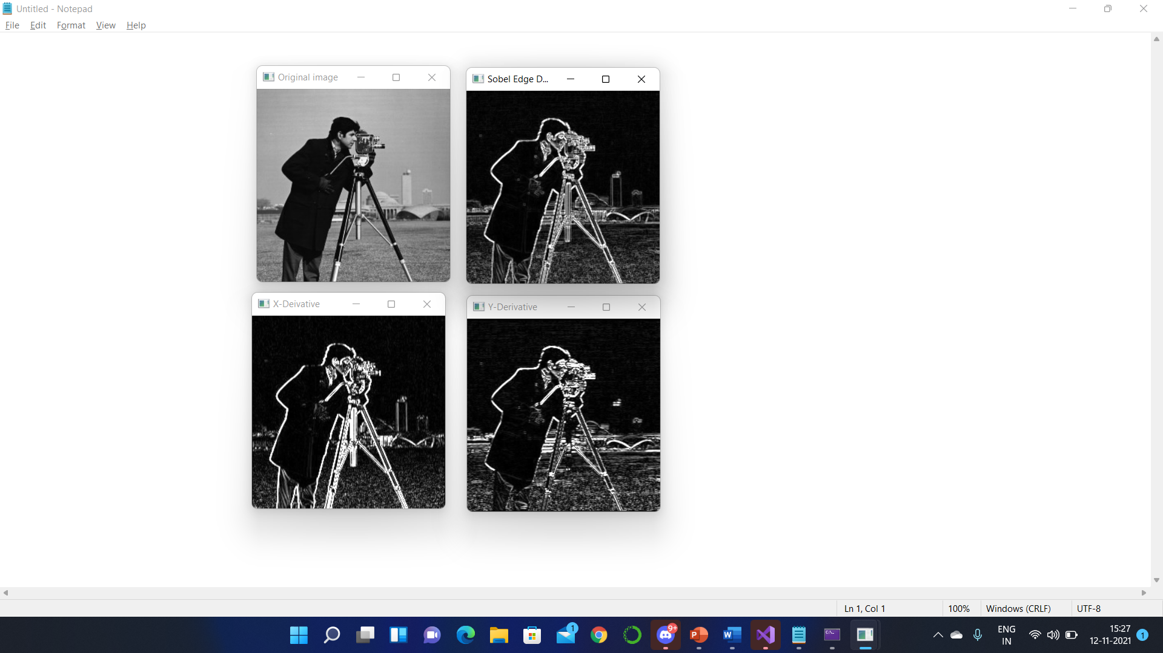

1. Region growing

In region growing a point (pixel) in the image is selected randomly and then compare with its neighboring pixels, if they satisfy the similarity criteria they will be added in the region and the same process is recursively applied until the region stops growing. Then another pixel is selected which is not the part of any region yet and the process is repeated until every pixel belongs to a region.

Data structure

Following data structure are used in the algorithms:

Vector: It is an array kind of data structure that can be dynamically increase/decrease its size. It is present in STL library of C++.

Set: As it names suggests it allow us a number of unique elements of same data type. It is also present in STL library of C++.

Pair: It allow us to store the pair of elements together. It is also present in STL library of C++.

Mat (OpenCV): It is used to store pixel values of the image. It is a multi-dimensional data structure present in Open cv library.

SWOT ANALYSIS:

Strength: The strengths are:

* Content-based image retrieval.
* Machine vision
* Medical Imaging
* Recognition task
* Traffic Control System
* Video Surveillance

Weakness: The image segmentation problem can be stated as the division of an image into regions that separate different objects from each other, and from the background.

Opportunities: Image segmentation is typically used to locate objects and boundaries (lines, curves, etc.) in images. When applied to a stack of images, typical in medical imaging, the resulting contours after image segmentation can be used to create 3D reconstructions with the help of interpolation algorithms like marching cubes.

Project Features:

Following are the areas where image segmentation is used:

* Autonomous driving
* Face detection
* Fracture detection
* Damaged cell/tissues detection
* Object detection

Design diagrams

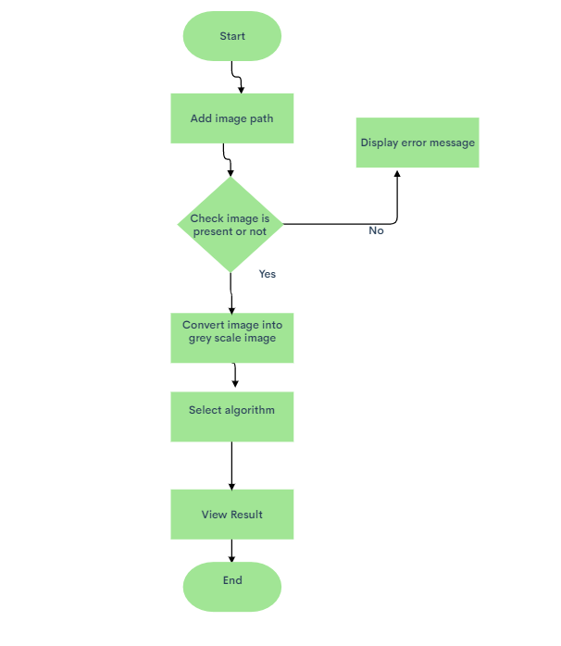

Tools and Libraries

Tool: Visual studio 2019

Library: Open cv version 4.5.3

SYSTEM REQUIREMENTS

Hardware requirements:

* Min. 1 Gb ram (or higher)
* Intel core i3 processor (or equivalent) (or higher)

Software Requirements:

* Windows 7 (or equivalent) (or higher)
* Visual studio 2019