SmartDialog Chatbot — Technical Architecture & Functional Workflow
Oct 4, 2026 · @Ketan

Context and constraints
SmartDialog is a multilingual RAG chatbot that answers policy questions from documents and payment questions from live data through MCP tools. It must be extensible to more tools and to an email channel without redesign.
Area | Decision / constraint
Language & framework | Java only (no Python in the office); LangChain4j
LLM | Gemma 4 31B, locally hosted; also the eval judge
Embeddings | bge-m3 (dense, 1024-dim, multilingual and cross-lingual)
Store | PostgreSQL + pgvector (vectors) and Postgres full-text search (lexical)
Corpus | 1,000+ docs, EN and FR only; inconsistent structure (some standalone, some depend on surrounding context)
Users | Any language
Tools | RetroFees MCP server: 1 tool today, 6–10 planned, payment data across several tables; more MCP servers later
Eval data | Historical Q&A stored in the DB; a few golden datasets
Future | Client servicing email channel; clarifying questions back to the user
Out of scope for evals: application regression testing. Evals measure question-and-answer quality.

Design principles
Six rules keep behaviour identical across languages and let new tools plug in without touching the core.
- One pipeline for every language. No per-language branches in retrieval or routing; language only changes the analyzer used and the language of the final answer.
- No LLM in the retrieval path unless measured. Retrieval runs on the user's original query (bge-m3 is cross-lingual), so a bad translation cannot cause a wrong answer.
- Channel-agnostic core. Chat and email are adapters; the orchestrator never knows which channel a question came from.
- Structured decisions, not free text. The router returns a typed RouteDecision (route, multi-route, clarify, out of scope) via structured output.
- Tools are registered, not hard-coded. Each tool carries its contract, examples, entitlements and its own eval cases. No eval cases, no release.
- Every answer is traceable. Each turn produces a trace (language, decision, tool calls, chunk IDs, answer) used for debugging, evals and audit.

Technical architecture
Five layers, with the router as the only place that knows which capabilities exist. Channels and capabilities can be added without changing the orchestrator.
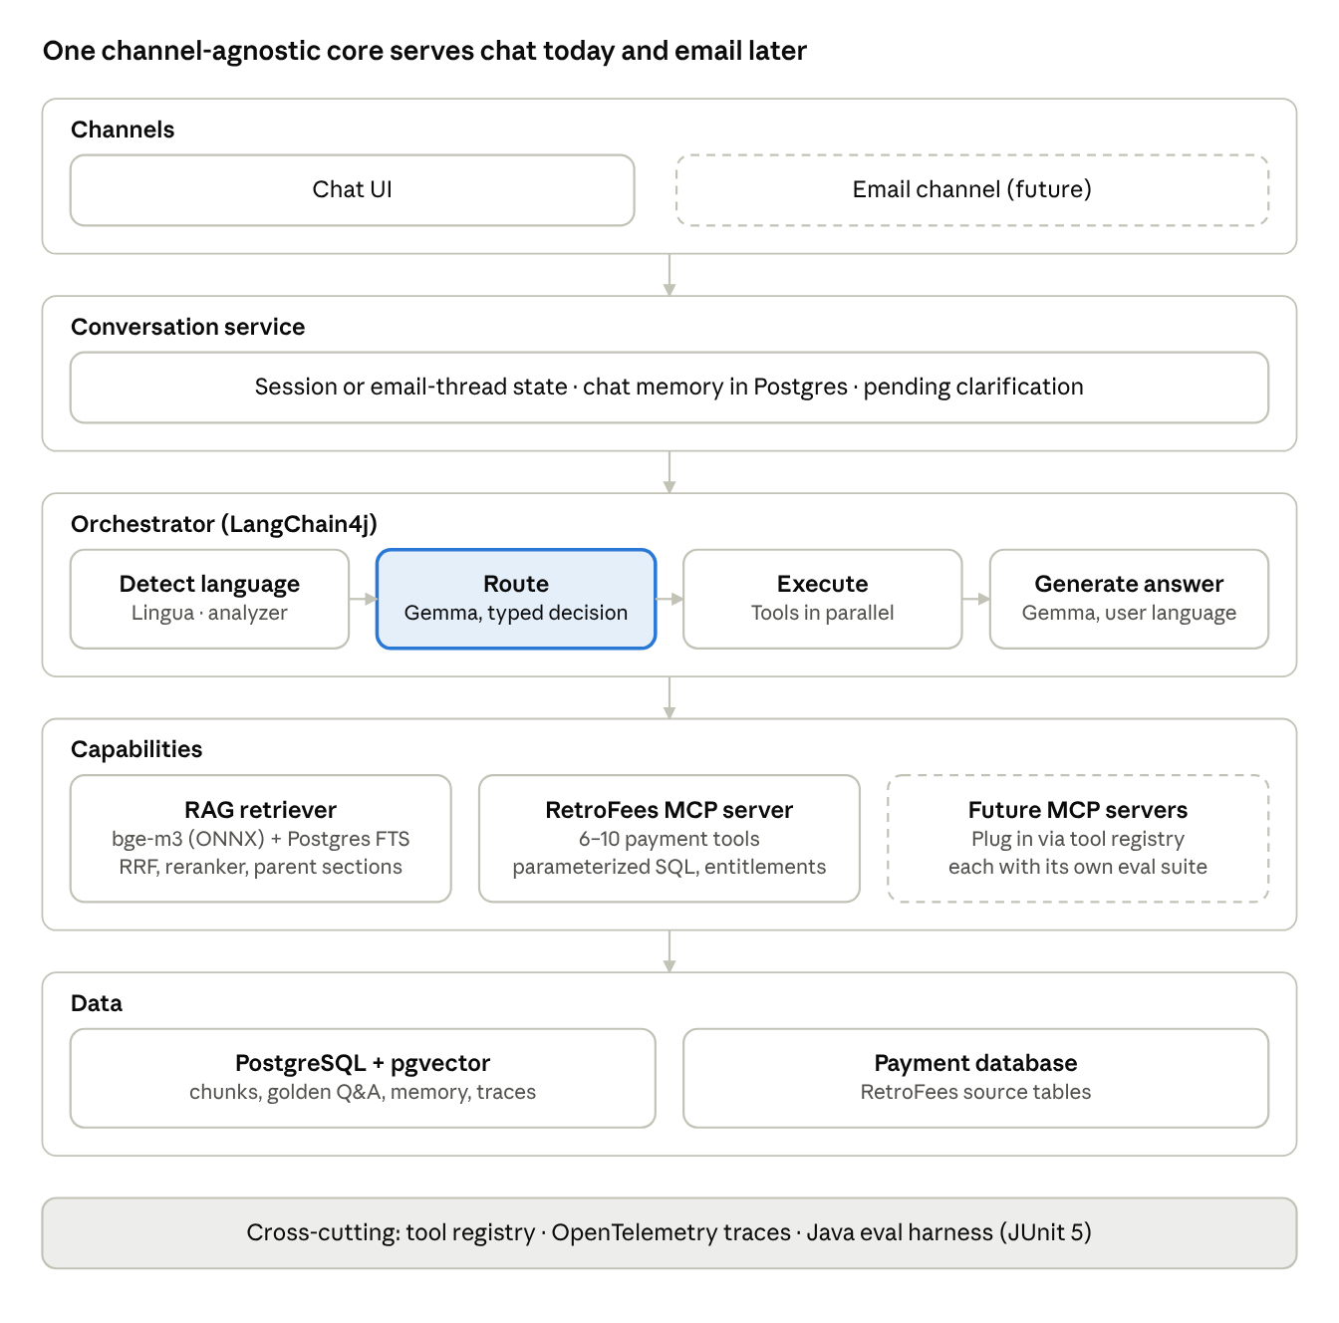
technical architecture · 5 layers
Dashed boxes are planned, not built. Every layer writes to the turn trace that the eval harness reads.
Component | Java building blocks
Orchestrator, router, generator | LangChain4j AiServices, structured output, OpenAI-compatible or Ollama client to local Gemma 4 31B
Language detection | Lingua (JVM)
Embeddings and reranking | LangChain4j OnnxEmbeddingModel (bge-m3), OnnxScoringModel (multilingual reranker)
Retrieval | pgvector HNSW + Postgres FTS, RRF in SQL, wrapped as a custom ContentRetriever
MCP tools | LangChain4j McpToolProvider
Memory | ChatMemoryProvider with a Postgres-backed ChatMemoryStore
Evals | JUnit 5, LangChain4j judges, optional Rage4j
Tracing | OpenTelemetry Java agent + custom spans

Retrieval design
Drop LLM query translation entirely: bge-m3 is cross-lingual, so the user's original query retrieves EN and FR documents directly. Keep a small lexical leg that needs no translation, and let evals decide whether it earns its place.
Why not vector-only by default. Dense search is weak on exact tokens: fee codes, product codes, client or account IDs, acronyms, regulation numbers. These tokens are identical in EN and FR, so a language-neutral keyword match catches them without any translation.
Pipeline (same for every language)
- Detect query language with Lingua (JVM library). Used only for the analyzer choice and the answer language, never to translate.
- Dense leg: embed the original query with bge-m3; pgvector HNSW cosine search, top 40.
- Lexical leg, two signals in one SQL query:
  - tsv_simple (Postgres simple config, no stemming) over all chunks: exact codes, IDs, names.
  - tsv_lang (english or french config per chunk): stemmed match, applied only to chunks in the query's language.
- Fuse with Reciprocal Rank Fusion in SQL (k = 60). Rank-based, so Postgres ts_rank not being true BM25 does not matter.
- Rerank the top 30 with a local multilingual cross-encoder (bge-reranker-v2-m3 via LangChain4j OnnxScoringModel), keep top 6–8. If no reranker can be hosted, skip this step rather than use Gemma as a reranker (slow, adds variance).
- Expand to parent sections (see Ingestion) and pass to generation with chunk IDs for citations.
All numbers above are starting values to tune with evals.
Chunk table (one table, one index version column)
Column | Purpose
chunk_id, doc_id, parent_id | Identity and parent-child expansion
lang | en / fr
doc_type | standalone / part-of-set
title, section_path | Context header and citations
content | Chunk text with context header prepended
embedding vector(1024) | bge-m3 dense; HNSW index, vector_cosine_ops
tsv_simple, tsv_lang | GIN indexes for the lexical leg
metadata jsonb | Product, date, entitlement tags
index_version | Ties every eval run to an index build
Decide with an ablation, not opinion. Run the golden set through each configuration and compare per language.
Config | What it tests
A. Dense only | Baseline you proposed
B. Dense + tsv_simple | Value of exact-token match
C. B + tsv_lang | Value of stemmed lexical match
D. Best of A–C + reranker | Value of reranking
Pick the simplest config within 2 points of the best on hit rate@8 and faithfulness. If you ever add translation, keep the original query as a retrieval input too and only adopt it if the ablation shows a gain.

Ingestion and document normalization
Inconsistent documents are fixed once at ingestion, so retrieval sees one uniform shape. Re-ingest the full corpus into a new index_version.
- Parse each doc (Apache Tika or LangChain4j document parsers) and detect its language (Lingua).
- Classify doc_type: standalone, or part of a set (series, annex, FAQ split across files). Use metadata and file naming first; Gemma only for leftovers, with SME spot-checks.
- Structure-aware split: by headings into sections (parents), then sections into chunks of roughly 300–500 tokens (children).
- Contextual header: prepend title > section path (and the set name for part-of-set docs) to every chunk before embedding and FTS indexing, so a line like "the fee is 0.5%" still carries what it belongs to.
- Embed with bge-m3 and build tsv_simple and tsv_lang.
- Exclude eval data: historical Q&A pairs used as the golden set are never indexed, or are filtered out during eval runs.
- Validate: count chunks per doc, flag empty or oversized chunks, and record the index_version.
At query time, retrieval matches on children and passes the parent section to the LLM, capped by a token budget.

Routing and tool layer
Routing is two-level and returns a typed decision. Level 1 picks the domain (RAG, RetroFees, future servers); level 2 picks the tool inside that domain via function calling. Adding a server adds one domain option, not ten new choices for the top router.
Decision contract (LangChain4j structured output into a sealed interface; enforce with JSON-schema constrained decoding in the Gemma serving layer)
sealed interface RouteDecision permits Route, MultiRoute, Clarify, OutOfScope {}
record Route(String domain, String tool, Map<String,Object> args, double confidence) implements RouteDecision {}
record MultiRoute(List<Route> routes) implements RouteDecision {}
record Clarify(String question, List<String> missingSlots, List<String> candidateTools) implements RouteDecision {}
record OutOfScope(String reason) implements RouteDecision {}
Tool registry entry (one per tool; loaded at startup, used to build router prompts and eval suites)
Field | Example
name, domain | getRetroFeesByClient, RetroFees
description | What it answers, in one paragraph
requiredSlots | client ID, date range
positiveExamples | 5–10 questions it should handle
negativeExamples | Near-miss questions that belong to a neighbour tool
entitlement | Role or client scope required
owner | Team responsible
evalSuite | ID of its routing and answer test cases
Overlap handling, in order
- Sharpen contracts: negative examples that name the neighbour tool fix most overlap.
- Merge tools that answer the same question shape into one parameterized tool.
- Allow MultiRoute when a question genuinely spans tools; run in parallel, synthesize once.
- Low margin between the top two candidates, or a missing required slot → Clarify.
- Deterministic precedence rules as a last resort (for example, a question containing an account ID never routes to RAG alone).
- Watch the routing confusion matrix in evals; any tool pair above an agreed confusion rate blocks release.
MCP servers connect through LangChain4j McpToolProvider; RetroFees tools use parameterized queries only, never LLM-generated SQL.

Functional workflow
Every turn checks for a pending clarification first, then routes once, and ends in exactly one of four outcomes.
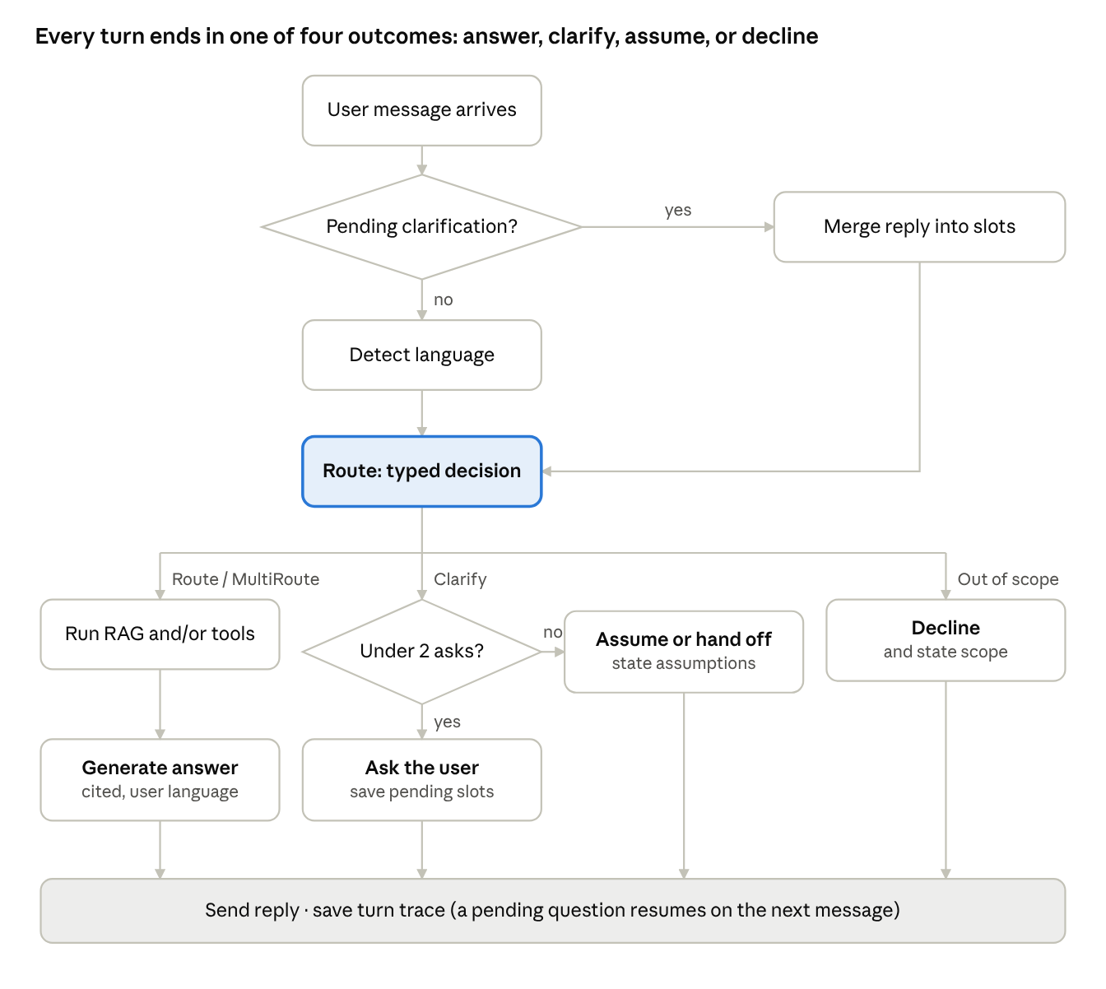
functional workflow · one turn, 4 outcomes
Step details
- Pending check. Load conversation state by session (chat) or thread ID (email). If a clarification is pending, merge the user's reply into its slots and re-route the original question plus the new answer.
- Detect language. Lingua sets the answer language and the FTS analyzer; nothing is translated.
- Route. One Gemma call returns a RouteDecision. Clarify when a required slot is missing, when the top two tools are close, or when an entity is ambiguous.
- Execute. RAG retrieval and tool calls run in parallel for a MultiRoute. Tool errors return a typed failure, never a guessed value.
- Generate. Gemma answers in the user's language from retrieved chunks and tool results only, citing chunk IDs and tool names. If evidence is insufficient, it says so and offers a human handoff instead of guessing.
- Clarification cap. At most two questions per user question; then answer with stated assumptions (for example, assuming the last 3 months) or hand off.
- Reply and trace. Send the reply and store the TurnTrace for monitoring and evals.

Future: client servicing email channel
Email plugs in as a second channel adapter on the same orchestrator; the bot drafts and a servicing agent approves. Nothing in routing, retrieval or tools changes.
- Listen. Microsoft Graph subscription (Exchange) or IMAP poller on the servicing mailbox; each email goes onto a queue, so processing is asynchronous and retryable.
- Adapt. Parse body and attachments, attach to the existing thread ID, strip signatures and quoted history, mask PII, run prompt-injection checks.
- Identify. Map the sender to a client and entitlement scope; unknown senders go straight to a human.
- Split. Gemma breaks the email into individual questions; each runs through the normal turn workflow.
- Compose. Combine answers into one draft reply in the client's language, with sources listed for the reviewer.
- Clarify. A clarification outcome becomes a question inside the draft, or a flag for the agent to resolve.
- Approve. The servicing agent approves, edits or rejects; nothing is auto-sent in the first release.
- Learn. Log the agent's edits; edited and rejected drafts become new golden-set cases after review.
Past servicing emails, if indexed later, go into a separate retrieval source with per-client access control, never into the policy document index.

Evaluation framework (Java only)
A JUnit 5 harness scores every layer separately, deterministic metrics first and Gemma-as-judge only where meaning must be judged. Results are compared against the previous baseline run, not fixed thresholds.
Harness components
Component | Built with
Test runner | JUnit 5 @ParameterizedTest, cases streamed from the eval tables
Pipeline under test | Real orchestrator returning a TurnTrace (language, decision, tool calls + args, chunk IDs, answer)
Deterministic scorers | Plain Java
LLM-judge scorers | LangChain4j AiServices per metric returning record JudgeResult(boolean pass, String reason); Rage4j as an optional head start
Results store | eval_run and eval_result tables (run ID, git SHA, model, prompt version, index_version)
Report | HTML or Allure report: per-metric deltas vs baseline, per language, per tool
Metrics by layer
Layer | Metric | Scorer
Routing | Domain/tool accuracy, confusion matrix, arg exact match | Deterministic
Clarification | Asked when expected, right slot, no over-asking | Deterministic on decision type + slots
Retrieval | Hit rate@k, MRR, context recall vs expected chunk IDs | Deterministic
Tool answers | Numbers and dates match DB ground truth | Deterministic
Generation | Faithfulness (claim-level), answer relevancy, correctness vs reference | Gemma judge
Language | Answer language = question language | Lingua, deterministic
Consistency | Same facts across translated variants of a question | Gemma judge on claim overlap
Living with one local model as both answerer and judge
- Prefer binary, claim-level checks: extract claims from the answer, then judge each claim "supported by context: yes/no". Far more stable than 1–10 scores.
- Use reference-based judging (against SME-validated answers) wherever a reference exists.
- Judge at temperature 0 with a separate prompt; run each judge case twice and flag disagreements.
- Calibrate: SMEs label about 100 cases; report judge–human agreement and re-check it after any model or prompt change.
Turning stored Q&A into the golden set
- Export, de-duplicate, and drop pairs older than the current policy versions.
- SME review of a sample to confirm the answers are still correct.
- Tag each case: expected route, language, expected source doc/chunk IDs (retrieve candidates once, SME confirms).
- Add cases history lacks: tool-overlap, clarification needed, out-of-scope, cross-lingual, and translated variants into 3–4 extra languages.
- Version the dataset; split into a 50-case smoke set (every PR) and the full set (nightly and before release).

Non-functional requirements
Payment data and client emails make entitlements and audit non-negotiable from day one.
- Entitlements: the caller's identity (chat user or email sender) is passed to every tool; RetroFees enforces client scope inside the tool, not in the prompt. RAG chunks carry entitlement tags filtered in SQL.
- Data safety: parameterized queries only; PII masked in logs, traces and eval exports; prompt-injection checks on retrieved text and inbound email.
- Observability: OpenTelemetry spans per step (detect, route, retrieve, tool, generate), with the TurnTrace stored per turn; dashboards on latency, route mix, clarification rate, fallback rate.
- Performance: embedding and reranking run in-process (ONNX); the two retrieval legs run in one SQL round trip; Gemma calls are the latency budget, so cap the number per turn (router + optional tool-arg fill + generation).
- Versioning: model, prompt, tool registry and index_version recorded on every trace and eval run, so any answer can be reproduced.
- Serving check: confirm that the Gemma 4 serving stack supports function calling and JSON-schema constrained output before building on them; otherwise fall back to prompt-based JSON with schema validation and one retry.

Delivery plan and open decisions
Build the eval harness first, so every later change is measured against a baseline.
- Phase 1: Measure. Golden set from stored Q&A, Java eval harness, TurnTrace, baseline on the current system. Exit: baseline report per language and route.
- Phase 2: Retrieval. Re-ingest with normalization and context headers; run the A–D ablation; remove per-language branches. Exit: chosen config beats baseline on hit rate@8 and faithfulness in EN and FR.
- Phase 3: Routing. Tool registry, two-level router, RouteDecision, clarification loop, RetroFees tools 2–10 each with eval cases. Exit: routing accuracy and confusion targets met.
- Phase 4: Email. Channel adapter, queue, question splitting, draft-and-approve. Exit: SME acceptance rate of drafts on a pilot mailbox.
Open decisions
- ☐ Can a local reranker (bge-reranker-v2-m3) be hosted, or does retrieval stop at RRF?
- ☐ Are Postgres extensions for true BM25 (for example ParadeDB pg_search) allowed, or is built-in FTS final?
- ☐ Does the Gemma serving stack support function calling and constrained JSON output?
- ☐ Which email platform (Exchange via Microsoft Graph, or IMAP) and which pilot mailbox?
- ☐ Who are the SMEs for golden-set validation and judge calibration?
- ☐ Release targets for routing accuracy, confusion rate and faithfulness.

