Feature – Audio/Podcast
Class - FFmpegMediaConverter
FFmpeg is used in audio/podcast creation from SlideshowRequestController and then this controller calls the generate video function from the FFmpegMediaConverter class.
Below is the generated ffmpeg command:
ffmpeg -loop 1 -i <imageUrl> -i <audioUrl> -vf "scale=<width>:<height>" -c:v libx264 -c:a aac -shortest -pix_fmt yuv420p <outputVideoPath>.mp4

Parameter | Explanation
-loop 1 | Continuously loops the input image so it behaves like a video stream
-i <imageUrl> | Input image used as the video source
-i <audioUrl> | Input audio file used as the audio track
-vf "scale=<width>:<height>" | Scales the image to the target video resolution (width and height are forced to even numbers)
-c:v libx264 | Encodes the video using the H.264 codec
-c:a aac | Encodes the audio using the AAC codec
-shortest | Stops encoding when the shortest input stream (usually audio) ends
-pix_fmt yuv420p | Uses a widely supported pixel format required for compatibility with most players
<outputVideoPath>.mp4 | Output MP4 video file
-----------------------------------------------------------------------------------------------------------------------
Feature – Edit Images in Videos and Podcasts
Class Name- FFmpegMediaConverter
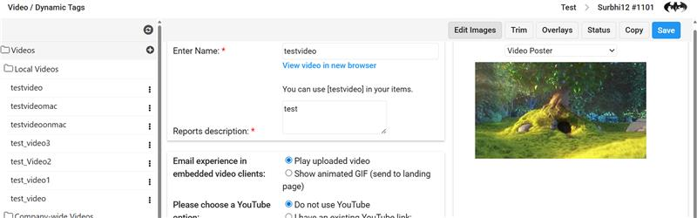
FFmpeg is used in VideoPosterAndGifEditor.aspx when the Edit Images button is clicked (as shown in the screenshot above. This button will be visible when you select any existing component from the podcast/audio or videos menu
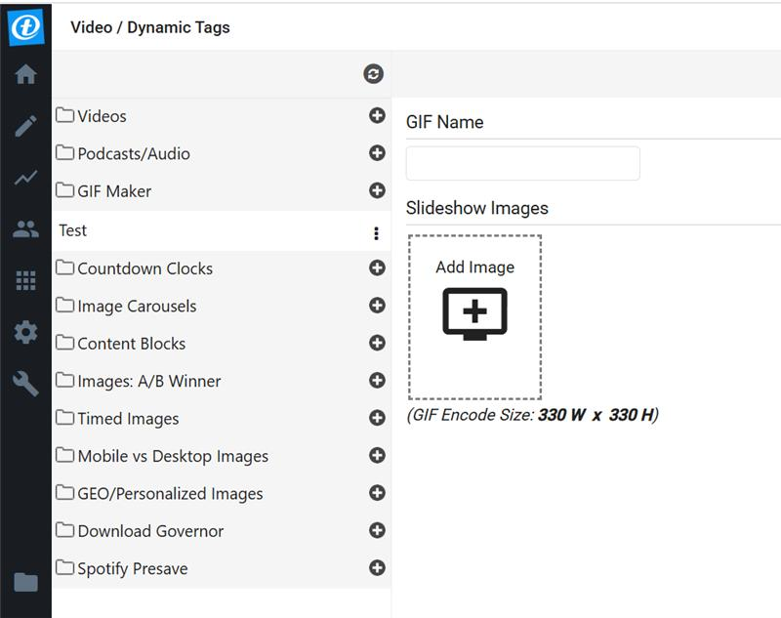

). The UI for this ASPX page is shown below.
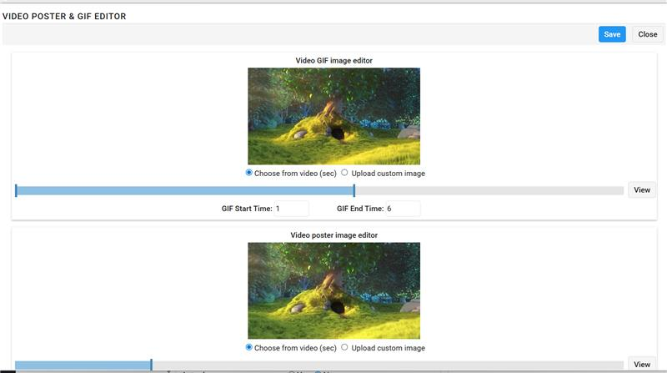

We use the image to generate an m3u8 poster when the Save button in the above page is clicked
The ffmpeg command is generated in below steps
Step 1: Convert Image to MP4
FFmpeg first converts the input image into a very short MP4 video.

ffmpeg -y -loop 1 -i <imageUrl> -c:v libx264 -vf "pad=ceil(iw/2)*2:ceil(ih/2)*2" -b:v 600k -maxrate 900k -bufsize 2400k -t 0.06 -pix_fmt yuv420p -an <tempOutputMp4Path>
Parameter | Meaning
-y | Overwrites the output file if it already exists
-loop 1 | Continuously loops the input image
-i <imageUrl> | Input image file
-c:v libx264 | Encodes video using the H.264 codec
-vf pad=ceil(iw/2)*2:ceil(ih/2)*2 | Pads width and height to even numbers (required by H.264)
-b:v 600k | Target video bitrate
-maxrate 900k | Maximum allowed bitrate
-bufsize 2400k | Rate-control buffer size
-t 0.06 | Output video duration (0.06 seconds)
-pix_fmt yuv420p | Pixel format compatible with most HLS players
-an | Disables audio
<tempOutputMp4Path> | Output MP4 file path

Step 2: Convert MP4 to HLS (M3U8 + TS)
The generated MP4 is then converted into an HLS stream.
ffmpeg -y -i <tempOutputMp4Path> -codec: copy -hls_segment_type mpegts -start_number 0 -hls_time 0.06 -hls_list_size 1 -f hls <outputM3u8Path>
Parameter | Meaning
-y | Overwrites existing output files
-i <tempOutputMp4Path> | Input MP4 file
-codec: copy | Copies audio/video streams without re-encoding
-hls_segment_type mpegts | Generates HLS segments in .ts format
-start_number 0 | Starts segment numbering at 0.ts
-hls_time 0.06 | Duration of each HLS segment
-hls_list_size 1 | Playlist contains only one segment
-f hls | Forces HLS output format
<outputM3u8Path> | Output .m3u8 playlist file

Feature – Regular video uploads (WindowsService – TmVideoProcessor)
Class - FFMPEGVIDEOEDITOR
The ffmpeg is also used in the WindowsService TmVideoProcessor and is used in the following steps:
- Trim original video
- Apply fade-out effect
- Resize CTA image
- Convert CTA image to video
- Convert MP4s to TS
- Concatenate all parts
- Produce final MP4
This video editing pipeline uses FFmpeg to trim and fade the original video, convert a CTA (Call-To-Action) image into a video clip, and then concatenate both segments using MPEG-TS for lossless merging into a final H.264 MP4 output.
1.Trim the Original Video
FFmpeg Command
ffmpeg -i <inputVideo> -ss <startTime> -t <duration> -c:v h264 -c:a aac -preset ultrafast -crf 28 <outputTrimmed.mp4>
Parameter | Meaning
-i <inputVideo> | Input source video
-ss <startTime> | Start time (seek position in seconds)
-t <duration> | Duration of the trimmed clip
-c:v h264 | Encode video using H.264
-c:a aac | Encode audio using AAC
-preset ultrafast | Faster encoding, lower compression efficiency
-crf 28 | Quality level (higher = more compression)
<outputTrimmed.mp4> | Trimmed output video

2. Apply Fade-Out Effect (Video + Audio)
FFmpeg Command (when audio exists)
ffmpeg -i <inputVideo> \
-filter_complex "[0:v]fade=t=out:st=<start>:d=<duration>[v];[0:a]afade=t=out:st=<start>:d=<duration>[a]" \
-map "[v]" -map "[a]" -c:v h264 -c:a aac -preset ultrafast -crf 28 <outputFade.mp4>
Parameter | Meaning
fade=t=out | Fade-out effect
st=<start> | Fade start time
d=<duration> | Fade duration
afade | Audio fade-out
-map "[v]" | Select processed video stream
-map "[a]" | Select processed audio stream

3.Resize CTA Image
FFmpeg Command
ffmpeg -i <inputImage> -vf scale=<width>:<height> <outputImage.jpg>
Parameter | Meaning
-i <inputImage> | Input CTA image
-vf scale=W:H | Resize image to exact width and height
<outputImage.jpg> | Resized image output

4.Convert CTA Image into Video
FFmpeg Command
ffmpeg -loop 1 -i <image> -c:v h264 -t <duration> \
-vf "scale=W:H:force_original_aspect_ratio=decrease,pad=W:H:(ow-iw)/2:(oh-ih)/2" \
<ctaVideo.mp4>
Parameter | Meaning
-loop 1 | Loop the image continuously
-t <duration> | Duration of CTA video
force_original_aspect_ratio=decrease | Preserve image aspect ratio
pad=W:H | Pad image to full video size
(ow-iw)/2:(oh-ih)/2 | Center the image

5.Convert MP4 Files to TS (for Concatenation)
FFmpeg Command
ffmpeg -i <input.mp4> -c copy <output.ts>
Parameter | Meaning
-c copy | Stream copy (no re-encoding)
<output.ts> | Temporary TS file

6.Concatenate All Video Segments
FFmpeg Command
ffmpeg -i "concat:file1.ts|file2.ts" -c copy <finalOutput.mp4>
Parameter | Meaning
concat: | FFmpeg concat protocol
 | `
-c copy | No re-encoding
<finalOutput.mp4> | Final combined video

Summary - The flow trims and fades the original video, converts a CTA image into a short video, and then concatenates both parts into one final MP4 using FFmpeg.
Feature – In Video As Background when author wants to use a video to generate a vbg which is in his local machine and also to generate thumbnails for regular Video elements
Class - VideoBackgroundService
FFmpeg is also used in Video uploads to generate video thumbnail and it is also used in og video chooser component (Upload video button in the below snap)
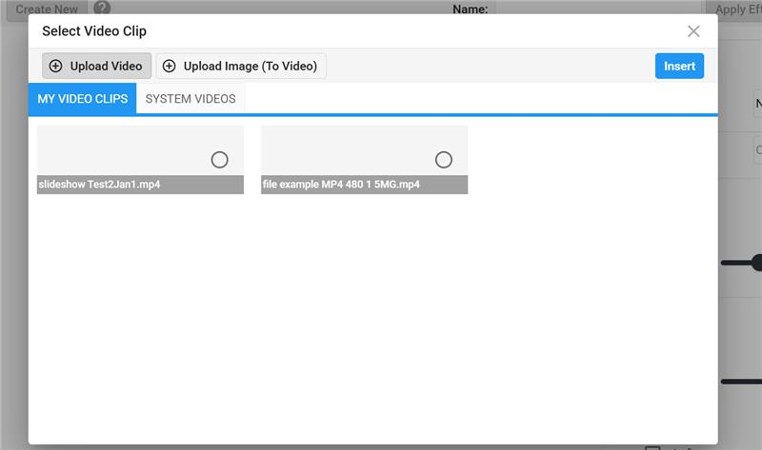

It is used to generate video thumbnail when an author uploads a video from his/her local pc.

This logic extracts a single image (thumbnail) from a video file.
Step1: Primary attempt – capture frame at 5 seconds

ffmpeg -y -i "<videoFilePath>" \
-vf "scale='if(gt(iw,400),400,iw)':'-1'" \
-ss 5 -vframes 1 "<thumbnailFilePath>"

Parameter | Meaning
-y | Overwrite output file if it already exists
-i "<videoFilePath>" | Input video file
-vf scale='if(gt(iw,400),400,iw)':'-1' | Resize thumbnail: max width 400px, maintain aspect ratio
iw | Input video width
gt(iw,400) | Checks if width is greater than 400
-ss 5 | Seek to 5 seconds into the video
-vframes 1 | Extract exactly one video frame
"<thumbnailFilePath>" | Output JPG thumbnail
Step 2: Check if thumbnail was created
What happens
- The code checks if the JPG file exists
- If yes → done
- If not → fallback logic is triggered
Step 3: Fallback – capture the last frame
This handles cases where:
- Video duration is less than 5 seconds
- Seeking to 5 seconds fails
FFmpeg command:
ffmpeg -y -i "<videoFilePath>" \
-vf "scale='if(gt(iw,400),400,iw)':'-1'" \
-ss -1 -vframes 1 "<thumbnailFilePath>"
-ss -1 means: Seek to the last frame of the video
Feature – Video As Background
Class - VideoAsBackground Service
Step 0: Input arrives
You start with a VideoEditorInput object that contains:
- One or more video snippets
  - Each snippet has StartTime, EndTime, and Url
- Crop rules
  - Crop ratio (e.g. 16:9)
  - Crop position (center, top-left, etc.)
- Output preferences
  - MP4
  - GIF
  - WebP
  - AVIF
  - Outlook fallback image
  - Gmail AVIF
- Destination output folder
Step 1: Trim the video snippets
What happens conceptually
- The input video may contain multiple sections
- Each section is cut out
- All cuts are stitched together into one clean video
FFmpeg command:
ffmpeg -y -i "<inputVideo>" \
-filter_complex "[0:v]trim=start=S:duration=D,setpts=PTS-STARTPTS[v0]; ... concat=n=N:v=1:a=0[outv]" \
-map "[outv]" "<trimmed.mp4>"
Parameter | Meaning
-filter_complex | Allows multiple trims + concatenation
trim | Cuts a section of video
setpts=PTS-STARTPTS | Resets timestamps
concat | Joins trimmed sections
-map "[outv]" | Selects final video output

Result: A trimmed MP4 video containing only selected segments

Step 2: Crop and resize the trimmed video
What happens
- The trimmed video is resized and cropped based on:
  - Aspect ratio (e.g. 16:9, 1:1)
  - Crop position (center, top, bottom, left, right)
FFMPEG command:
ffmpeg -y -i "<input.mp4>" \
-vf "scale=W:H:force_original_aspect_ratio=increase,crop=W:H:X:Y" \
-an "<cropped.mp4>"
Parameter | Meaning
scale | Resize video
force_original_aspect_ratio=increase | Avoid distortion
crop | Crop to exact position
-an | Remove audio

Result: A cropped + resized MP4 video

Step 3: Apply visual filters (optional)
What happens
- Color filters or gradient overlays may be applied
- Uses FFmpeg filters internally
FFmpeg command
ffmpeg -y -ss 0 -i "<video.mp4>" -frames:v 1 "<output.jpg>"

Parameter | Meaning
-ss 0 | Seek to start
-frames:v 1 | Capture one frame

Result: A filtered MP4 video

Step 4: Generate output formats
Now the same processed video is converted into multiple formats, depending on options.
4.1 MP4 output
- Simply copies the processed MP4
4.2 JPG fallback image
- Extracts the first frame
FFmpeg command:
ffmpeg -y -ss 0 -i "<video.mp4>" -frames:v 1 "<output.jpg>"
Parameter | Meaning
-ss 0 | Seek to start
-frames:v 1 | Capture one frame

4.3 Outlook fallback image
- Extracts a frame at a custom timestamp
ffmpeg -y -ss T -i "<video.mp4>" -vf "<cropResize>" -frames:v 1 "<output.jpg>"

Parameter | Meaning | Why it’s used
-y | Overwrite output file | Automation safety
-ss <grabTime> | Seek to specific time (seconds) | Capture a meaningful frame
-i <video.mp4> | Input video | Source video
-vf "<cropResizeCommand>" | Crop and resize filter | Matches email layout
-frames:v 1 | Extract exactly one frame | Creates a static image
<output.jpg> | Output JPG file | Outlook-compatible image

Fallback FFmpeg command (last frame)
If the video is too short or the timestamp fails:
Ffmpeg command:
ffmpeg -y -sseof -0.1 -i <video.mp4> -vf "<cropResizeCommand>" -frames:v 1 <output.jpg>

Parameter | Meaning | Why it’s used
-sseof -0.1 | Seek to 0.1 seconds before end | Ensures a valid frame

4.4 Transparent PNG (special case)
- Generates a transparent background PNG if type is png-poster and cropsize is Original
FFmpeg command:
ffmpeg -y -f lavfi -i color=c=black:s=WxH \
-vf "format=rgba,geq=r='r(X,Y)':a='0.0'" -vframes 1 "<output.png>"

Parameter | Meaning | Why it’s used
-y | Overwrite output | Automation safety
-f lavfi | Use FFmpeg’s filter input | Generates synthetic video
-i color=c=black:s=WxH | Create solid black frame | Base image canvas
format=rgba | Use RGBA color space | Required for transparency
geq=r='r(X,Y)' | Preserve red channel | Keeps color data
a='0.0' | Alpha channel set to 0 | Makes image fully transparent
-vframes 1 | Output only one frame | Static image
<output.png> | Transparent PNG file | Final output

4.5 Gif Creation

The gif creation is also done in 3 steps:

Step 1 — Palette Generation (FFmpeg)
This command takes the filtered MP4 and generates a GIF palette (256-color lookup table).
We limit it to the first 4 seconds and scale it down based on the required GIF size.
ffmpeg.exe -y -t 4 -i "C:\Users\vishalra\TM\AppData\CompanyFiles\Core\Temp_Files\videos\11Nov10_20251111140229785_outputFiltered.mp4" -vf fps=12,scale=600:600:flags=lanczos,palettegen "C:\Users\vishalra\TM\AppData\CompanyFiles\Core\Temp_Files\videos\11Nov10_20251111140742571_outputGifPalette.png"
What this does:
- -t 4 → only analyze first 4 seconds (keeps GIF small)
- fps=12 → GIF frame rate
- scale=600:600 → GIF output size
- palettegen → generate optimized 256-color PNG palette
- Output = *_outputGifPalette.png

Step 2 — GIF Creation Using Palette (FFmpeg)
This command takes the filtered video + the palette PNG and produces the actual GIF frames.
We again limit it to 4 seconds and apply the palette for correct color output.
ffmpeg.exe -y -t 4 -i "C:\Users\vishalra\TM\AppData\CompanyFiles\Core\Temp_Files\videos\11Nov10_20251111140229785_outputFiltered.mp4" -i "C:\Users\vishalra\TM\AppData\CompanyFiles\Core\Temp_Files\videos\11Nov10_20251111140742571_outputGifPalette.png" -filter_complex "fps=12,scale=600:600:flags=lanczos[x];[x][1:v]paletteuse" -an -f gif "C:\Users\vishalra\TM\AppData\CompanyFiles\Core\Temp_Files\videos\11Nov10_20251111141134699_outputGifPalette.gif"
What this does:
- -t 4 → export only the first 4 seconds into GIF
- fps=12 → generate 12 frames/sec (smooth but small file size)
- scale=600:600 → resize GIF
- lanczos → high-quality downscaling
- paletteuse → apply the palette created in Step 1
- -an → no audio
- Output = raw GIF file before optimization
Step 3 — GIF Optimization (Gifsicle)
After FFmpeg finishes creating the raw GIF, we run it through gifsicle to reduce file size while keeping good visual quality.
gifsicle.exe -O2 --lossy=100 "C:\Users\vishalra\TM\AppData\CompanyFiles\Core\Temp_Files\videos\11Nov10_20251111141134699_outputGifPalette.gif" -o "C:\Users\vishalra\TM\AppData\CompanyFiles\GroundZero\master\videobg\11Nov10.gif"
✅ What this does:
- -O2 → medium-level structural optimization
- --lossy=100 → applies lossy color compression (big size reduction)
- Takes the temporary GIF from Step 2
- Produces the final, optimized GIF that is saved to videobg folder
This step typically reduces file size by 70–90% while maintaining acceptable quality for email clients.
4.6 WebP output
- Converts video into animated WebP
FFmpeg command:
ffmpeg -y -i "<video.mp4>" \
-vf fps=15 -vcodec libwebp -lossless 1 -q:v 80 \
-loop 0 -preset picture -an -vsync 0 "<output.webp>"

Parameter | Meaning | Why it’s used
-y | Overwrite output if it exists | Avoids prompts during automation
-i <video.mp4> | Input video | Source video
-vf fps=15 | Force 15 frames per second | Keeps file size smaller and smooth enough for email
-vcodec libwebp | Use WebP video codec | Required for animated WebP
-lossless 1 | Enable lossless WebP encoding | Preserves image quality
-q:v 80 | Quality level (0–100) | Controls compression level
-loop 0 | Infinite animation loop | Required for email playback
-preset picture | Optimize for still-image style content | Best for email visuals
-an | Remove audio | WebP does not support audio
-vsync 0 | Pass frames as-is | Prevents frame duplication or dropping
<output.webp> | Output WebP file | Final animated WebP

4.7 AVIF output
- Converts video to AVIF (high compression)
FFmpeg command:
ffmpeg -y -i "<video.mp4>" \
-c:v libaom-av1 -crf 40 -b:v 0 -cpu-used 8 -row-mt 1 -an "<output.avif>"

Parameter | Meaning | Why it’s used
-y | Overwrite output | Automation safety
-i <video.mp4> | Input video | Source content
-c:v libaom-av1 | Use AV1 codec | Required for AVIF
-crf 40 | Constant Rate Factor (quality) | Balances quality & size
-b:v 0 | Disable target bitrate | Enables CRF-only quality control
-cpu-used 8 | Faster encoding mode | Speeds up AV1 encoding
-row-mt 1 | Enable row-based multithreading | Improves performance
-an | Remove audio | AVIF does not support audio
<output.avif> | Output AVIF file | Final AVIF

4.8 Gmail-specific AVIF
- Trims video again to short durations
- This is a 2 step process

Step 1 :
FFmpeg command:
ffmpeg -y -i "<video.mp4>" \
-filter_complex "[0:v]trim=...,setpts=...; concat=..." \
-map "[outv]" "<temp.mp4>"

Parameter | Meaning | Why Gmail needs it
trim=start=S:duration=D | Cuts short video segments | Gmail limits animation duration
setpts=PTS-STARTPTS | Reset timestamps | Required for concat
concat=n=N:v=1:a=0 | Join segments | Creates one short animation
-map "[outv]" | Select final video | Output only video

Then

Step 2:
FFmpeg command:
ffmpeg -y -i "<temp.mp4>" -c:v libaom-av1 -crf 40 -b:v 0 -cpu-used 8 -row-mt 1 -an "<gmail.avif>"

Parameter | Purpose
libaom-av1 | AVIF codec
-crf 40 | Compression level
-b:v 0 | CRF-only encoding
-cpu-used 8 | Faster encode
-row-mt 1 | Multi-threaded
-an | No audio

