***How to read and parse json data file in Selenium Cucumber Framework***

***Json file:- data.json***

***Code:-***

{

"firstName": *"John"*,

"lastName": *"Smith"*,

"urlss": *"buybuybaby"*,

"age": 25,

"address": {

"streetAddress": *"21 2nd Street"*,

"city": *"New York"*,

"state": *"NY"*,

"postalCode": 10021

},

"phoneNumbers": [

{

"type": *"home"*,

"number": *"212 555-1234"*

},

{

"type": *"fax"*,

"number": *"646 555-4567"*

}

]

}

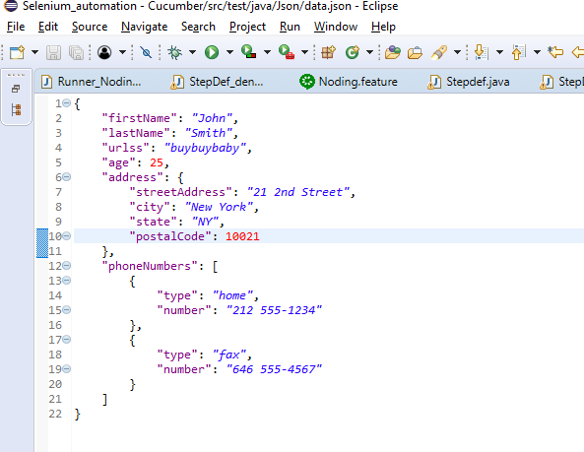

***Common file :-***

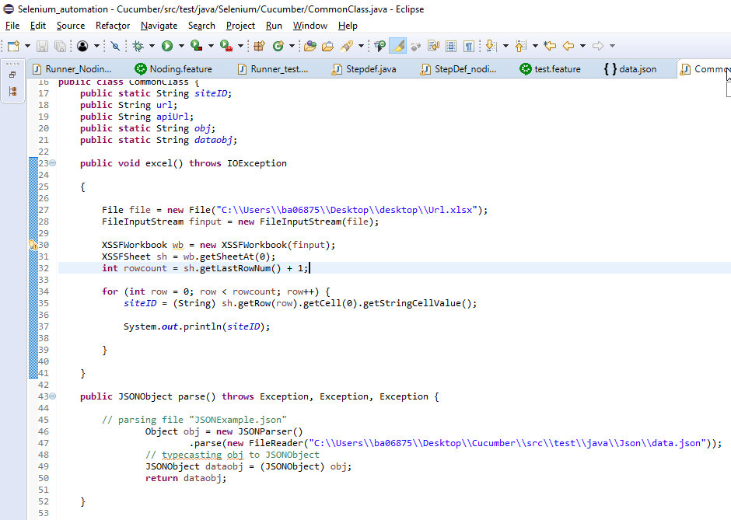

***Code:-***

***package Selenium.Cucumber;***

***import java.io.File;***

***import java.io.FileInputStream;***

***import java.io.FileNotFoundException;***

***import java.io.FileReader;***

***import java.io.IOException;***

***import org.apache.poi.xssf.usermodel.XSSFSheet;***

***import org.apache.poi.xssf.usermodel.XSSFWorkbook;***

***import org.apache.xmlbeans.impl.xb.xsdschema.Public;***

***import org.json.simple.JSONObject;***

***import org.json.simple.parser.JSONParser;***

***import org.json.simple.parser.ParseException;***

***public class CommonClass {***

***public static String siteID;***

***public String url;***

***public String apiUrl;***

***public static String obj;***

***public static String dataobj;***

***public void excel() throws IOException***

***{***

***File file = new File("C:\\Users\\ba06875\\Desktop\\desktop\\Url.xlsx");***

***FileInputStream finput = new FileInputStream(file);***

***XSSFWorkbook wb = new XSSFWorkbook(finput);***

***XSSFSheet sh = wb.getSheetAt(0);***

***int rowcount = sh.getLastRowNum() + 1;***

***for (int row = 0; row < rowcount; row++) {***

***siteID = (String) sh.getRow(row).getCell(0).getStringCellValue();***

***System.out.println(siteID);***

***}***

***}***

***public JSONObject parse() throws Exception, Exception, Exception {***

***// parsing file "JSONExample.json"***

***Object obj = new JSONParser()***

***.parse(new FileReader("C:\\Users\\ba06875\\Desktop\\Cucumber\\src\\test\\java\\Json\\data.json"));***

***// typecasting obj to JSONObject***

***JSONObject dataobj = (JSONObject) obj;***

***return dataobj;***

***}***

***};***

Feature file:- test.feature

**Code**

@ShopSuite

Feature: Test

@test

Scenario: Rest assuance

When ^Rest assurance2$

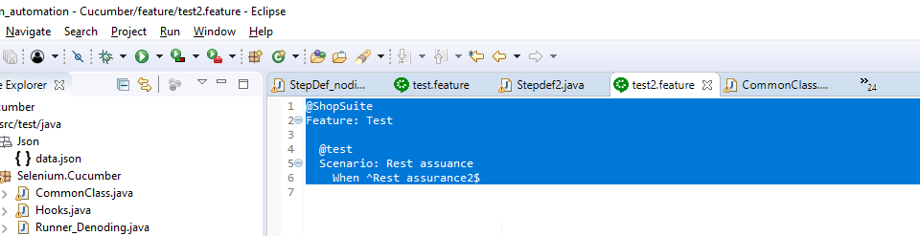

**Step Definition file**

**Code**

**package** Selenium.Cucumber;

**import** java.io.File;

**import** java.io.File;

**import** io.restassured.path.json.JsonPath;

**import** java.io.FileInputStream;

**import** java.io.FileNotFoundException;

**import** java.io.FileReader;

**import** java.io.IOException;

**import** java.io.Reader;

**import** java.nio.file.Files;

**import** java.nio.file.Paths;

**import** java.security.Permission;

**import** java.util.Arrays;

**import** java.util.Map;

**import** java.util.concurrent.TimeUnit;

**import** javax.swing.Spring;

**import** javax.swing.text.html.HTMLDocument.Iterator;

**import** org.apache.poi.xssf.usermodel.XSSFSheet;

**import** org.apache.poi.xssf.usermodel.XSSFWorkbook;

**import** org.json.simple.JSONArray;

**import** org.json.simple.JSONObject;

**import** org.json.simple.parser.JSONParser;

**import** org.json.simple.parser.ParseException;

**import** org.junit.Assert;

**import** org.openqa.selenium.chrome.ChromeDriver;

**import** cucumber.api.java.en.When;

**import** gherkin.deps.com.google.gson.JsonObject;

**import** groovyjarjarantlr.collections.List;

**import** **static** io.restassured.RestAssured.*given*;

**import** io.restassured.RestAssured;

**import** io.restassured.http.ContentType;

**import** io.restassured.http.Method;

**import** io.restassured.parsing.Parser;

**import** io.restassured.path.json.JsonPath;

**import** io.restassured.response.Response;

**import** io.restassured.response.ResponseBody;

**import** io.restassured.response.ResponseBodyData;

**import** io.restassured.response.ValidatableResponse;

**import** io.restassured.response.ValidatableResponseOptions;

**import** io.restassured.specification.RequestSpecification;

**public** **class** Stepdef2 {

CommonClass common = **new** CommonClass();

@When("^\\^Rest assurance2\\$$")

**public** **void** test() **throws** Exception {

JSONObject jsonObject = (JSONObject) common.parse();

// getting firstName and lastName

//common.parse();

String firstName = (String) jsonObject.get("firstName");

String lastName = (String) jsonObject.get("lastName");

String urlss = (String) jsonObject.get("urlss");

System.***out***.println(urlss);

System.***out***.println(firstName);

System.***out***.println(lastName);

// getting age

**long** age = (**long**) jsonObject.get("age");

System.***out***.println(age);

Map fulladdress = ((Map) jsonObject.get("address"));

System.***out***.println(fulladdress);

// getting address

Object address = ((Map) jsonObject.get("address")).get("city");

System.***out***.println(address);

JSONArray phonenumber = (JSONArray) jsonObject.get("phoneNumbers");

// iterating phoneNumbers

System.***out***.println(phonenumber);

}

};

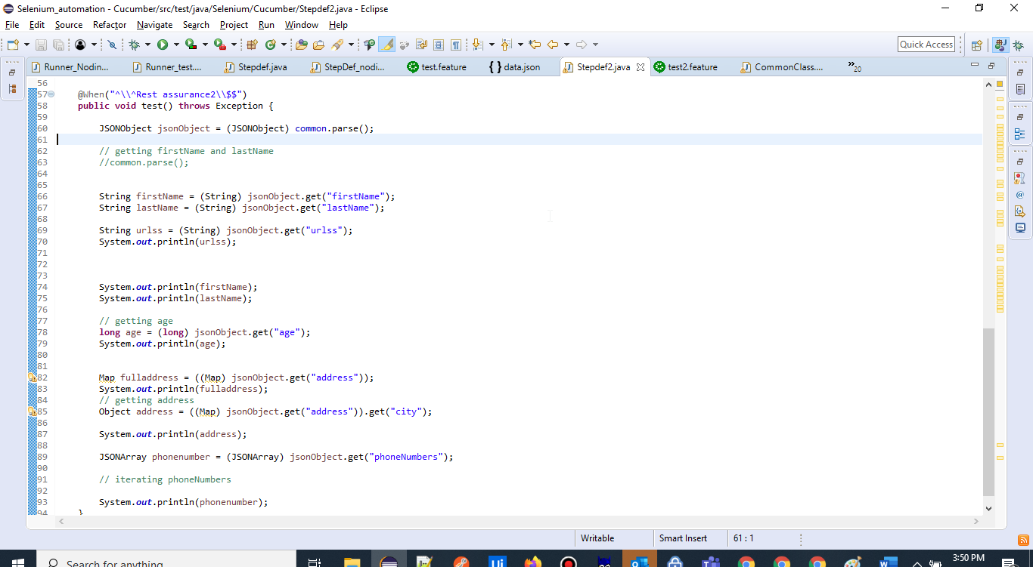

**Runner File**

**package Selenium.Cucumber;**

**import org.junit.runner.RunWith;**

**import cucumber.api.CucumberOptions;**

**import cucumber.api.junit.Cucumber;**

**@RunWith(Cucumber.class)**

**@CucumberOptions(monochrome = true,tags = { "@test2" }, glue = { "Selenium.Cucumber" }, features = {**

**"feature/" }, plugin = { "pretty", "json:target/jsonFolder/cucumber11.json" ,"html:target/htmlFolder/"})**

**public class Runner_test2 {**

**}**

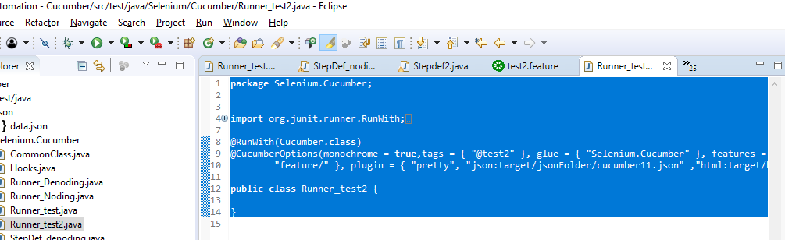

**OUTPUT**

