**HOSPITAL MANAGEMENT SYSTEM**

**IMPLEMENTATION**

In this phase we will create tables based on the design done in the first phase using SQL queries and will write select queries to retrieve information from database based on various criteria.

* **Creating Tables and inserting data**

**Department Table:**

>>create table department

(

dept_id int primary key,

name char(60),

hod_id int

);

>>insert into department values(01,'cardio',03);

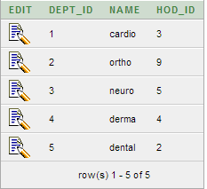

**Doctor Table:**

>>create table doctor

(

doctor_id int primary key,

dept_id int,

doctor_name varchar(60),

specialization varchar(60),

generalization varchar(60),

qualification varchar(60),

address varchar(60),

contact_no int,

foreign key(dept_id) references department

);

>>insert into doctor values(01,01,'Ankit','cardiologist','Sr. Consultant','MD','New Delhi',919876532521);

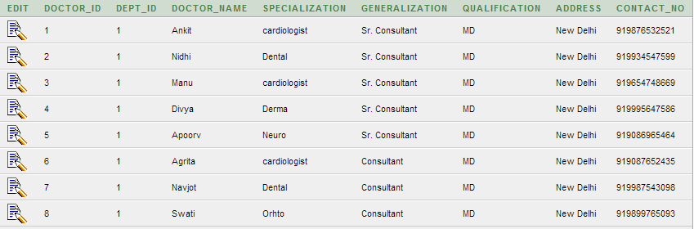

**Nurse table:**

>>create table nurse

(

nurse_id int primary key,

dept_id int,

nurse_name varchar(60),

designation varchar(60),

qualification varchar(60),

contact_no int,

address varchar(60),

foreign key(dept_id) references department

);

>>insert into nurse values(01,01,'Cherring','trainee','B Pharma',9834467586,'New Delhi');

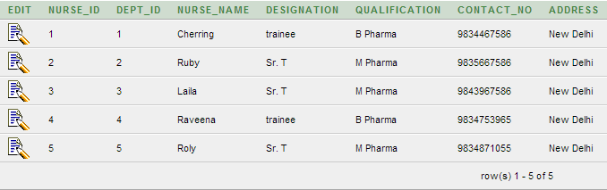

**Ward Table:**

>>create table ward

(

ward_id int primary key,

dept_id int,

ward_name varchar(60),

capacity int,

foreign key(dept_id) references department

);

>>insert into ward values(01,01,'Economy',26);

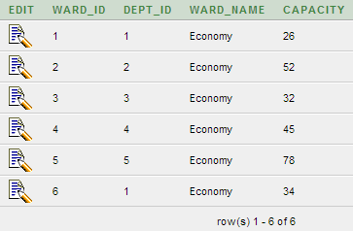

**Patient table:**

>>create table patient

(

patient_id int primary key,

ward_id int,

patient_name varchar(60),

sex char,

age int,

bed_no int,

disease varchar(30),

admit_date int,

discharge_date int,

address varchar(60),

contact_no int,

foreign key(ward_id) references ward

);

>>insert into patient values(1,01,'Kohli','M',57,1,'Disease1',12.09,12.10,'New Delhi',9832942016);

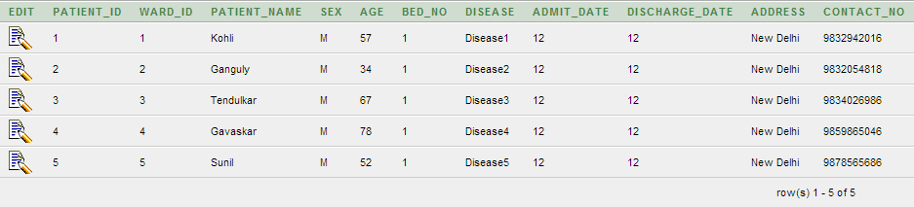

**Test table:**

>>create table test

(

test_id int primary key,

test_name varchar(60) not null

);

>>insert into test values(1,'test1');

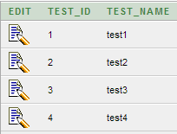

**Treats table:**

>>create table treats

(

doctor_id int,

patient_id int,

checkup_date int,

primary key(doctor_id,patient_id),

foreign key(doctor_id) references doctor,

foreign key(patient_id) references patient

);

>>insert into treats values(01,1,02.09);

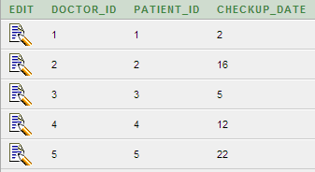

**Cares table:**

>>create table cares

(

nurse_id int,

patient_id int,

primary key(nurse_id,patient_id),

foreign key(nurse_id) references nurse,

foreign key(patient_id) references patient

);

>>insert into cares values(01,1);

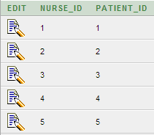

**Undergoes table:**

>>create table undergoes

(

test_id int,

patient_id int,

test_date int,

test_result varchar(30),

primary key(test_id,patient_id),

foreign key(test_id) references test,

foreign key(patient_id) references patient

);

>>insert into undergoes values(1,1,10.09,Result1);

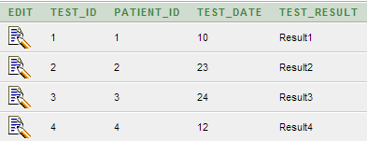

**Doctor_test table:**

>>create table doctor_test

(

doctor_id int,

test_id int,

primary key(test_id,doctor_id),

foreign key(test_id) references test,

foreign key(doctor_id) references doctor

);

**Dept_contact Table:**

>>create table dept_contact

(

dept_id int,

contact_no int,

primary ke(dept_id,contact_no),

foreign key(dept_id) references department

);

>>insert into dept_contact values(1,9839495732);

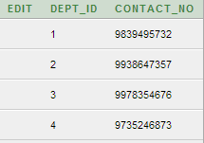

**QUERIES**

**Query 1:**

Find the details of HOD of dental department.

select doctor_id,doctor_name, specialization, generalization, qualification, contact_no, address

from department dp, doctor dr

where dp.dept_id=dr.dept_id

and name='cardio'

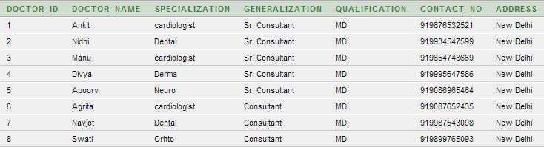

**Query 2:**

Find the ward with maximum capacity.

select ward_id, ward_name, capacity

from ward

where capacity>=all(select capacity from ward)

C:\Users\kunal\Desktop\ca\q2.PNG

**Query 3:**

Find the details of the patients whose name starts from G.

select *

from patient

where patient_name like 'G%'



**Query 4:**

List all contact numbers of cardio department.

select contact_no

from department d, dept_contact dc

where d.dept_id=dc.dept_id

and d.name='cardio'

C:\Users\kunal\Desktop\ca\q4.PNG

**Query 5:**

List all the information about doctors of 'cardio' department.

select doctor_id, doctor_name, specialization, generalization, qualification, contact_no,address

from department dp, doctor dr

where dp.dept_id=dr.dept_id

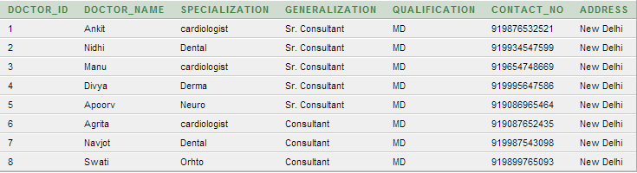

**Query 6:**

List all the patient who are treated by the doctor with doctor_name='Nidhi'

select p.patient_id, p.patient_name, p.age, p.admit_date, p.discharge_date

from doctor d, treats t, patient p

where d.doctor_id=t.doctor_id

and t.patient_id=p.patient_id

and d.doctor_id=2

C:\Users\kunal\Desktop\ca\q6.PNG

**Query 7:**

List all the details of nurse working in 'Derma' department.

select * from nurse n, department dp

where n.dept_id=dp.dept_id

and name='derma’

C:\Users\kunal\Desktop\ca\q7.PNG