**LIBRARY MANAGEMENT SYSTEM**

**IMPLEMENTATION**

In this phase we will create tables based on the design done in the first phase using SQL queries and will write select queries to retrieve information from database based on various criteria.

**Creating Tables**

**Publisher Table:**

>>Create table publisher

(

pub_id int primary key,

pub_name varchar(60),

contact_no int,

address varchar(60)

);

>>insert into publisher values(01,'Rahul',9899675432,'New Delhi');

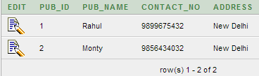

**Student Table:**

>>create table student

(

student_id int primary key,

name varchar(60),

department varchar(60),

semester int,

contact_no int

);

>>insert into student values('1','Ankit','COE',4,9867345430);

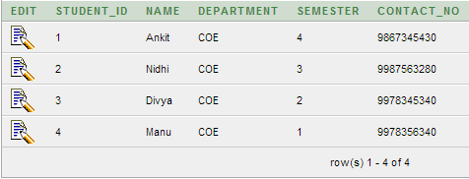

**Books Table:**

>>create table books

(

book_id char primary key,

pub_id int,

title varchar(60),

category varchar(60),

price int,

foreign key(pub_id) references publisher

);

>>insert into book values('B',01,'CSO','Computer Science',430);

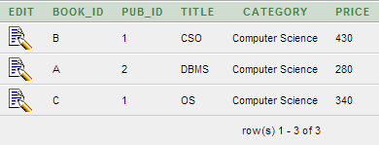

**Author Table:**

>>create table author

(

author_id char primary key,

author_name varchar(60),

contact_no int,

address varchar(60)

);

>>insert into author values ('E','Apoorv',9807646363,'New Delhi');

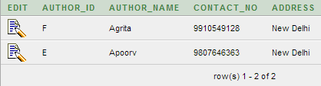

**Issue Table:**

>>create table issue

(

book_id char,

student_id int,

issue_date char(20),

return_date char(20),

fine int default 0,

remark varchar(30),

primary key(book_id,student_id);

foreign key(book_id) references book,

foreign key(student_id) references student

);

>>insert into issue values ('B',03,'01/03/13','22/03/13',0,'no binding');

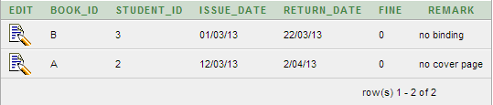

**Writes Table:**

>>create table writes

(

book_id char,

author_id char,

primary key(book_id,author_id),

foreign key(author_id) references author,

foreign key(book_id) references book

);

>>insert into writes values ('A','E');

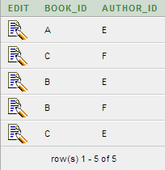

**QUERIES**

**Query 1:**

List the details of students who issued the book from library with book_id='B'.

select s.student_id,i.issue_date,i.return_date

from issue i, student s

where i.book_id='B'

and s.student_id=i.student_id



**Query 2:**

List the books which are available in library.

select b.book_id,b.title

from book b,issue i

where b.book_id=i.book_id

and return_date is not null

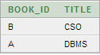

**Query 3:**

List the books which are not available in library(i.e. issued to students),also give detail of students to whom these books have been issued.

select b.book_id,b.title,s.student_id,s.name,i.issue_date

from book b,issue i,student s

where b.book_id=i.book_id

and s.student_id=i.student_id

and i.return_date is not null

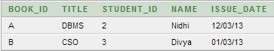

**Query 4:**

List the details of the author of the book 'DBMS'.

select a.author_id,a.author_name,a.contact_no

from author a,book b,writes w

where b.title='DBMS'

and a.author_id=w.author_id

and b.book_id=w.book_id



**Query 5:**

List the details of the books which are currently issued to student with id '3'.

select b.book_id, b.title, i.issue_date,remark

from book b,student s,issue i

where i.student_id=03

and b.book_id=i.book_id

and s.student_id=i.student_id

and i.return_date is not null



**Query 6:**

List down the details of the book written by the publisher='Rahul'.

select b.book_id, b.title, b.category, b.price

from publisher p, book b

where pub_name='Rahul'

and b.pub_id=p.pub_id

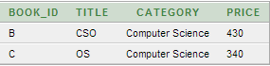

**Query 7:**

List the detail of the author of the book='OS'.

select a.author_id, a.author_name, a.contact_no, a.address

from author a, writes w,book b

where b.title='OS'

and b.book_id=w.book_id

and a.author_id=w.author_id

