SQL Practice Queries — employees table (Ketan_S)

1. Filter by salary greater than
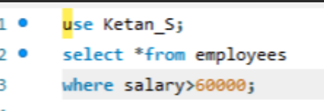

2. IN operator
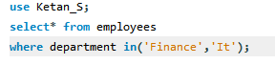

3. NOT IN operator
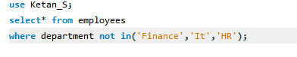

4. BETWEEN
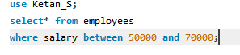

5. NOT BETWEEN
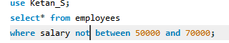

6. LIKE - ends with 'n'
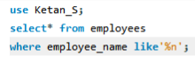

7. LIKE - contains 'an'
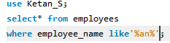

8. LIKE - contains 'an' (repeat)
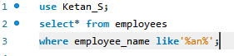

9. IS NULL
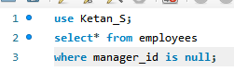

10. IS NOT NULL
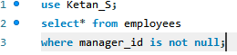

11. IFNULL()
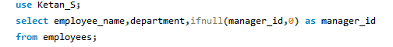

12. COALESCE()

13. CONCAT()
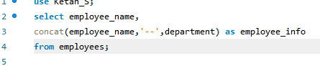

14. UPPER() and LOWER()
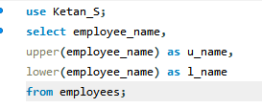

15. LENGTH()
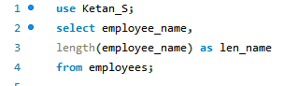

16. SUBSTRING()
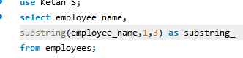

17. REPLACE()
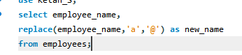

18. TRIM()
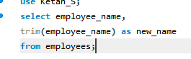

19. COUNT()
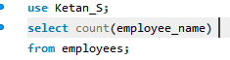

20. AVG()
