Exception
___________________________________________________
Q. What is exception?
___________________________________________________
Exception is events which occur at program run time and which is responsible for disturb the normal flow of application.

Q. What is purpose of exception handling?
___________________________________________________
1. It helps developer to detect run time error
2. To Skip the code in which exception may be occur and execute the remaining program in safe zone.

There are three types of exception
_____________________________________________
1. Checked Exception: Those exceptions occur at program compile time called as checked exceptions.
Checked Exceptions are precaution able means if we have logic and if there 100% possibility for run time error so better you can handle it at compile time.
Checked exception help us to provide compile time warning to developer related with possibility of exception
2. Unchecked Exception: those exceptions occur at program run time called as unchecked exceptions.

3. Error: Error is part of exception but it is not handling by programmer called as error.

Q. What is difference between exception and error?
Exception may be manageable by programmer or handle programmer but error cannot handle by programmer

If we want to work with exception handling in java we have some inbuilt classes provided by java to us.

Exception class hierarchy
_________________________________________________
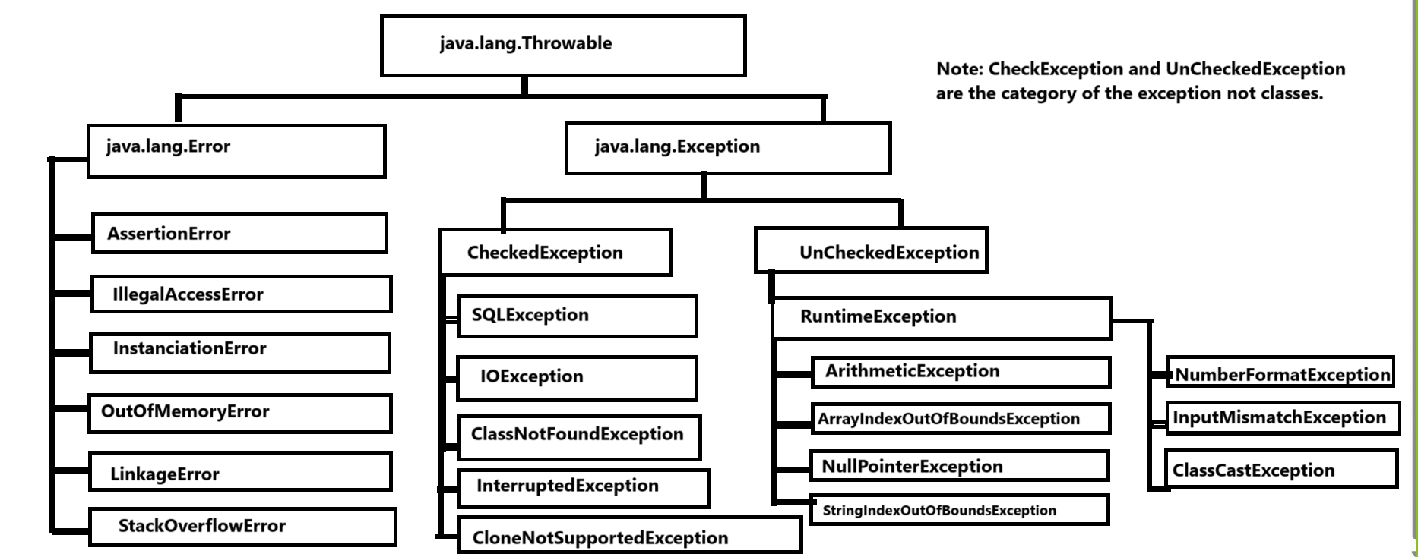

Note: if we want to work with exceptions in JAVA we have some inbuilt keywords and blocks for with exception

There are five keywords in exception handling
1. try: try is block in exception handling which help us to write code in which exception may be occur and when exception occur in try block then JVM create one exception object and hand over to catch for further execution.
2. catch: catch is block in exception handling which always execute when exception generate in try block and catch block define with try block.
Means we can say if we want to handle exception and detect it then we can do this task under catch block.
Means we can say catch block always use for
a) execute logic after exception
b) to detect the exception class and display exception error.
Syntax of try and catch block
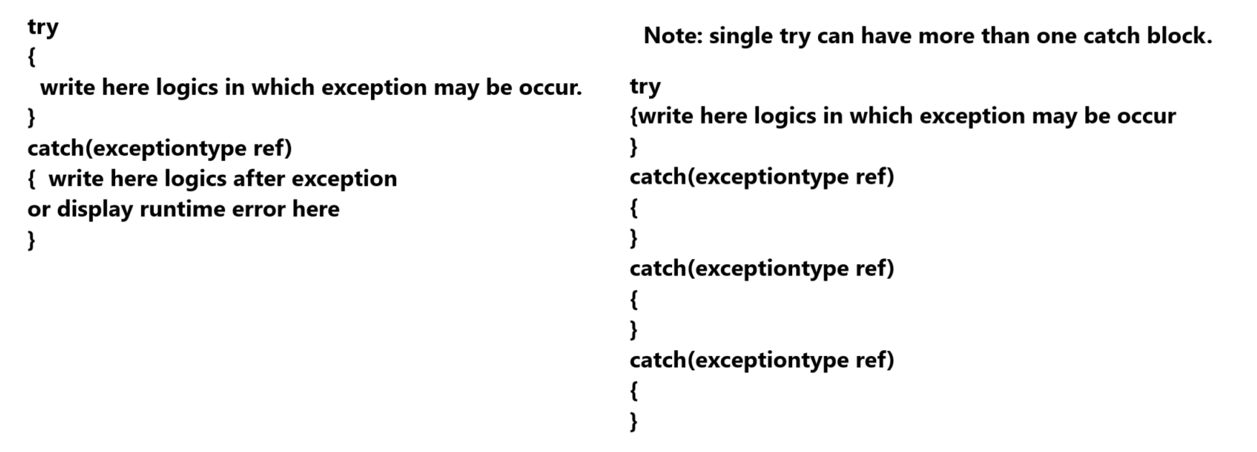

Now we want to discuss about example of exception

Example of ArithmeticException
____________________________________________________
ArithmeticException occur when we have any mathematical problem like as infinity or divide by zero
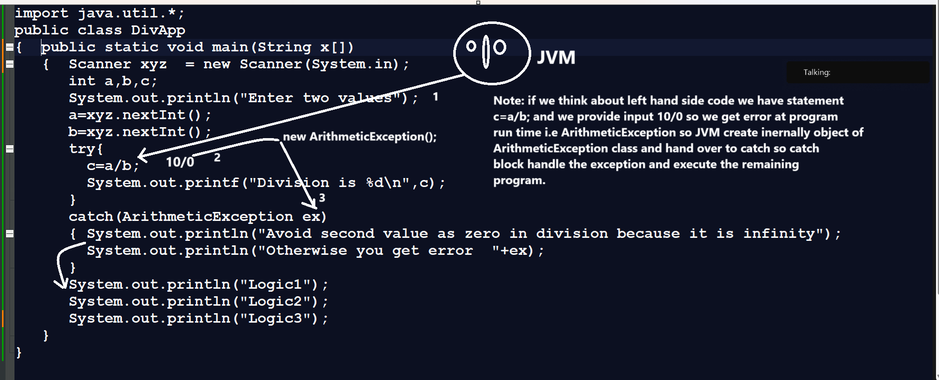

Example of ArrayIndexOutOfBoundsException?
________________________________________________
ArrayIndexOutOfBoundsException occur when we try to fetch data using index greater than or equal size of array.

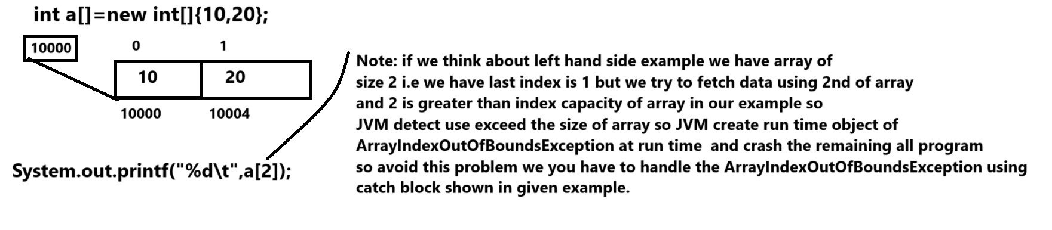

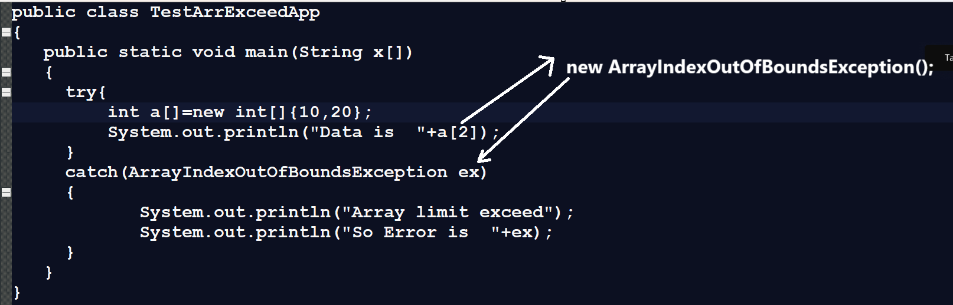
NegativeArraySizeException: This class help us to handle the negative size exception array means when user declare the array and set its size as negative then JVM create object of NegativeArraySizeException class internally and hand over to catch.
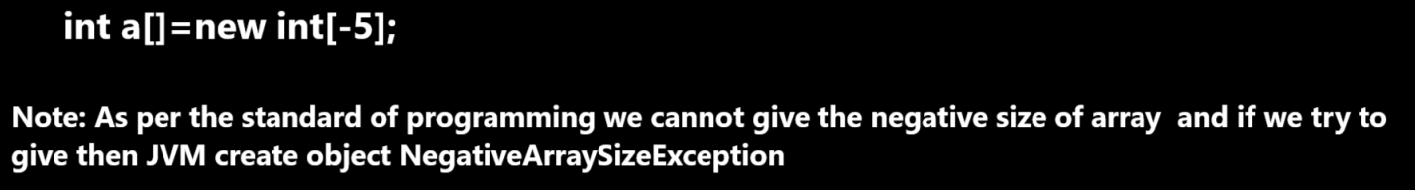

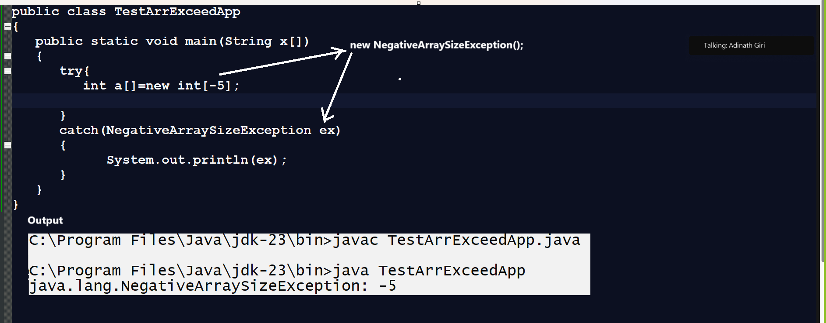

NumberFormatException
__________________________________________________
When we try to convert string value to any primitive type of data and there is any numeric value in string like as digit, alphabet etc then JVM generate run time error called as NumberFormatException

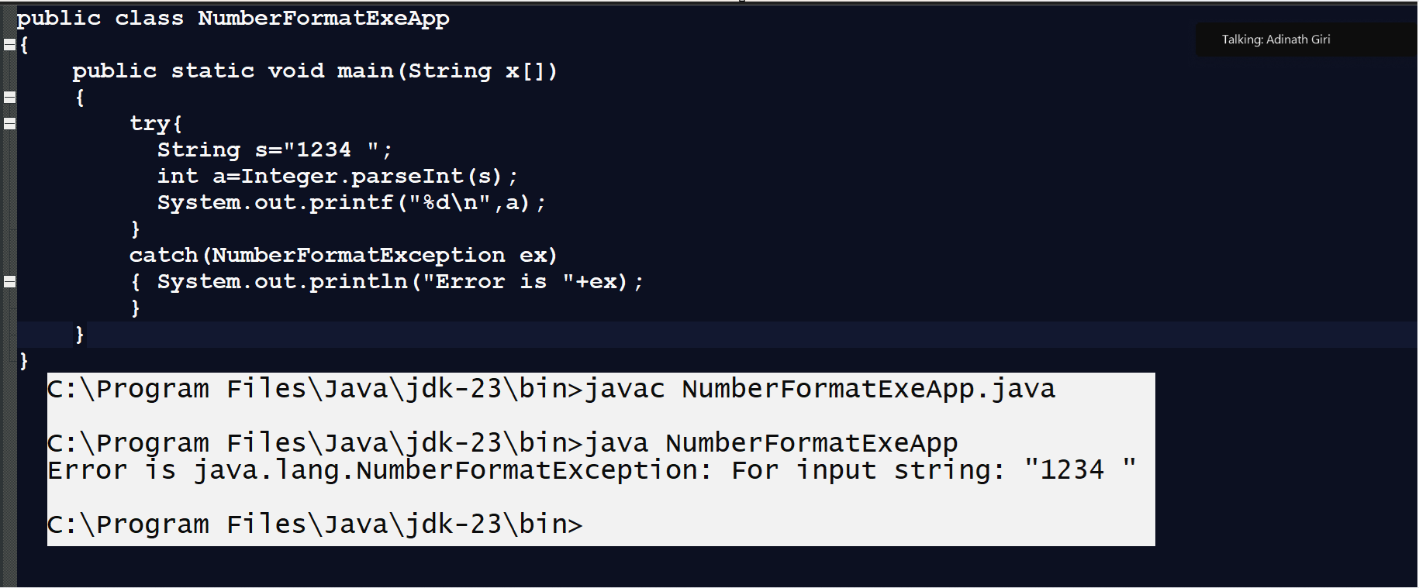

Example of NullPointerException
_________________________________________________
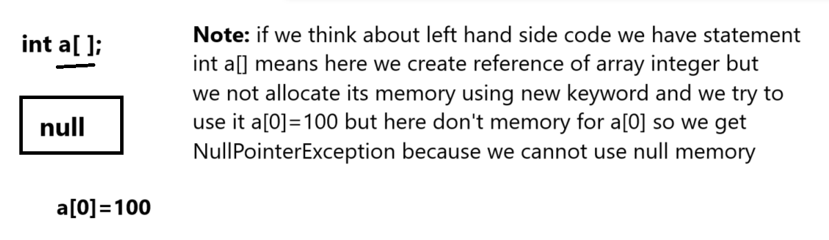

Example with source code
public class NullPointerApp
{ static int a[];
public static void main(String x[])
{ try
{
a[0]=100;
}
catch(NullPointerException ex)
{
System.out.println("Error is "+ex.getMessage());
System.out.println("Allocate memory of array using new keyword");
}

}
}
or
class A
{
void show(){
System.out.println("I am show method");
}
}
public class NullPointerApp
{ static A a1;
public static void main(String x[])
{
a1.show();
}
}

InputMismatchException in JAVA
__________________________________________________
import java.util.*;
public class MisMatchExeApp
{
public static void main(String x[])
{
try{
Scanner xyz = new Scanner(System.in);
int a,b,c;
System.out.println("Enter two values");
a=xyz.nextInt();
b=xyz.nextInt();
c=a/b;
System.out.println("Division "+c);
}
catch(InputMismatchException ex)
{ System.out.println("Error is "+ex);
}
}
}
Note: Java Provide generalize exception handling using Exception class Means when we pass Exception class in catch block then we can handle any kind of Exception using Java.

import java.util.*;
public class MisMatchExeApp
{
public static void main(String x[])
{
try{
Scanner xyz = new Scanner(System.in);
int a,b,c;
System.out.println("Enter two values");
a=xyz.nextInt();
b=xyz.nextInt();
c=a/b;
System.out.println("Division "+c);
}
catch(Exception ex)
{ System.out.println("Error is "+ex);
}

}
}
Interview
Q1. What is exception and why use it?
Q2. Explain benefits of exceptions?
Q3. Explain exception handling hierarchy?
Q4.Explain try and catch with example?
Q5. Explain types of Exceptions?
Q6. What is difference between exception and error?
Q7. Give example ArithmeticException,ArrayIndexOutOfBoundsException,
NegativeArraySizeException?

3. finally: finally is a block in exception handling which always execute if exception generate in code or not
Means you can write logic in finally which we want to execute always.

Example: database connection close, file close etc

Syntax of finally
___________________________________________
try{
}
finally
{
}
or
try{
}
catch(exceptiontype ref)
{
}
finally
{
}
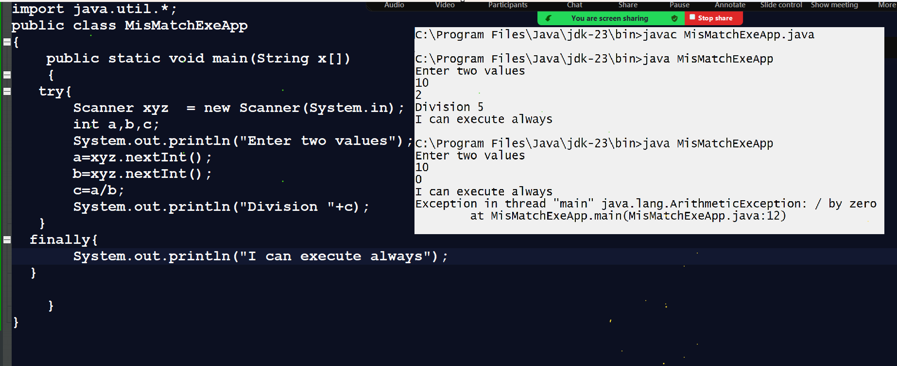

Note: when we use try, catch and finally then first catch get executed after that finally executed
Means when we write catch with try then first exception get handle and after that finally executed.
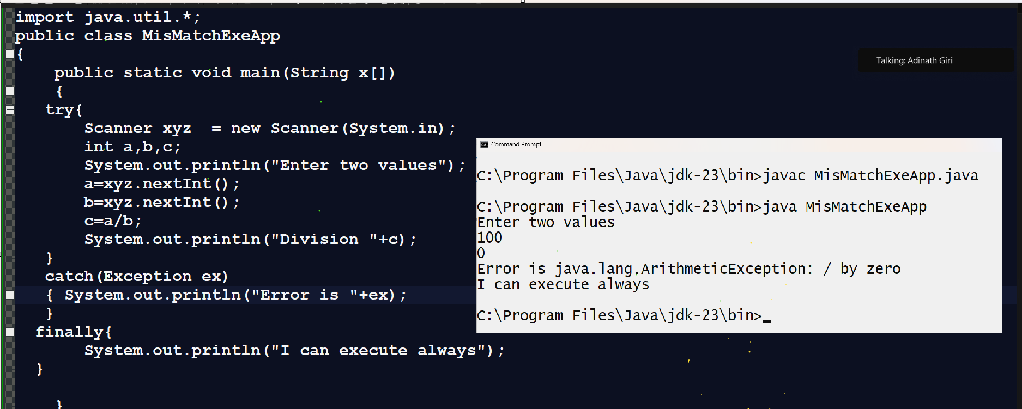

4. throws: throws/clause is keyword in exception handling which is used for handle the checked exceptions and normally we can use throws with function definition means when we use throws keyword with function definition we not need to write try and catch in function definition we need to write try and catch at function calling point.
Because when we use throws then exception generate function definition and handle at function calling point.
Syntax of throws clause
___________________________________________________
return type functionname(datatype variablename)throws exceptiontype
{ write here your logics
}
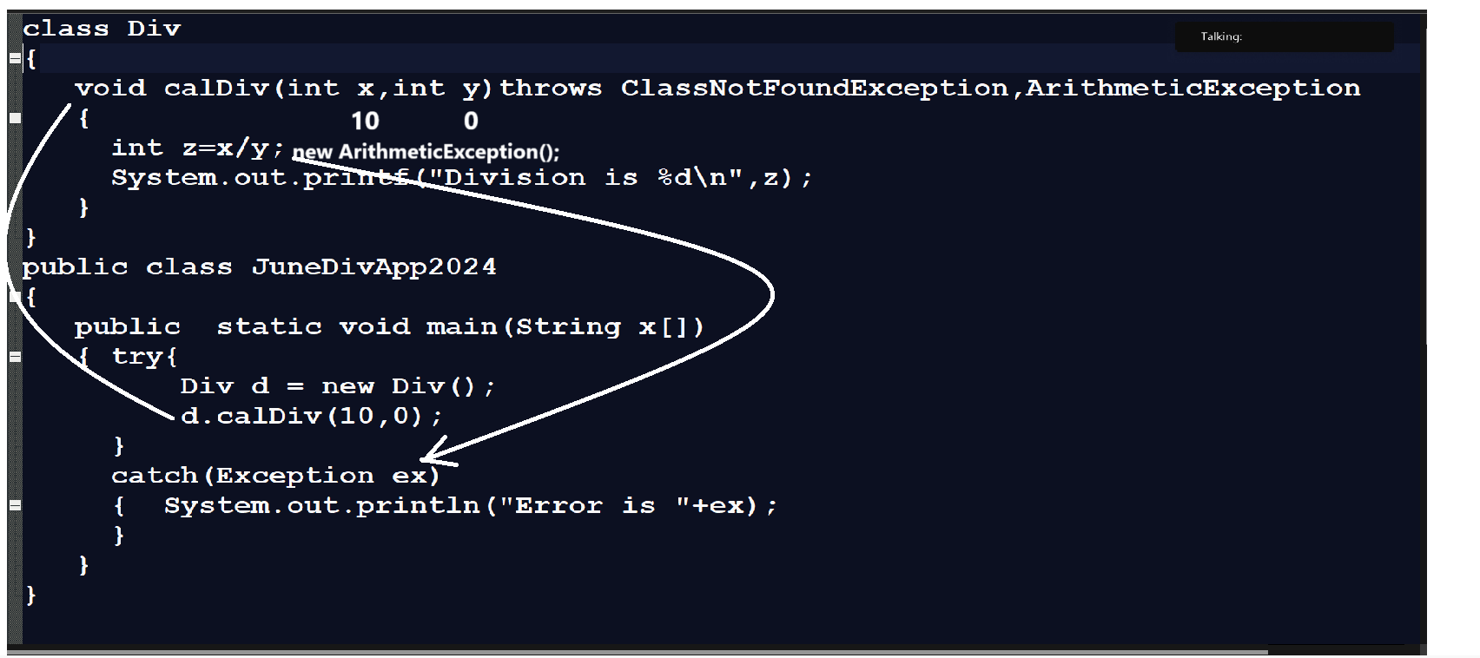
5. throw: throw keyword is used for handle the user defined exceptions using java.
Q. What is user defined exceptions & developer need to create own exception?
___________________________________________________
User define exception means when user define own exception classes for handle the exception called as user defined exceptions
User/developer need to create own exception classes
1. When developer has exception and java not provide exception handling class for user exception then developer need to create own exception class known as user defined exceptions.
2. when developer want to generate run time error messages according to project requirement then developer can create own exception class called as user define exceptions.

Important points related with throw
________________________________________________
1. Not need to write try and catch in function definition
2. Need to create user define exception object and throw it manually.
3. Write try and catch at function calling point.
Q. How to create user defined exception in java?
__________________________________________________
If we want to create own exception classes and handle it then we have some following steps.
1. Create User define class and inherit the exception class in it.
2. Define own methods for handle the exceptions according to logic
3. Create Exception class object and throw it using throw keyword
4. Write try and catch at function calling point.
Example: Suppose consider we are working voting application and we have one voting machine and we want to provide age of voter to voting machine but if age is less than 18 then voting should generate run time error or throw run time error you are not eligible for voting otherwise accept the vote.
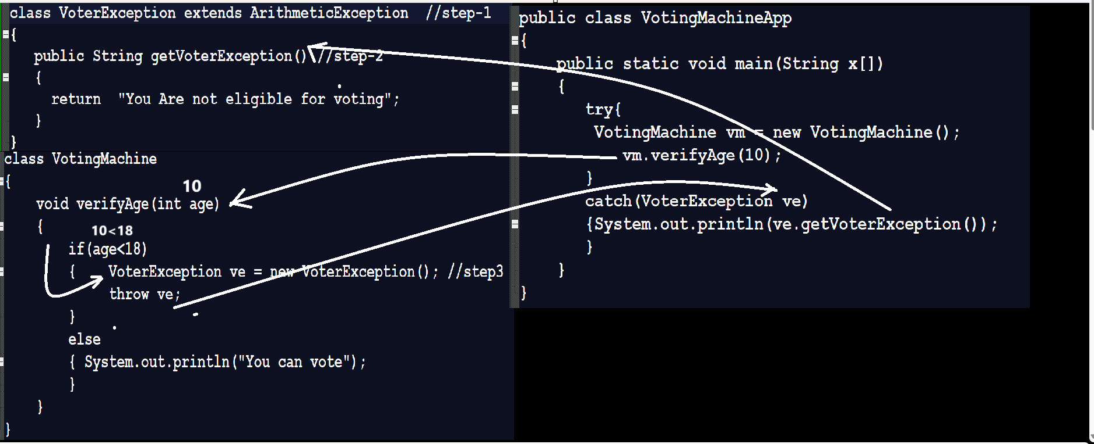
Q. What is difference between throw and throws?
_____________________________________________________
Throw | Throws
Throw is used for handle user defined exception | Throws is used for handle the checked exception
Throw need to create manual object of exception class | Throws not need to create manual object of exception JVM create internally according exception generate in function definition
Throw cannot work with more than one exception at time | Throws can work with more than one exception at time

Date: 15/11/2024
__________________________________________________
Q1. What is throw and why use it explain with source code example?
Q2. What is use of throws and why use it explain with source code example?
Q3. What is difference between throw and throws?

