Bug Description:
No error message was displayed when “Message” field was left blank and submitted the Marketing form.

Environment:
Brower Type- Chrome
Platform – Windows 10
Browser Zoom - 100%

Severity:
High

Priority:
High

Reported by:
Ketan

Reported date:
19-09-2023

Steps to reproduce:
- Launch website https://www.tendable.com/
- Click on “Contact Us” link from top right corner.
- On the Contact Us page, click on “Contact” button from ‘Marketing’ section
- Capture valid “Full name”
- Capture valid “Organisation name”
- Capture valid “phone number”
- Capture valid “Email”
- Select valid “Job role”
- Do not capture anything in the “Message” field
- Click on “I Agree” radio button
- Click on “Submit” button
- Verify if there is an error message is displayed

Actual Behaviour:
No error message is displayed, or the form has been submitted

Expected Behaviour:
Must have an error message “Sorry, there was an error submitting the form. Please try again.” Is displayed in red color above “Full name” input field.

Screenshots proof:
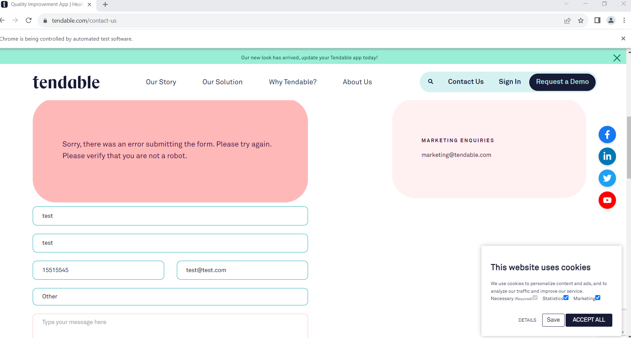

Additional Information:
No workaround is required to reproduce this issue.

