**PROJECT REPORT FOR SOLID WASTE MANAGEMENT OF TOWNS NOT FUNDED UNDER SWACHH BHARAT MISSION (URBAN)**

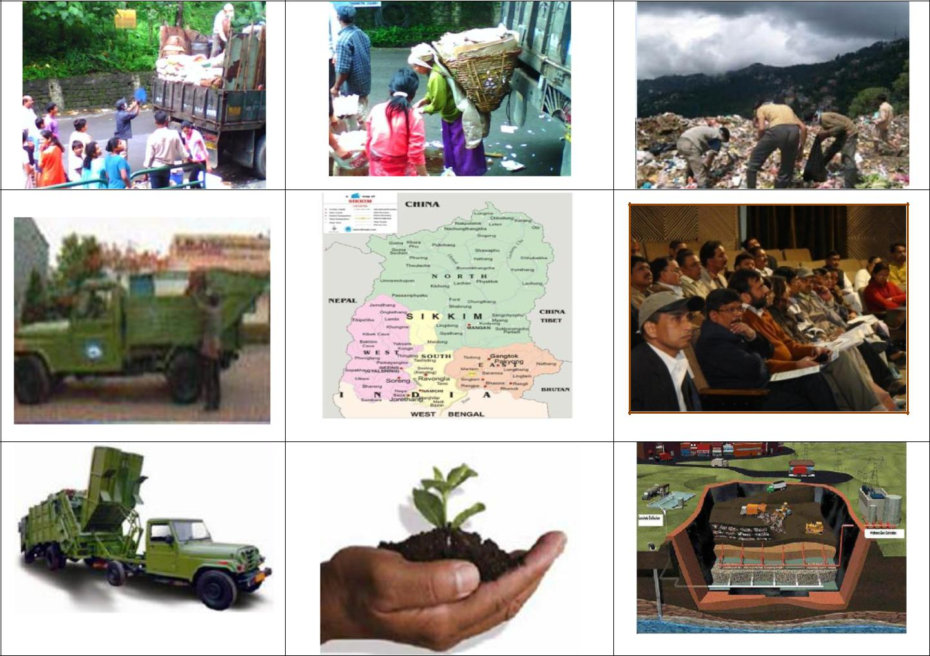

**SUBMITTED TO MINISTRY OF OVERSEAS AFFAIRS FOR FUNDING UNDER IDF-OI**



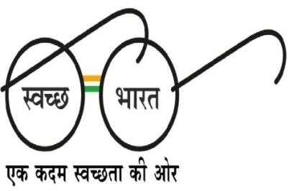

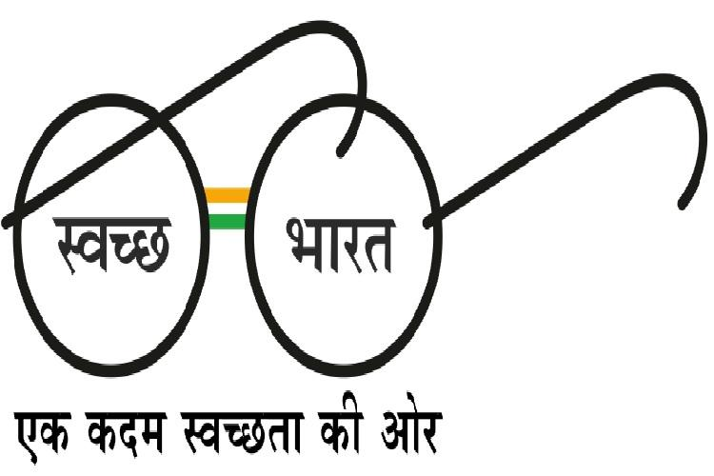

**State Mission Directorate – Swachh Bharat Mission (Urban)**

**Urban Development and Housing Department**

**Government of Sikkim**

**Gangtok**

**Background of Sikkim’s topography and Geographic Profile**

Sikkim is a landlocked state in the north-eastern region of India and shares international borders with China, Nepal and Bhutan, and state boundary with West Bengal.

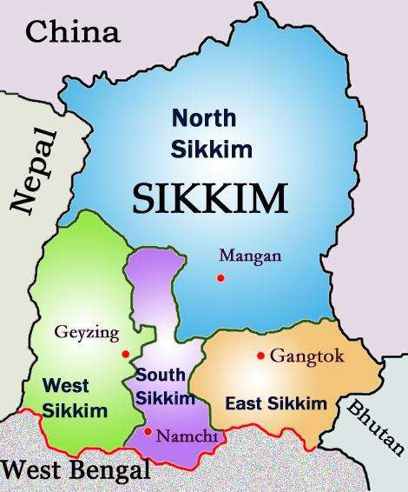

Owing to its location in the Himalayan Mountainous region, the geography of Sikkim is diverse in the form of high mountain peaks and steep river valleys. Tucked between the Himalayan ranges, the state has mountainous terrain with elevations ranging from 280 meters to 8585 meters. The climate of Sikkim varies from subtropical in the south to tundra in the northern parts. The tundra region in northern Sikkim is covered by snow for four months consecutively every year. The temperature during these winter months drops down to below 0°C. Most of the populated lower regions of Sikkim experience a temperate climate with temperatures ranging from 28°C in summer at times and dropping below 0°C in winters.

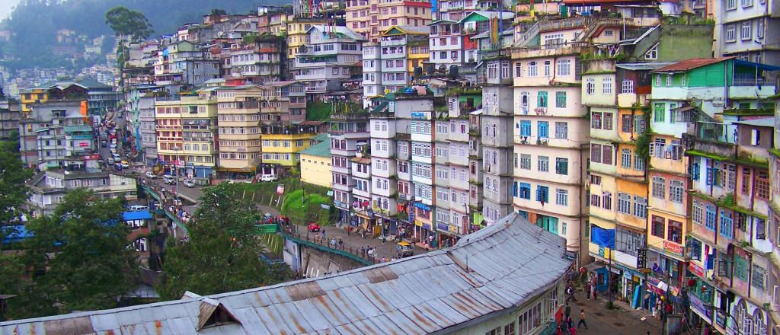

The Urban Development & Housing Department UDHD is the primary agency responsible for the town development and management matters, including the physical planning, growth management and the provision and management of core civic services. Growth trends are estimated to continue concentrating on the major towns which will lead to the aggravation of the imbalance in the already hard pressed civic facilities.

Unplanned urban expansion has strained the State resources. In Gangtok, the capital city, an estimated 50 MT of solid waste is generated daily in the Gangtok Municipal Area. In certain areas the curb-side collection is prevalent. Though GMC is primarily responsible for collection, transportation and disposal of the solid waste, collection and transportation of waste is being handled privately in certain small, organized areas. Burning the waste and dumping into the jhoras (rainwater drainage nala) in peripheral areas is not uncommon.

Sikkim has a very rugged topography due to which there are very less flat lands – no flat area more than a few hundred square meters exists in continuity. This makes management of Municipal Solid Waste very challenging especially in terms of collection of waste from the households.

Picking up national accolades in 2012 for being India’s cleanest state with the most innovative tourism project, Sikkim has set new benchmarks for responsible travel in the country. Checkbox sightseeing has rapidly made way for sustainable community-based tourism in less developed areas, while eco-friendly policies have lent new vigour to the virginal Himalayan wilderness that drapes the region’s mountains. Food-wise, there’s news too. Organic farming is the new mantra in Sikkim and is being promoted in a big way. Much of the produce available in local markets is already gunk-free, and the government proposes to convert Sikkim into a fully organic state very soon. And in 2014 the international travel magazine lonely planet ranked Sikkim as No.1 in the list for “Top Regions to visit in 2014”.

Read more: <http://www.lonelyplanet.com/travel-tips-and-articles/lonely-planets-best-in-travel-2014-top-10-regions#ixzz3nUiVGnRw>



DETAILED PROJECT REPORT (PHODONG-PHENSONG-CLASS II TOWN)

**1. Project title**:

Sanitation & Solid Waste Management

(SSWM); TOWARDS ZEROWASTE

**2. Aims of the project:**

a. Modern and Scientific Solid Waste Management

b. To effect behavioural change regarding healthy sanitation practices

c. Generate awareness about sanitation and its linkage with public health

d. Provision of Individual Household Latrines & Community Toilets for residents and floating population.

**3. Short justification of project:**

a. Introduction:-

**Phodong** is a town 38 kilometers north of Gangtok, the capital of the Indian state of Sikkim in North Sikkim district. Phodong is famous for the "Phodong Monastery" and the "Labrang Monastery" which is situated at a slightly higher altitude than the Phodong Monastery. The main occupation is farming on terraced slopes, though in recent years, tourism has contributed to the economy.

**Paney-Phensong** is a village in Mangan subdivision, North Sikkim district, Sikkim, India.

b. Waste generation details:-

|  |  |  |  |  |
| --- | --- | --- | --- | --- |
| Name of Town | No. of Households + Hotels | Population | Waste Generation per day (kg) | Waste Generation during Tourist Season |
|  |  |  |  |  |
| Phodong | 140 | 640(during non-tourist season) | 168 | 220 |

c. Current scenario:-

- There is an absence of hardware for effective Solid Waste Management.

These include a Community Collection Centre which is a shed for the storage of waste, treatment facilities for the wet waste being stored temporarily at these CCC, bio gas units at CCC wherever deemed feasible, and compactors for compaction of waste before they are sold to recyclers.

**4. Whether existing or new project:**

New project

**5. Sector:**

Class II Town

**6. Implementing agency and NGO associated:**

State Mission Directorate, Swachh Bharat Mission (Urban), Urban Development & Housing Department, Government of Sikkim

NGO: - **Phodong Rongong Youth**

**7. Target beneficiaries – no and nature (example- women, children, tribal, etc):**

Permanent residents and religious tourists. Has sizeable tribal population.

**8. Target geographic location (village, district, etc):**

North District

**9. Design of project (methodology, intervention, etc):**

The “Hierarchy of Waste Management” gives a priority listing of the waste management options and indicates important general guidelines on the relative desirability of the different management options. The hierarchy will be adopted and will aim at:

- Waste minimization/reduction at source

- Recycling

- Waste processing – with recovery of resources i.e. material (products) and energy

We will be following these management principles of Sustainability to design the project.

**Methodology**:-

a. IEC-

Prior to introducing the hardware and infrastructure, the software must precede it in terms of rigorous IEC & Awareness Campaigns. Publicity campaign for creating Community Awareness and Public Participation (CAPP) for segregation of waste will be carried out and continued to achieve segregated biodegradable waste for composting and minimizing the waste for final disposal.

b. Segregation and composting at source-

-Segregation at source will be made compulsory to all Households, commercial spaces (hotels, shops, and markets), Institutional premises (school, colleges, and offices)

-Residents will be asked to deposit segregated waste to Door to Door Collection Vehicle on time. They shall not throw any solid waste in their neighbourhood, on the street, jhoras, open spaces and into vacant plots or into drains. Punishment will be meted out to those who litter and dispose waste on streets etc.

- They shall keep the kitchen discards (food waste) as and when generated, in any type of domestic waste container and (a) hand over to the waste collector daily or (b) compost it at the household itself using suitable technology provided by the authorities. They shall keep Dry/recyclable waste preferably in bags or sacks in a segregated manner to be transported to Community Collection Centres periodically.

- They shall not dispose off wet waste in plastic or any other carry bags.

- They will keep domestic hazardous waste separately, for disposal at designated place arranged by authorities. Domestic hazardous/ toxic waste material will be deposited in special bins (provided by the local body at specific designated places in the towns) at the Community Collection Centres. These hazardous waste will be taken eventually to the landfill. This would facilitate maintaining hygienic condition and easy handling of the waste for further processing and proper disposal.

c. Collection & Transportation-

- Authorities will provide daily waste collection service to all households, shops and establishments for the collection of segregated bio-degradable waste due to its putrescible nature. This service must be reliable and regular. The practice of segregation of waste at source will be ensured through different category bins such as degradable, non-degradable, and hazardous so as to prevent the discards from reaching the waste stream and facilitate material recovery by means of composting and recycling. Door-to-door collection with community participation on cost recovery basis will be organized by authorities. In case of difficult household locations where households do not have vehicle accessibility, composting of segregated kitchen waste will be taken up at the household level itself which will not necessitate daily collection while dry waste can be stored category-wise and handed over to the Community Collection Centres on a periodic basis. Authorities will however ensure thorough sensitization of the community and follow it up with constant monitoring.

- Recyclable material can be collected at longer regular intervals as may be convenient to the waste producer and the waste collector, as this waste does not normally decay and hence need not be collected daily.

- Domestic hazardous waste is produced occasionally. Such waste can be collected periodically, however the waste producers need to be advised / directed to store them separately.

d. Storage and final disposal-

After collection of degradable waste (daily) and non-degradable or hazardous waste (periodically) they are brought to the Community Collection centres.

These CCC’s are basically sheds which will be used to store the waste temporarily.

They will additionally be provided with Waste Compactors of 5 or 7 cubic meter capacity to compact the waste before selling them to recyclers or sending them to landfill.

Wherever feasible Biogas units will be installed to process the biodegradable waste into biogas. This can be done whenever the supply of organic manure from biodegradable waste exceeds the demand.

**10. Expected outcomes/benefits proposed:**

a. Effective & efficient source segregation, collection, transportation

b. Maximum resources recovery

c. Effective treatment

d. Safe disposal

e. To avoid manual handling of waste and also minimize multiple handling by adopting state of the art modern SWM vehicles and equipments suitable to hilly terrain.

f. Developing of skills and mechanisms in waste collection of the “waste collection crew” which are humane and dignified.

h. All these benefits add up to our final aim of achieving a Zero Waste town. This model will help us sustain our ecologically rich and fragile environment.

**11. Project timeline (Date of commencement or completion):**

2nd Oct 2019.

**12. Estimated budget:**

|  |  |
| --- | --- |
| **Hardware:** |  |
| Vehicle (5 cum) for transportation of waste from Households to Community Collection Centres | Rs. 12.5 lakhs |
| Plastic Waste Compactor for waste volume reduction | Rs. 5 lakhs |
| CCC (Storage shed) | Rs. 9.5 lakhs |
| Ecobin (household composter for biodegradable waste) at household level, covering all households | Rs. 14.5 lakhs |
| Household bins | Rs. 4.00 lakhs |
| **Software component:** |  |
| Training, sensitization, IEC programmes: | Rs. 3.50 lakhs. |
| **Total Cost** | Rs. 49.00 lakhs |

**13. Whether cost includes capital cost as well as maintenance cost:**

The cost estimated will include only the capital cost.

The maintenance cost will be collected from the User Charges that is being planned to be levied on the public for the services (door to door collection where vehicle is not accessible) provided by UD & HD.

Also the money generated from the sale of compost as well as the recyclable dry waste will be pumped back into the maintenance of the structural facilities and services.

**14. Images of proposed project:**

