**Project 3:**

Step1: Create two linux instances,Use the first free linux AMI

ss2: select an instance and display instance details of server1

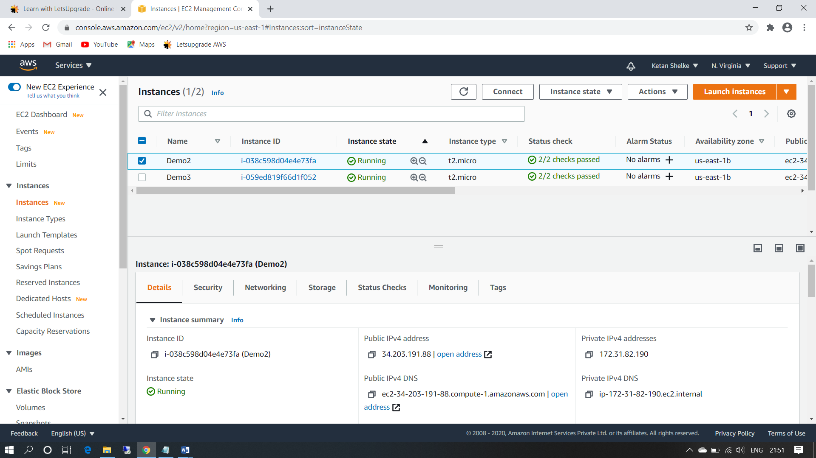

ss3:select a instance and display instance details of server2

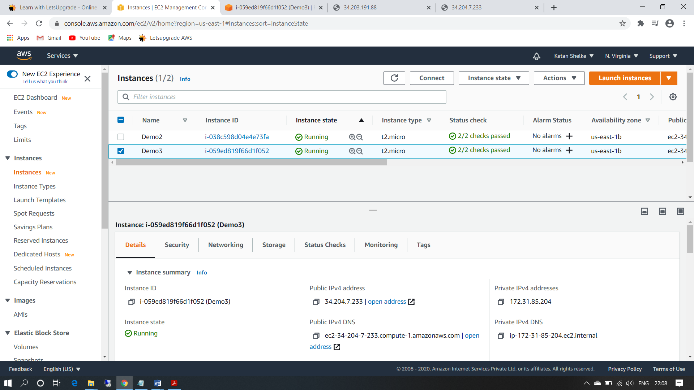

Step2: Launch both instances using EC2 Instance

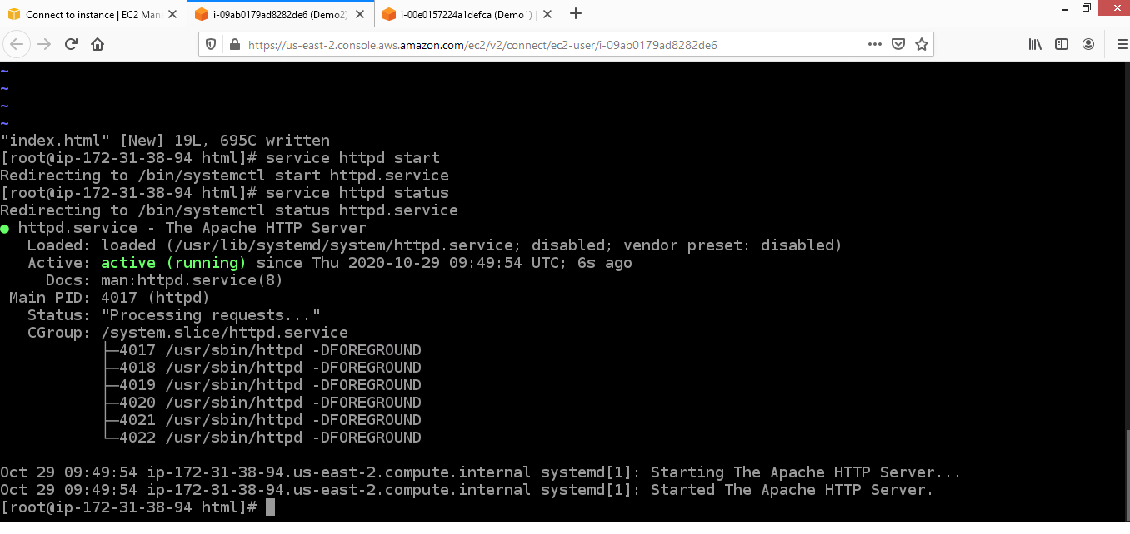

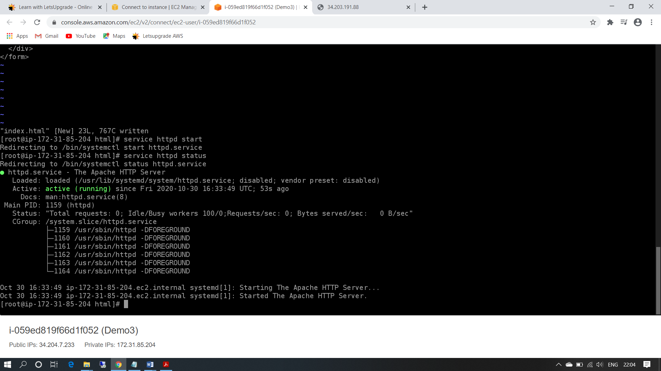

Step3:Host html login webpage on both servers

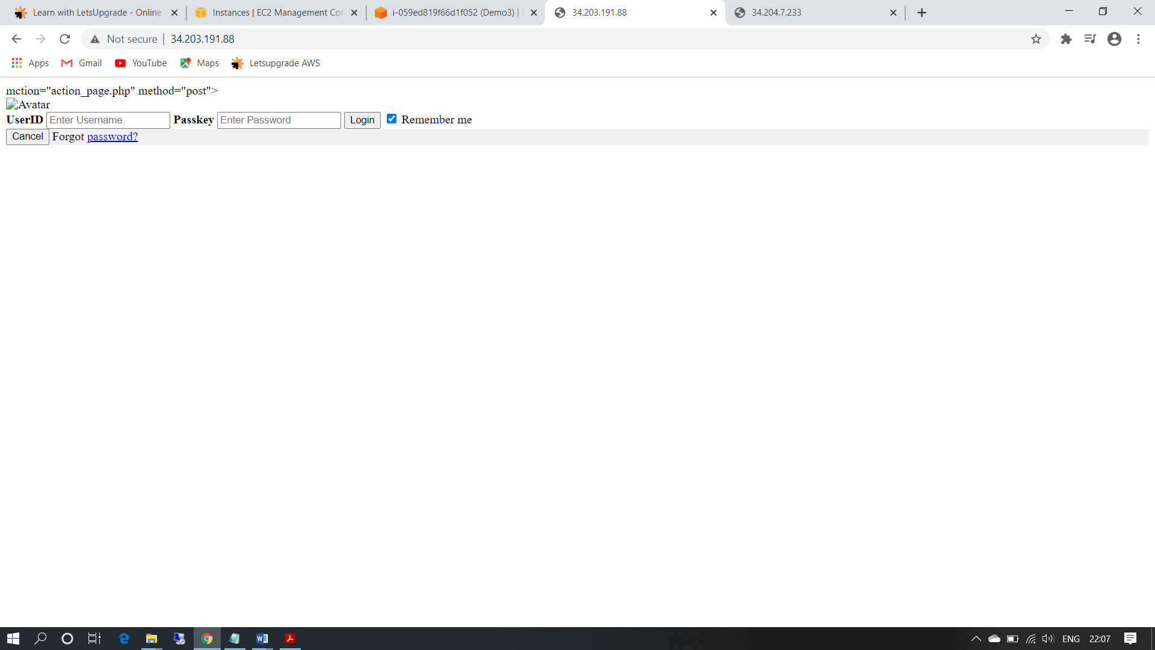

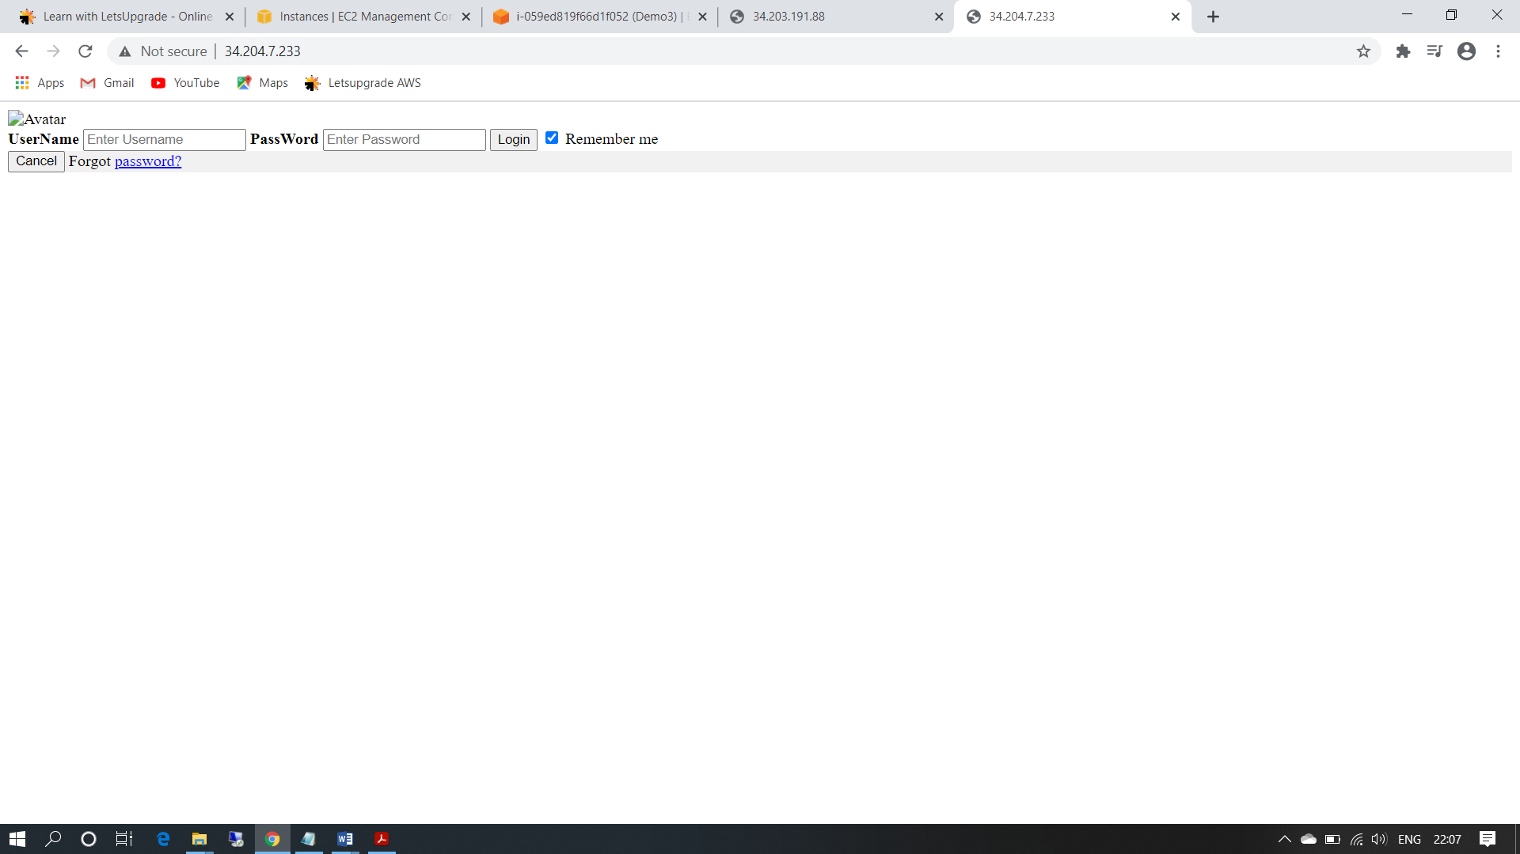

Step5:Create a application Load balancer with the above two instances as targets

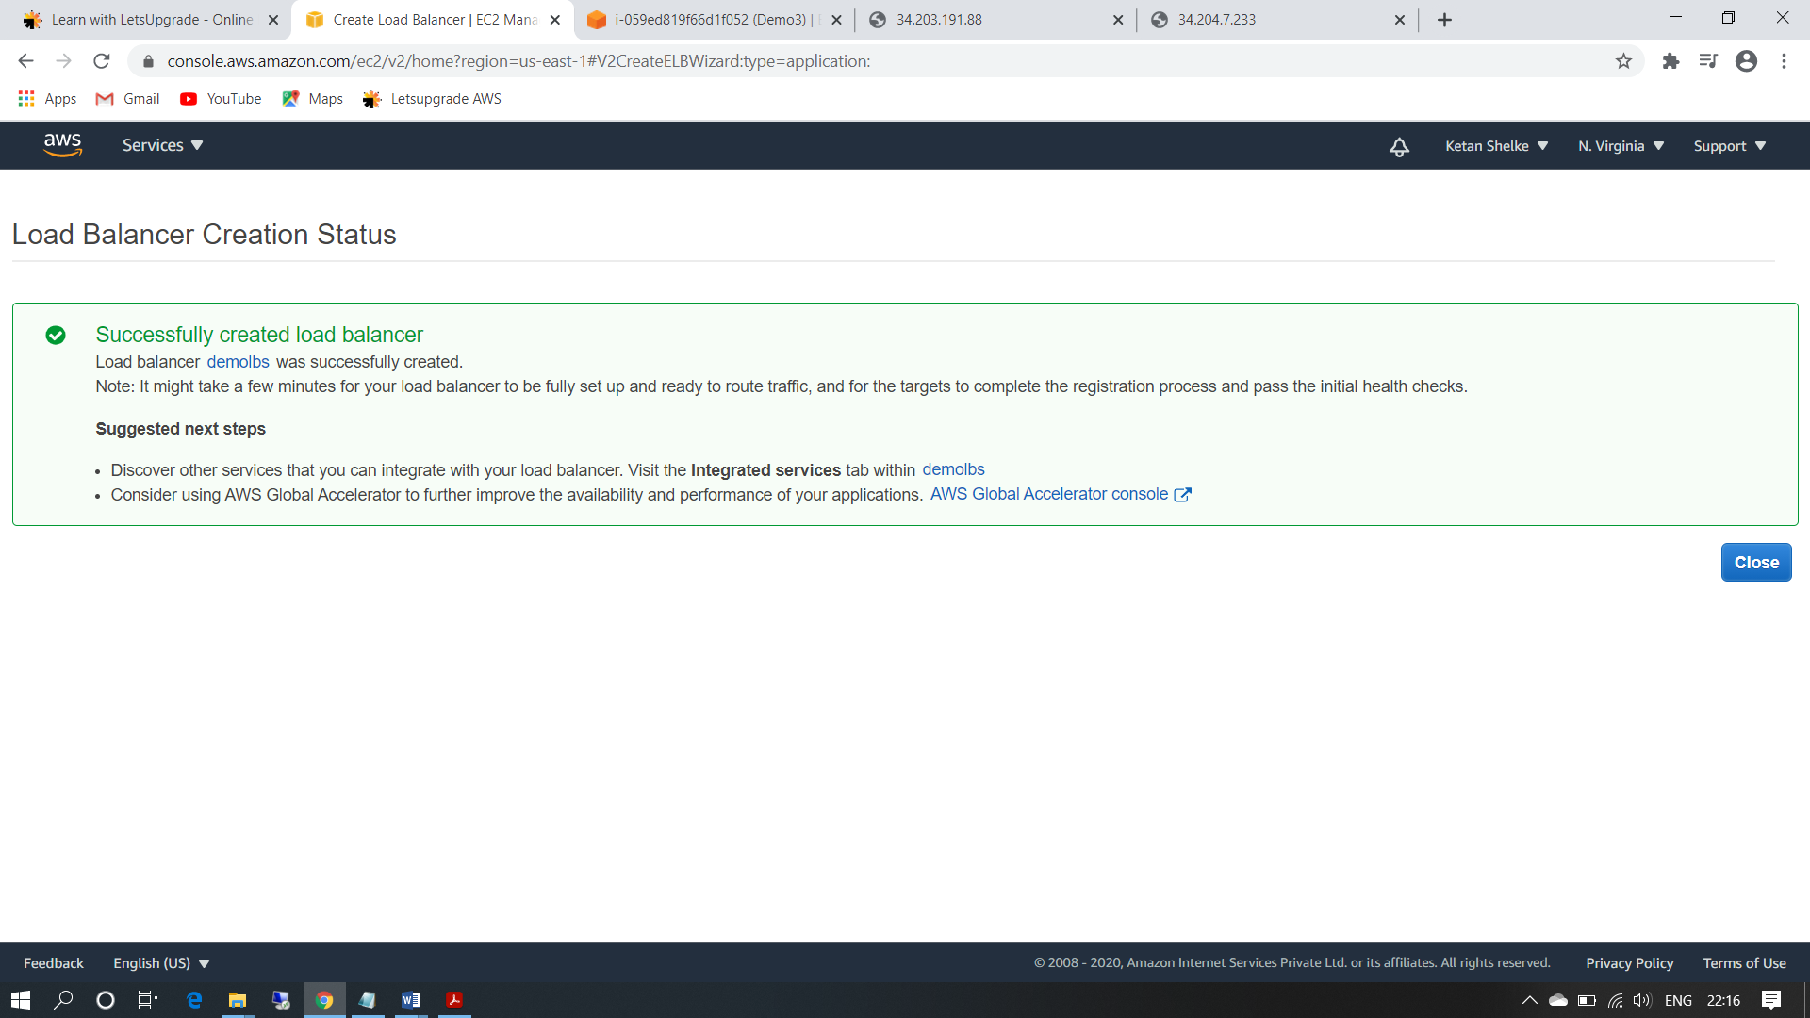

Step6:Check the functioning of ELB using the DNS of the ELB

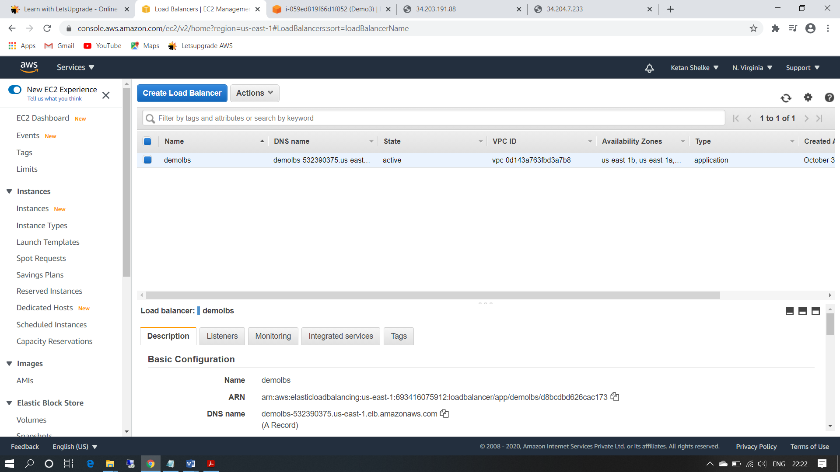

ss8: reply from server1

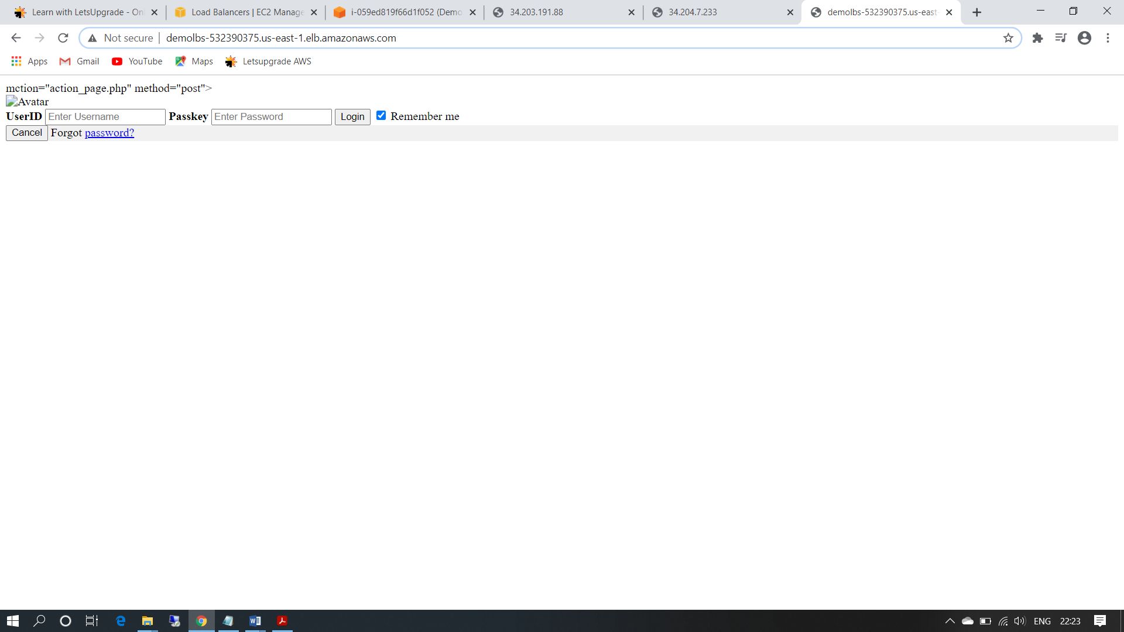

ss9:reply from server2

