Double-Delta Wing Baseline: One-Page Summary
Ketan Totlani · for Prof. Nocera · November 2026

What I ran
- Data: Shen & Alonso double-delta wings, all 272 wings x 9 angles (11–19°) = 2,448 cases. Each case has a cheap solution (VLM, seconds) and an accurate one (RANS, ~127 CPU-hours). I downloaded only the surface files (~19 GB of the 612 GB release).
- Preparation: RANS surface pressure averaged onto the same 960 panels the VLM uses, so both give lower-minus-upper pressure on each panel. Check: integrating the RANS surface reproduces the solver's own lift exactly; the 960-panel version keeps ~98% of it.
- Model: a graph neural network over the 960 panels (each linked to its 8 nearest). Input per panel: position, area, the 6 wing shape parameters, angle of attack, VLM pressure. Output: RANS pressure. Trained on 256 wings, tested on 16 wings never seen in training. Run on Google Colab (6 min per training run).

Results on the 16 unseen wings
 | Panel pressure error (RMSE) | Lift error | Moment error
VLM alone | 0.69 | 0.14 (~20% of lift) | 0.23
Network (trained on all 256 wings) | 0.075 | 0.019 (~2.7% of lift) | 0.028
Improvement | 9x | 7x | 8x

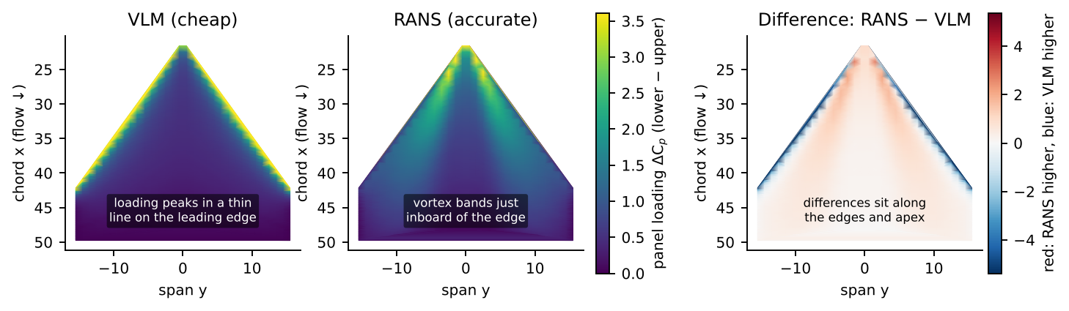  Where the solvers disagree (one test wing, 19°, from above): the VLM puts the loading in a thin line on the leading edge; RANS shows the leading-edge vortex just inboard. The difference sits along the edges. | 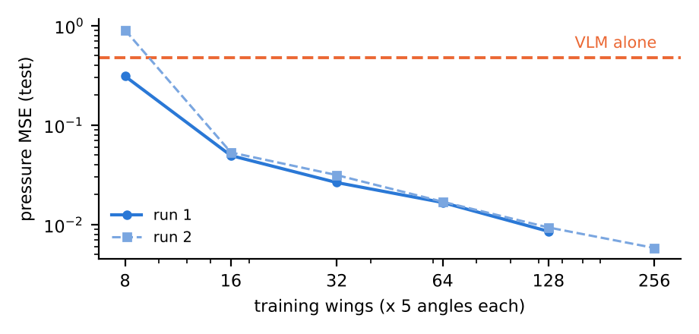  Error vs number of training wings (5 angles per wing, test = 80 cases, two runs). The network beats the VLM from about 16 wings, and error keeps falling with more data.

How it compares with the authors' published results
 | Panel pressure RMSE: VLM → network | Lift error: VLM → network
Shen & Alonso, AIAA Aviation 2025 (related wing set) | 0.96 → 0.19 (5x) | 11–18% → 4–9%
Shen & Alonso, AIAA SciTech 2025 (delta wings) | – | 29% → 7%
This work (double-delta, 16 unseen wings) | 0.69 → 0.075 (9x) | ~20% → ~2.7%
Same picture: the VLM error is of similar size, and the network removes most of it. Our network error is lower, likely because the wing sets and the way RANS is mapped onto the panels differ. Not an exact benchmark: the dataset paper's own results section (arXiv 2512.20941, Sec. 4) is not matched yet.

Issue found
One VLM input ("thickness") is stored differently in the training and test files. With it, the model failed only on the test wings (error 0.46 vs 0.04); removing it fixed this.

Next
Test whether choosing which wings get RANS (adaptive sampling, using the network's own uncertainty) reaches the same accuracy with fewer runs than the fixed Sobol order. Colab is enough for now; CARC would help for the full loop, larger models and any new CFD runs (edges/corners direction).
Full report (data, code, checks, all results) and code available on request. Parts of the code were written with AI assistance; all results come from running it and are checked against the solver outputs.

