Double-Delta Wing Baseline: Progress Summary
Ketan Totlani · for Prof. Nocera · November 2026

In short
- I downloaded the full Shen & Alonso double-delta wing dataset, prepared it, and checked it against the CFD solver's own results.
- A GNN that takes the quick, simple solver's result (VLM) as input predicts the accurate CFD result (RANS) with about 7x lower lift error than the VLM on its own, on 16 wings it never saw during training.
- This matches what the dataset's authors report in their own papers.
- I found one input in the dataset that is stored differently in the training and test files. It made the GNN fail on the test wings until I removed it.
- Next: test whether choosing which wings get an expensive CFD run (adaptive sampling) gives the same accuracy with fewer runs.

1. What I ran

Data
272 wing shapes (256 for training, 16 kept aside for testing), each at 9 angles of attack from 11° to 19°: 2,448 cases in total. Every case was solved twice:
 | Quick solver: VLM | Accurate solver: RANS CFD
Time per case | seconds | about 127 CPU-hours
What it gives | pressure on 960 flat panels covering the wing | the full flow; on the wing surface, about 56,600 points
Captures the vortex that forms at the wing's leading edge? | no | yes

The full dataset is 612 GB, mostly the 3D flow around each wing. I only needed what is on the wing surface, so I downloaded just those files (about 19 GB).

Preparing the data
- The CFD pressure on the wing surface is averaged onto the same 960 panels the VLM uses. Both solvers then give one value per panel: the pressure difference between the bottom and top of the wing, which is what creates lift.
- Lift and moment for both solvers are calculated the same way, using each wing's own reference area.
- Checked on all 2,448 cases: adding up the CFD surface pressure gives exactly the lift the CFD solver itself reports, and the 960-panel version keeps about 98% of it.

The GNN
- Each case is treated as a graph: the 960 panels are the points, and each panel is connected to its nearest neighbours.
- For each panel the GNN gets: where the panel is, its size, the wing's 6 shape settings, the angle of attack, and the VLM pressure. It predicts the CFD pressure for that panel.
- It is a smaller, simpler GNN than the one in the authors' papers.
- Trained on the 256 training wings, always tested on the 16 wings kept aside. Training runs on Google Colab (free GPU, about 6 minutes); my laptop was too slow.

2. Results

How far apart are the two solvers?
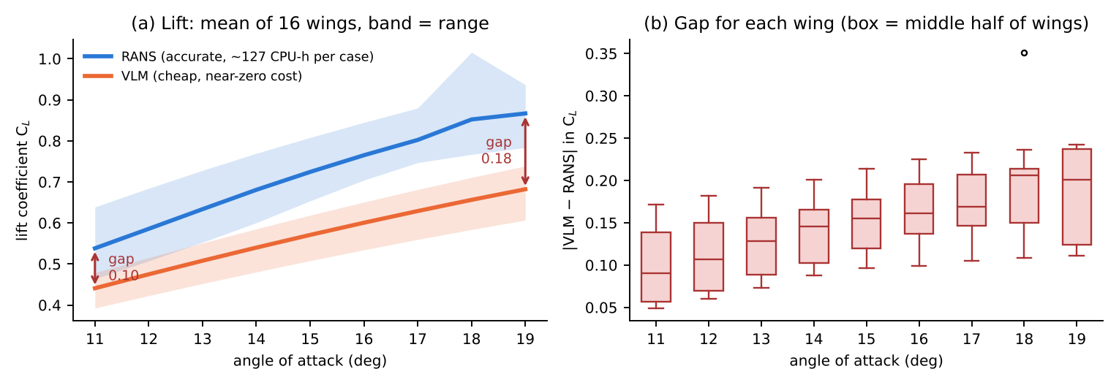
Left: average lift of the 16 test wings (shaded: lowest to highest wing). Right: how far off the VLM is for each wing at each angle. The VLM is about 20% too low on lift at every angle.
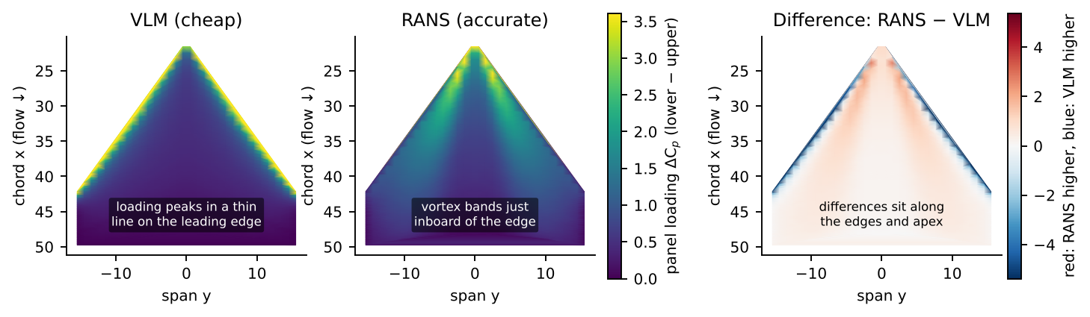
One test wing at 19°, seen from above. The VLM puts the load in a thin line along the front edge; CFD shows the vortex as bands just behind it. The two disagree mostly along the edges.

GNN vs VLM on the 16 test wings
 | Pressure error per panel | Lift error | Moment error
VLM on its own | 0.69 | 0.14 (about 20% of lift) | 0.23
GNN (trained on all 256 wings) | 0.075 | 0.019 (about 2.7% of lift) | 0.028
How much better | 9x | 7x | 8x
Pressure error = typical difference from CFD on each panel (root-mean-square). Lift and moment error = average difference from CFD.
Averaging CFD onto 960 panels already loses about 0.011 in lift, so with all the data the GNN is about as accurate as this panel setup allows. Training four times longer did not change the result.

How many training wings are needed?
Set up as in the dataset paper: 5 angles (11, 13, 15, 17, 19°), training on the first 8, 16, 32 ... 256 wings, testing on the 16 test wings (80 cases). Each was run twice.
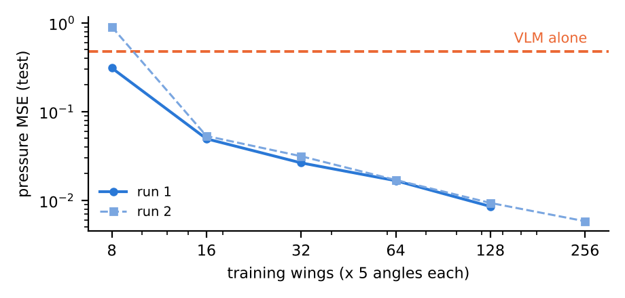
Training wings | 8 | 16 | 32 | 64 | 128 | 256
CFD cost (CPU-hours) | 5k | 10k | 20k | 41k | 81k | 163k
Pressure error, squared (run 1 / run 2) | 0.31 / 0.90 | 0.050 / 0.053 | 0.027 / 0.031 | 0.017 / 0.017 | 0.009 / 0.009 | – / 0.006
Lift error (run 1 / run 2) | 0.28 / 0.73 | 0.060 / 0.065 | 0.038 / 0.061 | 0.028 / 0.028 | 0.018 / 0.017 | – / 0.015

- With 16 or more wings the GNN is clearly better than the VLM, and it keeps improving as more wings are added.
- With only 8 wings the results jump around and can be worse than the VLM. Planned fix: have the GNN predict only the correction to the VLM, so with little data it stays close to the VLM.

3. Comparison with the authors' published results
I could not access the results section of the dataset paper (arXiv 2512.20941), so I compared with two earlier papers by the same authors. They use the same idea (VLM pressure in, CFD pressure out, GNN on the VLM panels) and report the same kind of error.
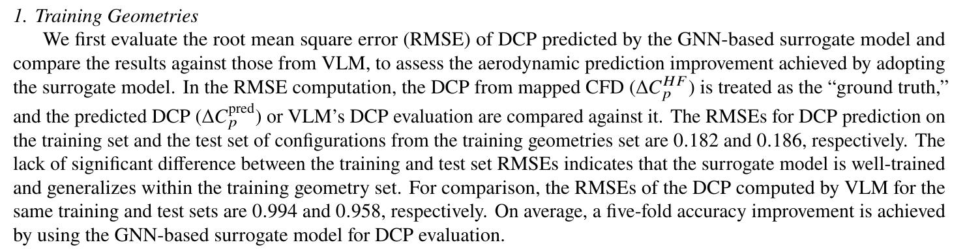
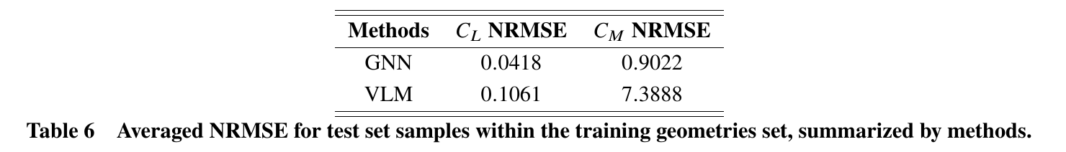
From Shen & Alonso, AIAA Aviation 2025 ("GNN-Guided Aerodynamic Shape Optimization ... Supersonic Transport Wings"), p. 11 and Table 6 (p. 15). DCP = the panel pressure difference; NRMSE = error divided by the average value.
 | Pressure error per panel: VLM → GNN | Lift error: VLM → GNN
Shen & Alonso, AIAA Aviation 2025 (similar wings) | 0.96 → 0.19 (5x) | 11–18% → 4–9%
Shen & Alonso, AIAA SciTech 2025 (delta wings) | – | 29% → 7%
This work (double-delta, 16 test wings) | 0.69 → 0.075 (9x) | about 20% → about 2.7%

- Same overall result: the VLM is off by a similar amount, and the GNN removes most of that error.
- Same kind of comparison, not 3D flow: like ours, their errors are measured on CFD surface pressure averaged onto the VLM panels. The 3D flow is only used to run the CFD, in their work and ours. Their panel grid is slightly finer (1,050 vs 960 panels).
- Our GNN error is lower (0.075 vs 0.19). Likely because the wing sets and angles differ, and averaging onto panels smooths the target. This shows our setup works as expected; it does not show our GNN is better than theirs.
- Their GNN predicts the difference between VLM and CFD; ours predicts the CFD pressure directly. Switching to the difference is my planned fix for small training sets.
- Still to do: match the dataset paper's exact setup once I can read its results.

4. Problems found in the data
Problem | What I did
One VLM input ("thickness") is stored differently in the training files (around −0.03) and the test files (around 0.5). With it, the GNN did well on new training wings but failed on the test wings (error 0.04 vs 0.46). | Removed that input; the test error went back to normal.
The lift and moment written in the VLM files do not match their own panel pressures. | Not used; both solvers' lift and moment calculated the same way.
Two wings have doubtful or duplicate CFD runs (150201-4SN at 18°, 130100-1XX at 13° and 15°). | Flagged; 3 of 2,448 cases.

5. Next steps
- Have the GNN predict the correction to the VLM, and rerun the training-size test.
- Adaptive sampling on the existing data: add the wings where the GNN is least sure, and compare with adding wings in the fixed order, at the same CFD cost.
- See where on the wing the GNN still makes errors. If it is at the edges, that supports refining only edges and corners.
- Look at the 3D flow for a few cases to see the leading-edge vortex.
- Computing: Colab is enough for now. Access to CARC would help for the full adaptive-sampling study, larger models, and any new CFD runs.

Code: private GitHub repository (link on request). Data: huggingface.co/datasets/yirens/double-delta-aero (CC-BY-2.0). Paper excerpts are included for discussion only. Parts of the code were written with AI assistance; all results come from running it and are checked against the CFD outputs.

