Double-Delta Wing Baseline: Progress Update
Ketan Totlani · for Prof. Nocera · November 2026

Summary
- Data: all 272 wings of the Shen & Alonso double-delta dataset (2,448 cases) are downloaded, prepared and checked against the CFD solver's own force outputs.
- Gap between the two solvers: the cheap solver (VLM) under-predicts lift by about 20%, and the disagreement sits mostly along the leading edges.
- Baseline works: a graph neural network that takes the VLM result as input predicts the accurate (RANS) result with about 7x lower lift error than the VLM alone, on 16 wings it never saw (0.14 to 0.019).
- Error vs amount of data: in the paper's own setting, error falls steadily as more training wings are added; about 16 wings already clearly beats the VLM.
- Compared with the authors' published results: our improvement over the VLM is in the same range as theirs (Section 5).
- Dataset issue found: one VLM input field is stored differently in the training and test files; it broke the model until removed.
- Next: test whether choosing which wings get an expensive simulation (adaptive sampling) reaches the same accuracy with fewer runs.

Term | Meaning here
VLM | Vortex-lattice method: a fast, simplified solver (seconds). Gives pressure on 960 flat panels covering the wing.
RANS | The accurate CFD solver (SU2), about 127 CPU-hours per case. Gives the full flow, including the leading-edge vortex.
Case | One wing at one angle of attack. Each wing is run at 9 angles (11 to 19 degrees).
ΔC_{p} | Pressure difference between the lower and upper surface of a panel (what creates lift).
MSE / RMSE | Mean squared error of the predicted panel pressures, and its square root (lower is better).
C_{L}, C_{M} | Lift and pitching-moment coefficients of the whole wing.

1. What data was downloaded
The full release is 612 GB, mostly the 3D flow around each wing. Our task only needs what is on the wing surface, so I extracted single files from the remote zip archives instead of downloading everything.
 | Wings | Cases | Source archives | Size kept
Training set | 256 (nested Sobol design) | 2,304 | 18 zip parts (trainingSet-part1 ... part18) | ~18 GB
Test (holdout) set | 16 (separate design, never trained on) | 144 | 1 zip part (holdoutSet-part1) | ~1.2 GB
Total | 272 | 2,448 | 19 archives | ~19 GB

File (per case) | Kept? | What it contains
<wing>.json (one per wing) | Yes | VLM result: panel geometry and pressure at all 9 angles
surface_flow.vtu (~7.5 MB) | Yes | RANS result on the wing surface: ~56,600 points with pressure, friction, etc.
forces_breakdown.dat | Yes | SU2's own lift, drag and moment (used to check our reading)
history.csv | Yes | Solver convergence history
flow.vtu (~437 MB) | Not yet | 3D flow around the wing. Has no VLM counterpart (the VLM only solves the surface), so it is not part of the cheap-vs-accurate pairing. A few cases are being downloaded to look at the vortex.
Also used: the design table (6 shape parameters per wing, and the Sobol order), each wing's reference area and moment centre, and the list of runs the authors repeated with a different numerical scheme (AUSM).

2. How the code works
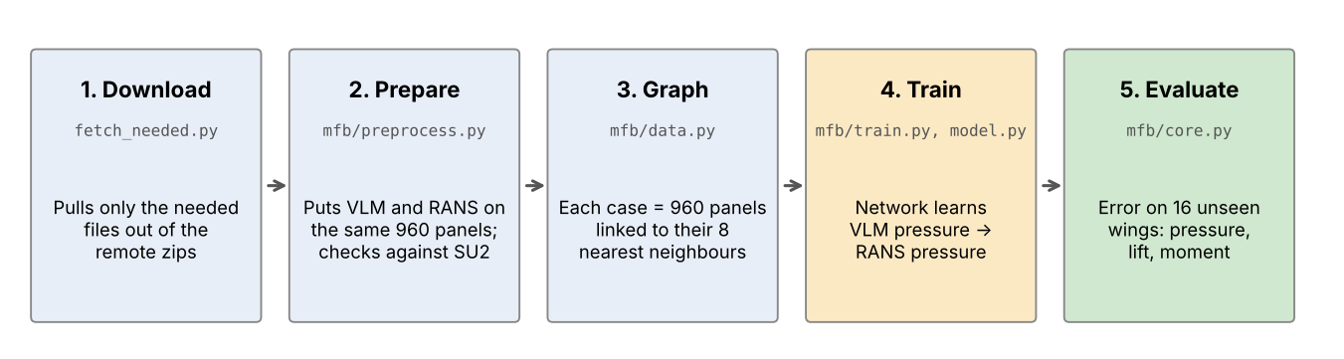
- Preparing the data: each RANS surface triangle is assigned to the VLM panel it lies in; pressures are averaged on the upper and lower side of each panel and the difference taken. This gives the RANS answer on exactly the same 960 panels as the VLM. Upper and lower values are also kept separately.
- Same yardstick for both solvers: lift and moment are always computed with the same formula and each wing's own reference area and moment centre.
- Inputs per panel: position, panel area, the 6 wing shape parameters, angle of attack, and the VLM pressure. Output: RANS pressure on that panel.
- Model: a graph neural network (graph attention, 4 layers, ~62,000 parameters). It has 5 output heads; their spread will serve as the model's uncertainty for adaptive sampling. Simpler than the authors' network (a graph U-Net).
- Testing: always on the 16 holdout wings, which are never used for training.

Checks on all 2,448 cases
Check | Result | Meaning
Our integration of the RANS surface vs SU2's reported lift / moment | max difference 0.0000005 / 0.0002 | files are read correctly
RANS mapped onto 960 panels vs SU2 lift | mean 0.011, max 0.042 | panel version keeps ~98% of the lift
Surface triangles that fall inside a VLM panel | 92% | rest are on rounded edges; given to nearest panel

3. How far apart are the two solvers?
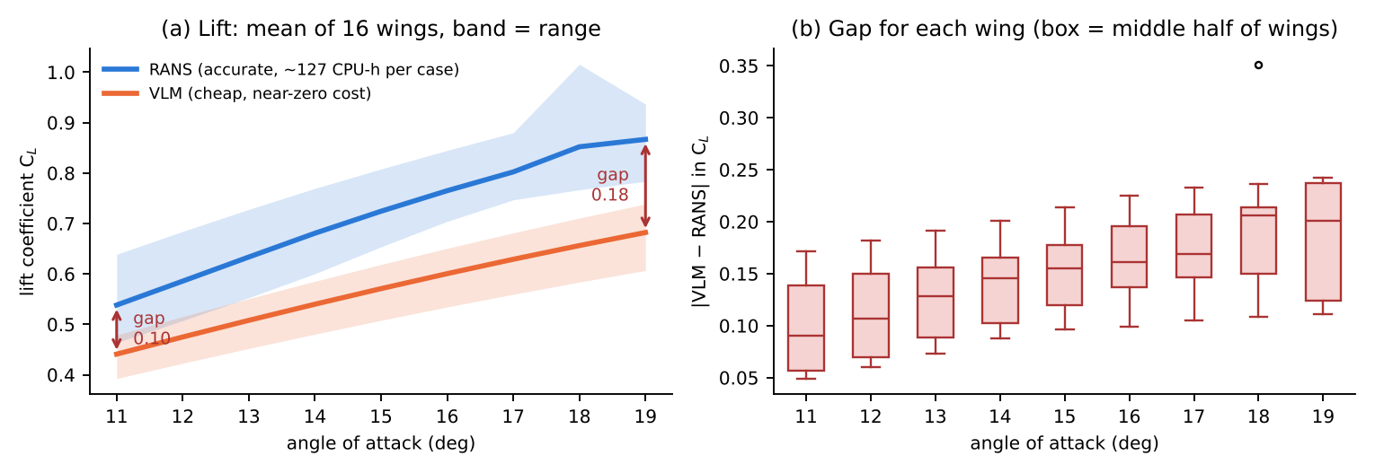
(a) Average lift over the 16 test wings; bands show the lowest and highest wing. (b) The gap for each wing at each angle.
Angle | 11° | 13° | 15° | 17° | 19°
RANS C_{L} (mean) | 0.54 | 0.63 | 0.72 | 0.80 | 0.87
VLM C_{L} (mean) | 0.44 | 0.51 | 0.57 | 0.63 | 0.68
Lift gap | 0.10 (18%) | 0.13 (20%) | 0.15 (21%) | 0.17 (22%) | 0.18 (21%)

- The VLM is about 20% low on lift at every angle; in absolute terms the gap nearly doubles from 11° to 19°.
- Across all 2,304 training cases, the worst 20% hold 44% of the total gap: uneven, but not concentrated in a few wings.
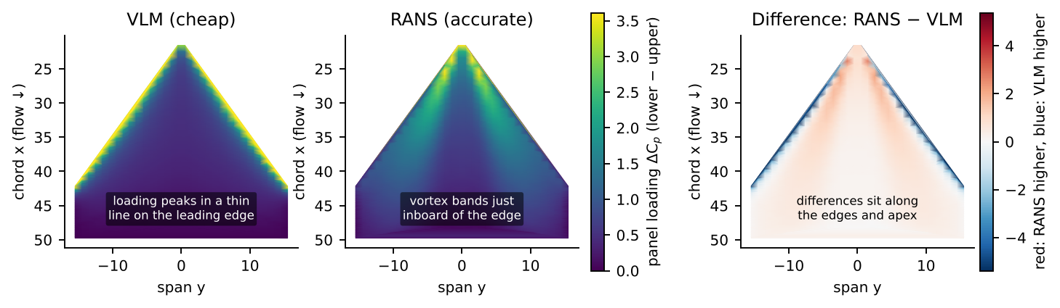
Wing with the largest gap (09190107DL) at 19°, seen from above. The VLM puts the loading in a thin line on the leading edge; RANS shows the leading-edge vortex as bands just inboard. The difference sits along the edges and the apex.

4. Baseline results
Method (tested on 16 unseen wings, 9 angles) | Pressure MSE (RMSE) | Lift error | Moment error
B0: VLM alone (no learning) | 0.47 (0.69) | 0.14 | 0.23
B1: network trained on all 256 wings (50 epochs) | 0.006 (0.075) | 0.019 | 0.028
B1, repeated with 200 epochs | 0.006 (0.079) | 0.019 | 0.030

For reference: mapping RANS onto the 960 panels itself loses about 0.011 in lift, so at full data the model is close to the accuracy the panel representation allows. Training 200 instead of 50 epochs did not help.

Error vs number of training wings (paper's setting)
Same as the dataset paper: 5 angles (11, 13, 15, 17, 19°), training sizes 40 to 1,280 cases (8 to 256 wings added in the dataset's Sobol order), test set 80 cases (16 wings x 5 angles). Run twice.
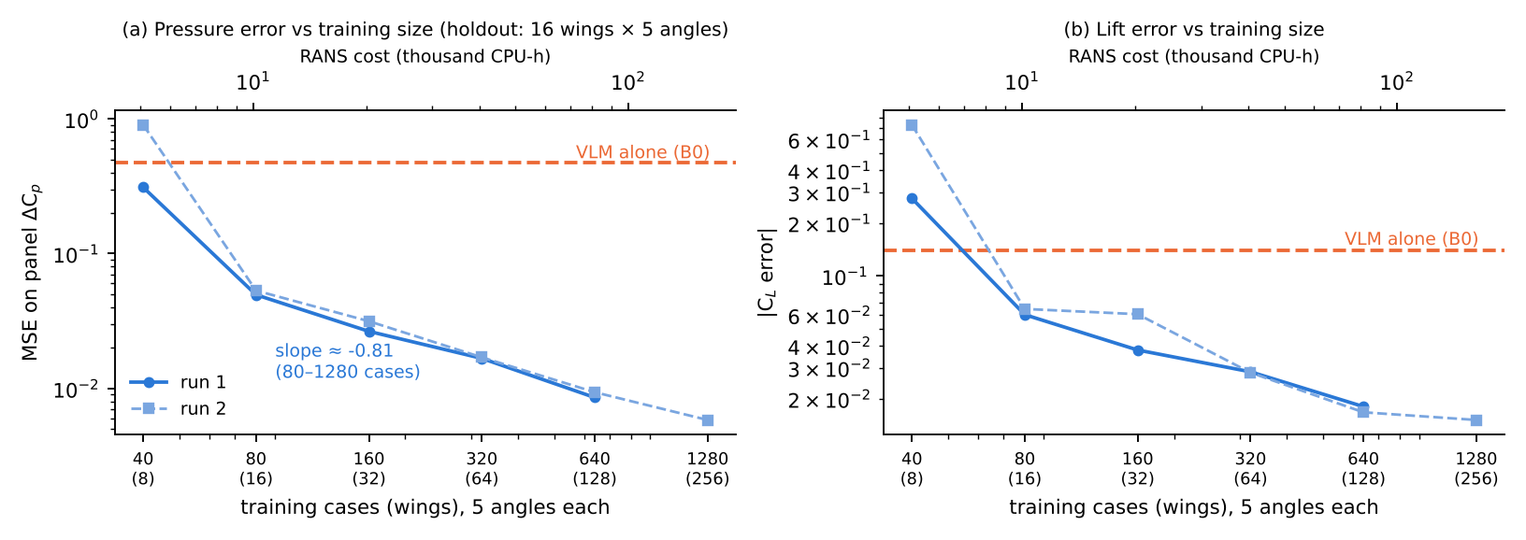
Training wings (cases) | 8 (40) | 16 (80) | 32 (160) | 64 (320) | 128 (640) | 256 (1,280)
RANS cost (CPU-hours) | 5k | 10k | 20k | 41k | 81k | 163k
Pressure MSE (run 1 / run 2) | 0.31 / 0.90 | 0.050 / 0.053 | 0.027 / 0.031 | 0.017 / 0.017 | 0.009 / 0.009 | – / 0.006
Lift error (run 1 / run 2) | 0.28 / 0.73 | 0.060 / 0.065 | 0.038 / 0.061 | 0.028 / 0.028 | 0.018 / 0.017 | – / 0.015

- From about 16 wings the network is clearly better than the VLM; after that, error keeps falling steadily (slope about −0.8 on the log-log plot, no plateau up to 1,280 cases).
- With 8 wings training is unstable and can be worse than the VLM itself. Fix planned: let the network learn the correction to the VLM, so with little data it falls back to the VLM.

5. Comparison with the authors' published results
The dataset paper's results section (arXiv 2512.20941, Sec. 4) was not accessible, so I compared against the same authors' two earlier papers that use the same approach (VLM pressure in, RANS pressure out, graph network on the VLM panels) and report directly comparable error measures.
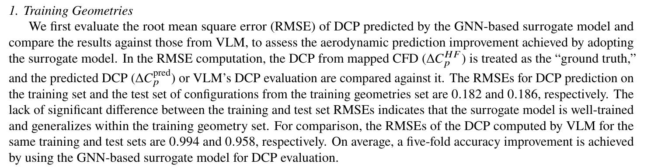
Shen & Alonso, "Graph Neural Network-Guided Aerodynamic Shape Optimization for Conceptual Design of Supersonic Transport Wings", AIAA Aviation 2025, p. 11.
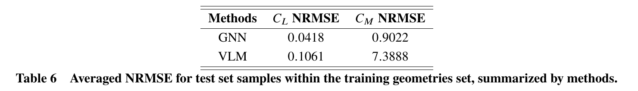
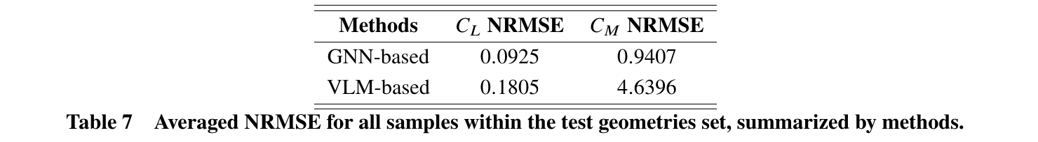
Same paper, Tables 6 and 7 (p. 15 and 17): Table 6 = new angles on wings seen in training; Table 7 = wings never seen in training. NRMSE = RMSE / mean value.
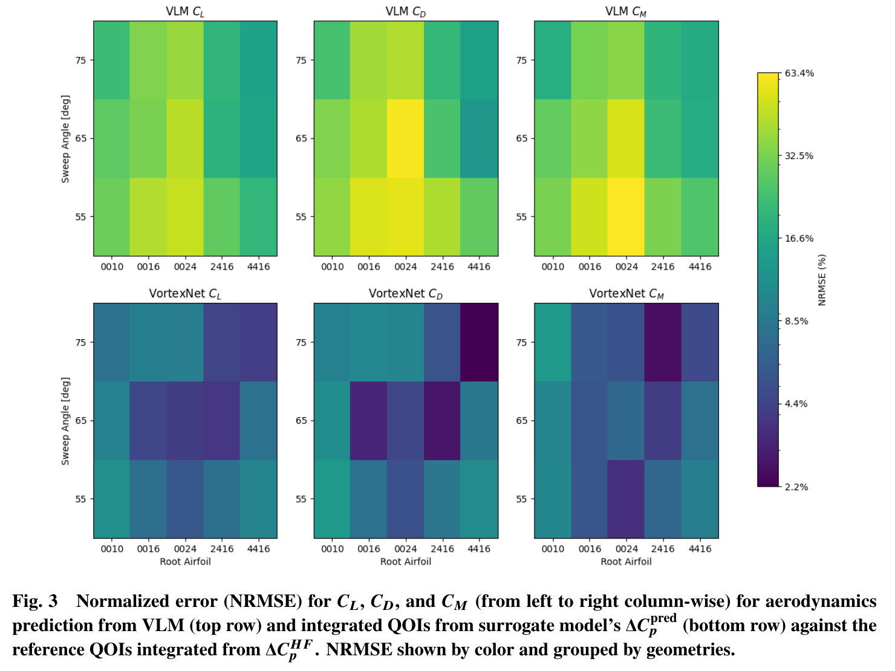
Shen & Alonso, "Performance Evaluation of a Graph Neural Network-Augmented Multi-Fidelity Workflow for Predicting Aerodynamic Coefficients on Delta Wings at Low Speed", AIAA SciTech 2025, Fig. 3 (p. 11). Average lift error: VLM 29.1%, network 7.2%.

Side by side
 | Panel pressure ΔC_{p} RMSE: VLM → network | Improvement | Lift error (% of mean lift): VLM → network
Aviation 2025, seen wings (Table 6) | 0.958 → 0.186 | 5x | 10.6% → 4.2%
Aviation 2025, unseen wings (Table 7) | – | – | 18.1% → 9.3%
SciTech 2025 (Fig. 3, average) | – | – | 29.1% → 7.2%
This work, 16 unseen wings, all data | 0.69 → 0.075 | 9x | ~20% → ~2.7%*

- Same picture: the VLM is off by roughly 10–30% in lift, and the network removes most of that error. Our improvement is in the same range or somewhat larger.
- Same kind of target, not 3D flow: like ours, their errors are measured on RANS surface pressure projected onto the VLM panels (Aviation 2025: "projected onto the same 35 x 30 lattice used in VLM"; their lattice has 1,050 panels vs our 960). The 3D volume flow is only used to run the CFD. Their network also learns the difference between VLM and RANS loading (SciTech 2025), which is my planned fix for small training sets.
- Not an exact benchmark: those papers use different wing sets (and different angle ranges), and their networks were trained on their own data. So this shows our pipeline behaves as expected, not that it is better.
- *Our lift number is mean absolute error divided by mean lift; their NRMSE uses root-mean-square error, which is slightly larger. I will add the exact same NRMSE to the code. Moment NRMSE is not compared: dividing by a mean moment close to zero makes it hard to interpret (their values reach 7.4).

6. Issues found and how they were handled
Issue | What I did
VLM "thickness" field stored differently in training (about −0.03) and test files (about 0.5). The model failed only on test wings (MSE 0.46 on test vs 0.04 on unseen training wings). | Removed that input; test error dropped to 0.047 in a quick check. Noted in the code README.
Lift/moment written in the VLM files do not match an integration of their own panel pressures (they likely include a vortex-lift correction). | Not used; both solvers' coefficients computed with the same formula.
Wing 150201-4SN jumps at 18° (lift 1.02 between 0.79 and 0.80); one of 28 wings with AUSM reruns. | Flagged (an "ausm" column in the data index); to check before final results.
Wing 130100-1XX has two versions of the 13° and 15° runs (lift 0.65 vs 0.81 at 13°). | Originals used; 2 of 2,304 cases, noted.
Dataset paper experiments use 5 of the 9 angles. | Added an option to train/test on those 5 angles only.

7. Compute
 | Laptop (Apple M2, 8 GB) | Google Colab (free, T4 GPU)
B1, all wings, 50 epochs | ~3 h (estimated); could not complete | 6 min
Size sweep (6 sizes, 200 epochs) | ~1–2 days (estimated) | ~30 min
Adaptive loop (several strategies x 3 seeds) | several days | hours; sessions disconnect

Colab works for the current experiments. CARC access would help for the adaptive loop at full scale, larger models on the full ~56,600-point surface, and any new CFD runs (for the edges/corners direction).

8. Datasets considered (short)
Dataset | Fidelities | Fields | Use
Shen & Alonso double-delta (272 wings x 9 angles) | 2: VLM + RANS | Surface + 3D flow | Main dataset (in use)
Transonic wing aerostructural (2,471 cases) | 1 (flow + structure) | Surface Cp, Cf, structure | Later: multiphysics
BSCW wing loads (Zenodo) | 3: panel / coarse / fine RANS | Loads only | Quick check of a 3-level choice
Setinek et al. 2025 airfoils (611 pairs) | 2: two RANS mesh levels | Full fields | Good second test; not released
AirfRANS (1,000 airfoils) | 1 | Full fields | Pipeline check only

9. Next steps
- Let the network learn the correction to the VLM (stable with little data); rerun the size sweep.
- Adaptive loop on the existing data: choose wings by model uncertainty and compare with Sobol order at equal RANS cost.
- Map where the trained model still makes errors; if they sit at the edges, that supports edge/corner refinement (region-level multi-fidelity).
- Look at the 3D flow for a few cases to see the leading-edge vortex.
- Report the authors' exact NRMSE measure, and match the dataset paper's Sec. 4 setup once accessible.

Code: GitHub (private; link to be shared). Data: huggingface.co/datasets/yirens/double-delta-aero (CC-BY-2.0). Dataset paper: Shen & Alonso, arXiv 2512.20941. Comparison papers: Shen & Alonso, AIAA SciTech 2025 (doi 10.2514/6.2025-2360) and AIAA Aviation 2025. Paper excerpts reproduced for discussion only. Parts of the code were written with AI assistance; all results come from running it and are checked against the solver outputs.

