Lab3: Op-Amp Performance and Limitations
Linus Pauly, Faiz Shaikh

Introduction
The operational amplifiers are extremely efficient and versatile devices. Their applications span the broad electronic industry filling requirements for signal conditioning, special transfer functions, analog instrumentation, analog computation, and special system design (Carter and Brown, 2001, p.7). Sometimes, they are used for simple uses, such as a simple comparator, even if this might not always be advisable. In this exercise we study the amplifier behavior by examining the performance limitations of a basic operational amplifier, the LM358 (specifically its KA358 variant). Throughout this report we will be comparing measured and simulated performance to each other when both were done; if a performance measure was done only in simulation or only in measurement, then we note this accordingly. We analyze bandwidth, slew rate, output voltage limits, bias current and amplifier input impedance, offset voltage, and crossover distortion. We also attempted to measure the op-amp’s noise.

Measurements and tests must be documented. A study without documentation is as good as no study at all. However, for all measurements it is not reasonable to write a report as thorough as a thesis or a scientific article. Usually it is enough to simply present the measurement or test and its results with suitable thoroughness. For example, a test institution may hand out a quite short report to a customer, where they compactly present whether a product fills the requirements set to it. On the other hand, the results of a research project are most likely to be documented with a bit longer report, which presents the research from a larger point of view. In practice, the assignment mandates on which form and how widely the study is documented. In scientific writing, there are however certain practices, which all reports follow to some extent.
This document works as a template and a quick guide for writing reports during laboratory courses in electrical engineering. Using common sense and own thinking is recommended: apply this document meaningfully, however, do not leave out any of the major sections of the report. Keep in mind what you are documenting and remember to answer all questions that are expected to be answered to in the report.
The introduction section is for presenting what measurement, test or other study is performed. It is especially important to describe, to which devices or what kind of a system the measure is for, and what properties of the subject are measured. In case of a test study, the devices should be specified (e.g. 3 pieces of ACME 442 chargers).
For short, customer report style reports it is typical that the reader is assumed to know especially well what the testing is about and what is the meaning of the test. That is why they often do not contain a complex or thorough review of the theoretical background of the test with references to scientific sources. Crucial references in this kind of reports may include, for example, the standards regarding the test or other relevant documents.
In case of a longer study report paper, the background review is more thorough. The reader is in this case assumed to know nothing about to what the report is made for, what is the study a part of, or why it has been performed in the first place. The background review should include suitable references. It is common that using references the reader is introduced to the field of the study from a little wider perspective than the study in the report is about, however by supporting the study of the report. This way the reader is introduced to the subject of the report smoothly. The background review can introduce, for example, research made elsewhere and the results others have received, or other sources, which will highlight the meaning of the report study.
The language of a scientific report is clear, precise, and compact. It must provide the message to the reader unambiguously and comprehensibly, and the text must consistently and solidly present the study. Say only what is necessary and avoid unprecise expressions and too long sentences.

Methods
In the SPICE simulation environment (LTSpice), the operational amplifier was simulated using the manufacturer-verified LM358 macromodel (https://github.com/rene-dev/stmbl/blob/master/hw/spice/LM358.lib), which incorporates internal transistor transconductances, internal dominant-pole Miller compensation, output impedance, and supply rail saturation boundaries. The frequency responses and output voltage swings were simulated, the input impedance and the slew rate determined and a 1kHz low-pass filter for noise measurements was designed. We then measure these circuits in the laboratory and compare the results.

Frequency response

The precision and flexibility of operational amplifiers are a direct result of the use of negative feedback, although this benefit comes at the cost of reduced gain (Carter and Brown, 2001, p.7). The different feedback configurations used to measure the frequency response of the amplifiers are shown in Figures 1 and 2.

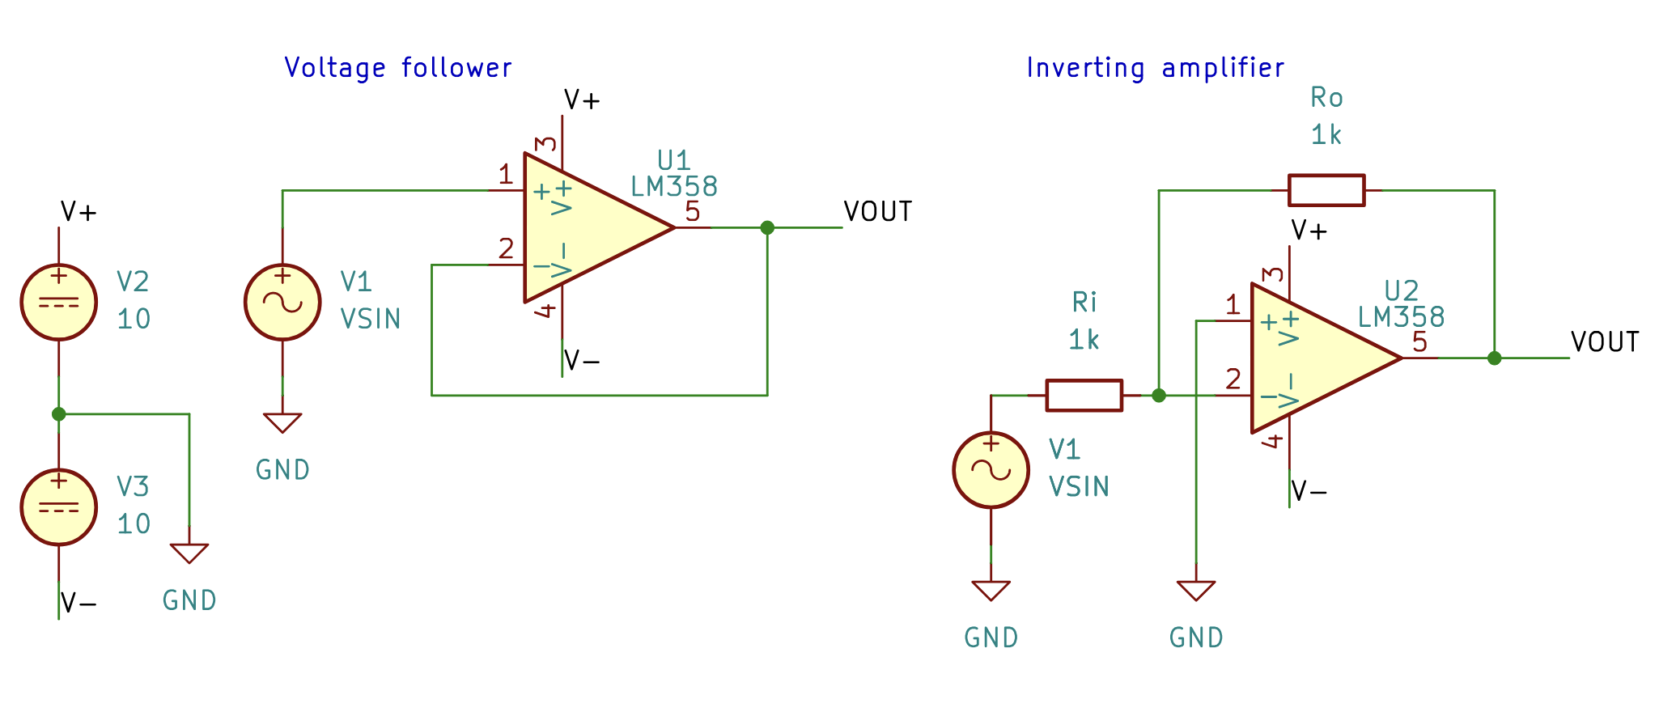
Figure 1. Detailed circuit schematics for the unity-gain amplifier configurations implemented for comparative simulation and laboratory characterization. Left: Non-inverting voltage follower (Av = 1, 0 dB), where the output terminal (pin 5) is connected directly in full negative feedback to the inverting input terminal (pin 2). Right: Inverting operational amplifier with unity gain (Av = -1, 0 dB), utilizing matched 1 kΩ precision resistors for input coupling (Ri) and negative feedback (Ro), with the non-inverting input tied directly to ground. Both circuits are energized by symmetric dual DC power rails of V+ = +10 V and V- = -10 V.

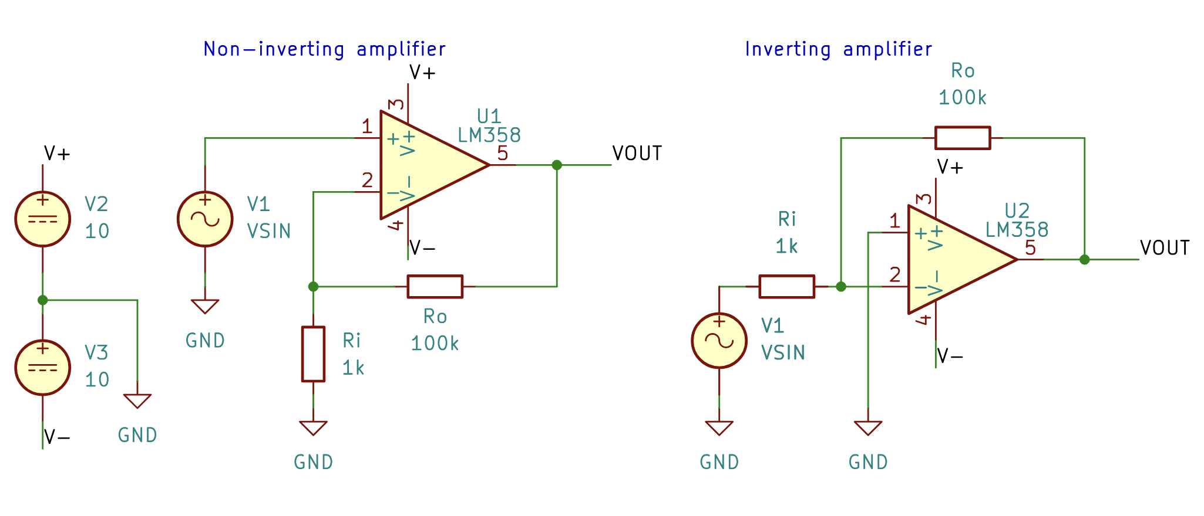
Figure 2. Detailed circuit schematics for the high closed-loop gain (+40 dB) configurations investigated in both LTSpice simulation and laboratory characterization. Left: Non-inverting amplifier employing a 1 kΩ precision resistors (Ri) coupled to ground and 100 kΩ precision resistors (Ro) for feedback. Right: Inverting amplifier with nominal closed-loop voltage employing a 1 kΩ precision resistor for input coupling (Ri) and 100 kΩ for negative feedback (Ro). Both circuits are energized by symmetric dual DC power rails of V+ = +10 V and V- = -10 V.

Input Impedance

The input impedance of the amplifier configurations was measured using a voltage divider formed by connecting a known series resistance, Rs, between the AC source and the amplifier input. A high input impedance is desirable so that the amplifier does not excessively load the signal source, since a low input impedance would draw current from the source and reduce the voltage that reaches the amplifier. The simulated setup is shown in Figure 3, together with its equivalent circuit as seen by the source.

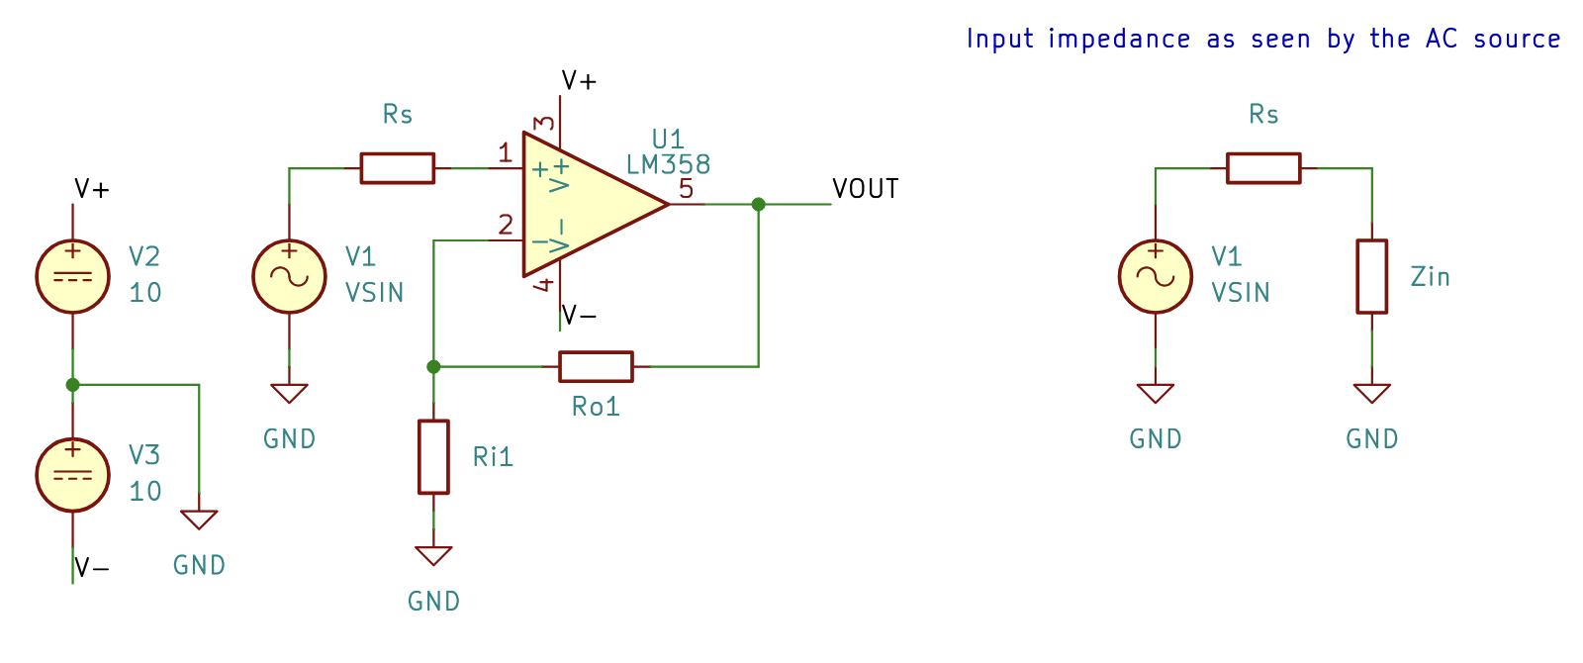
Figure 3. Circuit used to measure the input impedance of the amplifier configurations. Left: an example amplifier stage powered from ±10 V supplies, with the AC source V1 connected to the input through a known series resistor, Rs. A non-inverting configuration is shown here for illustration. Right: equivalent circuit as seen by the AC source, in which the amplifier is represented by its input impedance Z_{in}, forming a voltage divider with Rs.
Because Rs and Z_{in} form a voltage divider, the source voltage V_{in} divides between them in proportion to their values. Measuring V_{in} and V_{R} (the voltage across the series resistor) gives the input impedance as:
$$Z_{in}=R_{s}\left(\frac{V_{in}}{V_{R}}-1\right)$$

Step response
The slew rate of an op-amp is the maximum rate at which its output voltage can change in response to a step input voltage. It depends on the high-frequency response of the amplifier stages inside the op-amp. The high-frequency components of a voltage step are contained in its rising edge, and the upper critical frequency of an amplifier limits how well it can respond to a step input (Floyd, 2005, p.609). The slew rate was measured with the op-amp connected as a unity-gain voltage follower, as shown in Figure 4.
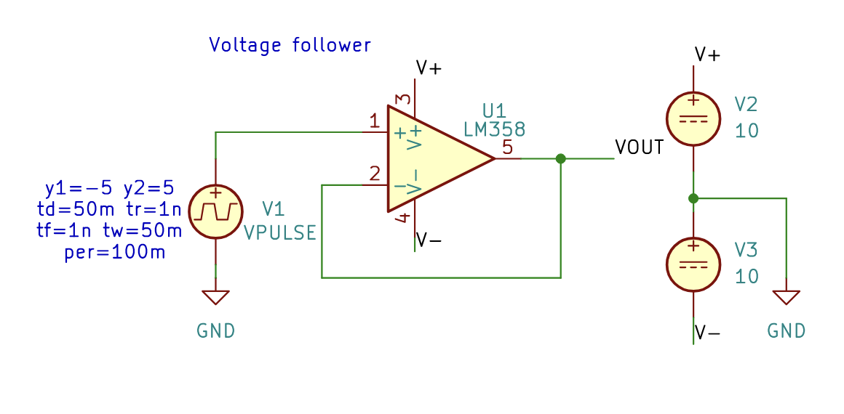
Figure 4. Circuit used to measure the slew rate and step response of the op-amp. An LM358 is connected as a unity-gain voltage follower, with the output connected directly to the inverting input, and is powered from ±10 V supplies. The pulse source V1 drives the non-inverting input with a step input, and the output voltage VOUT is observed to determine how quickly it can follow the rising edge.

The slew rate was determined from the output waveform by measuring the change in output voltage over the time taken for that change during the rising edge, as given by:

$$SR=\frac{ΔV}{Δt}$$

Output voltage swing

When no input signal is applied, the output of an op-amp is ideally 0 V, which is known as the quiescent output voltage. When an input signal is applied, the output could ideally swing as far as ±V_{CC}, the supply rail voltages. In practice, the output can come close to these limits but never quite reaches them. The peak-to-peak output swing depends on the load connected to the op-amp, and it increases as the load resistance increases (Floyd, 2005, p.607).

The LM358 is a so-called single-supply op amp. It has a C-M (Common mode) range that extends to, and often slightly below, the negative rail. That range allows its use in a wider range of circuits that operate close to ground. A “rail-to-rail” op-amp goes further, since it can operate with input voltages equal to, or even slightly beyond, both supply rails (Trump, 2017, p.4).

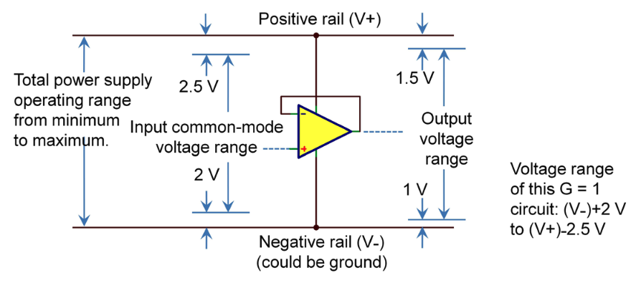
Figure 5. Input and output voltage ranges of a typical op amp used on dual supplies. The output capability of the example is limited to 2 V from the negative rail and 2.5 V from the positive rail, which is due to the limited-input C-M range. One would need to configure this op amp in a higher gain to deliver its full output-voltage range. (Trump, 2017, p.4).

The simulated output swing limits, V_{OH} and V_{OL}, were estimated using the circuit shown in Figure 6.

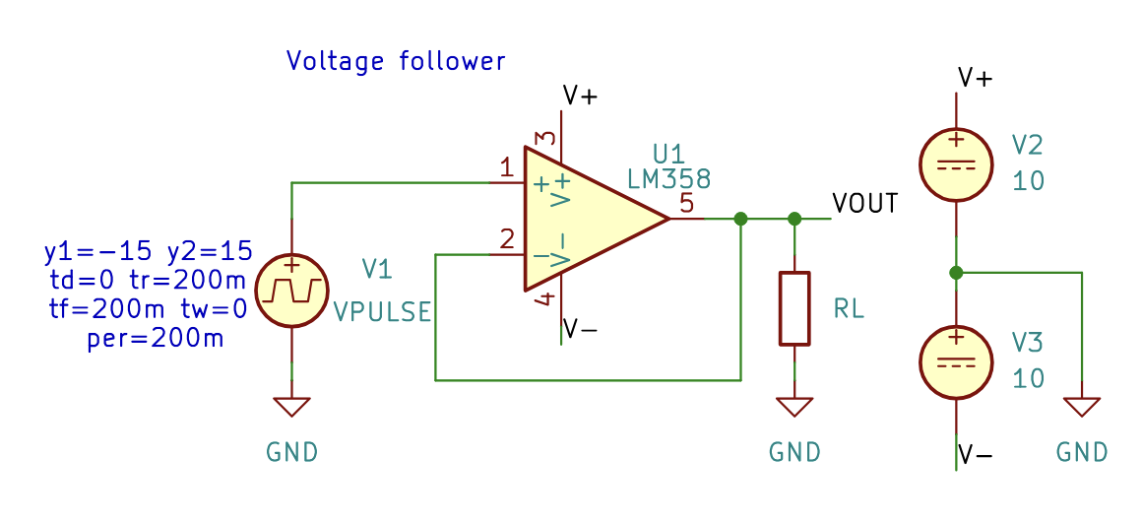
Figure 6. Circuit used to estimate V_{OH} and V_{OL}. A pulse source V1, configured to produce a triangular wave, drives an LM358 voltage follower powered from ±10 V supplies, with a load resistor R_{L} is swept through a set of values.

The circuit used for the laboratory measurements was a non-inverting amplifier with a gain of 100 (40 dB), as shown in Figure 7. The measurements were first carried out without any load connected to the output and then repeated with a 100 Ω load resistor.

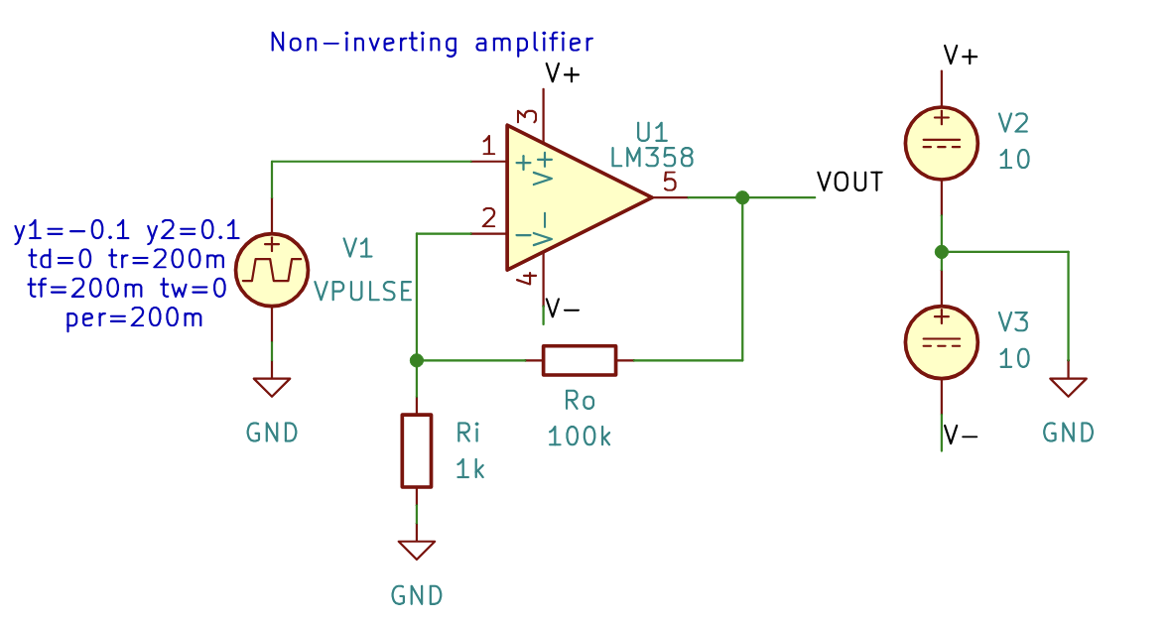
Figure 7. Circuit used for the laboratory output swing measurements. An LM358 non-inverting amplifier with a gain of about 100 (40 dB), powered from ±10 V supplies, and driven by the source V1.

The input was then switched to a sinusoidal signal. Its amplitude was increased until the output was just clipped, and the highest undistorted output and the just-clipped output were measured.

Filter design

To measure the noise of an amplifier it was followed by a first-order RC low-pass filter with a cutoff frequency of 1 kHz, as shown in Figure 7. The high gain raises the small noise voltage to a level that is easy to measure, and the filter limits the measurement bandwidth so that the noise is integrated over a well-defined frequency range.

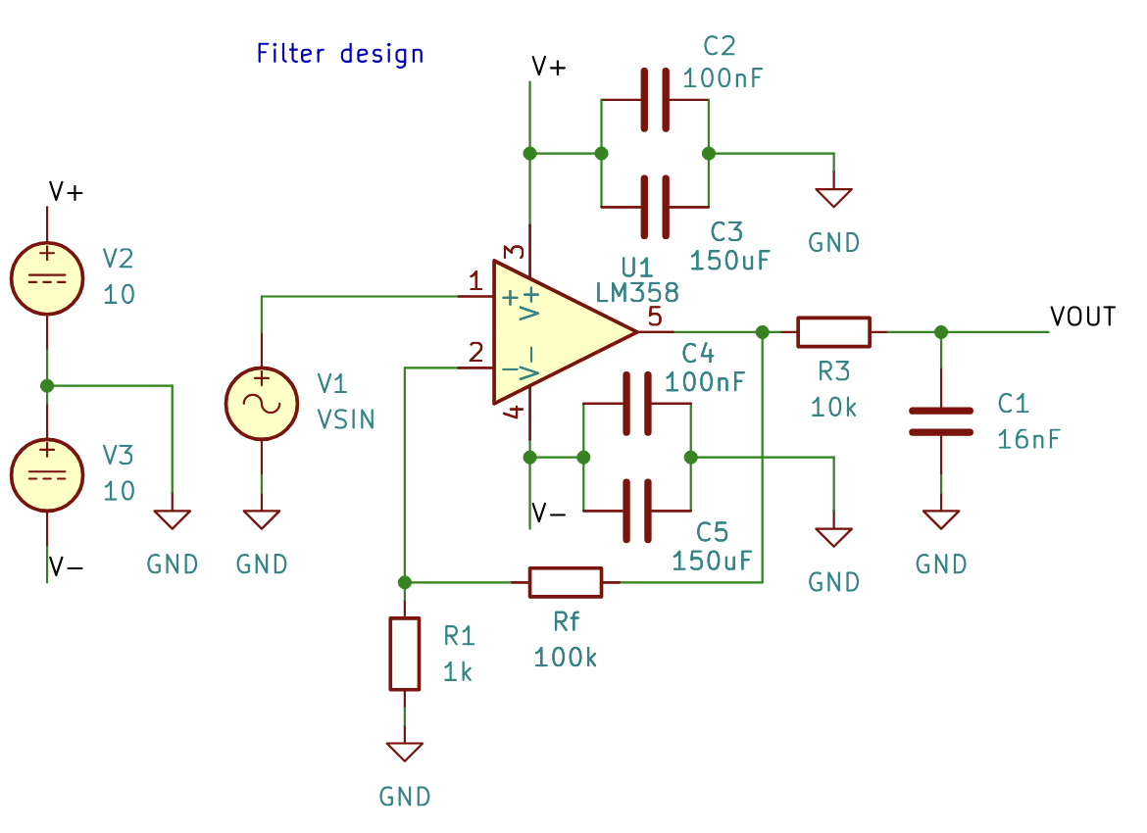

Figure 8. Circuit designed for the noise measurements. An LM358 non-inverting amplifier provides a gain of about 100 (40 dB), and a first-order RC low-pass filter at the output limits the measurement bandwidth to a cutoff frequency of 1 kHz.

The gain and cut-off frequency of the dimensioned filter:

$$Gain=1+\frac{R_{f}}{R_{1}}=101$$

$$f_{c}=\frac{1}{2πR_{3}C_{1}}=994.7$$

The positive and negative supply rails of the amplifier are decoupled to ground using a 150 µF electrolytic capacitor in parallel with a 100 nF ceramic capacitor on each rail as shown in Figure 7. These are values commonly used for power supply filtering. The large electrolytic capacitor supplies the low-frequency current demand and filters out slow variations on the supply. At higher frequencies, however, its equivalent series inductance make it a poor filter. The smaller 100 nF bypass capacitor is therefore added in parallel to keep the supply impedance low at these frequencies, so that the circuit can operate properly across the whole frequency range.

Input offset voltage

The input offset voltage is modeled as a small DC voltage source in series with one of the op-amp’s input terminals, as shown in Figure 9. In the unity-gain case (Figure 9a), the output offset is roughly equal to V_{OS}, so the output stays very close to midsupply. In the high-gain case (Figure 9b), the offset is multiplied by the closed-loop gain, so a few millivolts of V_{OS} can produce an output error of several volts. To move the output by this amount, a small extra differential voltage is needed at the input, determined by the open-loop gain. Treating the finite open-loop gain as an offset voltage that changes with the output voltage gives an intuitive way to estimate this error (Trump, 2017, p. 8).

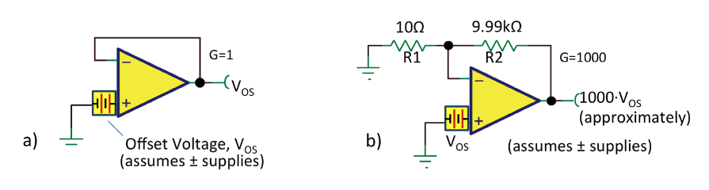
Figure 9. Output offset voltage where G = 1 V/V (a) and G = 1,000 V/V (b) (Trump, 2017, p.8).

The offset voltage can then be said to be:

$$ΔV_{\text{OS}}=\frac{ΔV_{\text{OUT}}}{A_{\text{OL}}}$$

To estimate the input offset voltage of the LM358, a non-inverting amplifier with a gain of 100 (40dB) was used, as shown in Figure 10. The input was grounded, so that any DC voltage at the output is due to the offset voltage of the op-amp, multiplied by the closed-loop gain of the circuit.

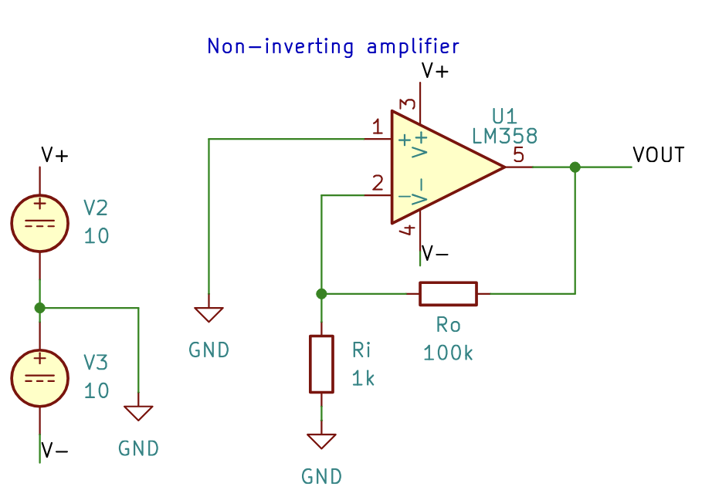
Figure 10. Circuit used to determine the input offset voltage. An LM358 non-inverting amplifier with a gain of about 100 (40 dB), powered from ±10 V supplies, with the non-inverting input grounded.

The offset voltage can now be calculated as:

$$V_{\text{OS}}=\frac{V_{\text{OUT}}}{A_{\text{v}}}$$

Input bias current

The input bias current was determined using the same circuit as for the input impedance measurement in Figure 3, but with the signal source removed and the input shorted to ground through the series resistor R_{s}, as shown in Figure 11. The bias current of the op-amp flows through R_{s}, so the DC voltage across it, measured with the bench multimeter, can only be caused by the input bias current.

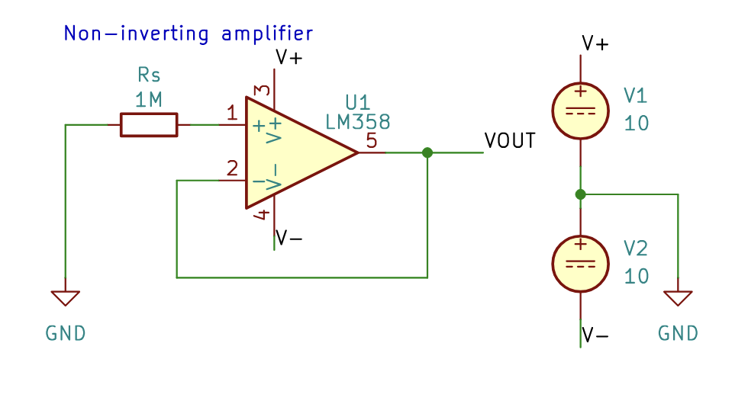
Figure 11. Circuit used to measure the input bias current. An LM358 voltage follower with the non-inverting input connected to ground through a 10 MΩ series resistor R_{s}, powered from ±10 V supplies.

The input bias current can then be calculated as:
$$I_{b}=\frac{V_{R}}{R_{s}}$$

where V_{R} is the DC voltage measured across R_{s}.

The methods section of a short report is compact, but comprehensive. It presents the measurement setup or any other experimentation setups for example with circuit diagrams or other demonstrative figures and dimensioning calculations, if necessary. It is especially important that after reading the section the reader understands what is measured using which instruments. If the result is calculated based on multiple measurements, the equations must be presented and justified shortly. In a longer research report paper the methods description is longer if needed. Typically, some justifications are presented for the selected methods or the instruments using literature or calculations.
Using figures can demonstrate for example circuits and the voltage and current behaviors in them (Figure 1). If the report has figures, they are numbered, and they must be referenced in the text. The figures must have a caption, which shortly explains the reader what the figure shows.
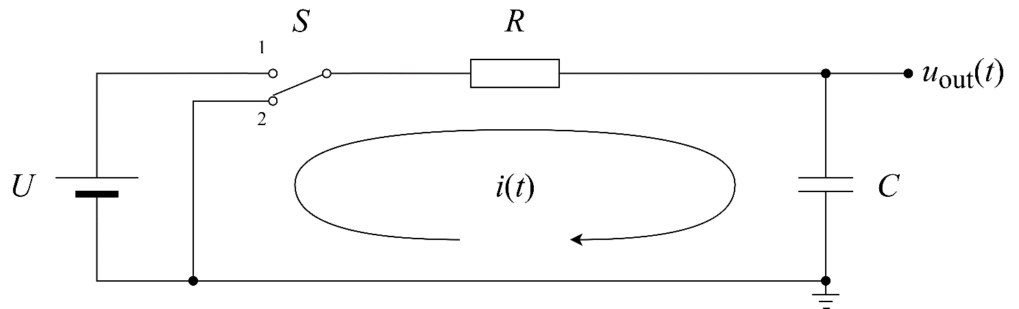
Figure 1. The measurement setup for RC circuit time constant. Switch S is turned from position 1 to position 2 at time t = 1 ms, and the capacitor C voltage is measured as a function of time using an oscilloscope. The circuit is supplied with voltage source U, which has a voltage of 1 V.
Sometimes using equations is necessary. The equations are numbered, and the variables present in them are explained if they are not explained before in the text. The variables in the text and in equations are italicized. For example, the current i(t) in figure 1 is
$i(t)=i_C (t)=C (du_C)/dt$ , | (1)
where i_{C} is the capacitor current and u_{C} = u_{out} is the capacitor voltage. Figure 2 presents capacitor voltage u_{c} when the switch position is changed.
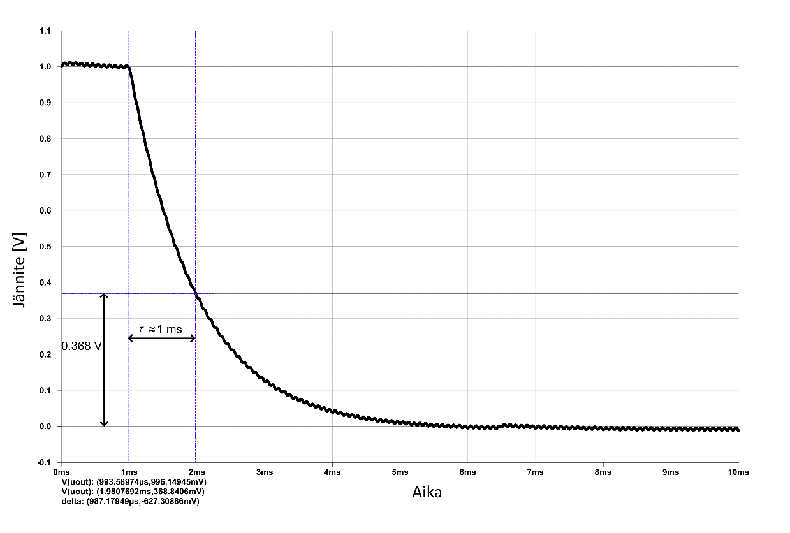
Figure 2. The capacitor voltage in function of time, when the switch is switched from position 1 to position 2 at the moment of time t = 1 ms. The figure can be added with clarification markings. In this example the time constant τ and its value which can be seen in the figure of about 1 ms is shown. The axes used and their units must be visible in the figure.
All reports require that they have enough information for the reader to be able to repeat the measurement, test or study conducted. The description has to be written out following good scientific practices so that a professional of the report field of study can re-make the same study, for example to check equations, measurements, calculations or the result and its conclusions. It is usually reasonable to support the presentation of methods with figures, such as circuit diagrams or other design documentation. A photograph of the measurement setup can also be presented, but it seldomly alone gives out a clear explanation of the method used.
The principles for determining the uncertainty of measurements (the sources of uncertainty, assumptions about error distributions, combining uncertainties etc.) can be presented in the methods section, or if the review is long, it can also be added as an appendix to the end of the report. Other long equation derivations should also be added as an appendix.

Results

Frequency response

The small-signal frequency responses of the four LM358 operational amplifier configurations were characterized across a broad frequency spectrum from 10Hz up to 24.83MHz. Each circuit configuration is subsequently evaluated by benchmarking its SPICE macromodel simulation against laboratory data.
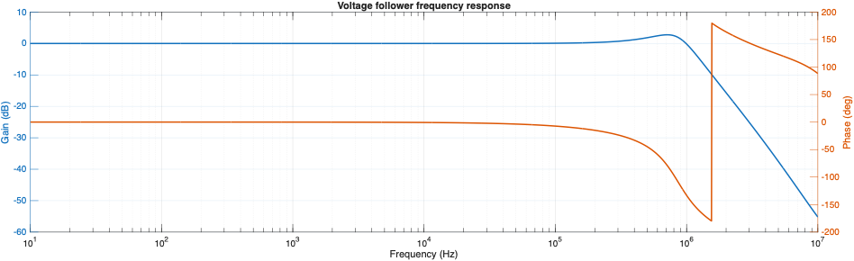
Figure 12. Simulated small-signal frequency response of the LM358 voltage follower (Av = 1, 0dB) in LTSpice from 10Hz to 10MHz. The simulation exhibits a flat 0 dB passband with mild gain peaking near 800kHz arising from phase margin degradation, reaching a -3dB cutoff frequency at 1.15MHz. Phase remains near 0° at low frequencies and starts dropping at 700kHz.

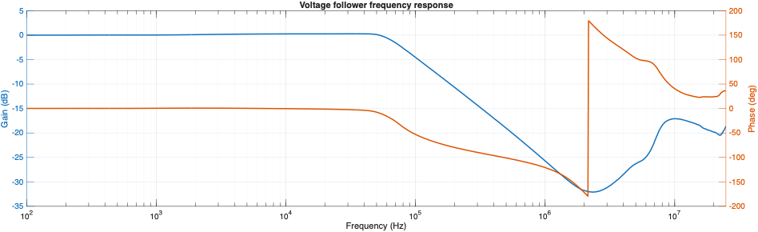
Figure 13. Measured small-signal frequency response of the LM358 voltage follower (Av = 1, 0dB) from 100Hz to 24.83MHz obtained in the laboratory. The low-frequency passband confirms unity gain (0dB) up to 50kHz, with the experimental -3dB cutoff occurring at approximately 84.14kHz. A standard -20dB/decade roll-off is maintained up to 2 MHz (-32 dB).

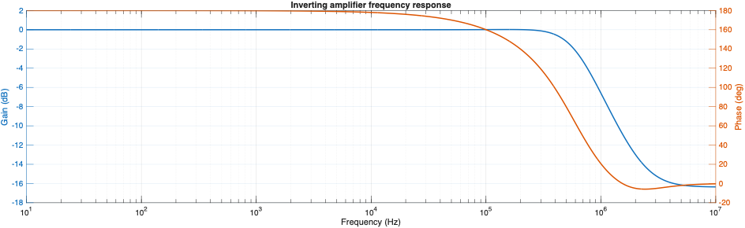
Figure 14. Simulated small-signal frequency response of the LM358 inverting operational amplifier with unity gain (Av = -1, 0dB) in LTSpice from 10 Hz to 10 MHz. The passband gain is 0dB with an initial phase shift of 180°. The -3dB bandwidth is approximately 675kHz. High-frequency attenuation settles near -16.5dB.

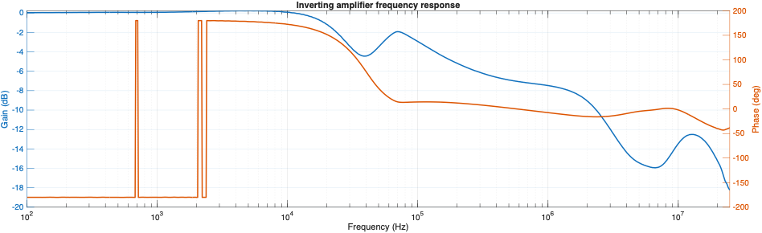
Figure 15. Measured small-signal frequency response of the LM358 inverting amplifier with unity gain (Av = -1, 0dB) from 100Hz to 24.83MHz. The passband exhibits 0 dB gain up to 20kHz, with the -3dB cutoff observed at 28.18kHz. A localized gain dip to -4.5dB occurs at 40kHz followed by a rebound to -2dB at 70kHz and progressive roll-off. Phase starts at 180° (with instrument artifacting at low frequencies) and trends toward 0°.

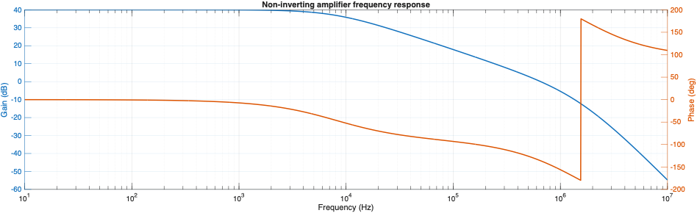
Figure 16. Simulated small-signal frequency response of the LM358 non-inverting amplifier with nominal gain Av = 101 (40.08dB) in LTSpice from 10Hz to 10MHz. The -3dB cutoff frequency is located at 7.86kHz, beyond which the magnitude rolls off at a classic -20dB/decade slope till an additional pole becomes active at about 1MHz. Phase remains near 0° at low frequencies and starts dropping at 10kHz with a second drop before the second pole becomes active.

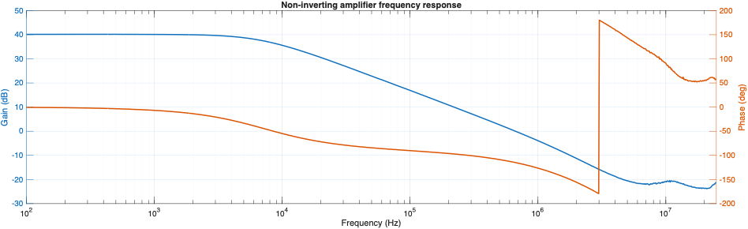
Figure 17. Measured small-signal frequency response of the LM358 non-inverting amplifier with nominal gain Av = 101 (40.08dB) from 100Hz to 24.83MHz. The measured low-frequency gain is 40.08dB with exceptional passband flatness up to 4kHz. The -3dB cutoff frequency occurs at 7.6kHz beyond which the magnitude rolls off at a classic -20dB/decade slope till 2.5MHz.

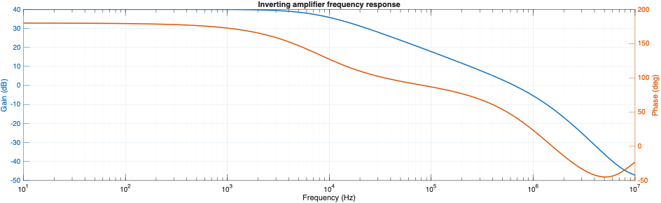
Figure 18. Simulated small-signal frequency response of the LM358 inverting amplifier with nominal gain Av = -100 (40dB) in LTSpice from 10Hz to 10MHz. The -3dB cutoff frequency is located at 7.78kHz, followed by a -20 dB/decade slopoe till an additional pole becomes active at about 1MHz. Phase starts at 180° and trends toward 0°.

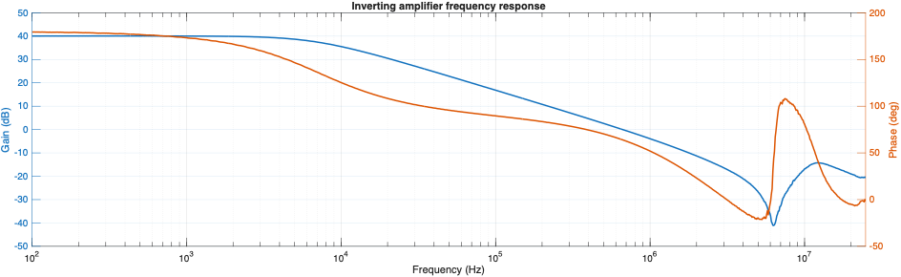
Figure 19. Measured small-signal frequency response of the LM358 inverting amplifier with nominal gain Av = -100 (40dB) from 100Hz to 24.83MHz. The low-frequency passband demonstrates 40.0 dB gain up to 4kHz, with the -3dB cutoff established at 7.67kHz. The response rolls off linearly at -20 dB/decade down to a notch resonance at 6.5MHz.

A common pattern in all of the frequency response plots above is phase degradation. The growing phase lag adds delay in the feedback path, which eventually causes the gain to collapse. Two further observations are worth noting. First, in certain configurations (Figures 13, 15 and 16) a second pole appears at high frequencies, steepening the roll-off from −20 dB/decade to −40 dB/decade. Second, Figure 16 shows a resonance near 6.5 MHz, where the phase suddenly shifts upward by roughly 90 degrees, indicating that the circuit briefly behaves inductively before the response continues to roll off.

Table 1. Comparison of the simulated and measured gain-bandwidth product (GBW) for the voltage follower and the inverting and non-inverting amplifier configurations. The GBW was calculated by multiplying the magnitude of the closed-loop gain by the measured −3 dB frequency of each circuit.

 | Simulated | GBW (sim) | Measured | GBW (meas)
Voltage follower | 1.15MHz | 1.15MHz | 84.140kHz | 84.140kHz
Inverting amplifier (Av = -1, 0dB) | 675kHz | 675kHz | 28.18kHz | 28.18kHz
Non-inverting amplifier (Av = 101, 40.08dB) | 7860Hz | 793.86kHz | 7600Hz | 767.6kHz
Inverting amplifier (Av = -100, 40dB) | 7780Hz | 778kHz | 7670Hz | 767kHz

The simulated GBW of the voltage follower,1.15MHz, agrees closely with the datasheet value of 1.2MHz (Texas Instruments, 2024), but the measured values in Table 1 are lower. At a gain of 100 the measured GBW is about 0.77MHz, in good agreement with the simulated values of about 0.78 to 0.79MHz, although still below the datasheet value. At unity gain the measured results are much lower, at 84kHz for the voltage follower and 28kHz for the inverting amplifier. The non-inverting voltage follower performs better than the inverting amplifier at unity gain, in both simulation and measurement, while the two configurations with a gain of 100 (40dB) have about the same GBW.

Input Impedance

Closed loop input impedance increases because of the loop gain in non-inverting applications. In the inverting or summing closed loop configuration, the summing junction is a virtual ground, and the input impedance is almost exactly the value of the summing impedance (Carter and Brown, 2001, p.43).

The simulted input impedance of the inverting amplifiers illustrated in Figures 16 and 17 is equivalent to the summing point impedance or the input resistance (R_{i}), as depicted in the circuit diagrams shown in Figures 2 and 3. This equivalence holds consistently throughout the low-pass frequency band up until the GBW corresponding of that specific circuit configuration is reached.

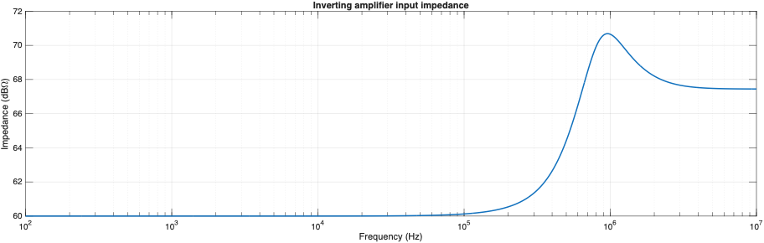
Figure 20. Input impedance response versus frequency for the unity gain inverting amplifier configuration. The plot shows a flat input impedance response of approximately 60dB across lower frequencies (100Hz to 0.1MHz), corresponding to the input resistance (R_{i}) at the virtual ground node. Beyond 0.1MHz, as loop gain declines near the GBW, the impedance rises sharply to a peak near 70.5dB around 1MHz before settling near 67.5dB at higher frequencies.

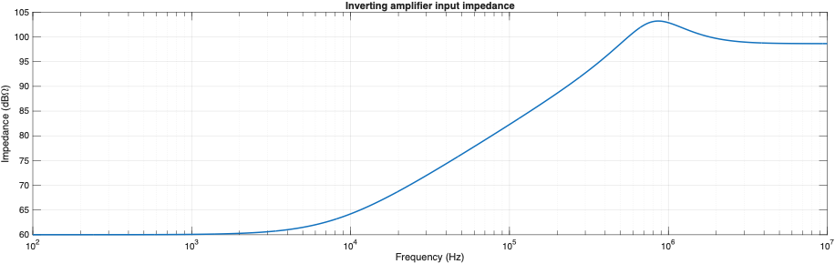
Figure 21. Input impedance response versus frequency for the inverting amplifier configuration with a gain of 100 (40 dB). Maintaining a flat baseline near 60dB at low frequencies 100Hz to 1kHz, corresponding to the input resistance (R_{i}) at the virtual ground node. Beyond 1kHz as loop gain declines near the GBW, the impedance rises sharply to a peak near 103dB around 1MHz before settling near 97dB at higher frequencies.

For non-inverting configurations, the effective input impedance corresponds to the product of the open-loop input impedance and the loop gain (Carter and Brown, 2001, p.43). The loop gain, βA₀, can be seen as the gap between two curves on a logarithmic scale, the open-loop gain A₀ and the closed-loop gain, which is approximately 1/β:

$${\log{A}}_{0}-\log{\frac{1}{β}}=\log{\frac{A_{0}}{\left(\frac{1}{β}\right)}}=\log{β}A_{0}$$

The product A₀β is the gain a signal experiences as it passes through the amplifier and around the feedback loop, so βA₀ is the loop gain and represents the excess gain available in the circuit. It is often assumed that the open-loop gain itself must be high for an op-amp circuit to be accurate. What actually matters is that the loop gain is high, meaning that the open-loop gain must be large compared with the closed-loop gain (Bramble and Alonso, 2015).

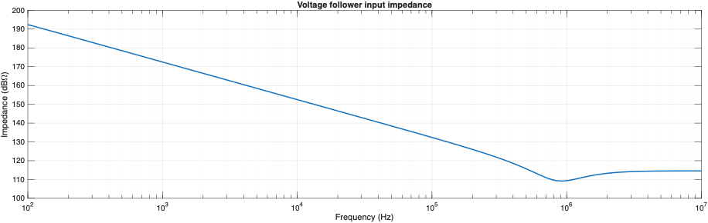
Figure 22. Input impedance response versus frequency for the voltage follower configuration. The plot demonstrates a high low-frequency input impedance of approximately 192dB at 100Hz, which decreases as loop gain rolls off with increasing frequency. A standard -20 dB/decade roll-off is maintained up to the GBW. The impedance reaches a minimum of approximately 109 dB near 0.9MHz before leveling off near 115dB at 10MHz.

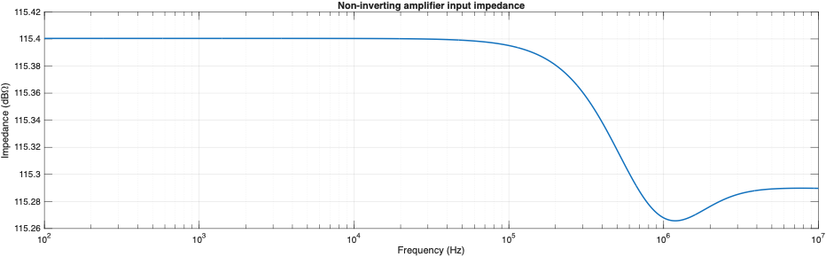
Figure 23. Input impedance response versus frequency for the non-inverting amplifier configuration with a gain of 100 (40 dB). The plot demonstrates a high input impedance of approximately 115.4dB at low-pass frequency band, which decreases as loop gain rolls off with increasing frequency. The impedance reaches a minimum of approximately 115.26dB near 1.2MHz before leveling off near 115.29dB at 10MHz.

Step response

The step response of the LM358 shows a perfectly damped response. The op amp responds by ramping toward the final value, gently slowing down as the feedback signal detects closure on the proper output voltage. In case of the simulated results, it overshoots by a very small margin, as seen in Figure 20.

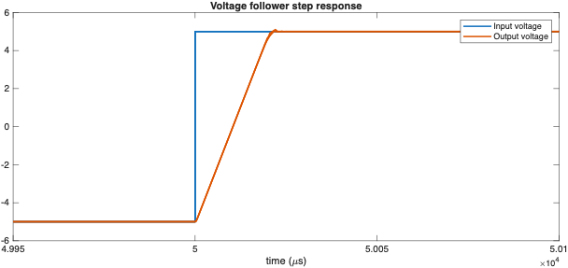
Figure 24. Simulated step response of the LM358 voltage follower. The output ramps toward the final value after the input step at a limited rate, corresponding to a slew rate of approximately 0.46 V/µs.

The slew rate was calculated from the voltage and time differences between the cursors placed on the start and end of the output ramp:
$$SR=\frac{ΔV}{Δt}≈0.46\frac{V}{μs}$$
This is very close to the typical slew rate of 0.5 V/µs given in the LM358 datasheet for the unity-gain voltage follower configuration (Texas Instruments, 2024).

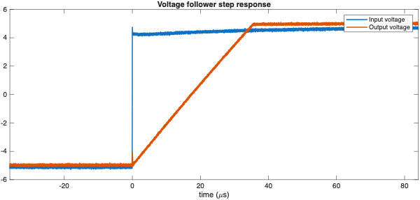
Figure 25. Measured step response of the LM358 voltage follower for a −5 V to +5 V input step. The output ramps toward the final value after the input step at a limited rate, corresponding to a slew rate of approximately 0.276 V/µs.

Using cursors on the oscilloscope, ΔV and Δt were read from the output ramp and the slew rate calculated as:
$$SR=\frac{ΔV}{Δt}=\frac{9.906V}{35.9008μs}=0.276\frac{V}{μs}$$
The calculated slew rate is slightly more than half of the 0.5 V/µs given in the LM358 datasheet (Texas Instruments, 2024). This lower result can be attributed to the limitations of the KA358 variant used in the laboratory, which has a lower GBW or citcal frequency, and therefore a lower slew rate, than the standard LM358.

Output voltage swing

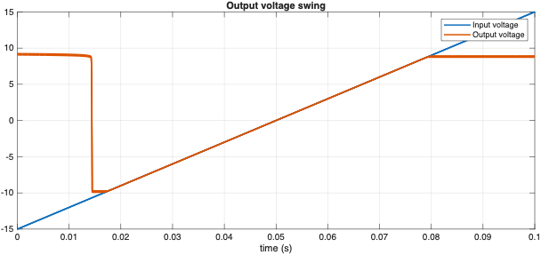
Figure 26. Simulated response of the LM358 voltage follower to a triangular input larger than the supply voltage, showing the output clipping at both extremes.

Figure 22 shows the simulated output for the 1 kΩ load. In the linear region the output follows the input, and it saturates where the input exceeds the range the output stage can reach. At the start of the run, the input is below the negative supply, outside the input common-mode range of the op-amp, and the output is held high instead of following the input (phase reversal). The values obtained from the clipped parts of the output for each load are summarized in Table 1.

Table 2. The maximum output voltage (V_{OH}), minimum output voltage (V_{OL}), and total undistorted voltage swing (V_{OH} - V_{OL}) measured in LTSpice across varying load resistors (R_{L}).

Load Resistor (R_{L}) | Max Output Voltage (V_{OH}) | Min Output Voltage (V_{OL}) | Total Undistorted Swing (V_{OH} - V_{OL})
1 kΩ | 9.0462 V | -9.7072 V | 18.7534 V
2 kΩ | 9.1421 V | -9.8134 V | 18.9555 V
10 kΩ | 9.2467 V | -9.9202 V | 19.1669 V

The results in Table 1 are consistent with the LM358 being a single-supply op-amp, as described in the methods: the output can swing much closer to the negative rail than to the positive rail. The datasheet gives typical values of 1.4V and 0.75V from the positive and negative rails respectively for a load drawing 1mA (Texas Instruments, 2024). The 10kΩ load in the simulation draws about 0.9mA, which is close to that condition, and the output reaches within 0.75V of the positive rail and 0.08V of the negative rail, which is better than the datasheet values. The swing also widens as the load resistance increases, from 18.75V at 1kΩ to 19.17V at 10kΩ.

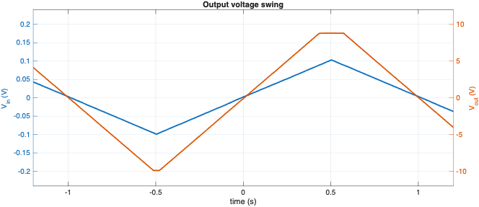Table 3.
Figure 27. Output voltage swing of the non-inverting amplifier with a gain of 100 (40dB) and no load connected, showing the output clipping at both extremes.

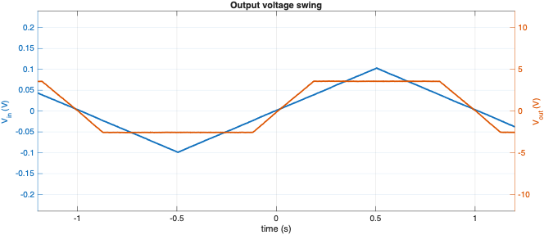
Figure 28. Output voltage swing of the non-inverting amplifier with a gain of 100 (40dB) and a 100Ω load resistor connected to the output, showing the output clipping at both extremes.

The results follow a similar pattern to the simulations. With no load, the output reaches almost to the negative supply rail (V_{OL} = −9.914V), while the positive swing stops about 1.2V short of the positive rail (V_{OH} = 8.822V), as expected for the LM358. When a small load such as the 100Ω resistor is connected, the output current increases considerably and the swing drops sharply, to V_{OH} = 3.613V and V_{OL} = −2.598V. The clipped parts of the waveform in Figure 25 are therefore set by the output current limit of the op-amp rather than by the supply voltage.

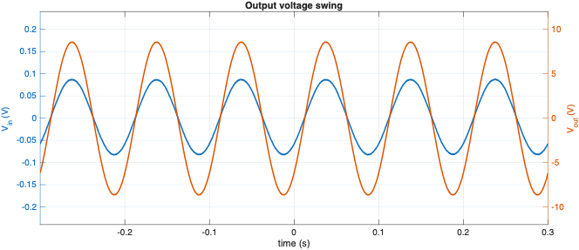
Figure 29.

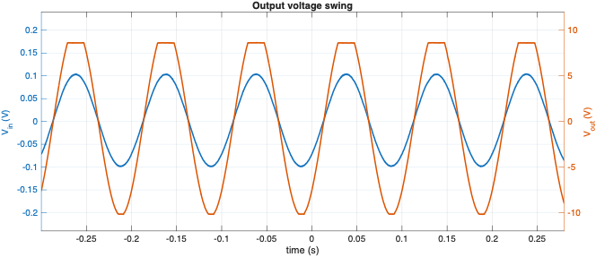
Figure 30.

Check this, were the power rails different than +-10. Can you check if I am getting something wrong
V_{OL} = -10.1884V V_{OH} = 8.6402V
The VOL is less htan the negative ppower rail

Crossover distortion

The distortion caused by the time interval between the positive and negative alternations of the input, due to the delay between switching on and off the transistors when none of them are conducting inside the integrated circuit, is called crossover distortion (Floyd, 2005, p.349).

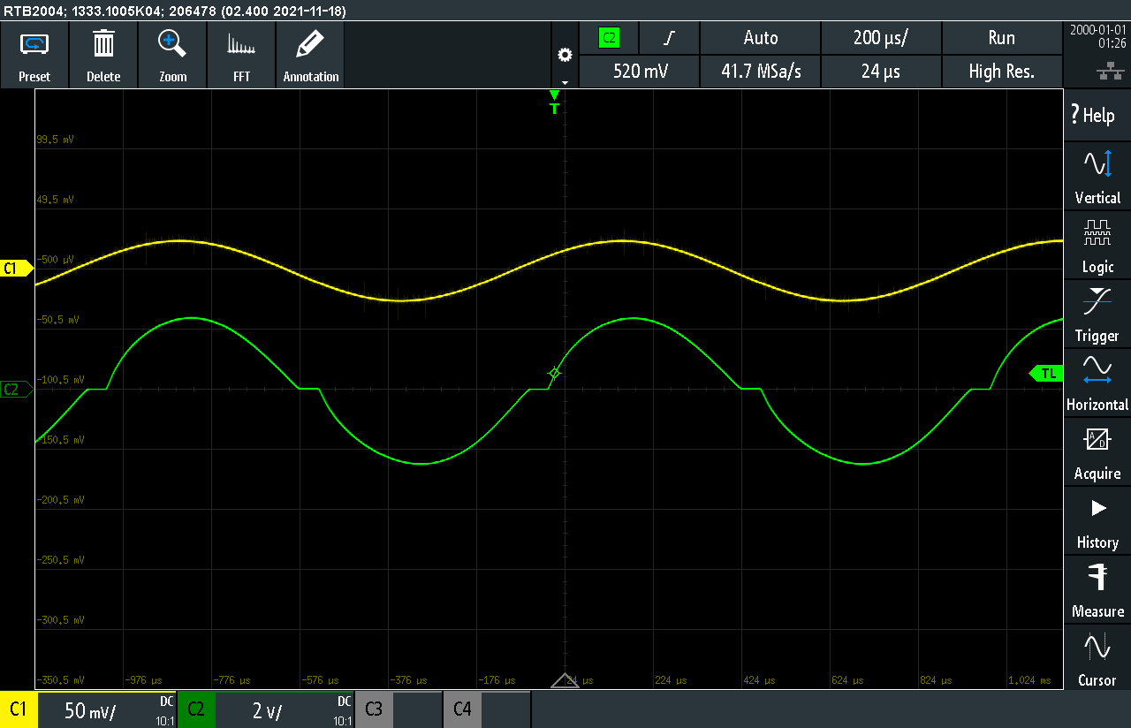
Figure 31. Input and output of the non-inverting amplifier with a 100Ω load and a 50mVpp input signal, with the 150µF filter capacitor and 100nF bypass capacitor connected to the power rails. Crossover distortion is visible as a flattened section at each zero crossing of the output.

The crossover distortion is not caused by the input stage, since the LM358 has no complementary NPN and PNP input pairs as found in dual-input rail-to-rail amplifiers. Instead, each input has a single composite darlington pair. Most of the distortion therefore originates in the output stage, where control passes between the Darlington pair that sources current and the PNP transistor connected to the output that sinks current to the load, as seen in Figure 31.

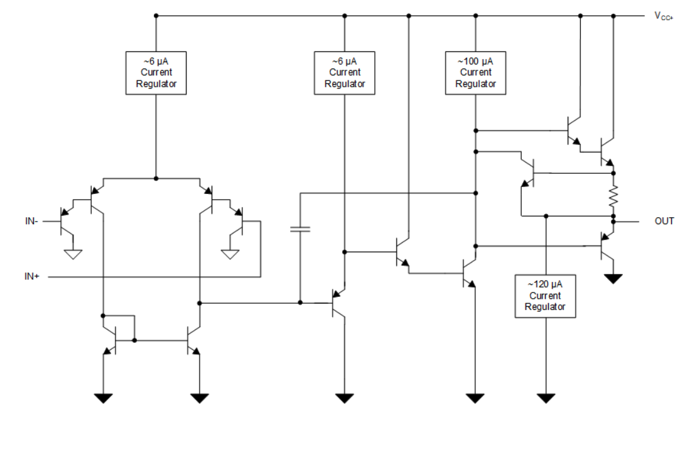
Figure 32. Functional block diagram of LM358 (Texas Instruments, 2024).

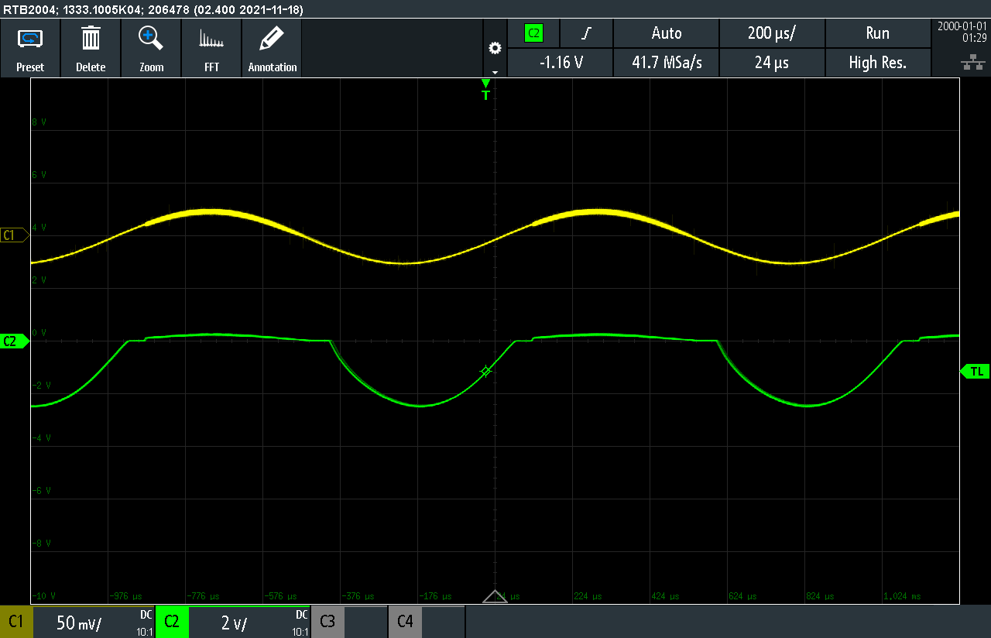
Figure 33. Input and output of the non-inverting amplifier with a 100 Ω load and a 50 mV p-p input signal, with no capacitors connected to the power rails. The positive half-cycle of the output is almost completely lost (V_{OH} stays close to 0V), while the negative half-cycle is reproduced with the expected amplitude.

When the filter and bypass capacitors are removed, the positive half-cycle of the output is lost while the negative half-cycle is still reproduced. The load and the input signal are unchanged from Figure 28, so the difference must be due to the supply. The positive half-cycle is sourced from the V+ rail, so the load current of up to about 25 mA must be delivered through the supply leads. The resistance and inductance of the leads most likely prevent the rail from holding its voltage at the op-amp, and also make the op-amp unstable, so the output cannot be driven positive.

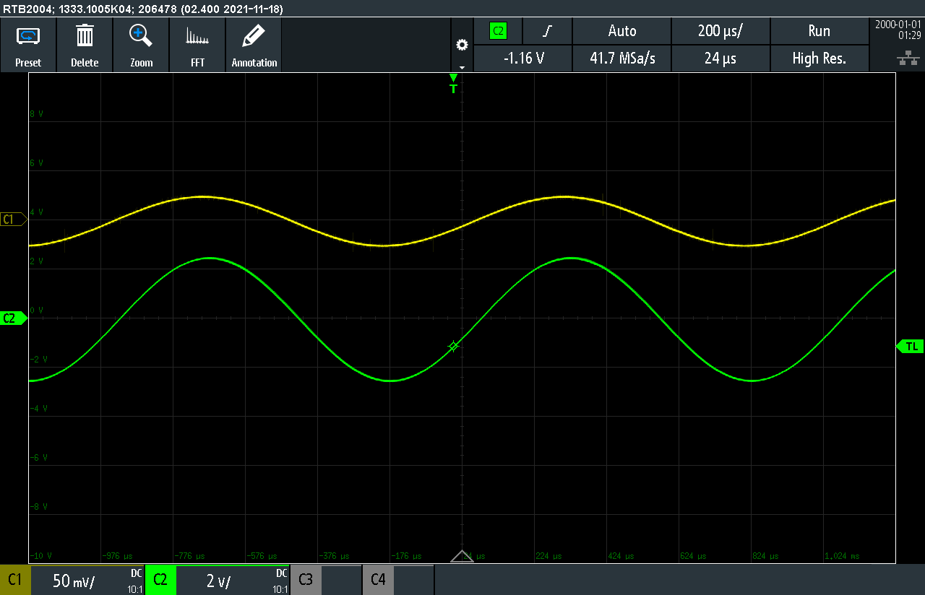
Figure 34. Input and output of the non-inverting amplifier with no load and a 50mVpp input signal and with the 150µF filter capacitor and 100nF bypass capacitor connected to the power rails. The output follows the input without visible distortion.

When the load is removed and no large current is drawn, the crossover distortion disappears as seen in Figure 30. With almost no output current to supply or reverse, the feedback loop can correct the small dead zone as the output stage passes through zero, so the output follows the input without visible distortion. (Check probably wrong.)

Input offset voltage

The input offset voltage was calculated from the measured DC output voltage with the input grounded, using the schematic in Figure 10. The measured output was −80mV, which is the offset voltage multiplied by the closed-loop gain of 101, so referred to the input:

$$ΔV_{\text{OS}}=\frac{V_{\text{OUT}}}{A_{\text{v}}}=\frac{-80 \text{mV}}{100}=-0.8 \text{mV}$$

This is well within the maximum offset voltage of ±3 mV given in the datasheet but still way below the typical value (Texas Instruments, 2024).

Input-referred noise

The noise was measured with the input of the circuit in Figure 8 shorted directly to ground. No resistor was used, so that the source’s thermal noise would not add to the result and most of the noise at the output would come from the amplifier itself. The oscilloscope was AC-coupled, to remove the DC offset at the output, and set to 500 µs/div. The RMS value of the output noise was read with the scope’s measurement function, giving:

$$e_{n}=1.5 {\text{mV}}_{\text{rms}}$$

BONUS 1

The circuit in Figure 11 was used, and the voltage drop across the series resistor was measured with a bench multimeter. The input bias current was then calculated from this voltage and the value of the resistor:

$$I_{b}=\frac{V_{R}}{R_{s}}=\frac{14.6 \text{mV}}{1 \text{M}Ω}=14.6 \text{nA}$$

The measured input bias current of 14.6 nA is somewhat higher than the typical value of 10 nA given in the datasheet (Texas Instruments, 2024), but it is well within the specified maximum.

BONUS 2

The thermal or Johnson-Nyquist noise in the filter resistors:

$$e_{R1}=\sqrt{4⋅1.38×{10}^{-23}⋅300⋅1×{10}^{3}⋅994.7}≈0.128 μ{\text{V}}_{\text{rms}}$$

$$e_{R_{f}}=\sqrt{4⋅1.38×{10}^{-23}⋅300⋅100×{10}^{3}⋅994.7}≈1.28 μ{\text{V}}_{\text{rms}}$$

$$e_{R3}=\sqrt{4⋅1.38×{10}^{-23}⋅300⋅10×{10}^{3}⋅994.7}≈0.406 μ{\text{V}}_{\text{rms}}$$

The total thermal noise caused by the filter resistors:

$$e_{r}=\sqrt{e_{R1}^{2}+e_{R_{f}}^{2}+e_{R3}^{2}}≈1.35 μ{\text{V}}_{\text{rms}}$$

The results section presents the results of the study to the reader. Typically, in case of laboratory assignments, the results are the results of a measurement, which are used to present and explain the phenomenon under study. All possible oscilloscope figures should not under any circumstances be dumped into the report. Usually there is no need to present the complete sheet of measurement readings – only the most crucial measurement results are needed.
So that the observations made in the study are useful to others also, the result analysis must be presented as thoroughly as possible. The observations of the study and the result analysis is presented unambiguously and compactly. A figure or table can be used for help in the presentation. The observations made, the analysis made on them and presented figures etc. are used to reason the conclusions of the study. The interpretation of result figures or numbers must not be left for the reader, the text must tell what the figures and numbers show, for example.
It is not usually obvious how the results should be presented. The writer must consider what is the best way to present and justify the conclusions derived from the observations. Some results are easiest to present in figure (example: figure 3), while others might be better suited to a table form (example: table 1).
The measurement results should be dealt with criticism, and the documentation of uncertainty of measurements is a part of a well-made study. Again: the tests and the measurements must be documented thoroughly enough so that another person could, if necessary, repeat the experiment and compare one’s results. You might want to take a photograph of the measurement setup – although you may not want to include it into the report, it may be useful when writing the report so you can see details on of the measurement setup which you might have forgotten.
It is worth remembering that a figure itself is not a result. You must interpret what needs to be seen from the figure and what the figure is trying to prove or show. A figure is not also automatically the best way to present the result, a table may be better suited for presentation of a few numeric values.

Table 1. The home charging methods and charge times T_{l} of two electric vehicles with charge voltage U, with fuse size I_{s} and its maximum allowed charge power P. Modified from reference (Tupamäki, 2018).
Charge method | U [V] | I_{s} [A] | P [kW] | T_{l} [h]
 |  |  |  | Nissan Leaf  30 kWh | Tesla S  100 kWh
Temporary charging from a wall outlet | 230 | 10 | 2.3 | 13 | 43
Slow home charging from a home charging station | 230 | 16 | 3.7 | 8 | 27
Medium speed charging from a home charging station | 230 | 32 | 7.4 | 4 | 14
Fast home charging from a home charging station | 400 | 16 | < 11 | 3 | 9
Extra fast home charging from a home charging station | 400 | 32 | < 22 | 2 | 5

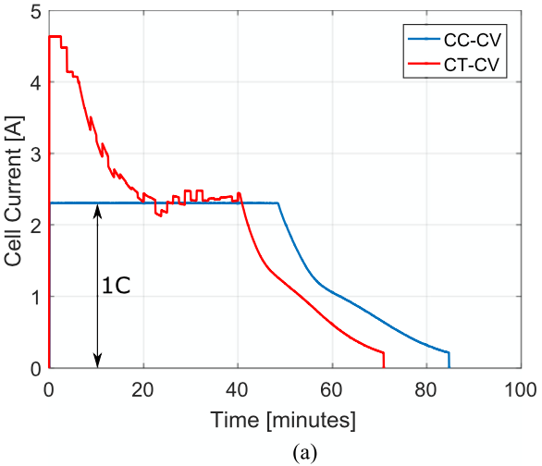
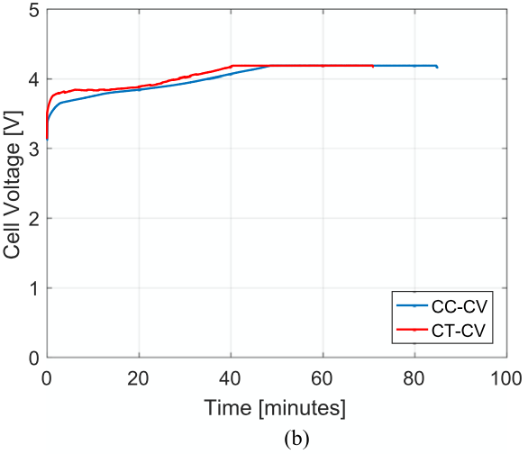
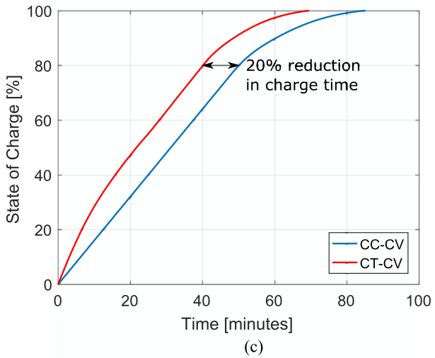
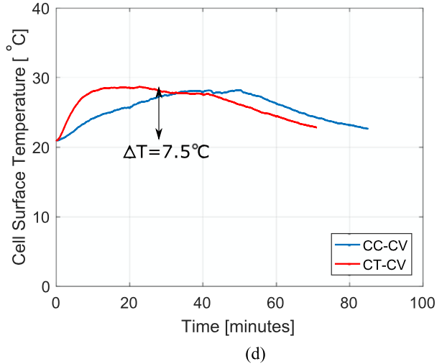
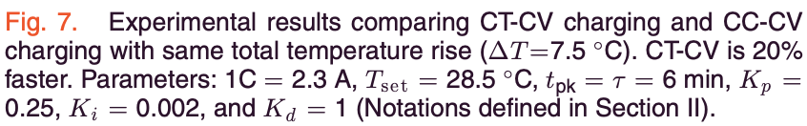
Conclusion
Figure 3. An example of presentation of experiment results using a figure (Patnaik et al. 2019). The figure shows a comparison between two different battery charging methods. Note, that in addition to curves there are also other illustrative markings, which help the reader to see the most crucial information. Also notice how the caption supports the figure.
Short measurement or test reports usually have a short and summarized conclusion section, which tells what the study was about and states the result. If the reader reads only the introduction and conclusion, the reader should get a good understanding about what was done in the study and what was the result.
In a longer study report paper, there can be a separate section for conclusions before the final summary. The section can bring up, for example, side observations from the results, the meaning and effects of the results, or factors which strengthen or weaken the credibility or reliability of the results. The summary chapter in the end is usually short and repeats the main points of the study: the target and the results. In scientific articles, in the end of the conclusion usually discuss also how the researchers intend to continue the research.
Do not settle for repeating the numeric values from the results, especially if the study was about testing whether a device fulfills a requirement. Note the difference between the following presentations:
- ”Charger voltage was about 5”
- ”The tested charger voltage was 4.84623957 V”
- ”The tested cellphone charger output voltage was (4.85 ± 0.08) V”
- ”The tested cellphone charger under load average output voltage was 4.85 V with 0.2 V standard deviation. Uncertainty of measurement (95 % level of confidence) was 0.08 V.”
- “The tested cellphone charger under load average output voltage was 4.85 V with 0.2 V standard deviation. Uncertainty of measurement (95 % level of confidence) was 0.08 V. The charger is specified to have output voltage between 45.5 and 5.5 V. According to our measurements, this specification is fulfilled.”
Each of the conclusions above is better than the previous one, but only the last one takes a stand about the fulfillment of the specification or requirement.
This section should not present any additional new information. Only the crucial result should be pieced together. The conclusions can be thought as a mirror to the introduction: if introduction presented the cyclist’s desire to measure speed as the motivation for the study, the conclusion can tell, if the presented solution is really suitable for it or is the solution better than some other ones available. This section usually also tells if there are any weaknesses in the solution and what kind of future work would be meaningful.

References
Carter, B. and Brown, T.R., 2001. Handbook of operational amplifier applications (Vol. 9). Dallas, TX: Texas Instruments. Available https://www.ti.com/lit/an/sboa092b/sboa092b.pdf

Floyd, T.L., 2005. Electronic devices. Pearson Education India.

Trump, B., 2017. The Signal: a compendium of blog posts on op amp design topics. Dallas, TX: Texas Instruments. Available at: https://www.ti.com/lit/eb/slyt701/slyt701.pdf

Instruments, T., 1976-Revised 2024. Industry-Standard Dual Operational Amplifiers. SLOS068AA. LM358 Datasheet. [online document]. [referenced 29.10.2026]. Available at: https://www.ti.com/lit/ds/symlink/lm358.pdf

Bramble, S. and Alonso, G., 2015. Loop Gain and its Effect on Analog Control Systems. [online document]. [referenced 29.10.2026]. Available at: https://www.analog.com/en/resources/technical-articles/loop-gain-and-its-effect-on-analog-control-systems.html

Appendices

Insteructions for appendices
It is very common that there are no appendices at all. In such case, the section title “Appendices” is removed completely. Appendices are not mandatory, but they can be used to tell crucial additional information which would be difficult to present in the main text part without making the text hard to read. Usually appendices present for example derivation of equations if they are long, or more specific description of uncertainty of measurement assessment. Also, long measurement value sheets and other large presentations supporting the study are presented as appendices, if they are crucial for the reader to see for understanding the study as whole.
Note, that “Appendix” does not in this context mean a separate appendix document, but rather an appendix section. Before appendices, place a section title called “Appendices” and then the title of the first appendix section. The appendix sections are numbered separately from the main text sections, and it is quite common that they are indexed with different symbols (for example with letters starting from A or with roman numerals). The body text, the captions etc. of the appendix section are formatted similarly to the main report.
Every appendix must be referenced in the main report. The reference is done by referencing to the appendix index, for example in this case, appendix A.

