1. Create a spring application for Transportation interface where customer choose the mode of transport  like airways,  railway,  waterways and inject dependency using 3 different variants

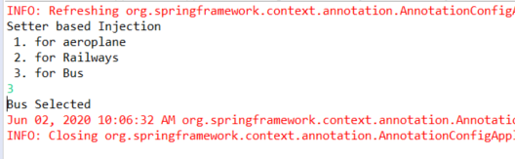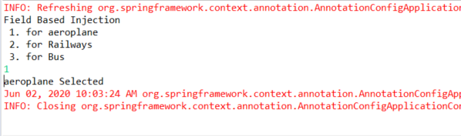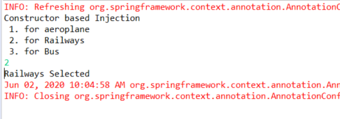

1. Create a spring application which uses lazy bean instantiation with prototype bean scope using init and destroy methods

