1. Write a billing application for bicycles rent shop, where user should be registered and calculate the bill based on hours and days based rent using spring MVC .

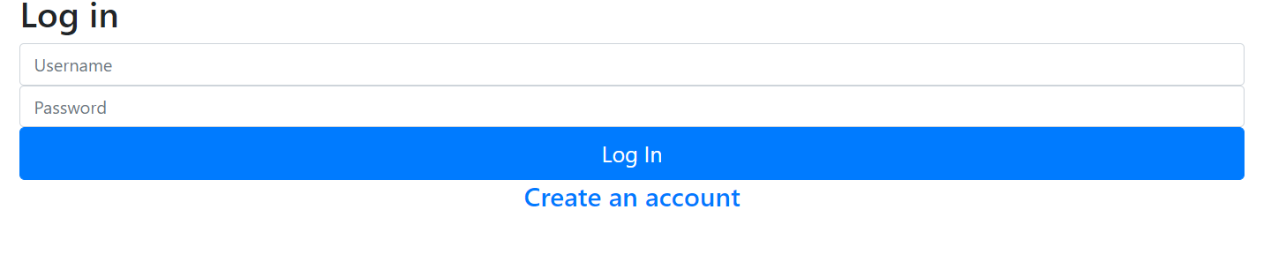

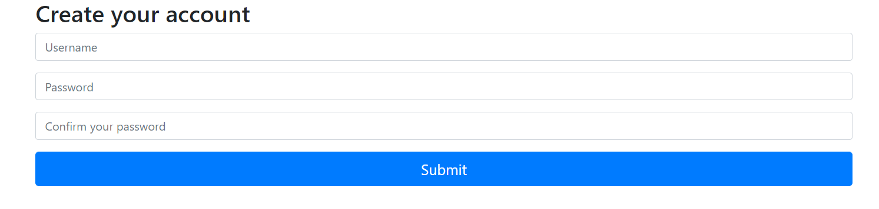

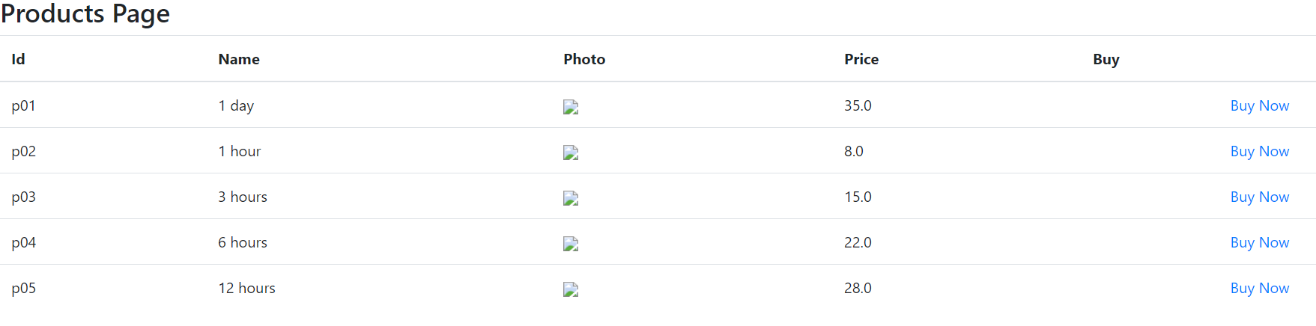

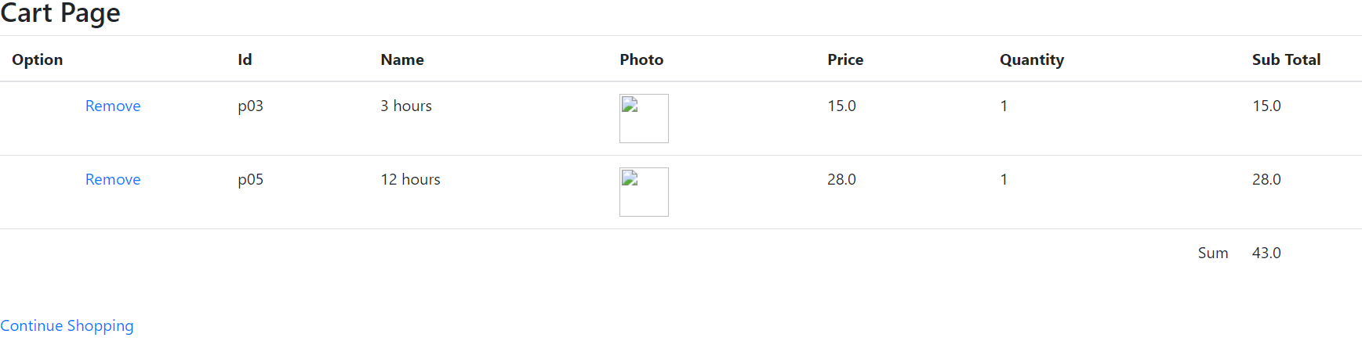

1. Write aspects for all tracing and expection handling in Junit as we discussed in session

