1. Create a spring boot application with multi profile each profile should connect to different schema of database with same table name

Db1:-

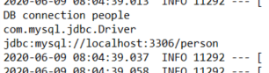

Html output profile1:-



DB2:-

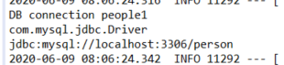

Htmlprofile2:-

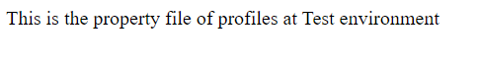

1. Create a Rest services using Jersey framework in springboot and consume the api in same app using resttemplate and http client



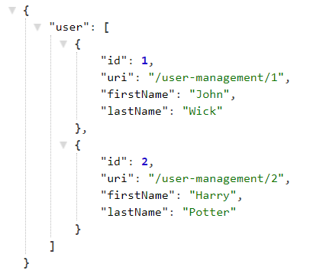

1. Create a rest service to upload and download files using springboot. Upload api should accept multiple files to be uploaded ,with json request multi form data.

