1. Create an hibernate application which performs basic CRUD operations using in memory database

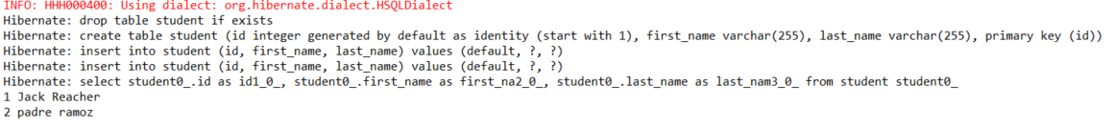

2.) Implement one to many  bi directional way of storing data for java application which deals with library where department ,authors will be available to choose the books.

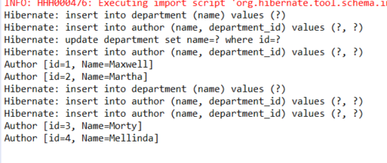

3.) Create a hibernate batch application in java

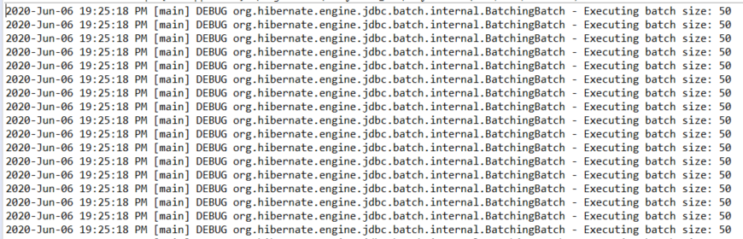

4.) Create a hibernate application using nativenamedquery annotation for complex join queries.

