1. Create a web application for library should maintain a database for users borrowing books and returning using jsp pages

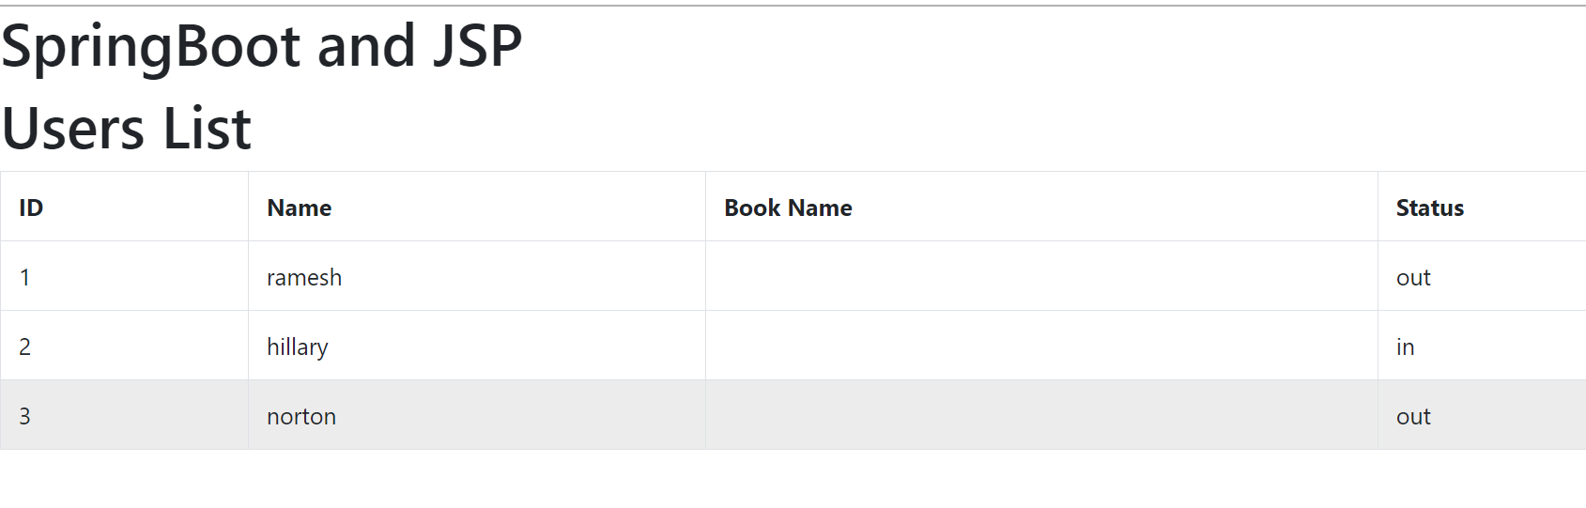

1. Create sign up form and login application with validator using spring mvc, jsp pages

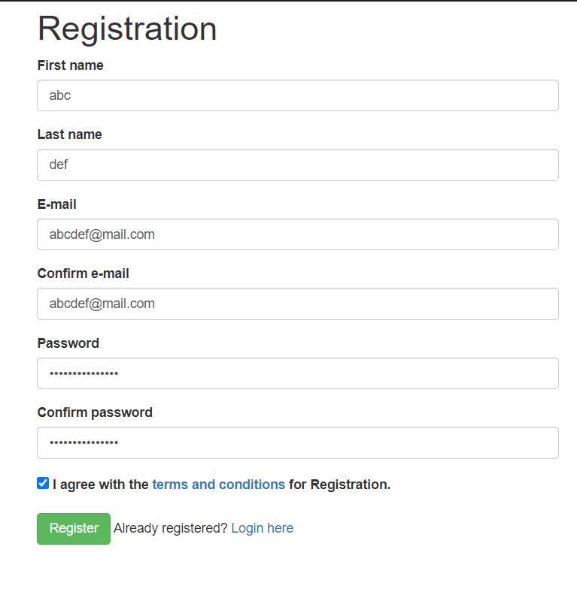

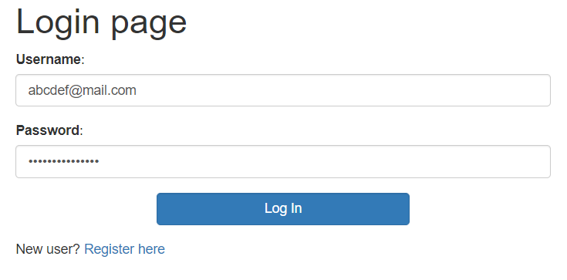

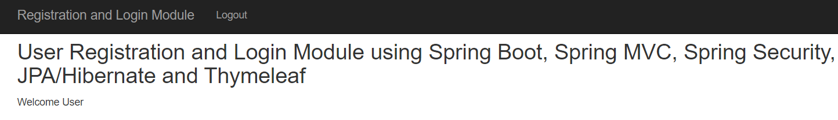

1. Create fitness tracker application for users to maintain their minutes of exercise,  cycle , adding new fitness goal like jogging,  trekking

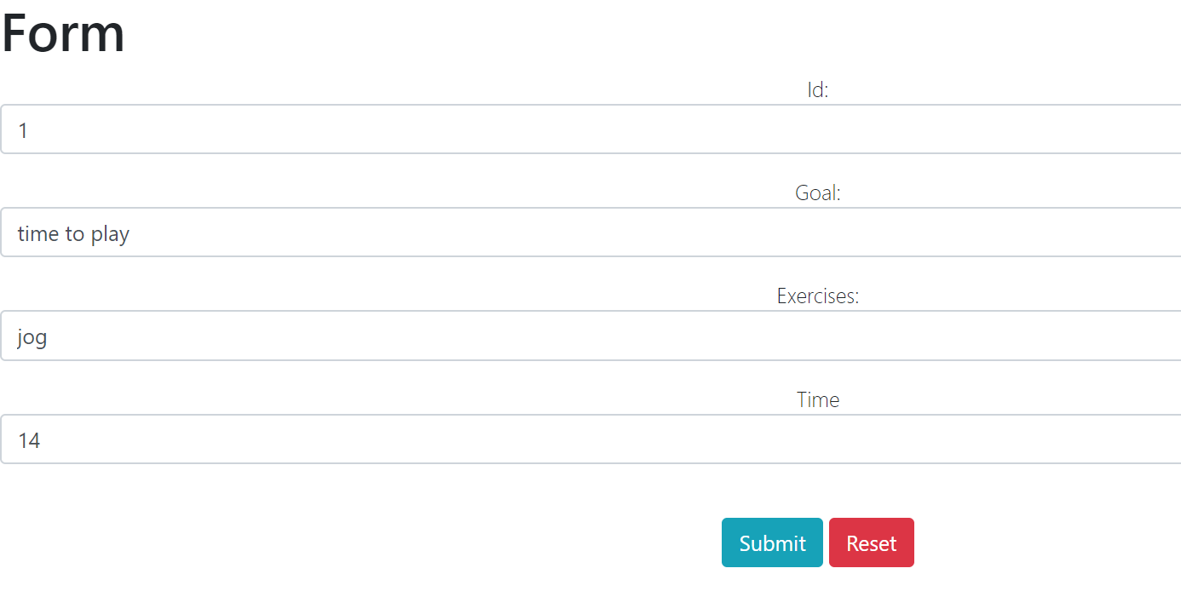

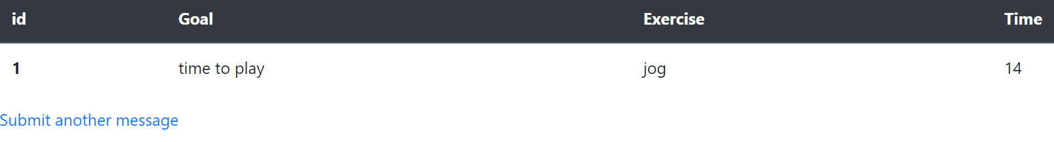

1. For fitness tracker, apply security and roles like admin , user.  Where admin can see all the users details.

