1.) Create 4 different simple microservices and use config server to externalize the properties of those 4 microservices include discovery server to find the services

3.) Enable loadbalancers for above 4 microservices in client side with and without service discovery

4.) Create a custom configuration for load balancer with different rules available in ribbon client for above microservices

5.) Enable circuit breaker using hystrix and maintain a dashboard for all the services

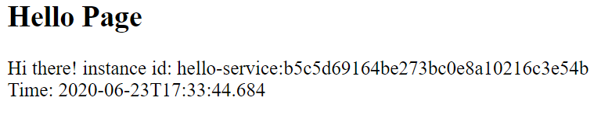

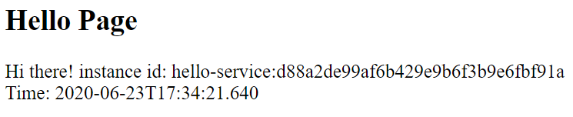

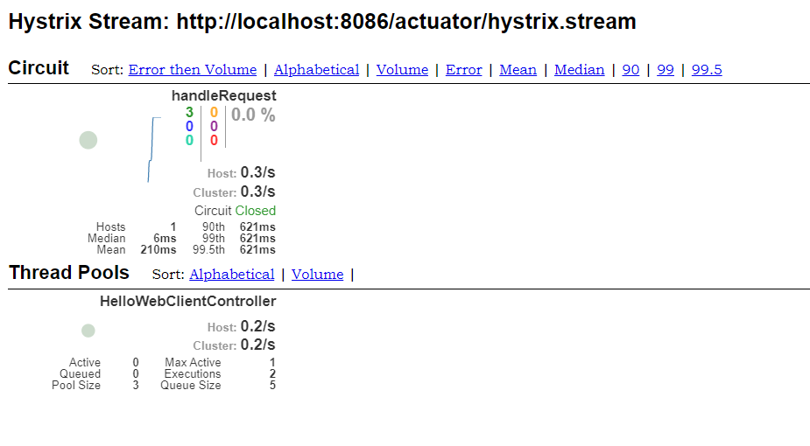

2.)create api Gateway for your cloud native applications and use Zuul filters to pre filter the request

