1. Create a online ticket reservation app using functional api and use webclient to consume and test.



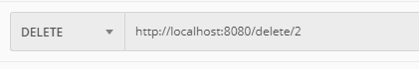



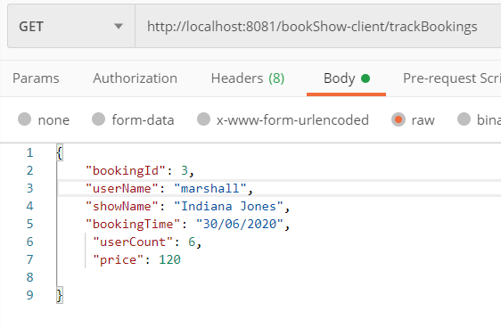

1. Create a singleton design pattern for database driver manager

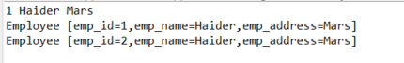



1. Implement builder pattern for shopping cart application

