1.) Create a mono publisher to retrieve data from DB and use flatmap operation in it.

2.) Create a inventory application to add and remove,  check  the products from inventory using annotation style webflux application

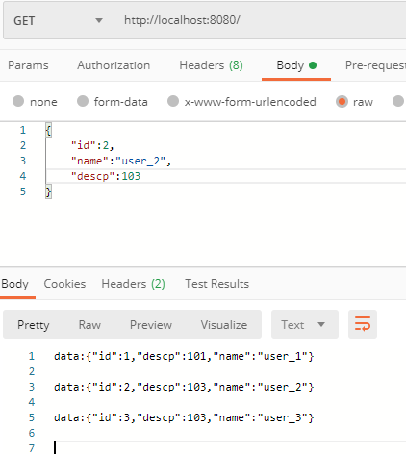

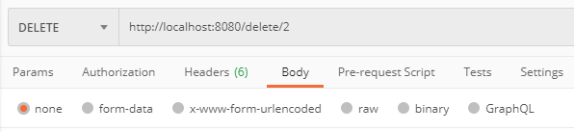

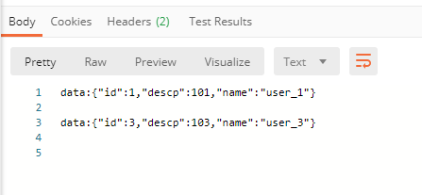

3.) Merge multiple fluxes into single flux publisher

4.) Try the above example with mono and use concat and zip operators





