|  |  |  |  |  |  |
| --- | --- | --- | --- | --- | --- |
| |  | | --- | |  | |  | **PES University, Bengaluru** |  |  |
|  |  | (Established under Karnataka Act 16 of 2013) |  |  |
|  | **Department of Computer Science & Engineering** | | | |
|  |  | Session: **Aug - Nov 2016** |  |  |

**UE17CS204 – Web Technologies – I**

**Theory Assignment**

Report on

**Peer-to-Peer Marketplace**

**By:**

**ESHWAR H S – PES1201700193**

**KETHAN M V – PES1201701085**

**NAVEEN D – PES1201701582**

**ANIRUDH JOSHI – PES1201701558**

**3rd Semester E Section**

1. **Project Description:**

Easy Ads is a peer-to-peer platform for buying and selling services and goods such as electronics, furniture, household goods, cars and bikes. A peer-to-peer (P2P) service is a decentralized platform whereby two individuals interact directly with each other, without intermediation by a third-party. Instead, the buyer and the seller transact directly with each other via the P2P service. When a [third party](https://www.investopedia.com/terms/t/third-party.asp) is removed from the transaction, there is a greater risk that the provider of the service may fail to deliver, that the service will not be of the quality expected, or that the buyer may not pay. This extra risk is often defrayed by reduced [transaction costs](https://www.investopedia.com/terms/t/transactioncosts.asp) and lower prices. Easy Ads connects local people to buy, sell or exchange used goods and services by making it fast and easy for anyone to post a listing on the web.

1. **Technologies Used:**

**HTML:**

Tables, Forms, <div> tag, Anchor tags, Image tags, Heading tags, <link> tags to specify the CSS, font-family links.

**CSS:**

CSS was used to format the HTML tags, to specify various attributes like padding, margins, background-color, transition, border, etc. to style the webpages

**JAVASCRIPT:**

JavaScript was used to capture user actions like hover, on mouse click, on key press, etc. Also it was used to create a slideshow displaying advertisements in the side.

**PHP:**

PHP was mostly used to perform back-end operations such as retrieval of data from database, data validation and encryption.

**MYSQL:**

MYSQL was used to store data from Login, Register and Submit Ad forms. Two tables were created to store user data and advertisement data.

1. **List of Functionalities:**

**Front-End:** Users can create an account or Log in to an existing account. User can browse through advertisements from different categories like Pets, Electronics, Mobiles, Properties, etc. User can Submit advertisements from his account and also view the most recently published advertisements from the Listings page. User can view all details of the advertisement by clicking on the Ad card. The Ad page provides all details about the Ad like Seller name, Publish date, Contact Number, Price of the item, etc. There is also a Contact Us page displaying information to get in touch with the advertisement website company.

**Back-End:** Server side functionalities include storing and retrieval of data from the database. The data entered in forms is validated and sensitive information is encrypted using md5 algorithm. The database stores and retrieves images also. Back-end script checks for existing users and doesn’t allow creation of multiple accounts with the same username or Email ID.

1. **Link to GitHub repository:**

<https://github.com/eshwarhs/wtproject>

1. **Screenshots:**

index1.php

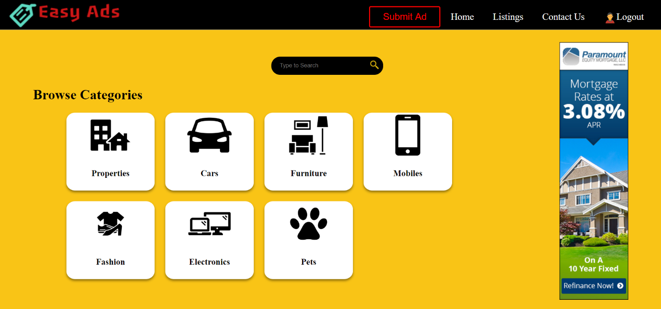

login.php

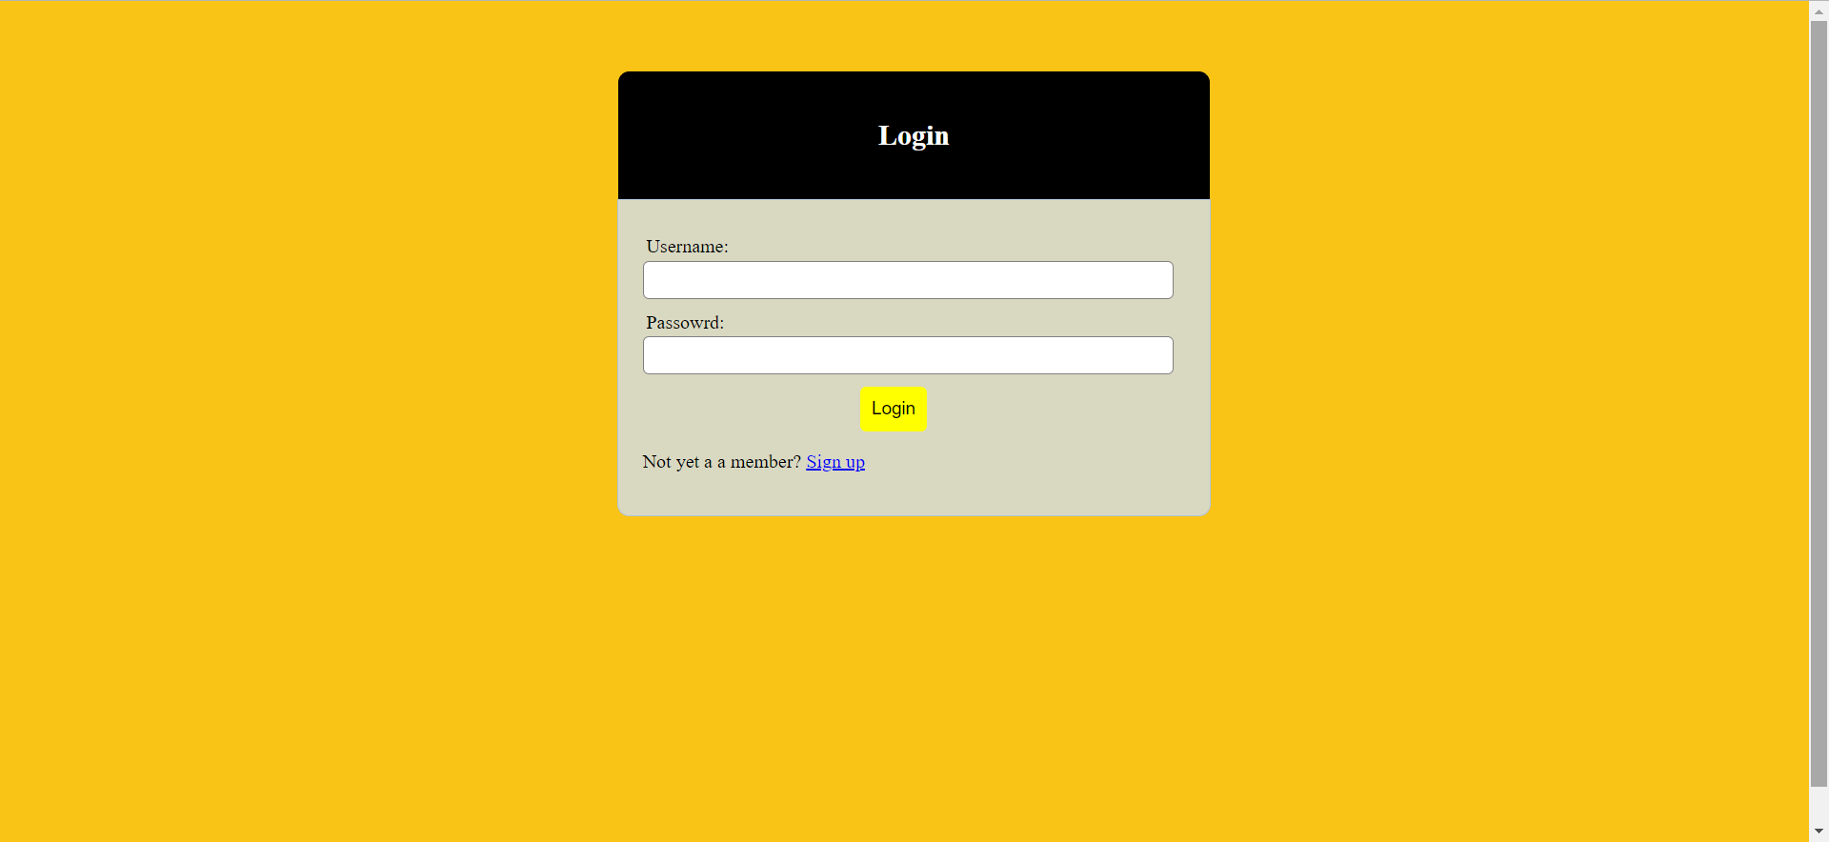

submitad.php

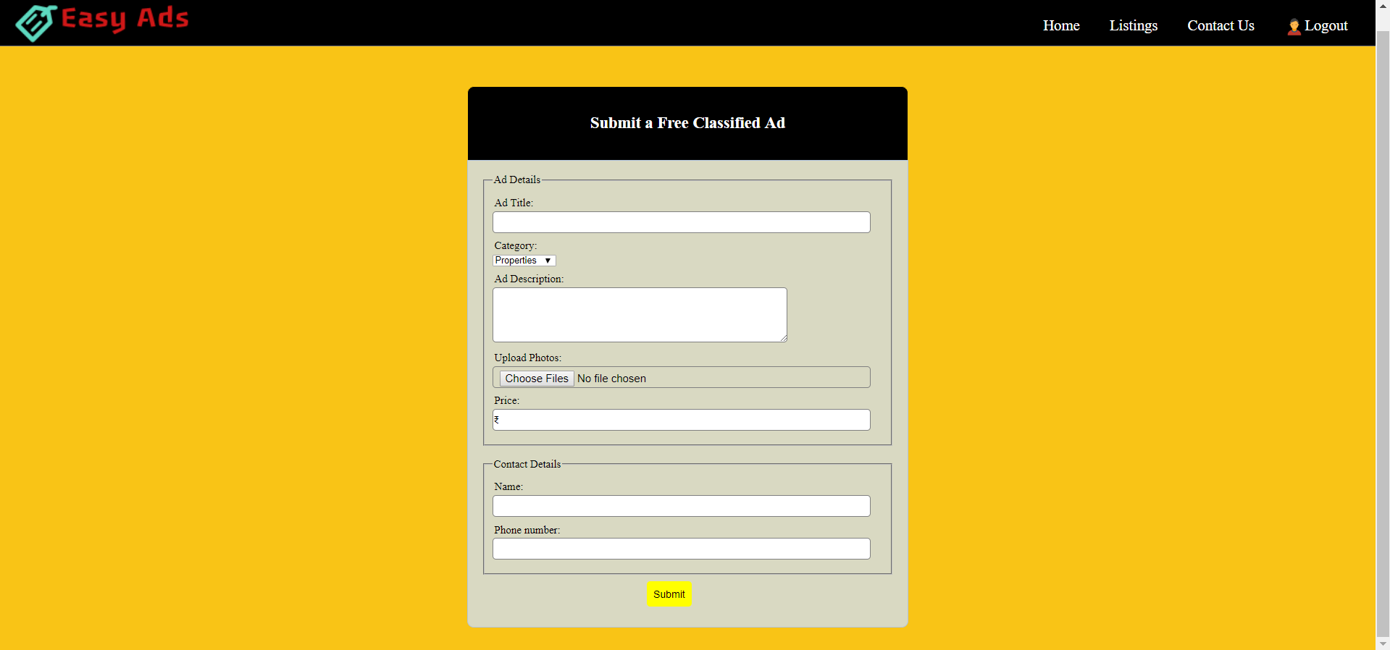

contact.php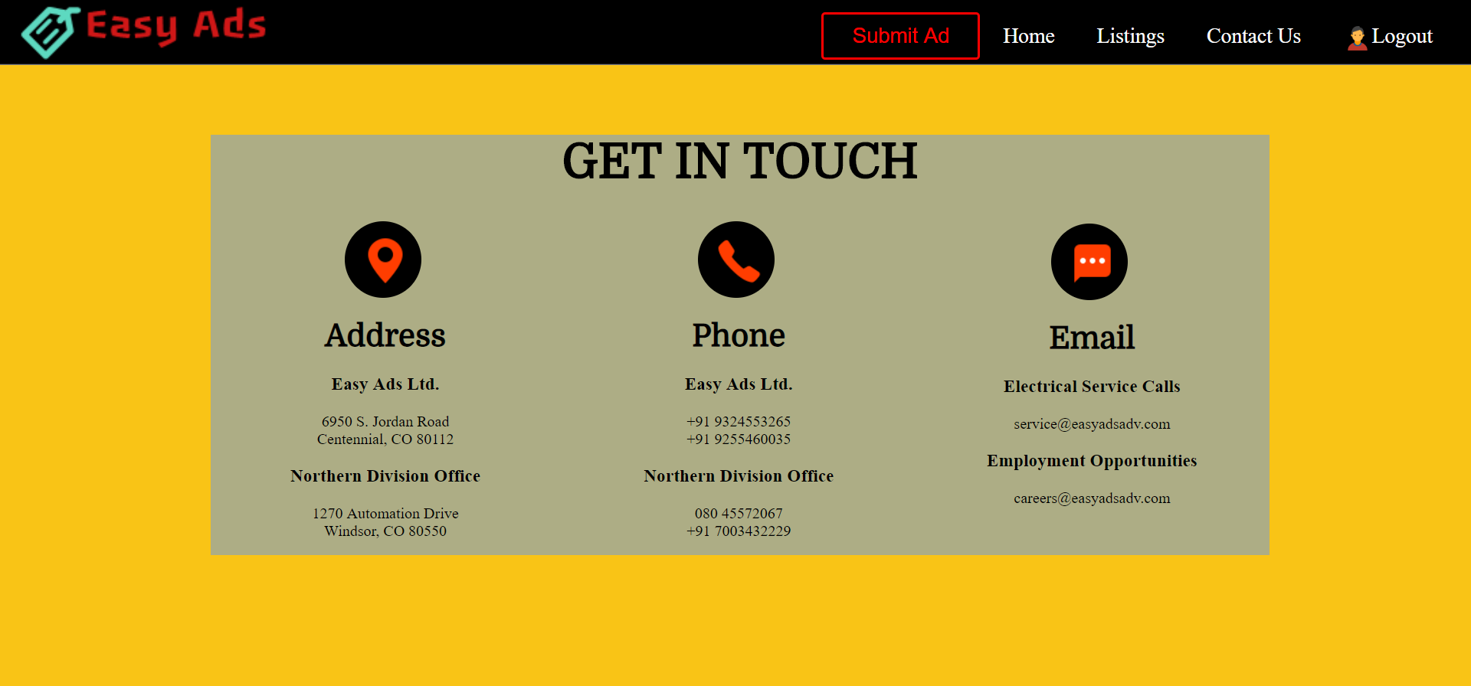

listings.php

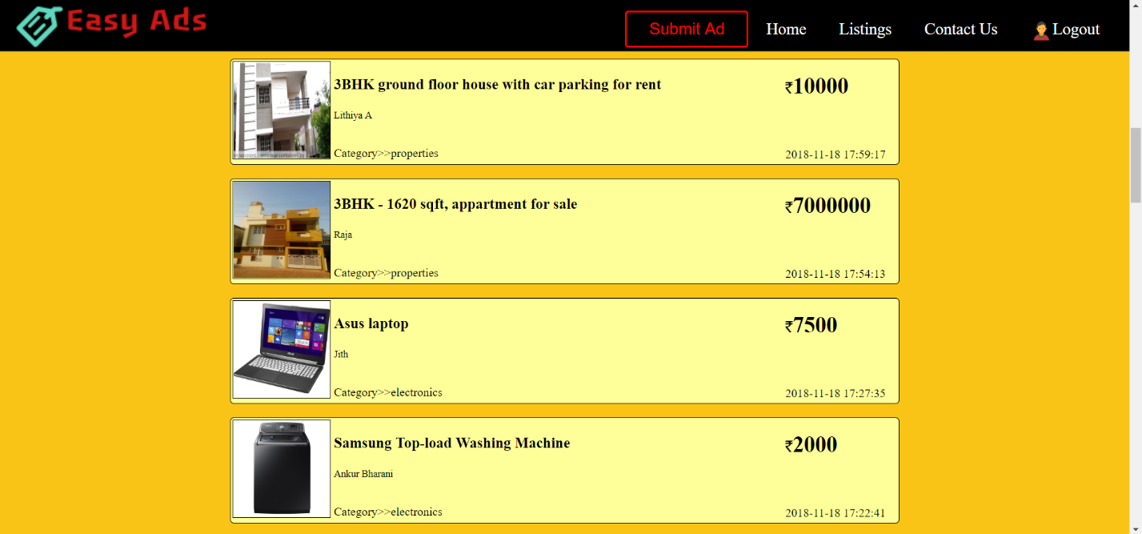

ad.php

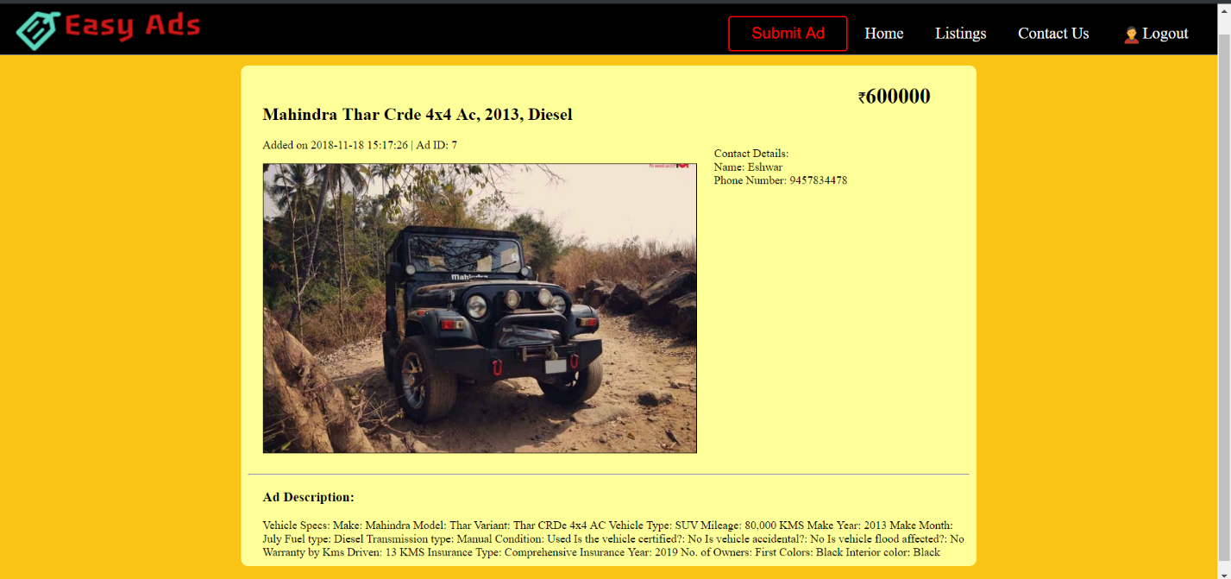

MYSQL tables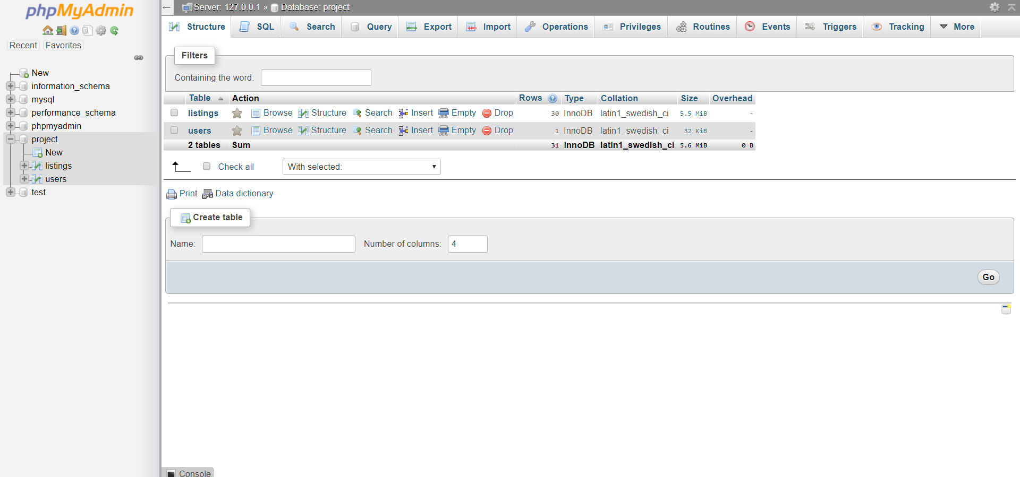

Listings table