CodeGen: A Schema-Aware, Multi-Engine
Natural-Language-to-Query System
Text-to-SQL (PostgreSQL) and Text-to-NoSQL (MongoDB), with SQL-to-NoSQL migration
AIML PGCP Capstone — Project 6 — First Proposal Draft
Team: Kethan Uppalapati, Srinivas K, Venkat Ramana, Shiv Prasanth Dixit
Status: Draft for professor discussion

1. Problem Statement
Most people who need answers from data cannot write database queries. The barrier is two-fold: they must know both the query language (SQL or a NoSQL query API) and the exact structure of the database schema. This project builds a system that converts a plain-English question into a correct, executable query against either a relational database (PostgreSQL) or a document database (MongoDB), and verifies correctness by actually running the query.
Three capabilities are in scope:
- Text-to-SQL: English question -> PostgreSQL query, executed and validated against a live database.
- Text-to-NoSQL: English question -> MongoDB query / aggregation pipeline, executed and validated.
- SQL-to-NoSQL (migration): when the input is already a SQL query, translate it to an equivalent MongoDB query. This is deferred to a later phase and treated as a migration utility, not the primary path.
The central difficulty, well-documented in the literature, is schema understanding: small models hallucinate table/column names and produce queries that do not execute. The project therefore centres on a schema-aware retrieval-augmented generation (RAG) design rather than naive prompting.

2. Literature Review
The design is grounded primarily in two papers (full citations and summaries in Section 8):
- SchemaRAG (Wu et al., SIGMOD 2026) shows that for Text-to-SQL, naive text-similarity RAG can actually reduce accuracy, because it retrieves examples that look similar in words but differ structurally. Its gains come from (a) a trained schema linker, (b) a schema-aware retriever, and (c) executability-based candidate selection. Crucially, its trained SchemaLinker model and training data are open-sourced.
- Text-to-NoSQL (the TEND paper) defines the Text-to-NoSQL task, a method to build parallel NoSQL datasets by transforming relational schemas into nested documents, and execution-based metrics. It reports that tiny sequence models score ~0% and that cascading Text-to-SQL then SQL-to-NoSQL accumulates errors and underperforms direct generation — which is why direct Text-to-NoSQL is our primary path.
Supporting context: Spider and BIRD are the standard Text-to-SQL benchmarks and the source databases we transform for the NoSQL track. Execution Accuracy (does the query return the right result?) is the field-standard headline metric; Exact Match is reported only as a secondary diagnostic because it penalises harmless surface differences.

3. Objectives
- Build working Text-to-SQL and Text-to-NoSQL generation over live PostgreSQL and MongoDB instances.
- Establish honest baselines with a small code LM (codegen-350M) and show where it fails, then improve accuracy with a fine-tuned open model wrapped in a schema-aware RAG pipeline.
- Reuse and adapt the open-source SchemaRAG components, and extend the schema-aware principle — originally SQL-only — to NoSQL query generation.
- Orchestrate the pipeline as an agentic workflow (routing + self-correction) using LangGraph.
- Add SQL-to-NoSQL translation as a migration utility once direct generation is solid.
- Evaluate everything with execution-based metrics on standard benchmarks (Spider/BIRD and a TEND-style NoSQL set), and deploy a simple demo.
Primary learning goal: gain hands-on command of RAG, model fine-tuning (QLoRA), agentic orchestration (LangGraph), and multi-engine query execution.

4. Unified Architecture
A single schema-aware RAG pipeline serves both query languages. It differs only in (a) the target query language the generator emits and (b) the execution engine. The whole flow is orchestrated as a LangGraph state machine so it can route by intent and self-correct on execution errors.
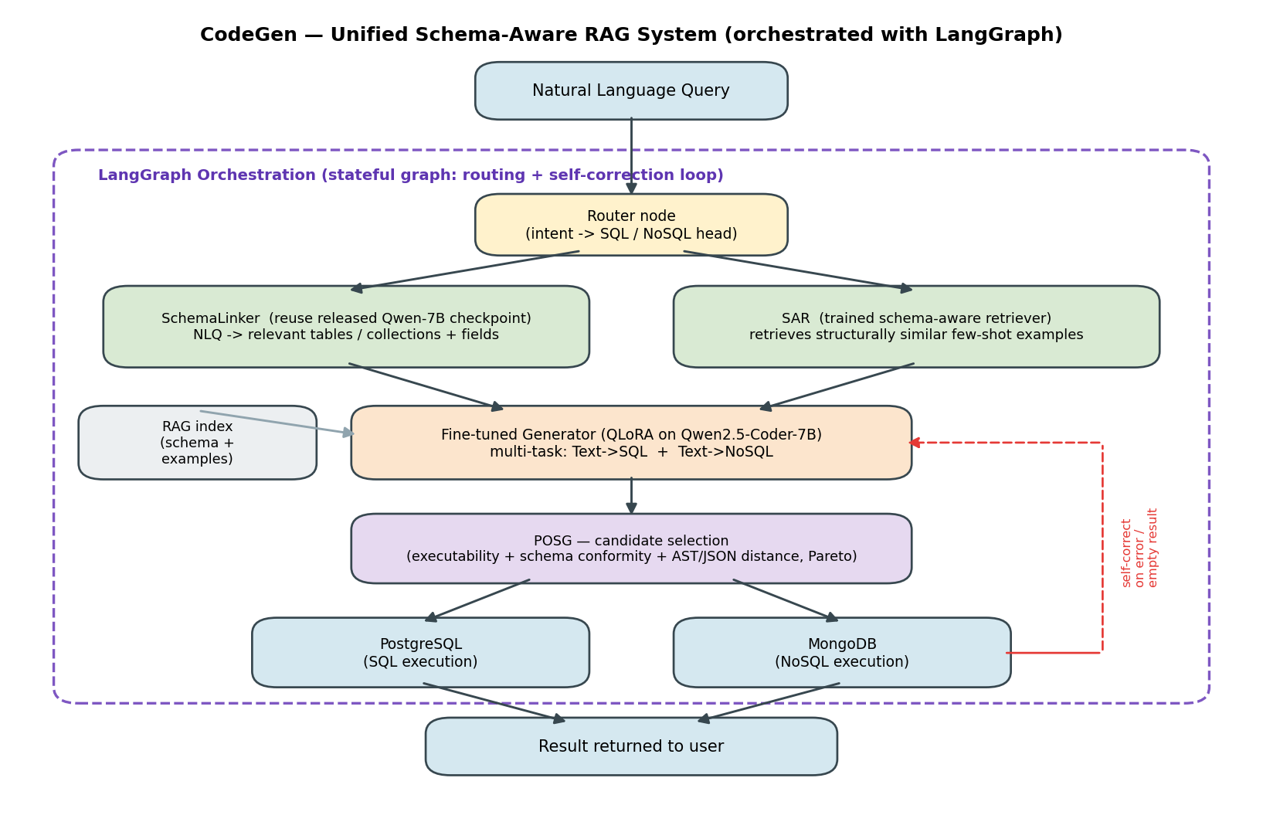
Figure 1. Unified schema-aware RAG architecture, orchestrated with LangGraph.
Flow in brief:
- Router classifies the question and selects the SQL or NoSQL head (and execution engine).
- SchemaLinker identifies the relevant tables/collections and fields (reusing the released Qwen-7B checkpoint).
- SAR retrieves structurally similar few-shot examples from the RAG index (schema + prior query examples).
- Generator (fine-tuned Qwen2.5-Coder-7B, multi-task on SQL + NoSQL) produces candidate queries.
- POSG executes candidates, keeps those that run, and selects the best by schema conformity and structural similarity.
- Self-correction loop: on an execution error or empty result, the error is fed back and the query is regenerated (capped retries).
Components used: RAG (schema-aware retrieval), LangGraph (agentic orchestration), QLoRA fine-tuning, PostgreSQL and MongoDB execution engines, and the open-source SchemaRAG modules (SchemaLinker, SAR, POSG).

4.1 SQL-to-NoSQL Migration Variant
The same backbone serves SQL-to-NoSQL migration; only the front end changes, and verification gets stronger. Because the input is already a SQL query, schema linking is no longer a guessing problem — the tables, columns and joins are read directly from the SQL by a parser. The router is skipped (the target is always MongoDB). The retriever, generator, candidate selection and self-correction loop are all reused unchanged.
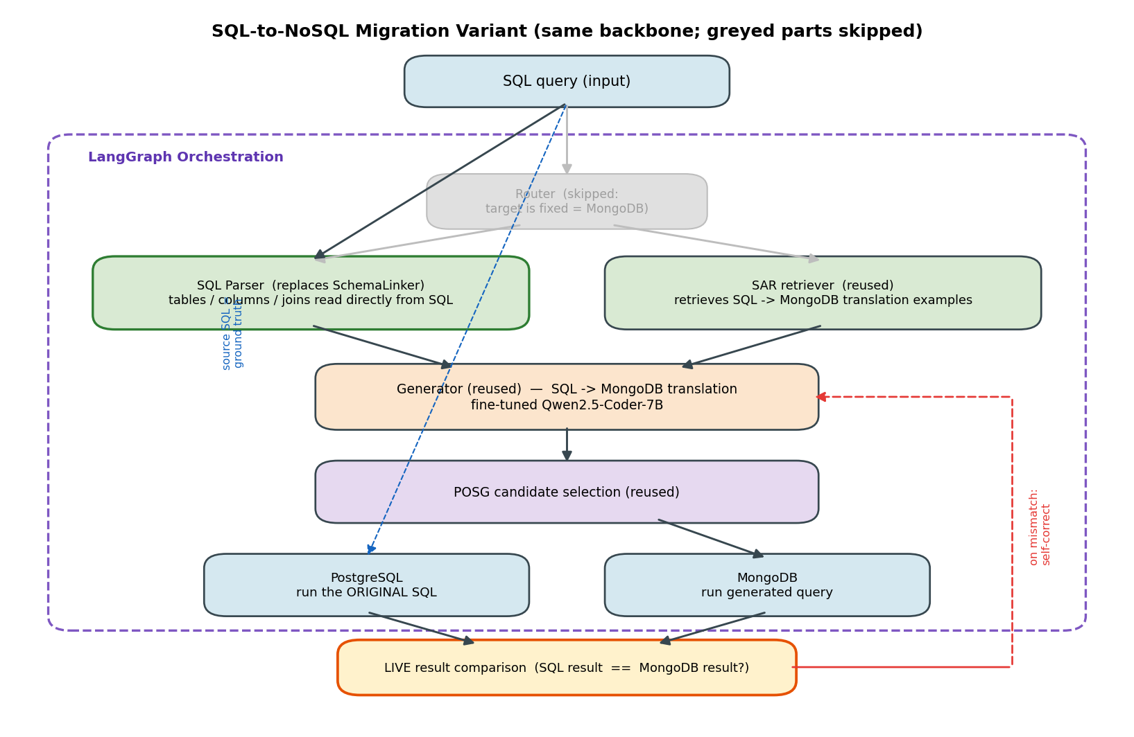
Figure 2. SQL-to-NoSQL variant. Greyed boxes are skipped; the live SQL-vs-MongoDB result comparison is the key advantage.
Key advantage and key limitation:
- Stronger correctness check: the original SQL is run on PostgreSQL and the generated query on MongoDB, and their results are compared live — the source SQL acts as ground truth, so no stored answer is needed.
- Structural mismatch is the hard part: normalized joins must become embedded documents or $lookup, and some SQL constructs have no clean MongoDB equivalent. The deliverable reports which query classes translate cleanly.
- Scoped as migration-only and deferred: it is used when the input is already correct SQL (e.g., porting an app), not for English questions, to avoid stacking errors.

4.2 What We Train vs. What We Reuse
Training happens offline, before the inference flow shown above. Only two components are actually trained:
- Trained (main): the Generator — fine-tune Qwen2.5-Coder-7B with QLoRA on combined SQL + NoSQL data (CP2).
- Trained (small): the SAR retriever — light contrastive training so it retrieves by query structure; the underlying text-embedding model stays frozen (CP2/CP3).
- Reused, not trained: the SchemaLinker — the authors’ released Qwen-7B checkpoint, run in inference only. Skipping this training is the biggest time-saver.
- Not trained (logic only): POSG candidate selection, LangGraph orchestration, and the SQL parser.
- Used untrained on purpose: codegen-350M as the weak baseline, to show where small models fail.

5. Checkpoint-Mapped Deliverables
Checkpoint | Focus | Deliverables
CP1 | Data + baselines | PostgreSQL & MongoDB in Docker; convert a clean subset of Spider DBs to MongoDB (nested-document transform); codegen-350M baseline for Text-to-SQL and Text-to-NoSQL with execution-based scores.
CP2 | Schema-aware generation | Integrate released SchemaLinker; train SAR retriever; wire POSG selection; fine-tune Qwen2.5-Coder-7B (QLoRA, multi-task SQL+NoSQL). Report Execution Accuracy lift over baseline.
CP3 | RAG + agentic orchestration + NoSQL extension | LangGraph orchestration (routing + self-correction); extend schema-aware retrieval to MongoDB; full RAG evaluation; component ablation (effect of linker / retriever / selection).
CP4 | Migration + deployment | SQL-to-NoSQL migration utility (SQL input only); end-to-end demo (simple API/UI); final comparative evaluation across both engines; report + presentation + 3 paper summaries.

Note: the roadmap is intentionally custom (focused on querying rather than documentation generation) and will be refined after discussion with the professor.

6. Technologies and Components
Area | Choice
Baseline model | codegen-350M-multi (deliberately weak baseline)
Main generator | Qwen2.5-Coder-7B-Instruct or LLAMA 8B, fine-tuned with QLoRA (multi-task SQL + NoSQL)
Schema linking | SchemaRAG SchemaLinker (open-source Qwen-7B checkpoint, reused)
Retrieval (RAG) | Schema-Aware Retriever (SAR) over a schema + example index
Candidate selection | POSG: executability + schema conformity + structural similarity (Pareto)
Agentic orchestration | LangGraph (routing + self-correction loop)
Databases | PostgreSQL (relational), MongoDB (document) — run locally in Docker
Evaluation | Execution Accuracy (primary); Exact Match / field-match (diagnostics)
Datasets | Spider, BIRD; TEND-style NoSQL set built from Spider

6.1 Evaluation Metrics
Correctness is judged by executing queries, not by how they look:
- Execution Accuracy (EX) — primary metric for both SQL and NoSQL: run the generated query and check it returns the same result as the gold query.
- Valid query / executability rate — fraction of generated queries that run without error.
- Exact Match (EM) — secondary, string-level match for SQL; reported only as a diagnostic because it unfairly penalises harmless surface differences.
- NoSQL field/value match — Exact Field Match and Exact Value Match: does the query touch the right fields and return the right values?
- SQL-to-NoSQL migration — direct result equivalence: run the source SQL on PostgreSQL and the generated query on MongoDB and compare result sets live.
- Component ablation — measure the EX gain from adding SchemaLinker, SAR, and POSG (mirrors the SchemaRAG study).

7. Scope and Risk Notes
- Direct Text-to-NoSQL is the primary path; SQL-to-NoSQL is a later migration-only feature, because cascading two models accumulates error (per the Text-to-NoSQL paper).
- The small baseline model is expected to score poorly, especially on NoSQL syntax — this is intentional and used to motivate the schema-aware, fine-tuned approach.
- Naive text-similarity RAG can hurt accuracy; the project uses schema-aware retrieval to avoid this.
- Reusing the open-source SchemaLinker checkpoint removes the most expensive training step.

8. Key References and Summaries

SchemaRAG (Wu, Tang, He, Luo — Proc. ACM on Management of Data / SIGMOD 2026)
SchemaRAG is a schema-aware RAG framework for Text-to-SQL with three parts: a fine-tuned SchemaLinker that maps a question to the right tables and columns; a Schema-Aware Retriever (SAR) that fetches few-shot examples by SQL structure rather than surface text; and a Pareto-optimal generator that picks the best executable candidate. It shows naive RAG can reduce accuracy on small models, while schema-aware retrieval and schema linking give consistent gains across Spider, BIRD and harder benchmarks. The trained SchemaLinker model and datasets are released, so the framework can run on open models like Llama or Qwen. It is the methodological backbone of this project.

Text-to-NoSQL (TEND) — Text-to-NoSQL task, dataset and metrics
This paper introduces the Text-to-NoSQL task: generating MongoDB queries from natural language. It builds parallel data by transforming relational schemas into nested document collections and converting queries, verifying each pair by executing both versions. It defines execution-based metrics (e.g., exact field/value match) suited to documents. Key findings used here: tiny sequence models essentially fail (~0%), fine-tuned small LLMs do far better, and direct Text-to-NoSQL beats cascading Text-to-SQL then SQL-to-NoSQL because the cascade accumulates errors. This justifies our direct-generation-first strategy and our evaluation design.

