Telemedical Consultation System
Database Systems Final Project
Instructor: Dr. Howlader
Presentation Date: May 05, 2026

Group Member Name | Student ID
Your Name | Your Student ID
Member 2 | Your Student ID
Member 3 | Your Student ID
Member 4 | Your Student ID

1. Project Description
The Telemedical Consultation System is a database-driven web application designed to manage remote medical consultations. The system allows healthcare staff to register patients, add doctors, book consultation appointments, update appointment status, and record diagnosis, treatment, prescription, and follow-up information.

Purpose and Background
Telemedicine is useful when patients need medical advice without physically visiting a clinic. A small clinic needs an organized system to store patient information, doctor information, appointment schedules, and consultation records. This project demonstrates how a MySQL relational database can support a real-world telemedical workflow.

Key Features
- Add and view patients.
- Add and view doctors.
- Book telemedical appointments.
- Update appointment status.
- Add medical records after consultations.
- View dashboard summary counts.

Design Considerations
The database is normalized into four main tables: Patients, Doctors, Appointments, and Medical Records. Foreign keys are used to maintain relationships and data integrity. The front-end is simple and easy to use for a classroom demonstration.

2. Requirement / System Analysis

Functional Requirements
- The system shall allow users to add new patients.
- The system shall allow users to add new doctors.
- The system shall allow users to book appointments between patients and doctors.
- The system shall allow users to update appointment status.
- The system shall allow users to add medical records for appointments.
- The system shall display dashboard statistics.

Non-Functional Requirements
- The system should be simple and easy to use.
- The system should store data in MySQL.
- The system should maintain relationships using primary keys and foreign keys.
- The system should run locally on a MacBook for class demonstration.

3. ER Model
The following ER model shows the main entities, keys, and relationships used by the project.
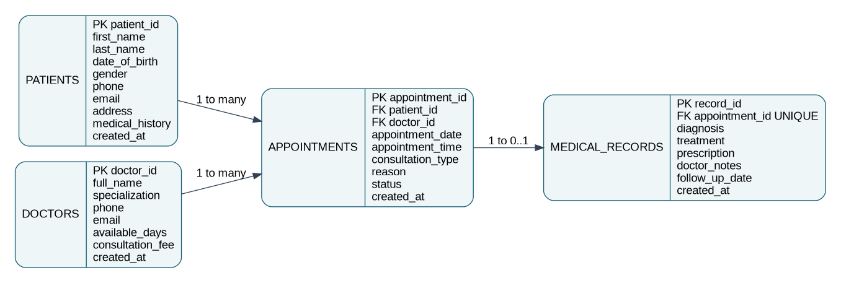

4. Relational Schema
Table | Attributes
Patients | patient_id PK, first_name, last_name, date_of_birth, gender, phone, email, address, medical_history, created_at
Doctors | doctor_id PK, full_name, specialization, phone, email, available_days, consultation_fee, created_at
Appointments | appointment_id PK, patient_id FK, doctor_id FK, appointment_date, appointment_time, consultation_type, reason, status, created_at
Medical_Records | record_id PK, appointment_id FK UNIQUE, diagnosis, treatment, prescription, doctor_notes, follow_up_date, created_at

Relationships
- Patients.patient_id -> Appointments.patient_id: one patient can have many appointments.
- Doctors.doctor_id -> Appointments.doctor_id: one doctor can have many appointments.
- Appointments.appointment_id -> Medical_Records.appointment_id: one appointment can have one medical record.

5. Front-End Interface
After running the project, insert screenshots of these pages. Use Shift + Command + 4 on Mac to take screenshots.
Interface | Purpose | Screenshot Placeholder
Dashboard | Displays total patients, doctors, appointments, medical records, and recent appointments. | Paste screenshot here
Patients Page | Adds patient information and displays registered patients. | Paste screenshot here
Doctors Page | Adds doctor information and displays doctor availability and consultation fee. | Paste screenshot here
Appointments Page | Books appointments and updates appointment status. | Paste screenshot here
Medical Records Page | Stores diagnosis, treatment, prescription, doctor notes, and follow-up date. | Paste screenshot here

6. Conclusion
The Telemedical Consultation System demonstrates a complete database application with a front-end interface and a MySQL back-end. It uses ER modeling, relational schema design, primary keys, foreign keys, and a working web interface to manage telemedical consultations.

