Robust Image Classification: Classical ML Model Comparison
Comparing SVM, Decision Tree, Random Forest, KNN, Gradient Boosting, and XGBoost on a CIFAR-10-style image dataset, with hyperparameter tuning via GridSearchCV.

1. Project Overview
This project builds and compares six classical machine learning classifiers for 10-class image classification (airplane, automobile, bird, cat, deer, dog, frog, horse, ship, truck) on 32x32 RGB images. Each model was tuned with GridSearchCV over a hyperparameter grid, evaluated on a held-out validation split, and the best model was used to generate predictions on the unlabeled test set.

2. Dataset
- 29,400 labeled training images (32x32 RGB, PNG format), 7,600 unlabeled test images.
- 10 classes: airplane, automobile, bird, cat, deer, dog, frog, horse, ship, truck.
- Class distribution is imbalanced: airplane/automobile/bird/cat = 5,000 each; dog/deer = 4,000 each; frog/horse = 500 each; ship = 300; truck = 100.
- Train/validation split: 85% / 15%, stratified by class (24,990 train / 4,410 validation).

3. Feature Engineering & Pipeline
Classical ML models do not operate on raw image tensors the way CNNs do, so the pipeline converts each image into a fixed-length numeric feature vector:
- Pixels flattened to a 3,072-dim vector (32x32x3) and scaled to [0,1].
- Standardization (zero mean, unit variance) via StandardScaler, fit on the training split only.
- Dimensionality reduction via PCA to 100 components, retaining ~90% of variance. This makes SVM/KNN/GB training tractable and reduces overfitting risk for tree-based models.
- The same scaler and PCA transform (fit only on training data) were applied to the validation and test sets.

4. Hyperparameter Tuning (GridSearchCV)
Each model was tuned with scikit-learn's GridSearchCV (3-fold stratified cross-validation, accuracy scoring). Due to running in a single-CPU-core sandbox environment, grid search was performed on stratified subsamples of the training data (sizes noted below) rather than the full 24,990-row training set, and the winning configuration was then refit on a larger/full training set for final evaluation. This is a practical compute trade-off — with more compute, the same grids could be searched over the full training set directly.
Model | Val Accuracy | CV Accuracy | Tune Time(s) | Final Fit(s) | Tune N | Final N
SVM | 55.71% | 50.58% | 41.9 | 51.7 | 6000 | 24990
XGBoost | 55.12% | 51.69% | 301.0 | 43.1 | 8000 | 24990
RandomForest | 52.09% | 48.85% | 90.2 | 50.0 | 8000 | 24990
GradientBoosting | 47.73% | 43.83% | 510.9 | 239.3 | 3000 | 8000
KNN | 44.24% | 39.63% | 2.8 | 0.0 | 10000 | 24990
DecisionTree | 39.21% | 34.89% | 10.8 | 2.8 | 8000 | 24990

Best hyperparameters found for each model:
Model | Best Hyperparameters (via GridSearchCV)
SVM | C=1, gamma=scale
XGBoost | learning_rate=0.2, max_depth=6, n_estimators=200
RandomForest | max_depth=20, n_estimators=200
GradientBoosting | learning_rate=0.2, n_estimators=100
KNN | n_neighbors=7, weights=distance
DecisionTree | max_depth=10, min_samples_split=10

5. Model Comparison
Ranked by validation accuracy, SVM (RBF kernel) was the best-performing classical model, closely followed by XGBoost. Both substantially outperform Decision Tree and KNN, reflecting their greater capacity to model the complex, non-linear structure of image pixel data even after PCA compression.
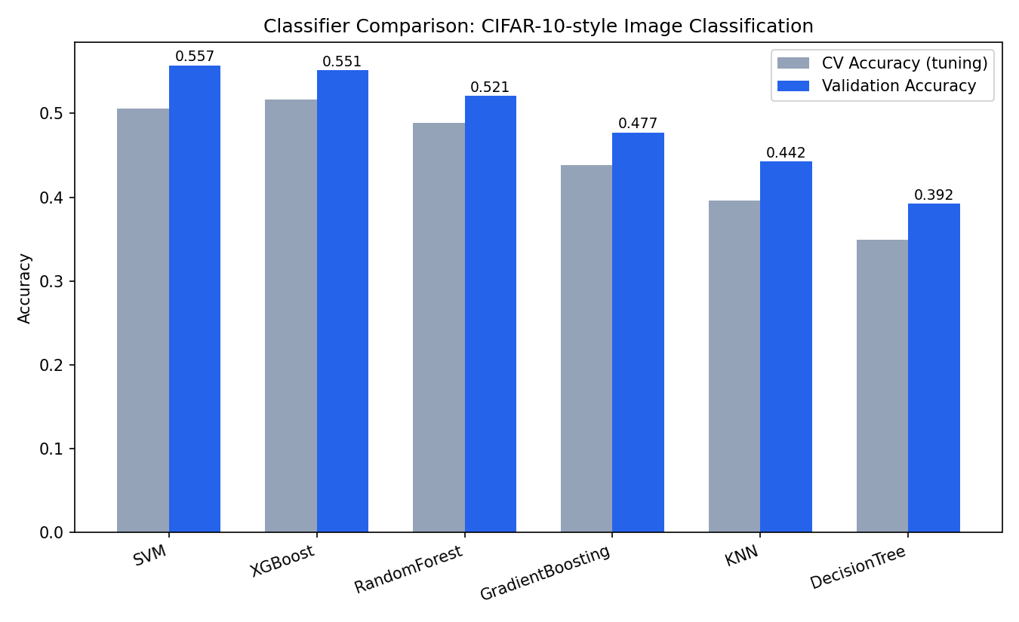

6. Best Model: Detailed Evaluation (SVM)
The best model was SVM with a validation accuracy of 55.71% (hyperparameters: C=1, gamma=scale).
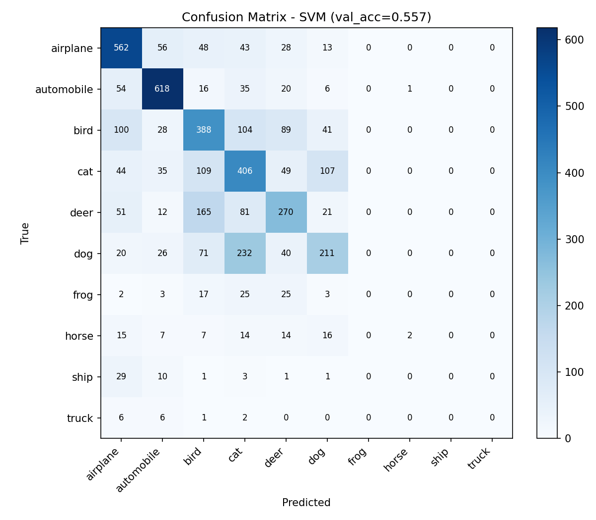
The confusion matrix shows strong performance on the majority classes (airplane, automobile, bird, cat, deer, dog) but near-zero recall on the minority classes (frog, horse, ship, truck), which have far fewer training examples (100-500 vs. 4,000-5,000). This is a direct consequence of class imbalance rather than a flaw in the model itself.
A class-weighted variant (class_weight='balanced') was also tested: it traded overall accuracy (52.1% vs. 55.7%) for substantially better recall on minority classes (e.g. frog recall improved from 0% to 37%, ship from 0% to 49%), illustrating the standard accuracy/fairness trade-off under class imbalance. For a production system where minority classes matter, this weighted variant (or oversampling/SMOTE) would be preferable despite the lower raw accuracy.

7. Key Takeaways
- SVM (RBF) and XGBoost were the top two models, both achieving ~55% validation accuracy — a reasonable ceiling for classical ML on raw/PCA pixel features without convolutional feature learning.
- Tree-based ensembles (Random Forest, XGBoost) outperformed single Decision Trees, confirming the value of ensembling for this task.
- KNN and Decision Tree underperformed, both being more sensitive to the curse of dimensionality and less able to capture the non-linear pixel patterns that distinguish visually similar classes (e.g. cat vs. dog, deer vs. horse).
- Class imbalance is the single biggest limiter of minority-class performance; addressing it (class weights, oversampling, or additional data collection) would likely yield the largest accuracy gains from here.
- A CNN-based approach (referenced in the original project scope) would be expected to substantially outperform all classical models here, since convolutional layers learn spatially-aware features directly from pixels rather than relying on flattened/PCA-compressed vectors.

8. Deliverables
- load_data.py — loads images and labels into numpy arrays.
- preprocess.py — scaling + PCA feature pipeline.
- train_models.py — GridSearchCV tuning and training for all 6 classifiers.
- finalize.py — best-model selection, test-set predictions, confusion matrix & comparison charts.
- submission.csv — predicted labels for all 7,600 test images (id, label columns).
- results.json — full metrics and best hyperparameters for every model.
- best_estimators.pkl — pickled fitted models for all 6 classifiers.

