Система оркестрации

Манифест deployment green ( 2 ) и blue ( 1 )

apiVersion: apps/v1
kind: Deployment
metadata:
name: web-go-blue
labels:
app: myapp
version: "1.0"
spec:
replicas: 10
selector:
matchLabels:
app: myapp
color: blue
template:
metadata:
labels:
app: myapp
color: blue
version: "1.0"
spec:
containers:
- name: myapp-container
image: kethisxd/do.kt3:1.0.0
ports:
- containerPort: 8080
imagePullPolicy: IfNotPresent

apiVersion: apps/v1
kind: Deployment
metadata:
name: web-go-green
labels:
app: myapp
version: "2.0"
spec:
replicas: 10
selector:
matchLabels:
app: myapp
color: green
template:
metadata:
labels:
app: myapp
color: green
version: "2.0"
spec:
containers:
- name: myapp-container
image: kethisxd/do.kt3:2.0.0
ports:
- containerPort: 8080
imagePullPolicy: IfNotPresent

Servece

apiVersion: v1
kind: Service
metadata:
name: myapp-service
labels:
app: myapp
spec:
type: NodePort
selector:
app: myapp
color: blue # на старте направляем трафик на blue
ports:
- port: 80
targetPort: 8080
nodePort: 30081

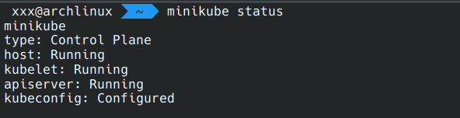
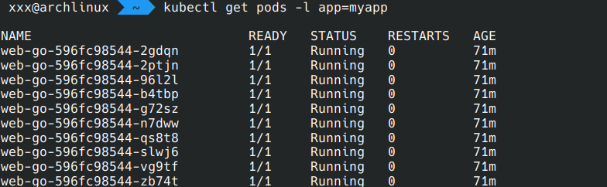

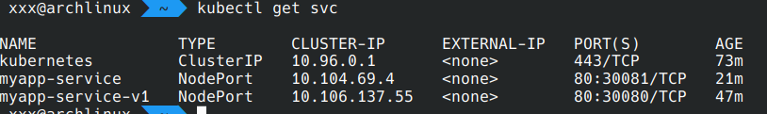

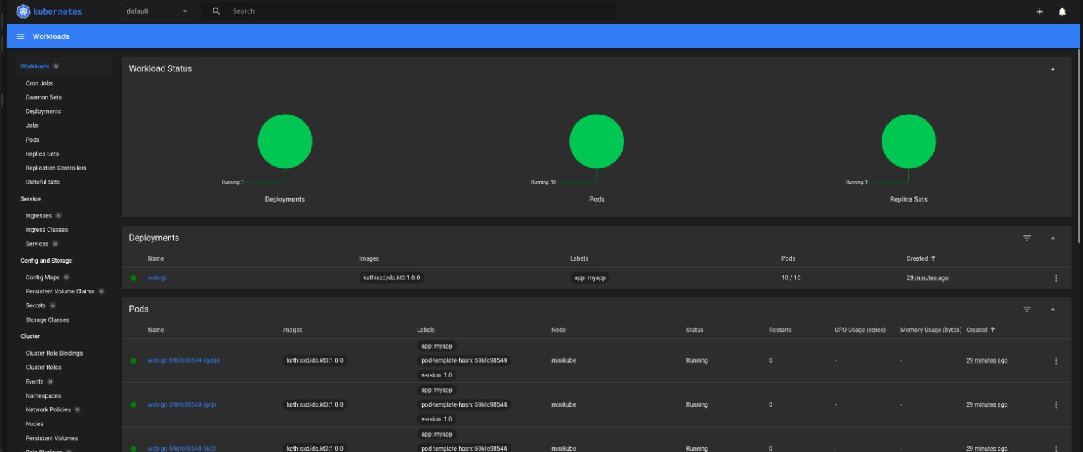
дашборд

Обновление версии
1. Прописываем манифесты
kubectl apply -f deployment-b.yml
kubectl apply -f deployment-g.yml

2. Переключение трафика

kubectl patch service myapp-service \
--type='json' \
-p='[{"op":"replace","path":"/spec/selector/color","value":"green"}]'

3. Удаление старой версии

kubectl delete deployment web-go-blue
