FREE UNIVERSITY OF TBILISI
School of Computer Science, Mathematics and Engineering (MACS[E])
Electrical and Computer Engineering Program
[Surname Name]
[Surname Name]
SENIOR PROJECT
A Gesture-Controlled Wearable Musical Instrument:
Two Asymmetric Sensor Gloves for Real-Time
Sound Synthesis and Live Looping
Supervisor: [Surname Name]
Tbilisi
2025

Abstract
This project presents a gesture-controlled wearable musical instrument built from two sensor gloves. Each glove carries an ESP32 microcontroller, a BNO08x inertial measurement unit with on-chip sensor fusion, two flex sensors, a MEMS microphone and a push button, and communicates with a host computer over Bluetooth Low Energy. The host runs a real-time synthesis and audio-processing engine written in Python and NumPy, together with a browser-based control panel.
The problem addressed is the discrete nature of conventional musical controllers. Keyboards, pads and control surfaces are built from switches and potentiometers, each of which maps one fixed physical action onto one parameter. Continuous, simultaneous and expressive control of several sound parameters at once is therefore awkward, and the physical link between what the performer does and what the audience hears is weak. Commercially available gestural instruments such as the Mi.Mu gloves demonstrate that the approach works musically, but their cost places them beyond most performers, students and institutions.
The central design decision of this project is that the two hands are deliberately asymmetric. One hand produces sound — pitch, brightness, dynamics and articulation — and never touches an effect. The other hand shapes material that has already been captured: position within a recording, playback rate, texture, spatial placement and freezing of time. Every parameter of the instrument belongs to exactly one hand. An earlier symmetric design, in which both hands carried the same vocabulary pointed at two sound sources, was rejected because it amounted to one instrument played twice.
The system was built and measured rather than simulated. Audio is rendered in blocks of 256 samples at 44.1 kHz, giving a 5.8 ms deadline for every block; gesture data is applied at a 100 Hz control rate, and the gloves report orientation at 50 Hz. Several engineering problems were identified and solved during development, including an I2C bus speed that caused the inertial sensor to wedge under Bluetooth load, a flex sensor divider that used only about five percent of the available analogue-to-digital range, a hardware fault mode in which a shorted button silently overwrote recorded material, and an instrument designer whose presets were measurably almost identical until a per-voice filter was introduced.
The result is a working two-handed instrument that can be played live, can capture and manipulate audio from its own microphone, can load and perform on external audio files, and allows the performer to design new synthesiser voices. The total hardware cost is a small fraction of the commercial alternative.
Keywords: gestural interface, wearable computing, digital musical instrument, real-time audio synthesis, inertial measurement, Bluetooth Low Energy, live looping, embedded systems.

ანოტაცია
წინამდებარე პროექტი წარმოადგენს ჟესტებით მართვად wearable მუსიკალურ ინსტრუმენტს, რომელიც აგებულია ორი სენსორული ხელთათმანისგან. თითოეულ ხელთათმანზე განთავსებულია ESP32 მიკროკონტროლერი, BNO08x ინერციული სენსორი ჩაშენებული სენსორული შერწყმით, ორი flex სენსორი, MEMS მიკროფონი და ღილაკი. ხელთათმანები კომპიუტერს უკავშირდებიან Bluetooth Low Energy პროტოკოლით. კომპიუტერზე მუშაობს რეალურ დროში ხმის სინთეზისა და დამუშავების სისტემა, დაწერილი Python-სა და NumPy-ზე, აგრეთვე ბრაუზერზე დაფუძნებული სამართავი პანელი.
პროექტი პასუხობს ტრადიციული მუსიკალური კონტროლერების დისკრეტულობის პრობლემას. კლავიატურები, პედლები და საკონტროლო პანელები აგებულია ღილაკებისა და რეგულატორებისგან, რომელთაგან თითოეული ერთ ფიზიკურ მოქმედებას ერთ პარამეტრზე ასახავს. შესაბამისად, რამდენიმე პარამეტრის ერთდროული და უწყვეტი მართვა რთულია, ხოლო შემსრულებლის მოძრაობასა და მიღებულ ხმას შორის კავშირი სუსტია. ბაზარზე არსებული ჟესტური ინსტრუმენტები, როგორიცაა Mi.Mu ხელთათმანები, ადასტურებენ მიდგომის მუსიკალურ ღირებულებას, თუმცა მათი ფასი მათ მიუწვდომელს ხდის შემსრულებელთა უმრავლესობისთვის.
პროექტის ცენტრალური საინჟინრო გადაწყვეტილებაა ორი ხელის განზრახ ასიმეტრიულობა. ერთი ხელი ქმნის ხმას — სიმაღლეს, სიკაშკაშეს, დინამიკას და არტიკულაციას — და ეფექტებს არასოდეს ეხება. მეორე ხელი ამუშავებს უკვე ჩაწერილ მასალას: პოზიციას ჩანაწერში, დაკვრის სიჩქარეს, ტექსტურას, სივრცულ განლაგებას და დროის გაყინვას. ინსტრუმენტის თითოეული პარამეტრი ზუსტად ერთ ხელს ეკუთვნის. ადრეული სიმეტრიული ვერსია, სადაც ორივე ხელს ერთნაირი ფუნქციები ჰქონდა, უარყოფილ იქნა, რადგან ის წარმოადგენდა ერთ ინსტრუმენტს, ორჯერ დაკრულს.
სისტემა აგებულია და გაზომილია და არა სიმულირებული. ხმა გენერირდება 256 სემპლიანი ბლოკებით 44.1 kHz სიხშირეზე, რაც თითოეული ბლოკისთვის 5.8 მილიწამიან ვადას განსაზღვრავს; ჟესტების მონაცემები გამოიყენება 100 Hz სიხშირით, ხოლო ხელთათმანები ორიენტაციას 50 Hz-ზე აგზავნიან. მუშაობის პროცესში გამოვლინდა და გადაიჭრა რიგი საინჟინრო პრობლემა: I2C მაგისტრალის სიჩქარე, რომელიც Bluetooth-ის დატვირთვისას ინერციულ სენსორს აჩერებდა; flex სენსორის გამყოფი, რომელიც ანალოგურ-ციფრული გარდაქმნის დიაპაზონის მხოლოდ ხუთ პროცენტს იყენებდა; აპარატურული ხარვეზი, რომლის დროსაც შემოკლებული ღილაკი უჩუმრად შლიდა ჩაწერილ მასალას; და ინსტრუმენტების დიზაინერი, რომლის პრესეტები გაზომვით თითქმის იდენტური იყო, სანამ თითოეულ ხმას ცალკე ფილტრი არ მიენიჭა.
შედეგად მიღებულია მომუშავე ორხელიანი ინსტრუმენტი, რომელიც საშუალებას იძლევა ცოცხალი შესრულების, საკუთარი მიკროფონიდან ხმის ჩაწერისა და დამუშავების, გარე აუდიოფაილებზე მუშაობისა და ახალი სინთეზატორული ხმების შექმნის. აპარატურის ჯამური ღირებულება კომერციული ალტერნატივის მცირე ნაწილს შეადგენს.
საკვანძო სიტყვები: ჟესტური ინტერფეისი, wearable ტექნოლოგია, ციფრული მუსიკალური ინსტრუმენტი, რეალურ დროში ხმის სინთეზი, ინერციული სენსორები, Bluetooth Low Energy, ლაივ ლუპინგი, ჩაშენებული სისტემები.

Table of Contents
Abstract
ანოტაცია
Table of Contents
List of Figures and Tables
Figures
Tables
1. Introduction
1.1 Choosing the topic
1.2 Motivation
1.3 Prior work and the novelty of this project
1.4 Relevance
1.5 Aim of the project
1.6 Methods and approach
1.7 Intended users and fields of application
1.8 Known limitations
2. Problem Statement and Field Research
2.1 Technologies and market in the field
2.1.1 Conventional MIDI controllers
2.1.2 Camera and optical systems
2.1.3 Wearable gestural controllers
2.1.4 Research instruments
2.2 Challenges in the field
2.3 Development prospects
2.4 Statement of the problem
2.5 Why the project is innovative
2.6 Technical task
2.7 Material and technical resources
2.8 Relevance and potential commercialisation
3. Technical Implementation
3.1 System architecture
3.2 Hardware design
3.2.1 Orientation sensing
3.2.2 Finger sensing
3.2.3 Audio capture
3.2.4 Indication
3.3 Gesture mapping: the central design decision
3.3.1 The live hand
3.3.2 The loop hand
3.3.3 Two-handed gestures
3.3.4 Separating postures from continuous control
3.4 Synthesis engine
3.4.1 Voice generation
3.4.2 Filtering and effects
3.4.3 Time-domain manipulation
3.5 Communication protocol
3.7 Engineering problems and their resolution
3.7.1 Inertial sensor stalling under Bluetooth load
3.7.2 Flex sensor resolution
3.7.3 A hardware fault that destroyed the performer's work
3.7.4 Instrument presets that were not actually different
3.7.5 Playhead instability from hand tremor
3.7.6 Memory and pin allocation constraints
3.8 Timing budget
3.9 Justification of the chosen approach
4. Results and Evaluation
4.1 Final result
4.2 Evaluation against the success criteria
4.2.1 Gesture recognition
4.2.2 Latency
4.2.3 Stability
4.2.4 Subjective usability
4.3 Assessment against the project aim
4.4 Division of work
5. Conclusion
5.1 Principal aspects of the project
5.2 Results obtained
5.3 Knowledge and experience gained
5.4 Future work
6. References
7. Appendices
Appendix A. Source code
Appendix B. Gesture reference
Appendix C. Hardware reference

List of Figures and Tables
Every figure and table in this report is numbered and captioned. The list below must be regenerated once the final figures are inserted.

Figures
Figure 1. The glove — hardware layout, components and pin assignments. 10
Figure 2. The two hands — what each movement does. 11
Figure 3. The assembled gloves. 12
Figure 4. The wrist enclosure as modelled. 14
Figure 5. The browser control panel during a live session. 20
Figure 6. Flex sensor voltage divider and its usable ADC range. 21
Figure 7. Spectral similarity between designed instruments, before and after the per-voice filter. 23

Tables
Table 1. Hardware components and their role.
Table 2. Gesture vocabulary of the live hand.
Table 3. Gesture vocabulary of the loop hand.
Table 4. Two-handed combined gestures.
Table 5. Timing budget of the real-time path.
Table 6. Engineering problems encountered and their resolutions.
Table 7. Evaluation against the project's success criteria.

1. Introduction

1.1 Choosing the topic
The subject of this project was chosen at the intersection of two interests within the team: electronic music performance and embedded sensing. Both authors had encountered the same frustration from opposite directions. Performing electronic music in front of an audience is visually inert — the performer stands behind a laptop, and the causal link between the performer's actions and the sound is invisible. From the engineering side, the sensors required to capture human movement precisely enough to drive sound have become inexpensive and accurate, while the instruments built from them remain rare and costly.
The specific trigger was the Mi.Mu glove system, developed by a team including the musician Imogen Heap. Mi.Mu demonstrates convincingly that a glove-based instrument is musically viable rather than a novelty. It also demonstrates the barrier: at the time of writing the gloves are priced far beyond the reach of a student, an amateur performer or a university music department. The question that framed this project was therefore not whether gestural musical control can work, but whether a system of comparable expressive range can be built from components costing a small fraction of that price.

1.2 Motivation
Conventional electronic instruments are built almost entirely from discrete controls. A key is pressed or not pressed; a pad is struck or not struck; a knob is turned to a position and stays there. Continuous expression is possible only through additional dedicated controls — a modulation wheel, an expression pedal, an aftertouch sensor — each of which adds a separate physical action for the performer to manage. As a result, controlling several parameters simultaneously and continuously requires either both hands on a control surface or a prepared automation.
Acoustic instruments do not work this way. A violinist controls pitch, volume, timbre and articulation simultaneously and continuously through a single coordinated physical gesture, and the relationship between the movement and the sound is legible to an audience. The motivation for this project is to recover that property for electronic sound: to make the hand itself the controller, so that several parameters move together as one physical action.

1.3 Prior work and the novelty of this project
Gestural control of music is an established field. Camera-based systems, infrared hand trackers such as the Leap Motion, accelerometer-equipped wands and glove controllers have all been demonstrated. Commercially, the Mi.Mu glove is the most complete realisation of the glove approach [8]. In research, the field is served by the New Interfaces for Musical Expression (NIME) community, which has produced a large literature on mapping strategies — the question of how sensor data should be connected to sound parameters [6], [7].
What distinguishes this project is not the use of gloves, which is not new, but three specific design positions taken together:
- The two hands are asymmetric by design. Each parameter of the instrument exists exactly once and belongs to exactly one hand. This is a mapping decision rather than a hardware one, and it is the decision that most affects how the instrument plays.
- The system is a complete instrument, not a controller. Rather than emitting MIDI for other software to interpret, it contains its own synthesis engine, its own effects, its own looper and its own instrument designer. The gesture-to-sound path is therefore fully under the project's control, and the latency of that path is a property that can be measured and optimised rather than inherited.
- Audio capture is part of the instrument. Each glove carries a microphone, so the performer's voice or any nearby sound can be captured and then manipulated by gesture. The material being shaped is not limited to what the synthesiser can produce.
The novelty claimed is therefore one of integration and of mapping discipline at a cost level that makes the approach accessible, rather than the invention of a new sensing technology.

1.4 Relevance
The relevance of the project is threefold. For performers, it lowers the cost barrier to gestural performance by roughly two orders of magnitude relative to the commercial alternative. For audiences, it restores the visible causality between movement and sound that electronic performance generally lacks. For engineering education, it is a compact example of a hard real-time system in which sensing, wireless communication, digital signal processing and user interface design all constrain one another, and in which failure is immediately audible.

1.5 Aim of the project
The aim of the project is to design, build and evaluate a wearable, gesture-controlled musical instrument consisting of two sensor gloves and a host synthesis engine, such that a performer can control pitch, timbre, dynamics, spatial placement and time-based effects continuously and simultaneously through natural hand movement, with a latency low enough for live performance.

1.6 Methods and approach
The project followed an iterative hardware-and-software approach. Sensor characterisation came first: establishing what the inertial measurement unit and the flex sensors could actually resolve, and how much noise had to be removed before the data could drive sound. The synthesis engine was then developed against a simulated glove, so that the audio path could be designed and debugged independently of hardware availability. Gesture mapping was developed last, because it is the layer where musical judgement rather than engineering correctness decides the outcome, and it required a working instrument to evaluate.
Throughout, decisions were made against measurement rather than impression wherever a measurement was possible. Section 3 describes several cases in which an apparently working subsystem was shown to be defective only once it was measured.

1.7 Intended users and fields of application
- Live electronic performers who want a visible, physical relationship between movement and sound.
- Studio musicians seeking continuous, hands-free control of effect parameters during recording.
- Educational settings, where the low cost makes a class set feasible and the system serves as a worked example of embedded real-time engineering.
- Accessibility applications, where an instrument requiring gross hand movement rather than fine fingering may be playable by people for whom conventional instruments are not. This is identified as a possible direction rather than a tested claim.

1.8 Known limitations
Several limitations are inherent to the approach and are stated here rather than discovered later in the report.
- The inertial sensor reports orientation only. Absolute position in space cannot be recovered, because obtaining it would require double integration of acceleration, which drifts into meaninglessness within seconds. “Raising the hand” is therefore not available as a gesture; tilting it is.
- Bluetooth Low Energy cannot carry live audio at usable quality and latency. Microphone material is therefore recorded on the glove and transferred after the fact, which is sufficient for looping but excludes live vocal processing through the glove microphone.
- Two flex sensors per hand give four distinguishable static postures. Richer finger vocabulary would require more sensors and more careful mechanical integration.
- The instrument is monophonic in its live voice. Polyphony is not a technical impossibility but was not pursued within the scope of this project.

2. Problem Statement and Field Research

2.1 Technologies and market in the field
The field of digital musical instruments can be divided, for the purposes of this project, into four groups.

2.1.1 Conventional MIDI controllers
Keyboards, drum pads, control surfaces and pedals dominate the market. They are mature, inexpensive and reliable, and their discrete nature is exactly what makes them precise. Their weakness is expressive: continuous control requires dedicated extra hardware, and the performer's body is largely static during use. Recent developments such as MIDI Polyphonic Expression (MPE) address this partially by allowing per-note continuous control, but the physical interface remains a surface under the fingers.

2.1.2 Camera and optical systems
Systems based on cameras or infrared sensors, of which the Leap Motion is the best known, track the hand without instrumenting it. The advantage is that nothing is worn. The disadvantages are significant for performance: the hand must remain within a fixed sensing volume, performance degrades under stage lighting, and occlusion — one hand passing in front of the other — causes tracking loss at exactly the moments when a performer is most likely to make an expressive gesture.

2.1.3 Wearable gestural controllers
Inertial controllers worn on the body avoid the volume and occlusion limits because the sensor travels with the performer. This is the category the present project belongs to. The Mi.Mu glove is the reference product: a glove with inertial sensing, flex sensing and haptic feedback, with an accompanying mapping environment [8]. It is a complete and musically credible system, and its principal limitation is cost.

2.1.4 Research instruments
The NIME community has produced a large number of one-off instruments exploring mapping strategies, from simple one-to-one assignments to many-to-many mappings mediated by machine learning. The relevant conclusion from this literature for the present project is that mapping, rather than sensing, determines whether an instrument is playable [6], [7].

2.2 Challenges in the field
- Cost. Credible commercial gestural instruments remain priced as professional equipment, which excludes most of their potential users.
- Latency. The human tolerance for delay between an action and the resulting sound is low — on the order of ten milliseconds before a performer begins to perceive the instrument as unresponsive. Wireless links, operating-system audio stacks and processing all consume part of that budget.
- Drift and calibration. Inertial sensors must be referenced to some zero, and that reference moves. An instrument that must be recalibrated mid-performance is not usable on stage.
- The mapping problem. A sensor glove produces a continuous stream of numbers; music requires discrete events as well as continuous shaping. Deciding which gestures are events and which are continuous, and preventing one from accidentally triggering the other, is the central design difficulty.
- Mechanical durability. Wearable electronics fail at the wires, not at the components, and a glove is flexed thousands of times per session.

2.3 Development prospects
Two trends favour this class of instrument. First, inertial measurement units with on-chip sensor fusion — which output orientation directly rather than requiring the host to fuse raw accelerometer, gyroscope and magnetometer data — have become inexpensive. The BNO08x used in this project performs this fusion internally [10], which removes an entire category of filtering work from the host and is the single component decision that most simplified the system. Second, general-purpose processors are now fast enough to run non-trivial audio synthesis in an interpreted language with vectorised numerical libraries [12], which shortens development time considerably relative to writing the engine in C.

2.4 Statement of the problem
The problem this project addresses can be stated precisely as follows.
Conventional electronic musical controllers map discrete physical actions onto individual sound parameters, which prevents continuous simultaneous control of multiple parameters and severs the visible link between performer movement and resulting sound. Existing gestural instruments that solve this problem are priced beyond the reach of most performers. The task is to build a gesture-controlled instrument of comparable expressive range from inexpensive, widely available components, and to demonstrate that it responds quickly and reliably enough for live performance.

2.5 Why the project is innovative
The project is positioned as an innovative route to solving an existing challenge rather than as a new sensing technology. Its specific contributions are the asymmetric two-hand mapping described in Section 3.3, the integration of synthesis, effects, looping and instrument design into a single self-contained system, and the demonstration that this is achievable at a component cost roughly two orders of magnitude below the commercial reference.

2.6 Technical task
The technical task was decomposed into the following requirements.
- Capture hand orientation and finger flexion on both hands, with sufficient resolution to drive continuous sound parameters without audible stepping.
- Transmit that data wirelessly to a host computer at a rate adequate for musical control.
- Synthesise and process audio in real time on the host, within a block deadline short enough that total latency is not perceptible in performance.
- Record audio from a microphone on the glove and make it available for gestural manipulation.
- Provide a visual interface for state that cannot be conveyed by sound alone.
- Survive hardware faults without silently corrupting the performer's work.

2.7 Material and technical resources
Component | Role in the system | Qty
ESP32 (WROVER module) | On-glove processing, sensor reading, BLE communication | 2
BNO08x IMU | Hand orientation (roll, pitch, yaw) with on-chip sensor fusion | 2
Flex sensors | Finger bend, for continuous control and posture detection | 4
INMP441 MEMS microphone | I2S audio capture on the glove | 2
WS2812B addressable LED | Status and musical-state indication | 4
Push button | Discrete events: scene change and recording | 2
Elastic glove, wiring, resistors | Mechanical integration | 2 sets
Host computer | Synthesis, effects, looping, control panel | 1
Table 1. Hardware components and their role.

2.8 Relevance and potential commercialisation
The component cost of one pair of gloves is a small fraction of the price of the commercial reference product. This difference is what makes the system relevant to the users identified in Section 1.7, for whom the existing option is not merely expensive but unavailable.
Commercialisation is possible but was not the objective of this project, and three obstacles should be stated honestly. Mechanical durability of a hand-assembled glove is far below that of a manufactured product. Calibration currently requires the performer to understand what is being calibrated. And the software, while complete, assumes a user comfortable with a command line. A commercial route would require addressing all three, and would most plausibly target education, where cost sensitivity is high and tolerance for setup is greater than in professional performance.

3. Technical Implementation

3.1 System architecture
The system has three parts: the gloves, the host engine and the control panel.
Each glove is a self-contained embedded device. An ESP32 reads the inertial sensor over I2C, the two flex sensors through its analogue-to-digital converter, the button through a digital input with an internal pull-up, and the microphone over I2S [11]. It assembles the sensor readings into a fixed-format packet and transmits it over Bluetooth Low Energy as a notification, fifty times per second. The glove performs no musical interpretation whatsoever: it reports what the hand is doing and nothing more.
The host engine receives both gloves' streams, converts raw readings into musical control values, and renders audio. It is written in Python, with nearly all signal processing vectorised through NumPy, and runs its audio callback under PortAudio. The control panel is a browser page connected to the engine over a WebSocket on the local machine; it displays state and provides controls that the gloves have no hardware for, such as choosing an instrument or loading a track.
Figure 1 shows what is mounted on a glove and on which pin, together with the path a movement takes from the sensor to the loudspeaker. Figure 2 sets the two hands side by side; both are drawn from the pin numbers and the mapping tables in the source itself.
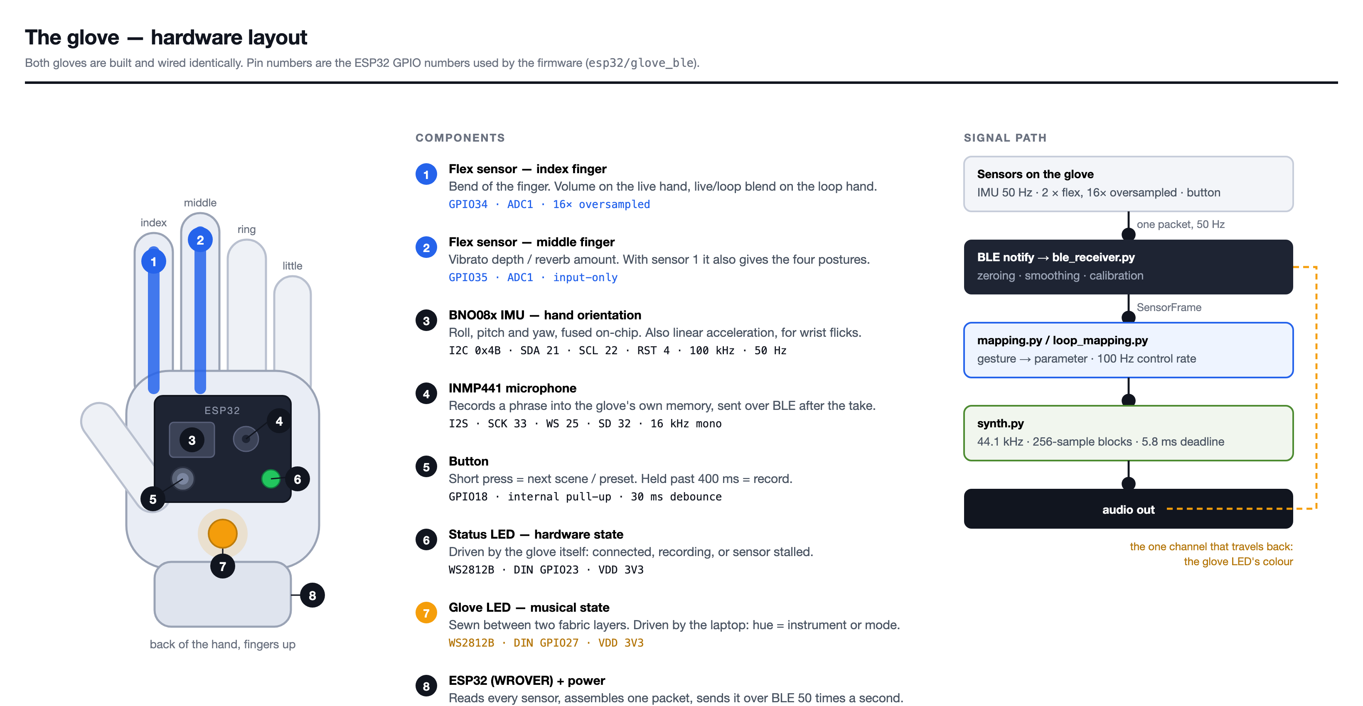
Figure 1. The glove — hardware layout. Both gloves are wired identically.

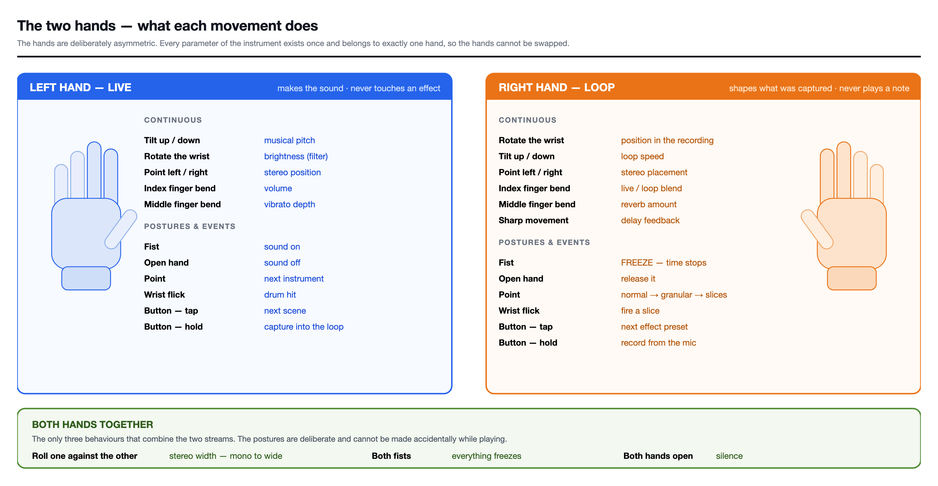
Figure 2. The two hands — what each movement does.

3.2 Hardware design
Figure 3 shows what this section amounts to in hardware: two gloves, a flex sensor along the index and middle finger of each, and a printed enclosure at the wrist holding the microcontroller and the inertial sensor. Every part described below is visible in it.
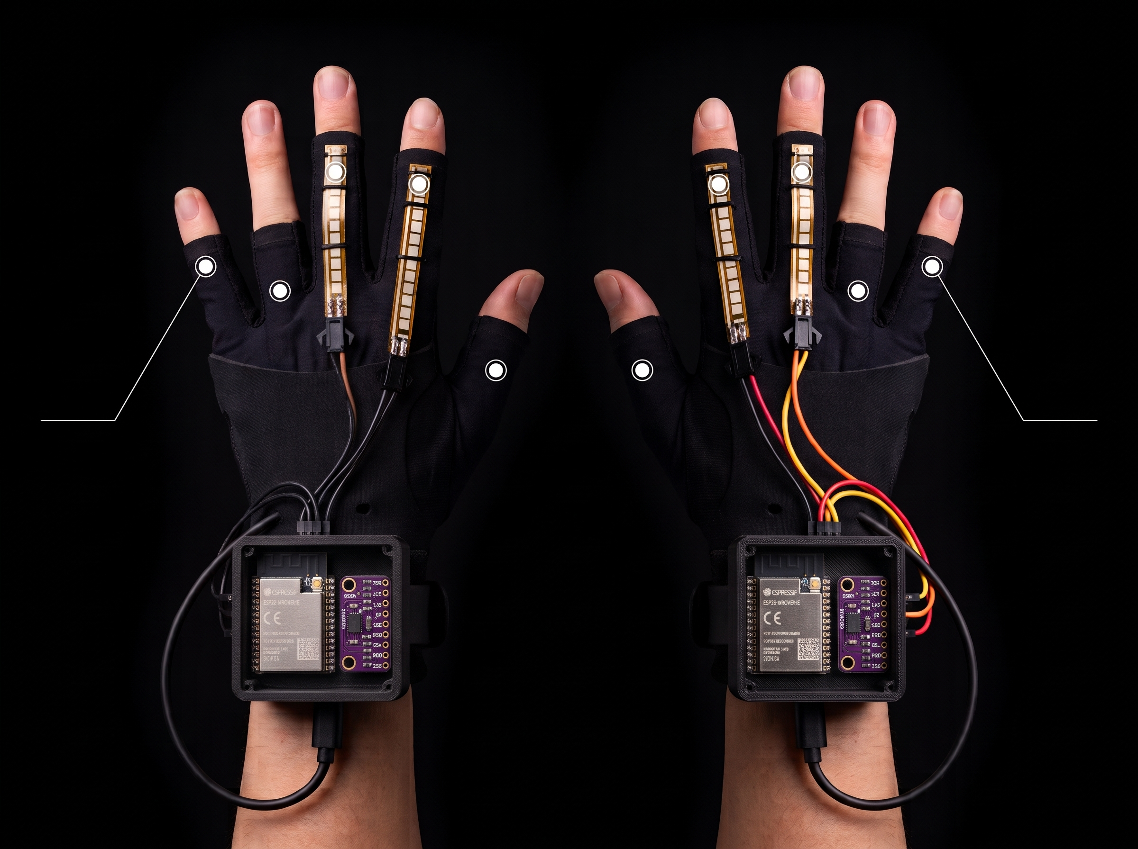
Figure 3. The assembled gloves. Flex sensors run along the index and middle fingers; the wrist enclosure holds the ESP32-WROVER-E and the BNO08x breakout.

3.2.1 Orientation sensing
Hand orientation is measured with a BNO08x inertial measurement unit configured for I2C operation. The decisive property of this device is that it performs sensor fusion on-chip and reports a rotation vector directly. Had a raw nine-axis sensor been used, the host or the ESP32 would have had to implement and tune a complementary or Kalman filter, with all the drift and magnetic-interference problems that entails. Choosing a fused sensor removed that work entirely.
The unit is polled for two reports: the game rotation vector, from which roll, pitch and yaw are derived by quaternion-to-Euler conversion, and linear acceleration, which is used for detecting sharp movements. Reports are requested at fifty hertz.

3.2.2 Finger sensing
Each hand carries two flex sensors, on the index and middle fingers, in a voltage divider arrangement. The analysis of this circuit produced one of the project's more instructive results and is given in Section 3.7.2.
Two sensors yield four distinguishable static postures — both fingers curled, both straight, and the two mixed cases — which is sufficient for the gesture vocabulary adopted. The sensors are read on ADC1 rather than ADC2, because the ESP32's second analogue converter is unavailable while the Bluetooth radio is active; this is a documented hardware constraint that is easy to overlook and produces a sensor that works perfectly until the device connects.

3.2.3 Audio capture
An INMP441 MEMS microphone is connected over I2S. Audio is captured at 16 kHz in 16-bit mono, which is adequate for voice and for the textural uses the material is put to, and which keeps the transfer time over Bluetooth acceptable.

3.2.4 Indication
Each glove carries two addressable RGB LEDs. One is mounted on the board and reports hardware state — advertising, connected, recording, transferring, or sensor fault — and is driven entirely by the glove itself. The second is sewn between two layers of the glove fabric, which diffuses it into a patch of light, and is driven by the host to show musical state: hue indicates the instrument or loop mode, brightness follows how strongly the hand is playing, and a pulse marks the loop boundary.
The separation matters. When the gloves are powered from a battery rather than from the host's USB port, no serial console is available, and the on-board LED becomes the only diagnostic channel the system has.

3.2.5 Enclosure
The electronics are held at the wrist in a two-part enclosure modelled for this project and printed in PLA. Mounting the board on the hand rather than at the belt is the decision that removed the cables the proposal had expected to run along the arm, and it only works if the housing is small and light enough not to change how the wrist moves — which is the hand's principal control.
The body carries the board on standoffs and is cut away at one side for the USB connector, so a glove can be flashed and powered without being opened. The lid is a separate part with two openings: a round one for the status LED and a smaller one for the button. Keeping those in the lid rather than the body means the piece the performer touches is also the piece that can be reprinted on its own when a position turns out to be wrong.
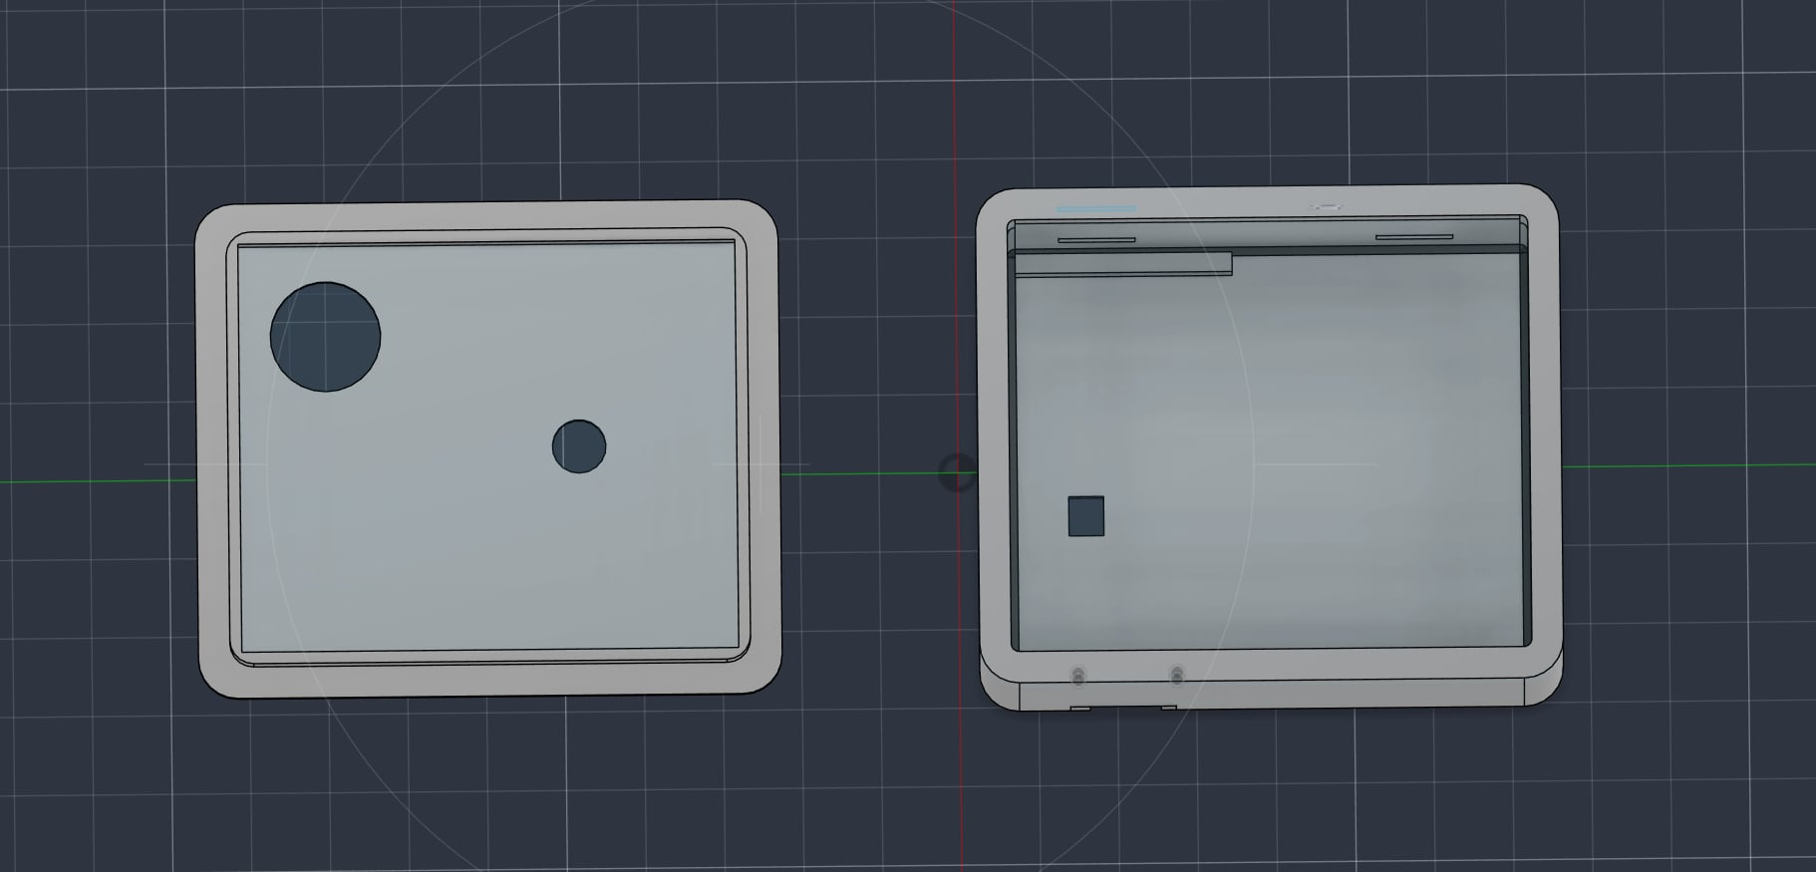
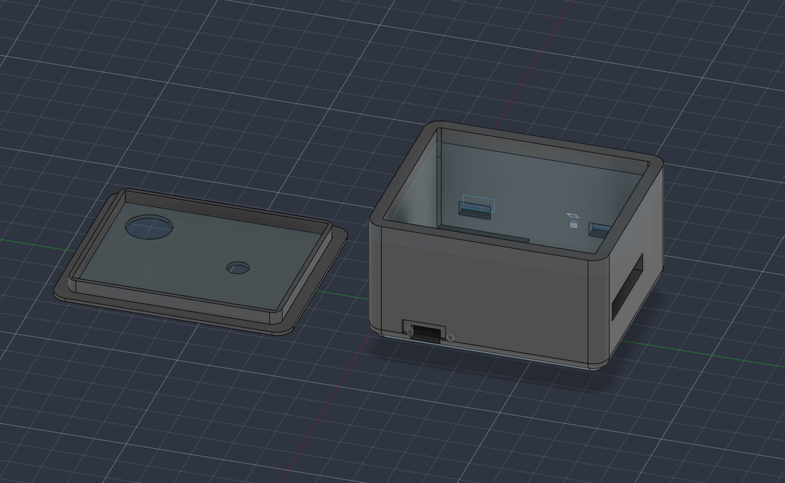
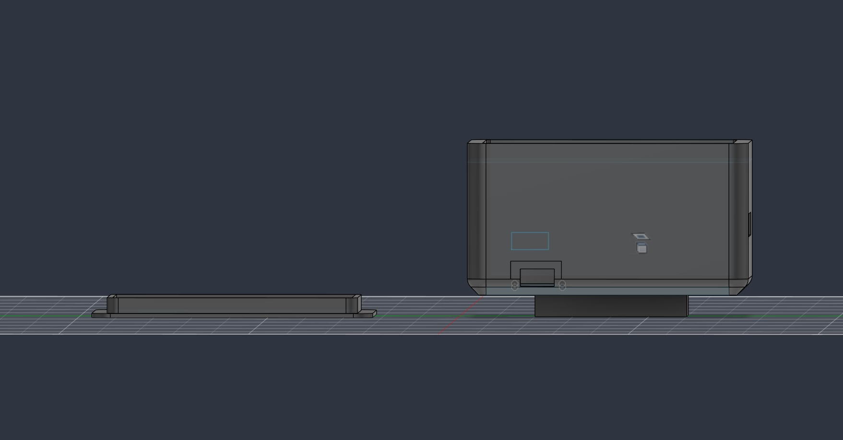
Figure 4. The wrist enclosure as modelled: lid and body from above, the two parts separated, and the side elevation. The openings in the lid are for the status LED and the button; the cut-out in the body side is for USB.

3.3 Gesture mapping: the central design decision
The mapping layer — the rule set connecting sensor values to sound parameters — received more design attention than any other part of the system, because it is where the instrument becomes playable or does not.
An early version gave both hands the same vocabulary, each pointed at its own sound source: tilt controlled pitch, yaw controlled pan and finger bend controlled volume, on both hands independently. This was symmetric, easy to explain, and dull to play. It was effectively one instrument played twice, and it wasted the opportunity that two independent sensing hands provide.
The design was replaced with a deliberately asymmetric one, governed by a single rule: every parameter of the instrument exists exactly once, and belongs to exactly one hand. The test applied was whether the hands could be swapped and still make sense. In the symmetric design they could, which is precisely the problem; in the final design they cannot, because scrubbing through a recording is meaningless on the hand that is playing live.

3.3.1 The live hand
The live hand produces sound and never touches an effect. Figure 2 shows both vocabularies together.
Gesture | Parameter
Tilt the hand up and down | Musical pitch, quantised to the current scale
Rotate the wrist | Filter cutoff frequency, heard as brightness
Point left and right | Stereo position
Bend the index finger | Volume and expression
Bend the middle finger | Vibrato depth
Make a fist | Activate the sound
Open the hand | Deactivate the sound
Point (index straight, middle curled) | Advance to the next instrument
Flick the wrist | Percussive hit
Button, short press | Advance to the next scene
Button, hold | Capture the phrase into the loop
Table 2. Gesture vocabulary of the live hand.

3.3.2 The loop hand
The loop hand shapes material that already exists and never plays a note. Before anything has been recorded it shapes the live microphone input instead, so that it is never idle.
Gesture | Parameter
Rotate the wrist | Playback position within the recording
Tilt the hand up and down | Loop playback rate
Point left and right | Stereo placement of the material
Bend the index finger | Blend between live sound and loop
Bend the middle finger | Reverb amount
Move the hand sharply | Delay feedback
Make a fist | Freeze: hold the current moment, time stops
Open the hand | Release the freeze
Point | Cycle loop mode: normal, granular, slices
Flick the wrist | Fire a slice of the recording
Button, short press | Advance to the next effect preset
Button, hold | Record from the glove microphone
Table 3. Gesture vocabulary of the loop hand.

3.3.3 Two-handed gestures
Three behaviours exist only when both hands act together. These are the only cases in which the two data streams are combined rather than interpreted separately.
Gesture | Effect
Relative roll between the hands | Stereo width, from mono to wide
Both hands make a fist | Everything freezes
Both hands open | Silence
Table 4. Two-handed combined gestures.
The two posture combinations were chosen because they are deliberate and essentially impossible to produce accidentally while playing, which is the correct property for a gesture that stops everything. Stereo width is the one parameter in the instrument that genuinely requires two inertial sensors and could not be obtained from one.

3.3.4 Separating postures from continuous control
A difficulty arises because the index finger is simultaneously the volume control and part of the posture detector. A performer making a volume swell sweeps the finger through the whole posture range continuously, and a naive implementation would fire posture events throughout.
This was solved with two mechanisms. First, a posture fires only on entry and only once, rather than continuously while held. Second, a dead band separates the posture thresholds: readings in the intermediate region are interpreted as playing, not as posturing, and a posture must be held steady for a short dwell time before it is accepted. The dwell time is tuned per posture, because an accidental fist is more costly than an accidental open hand.

3.4 Synthesis engine
The host engine renders audio at 44.1 kHz in blocks of 256 samples. Most processing is vectorised: the engine computes an entire block of samples with array operations, which is what makes real-time synthesis in Python feasible. The resonant filter is the exception: it runs sample by sample, because its feedback needs the previous output.

3.4.1 Voice generation
Four synthesis methods are implemented, chosen to span a wide timbral range from a small amount of code.
- Karplus–Strong plucked string. A short burst of noise is injected into a delay line with a damping filter in the feedback path [1], [5]. The result is a convincing plucked string for very little computation, and it is the basis of the guitar and pluck voices.
- Two-operator frequency modulation. One oscillator modulates the frequency of another [2]; the ratio between them determines whether the result is metallic or warm, and an envelope on the modulation index gives the characteristic bell attack.
- Band-limited sawtooth ensemble. Several detuned sawtooth oscillators are summed. Naive sawtooth generation produces severe aliasing, so a polynomial band-limited step correction is applied at each discontinuity.
- Additive synthesis. Six sine partials with independently controlled amplitudes, which gives direct control over the harmonic spectrum.

3.4.2 Filtering and effects
Every voice passes through a four-pole resonant low-pass filter modelled on the classic ladder topology, which the live hand's wrist rotation controls directly. Reverberation uses a Schroeder topology of parallel comb filters followed by series all-pass filters [3]. A delay line with gesture-controlled feedback completes the effect chain.

3.4.3 Time-domain manipulation
Recorded material can be manipulated in three modes beyond ordinary playback.
- Granular. The recording is decomposed into short overlapping windowed grains [4], which are then replayed at a position and density controlled by the hand. Because grain position and playback rate are independent, the material can be slowed arbitrarily or held still without changing pitch.
- Slices. The recording is divided into equal segments; a wrist flick fires one segment as a one-shot, and wrist rotation selects which. This converts a recorded phrase into a percussion instrument.
- Freeze. The current position is held and looped over a very short window, so that time stops while the material continues to sound.

3.5 Communication protocol
Each glove exposes a Bluetooth Low Energy service with three characteristics [9]. The first carries sensor data as notifications: orientation, linear acceleration, both flex readings, a sensor health flag and a running count of button presses, fifty times per second.
The button press count deserves comment. It is transmitted as a cumulative counter rather than as a momentary flag, because a dropped notification would silently swallow a flag and the press would be lost, whereas a counter that has advanced is still detected whenever the next packet arrives. This is a general principle for unreliable transports and was applied deliberately.
The second characteristic carries recorded audio: a short header followed by raw samples in fixed-size chunks, with a short delay between chunks to let the Bluetooth stack drain. Latency is irrelevant here because the recording has already finished, which is precisely why this works where live streaming would not.
The third characteristic is the only one written to rather than read from. It allows the host to tell the glove what the music is doing, so that the LED sewn into the fabric can show the current instrument, mode and loop position — information the glove has no other way of knowing. The host sends a compact description, and the glove animates the pattern from its own clock between updates, so that the rhythm remains smooth even if packets are dropped.

3.6 The control panel
The browser panel is the half of the instrument the gloves cannot be: it shows state that has no sound of its own and supplies the controls the hardware has no switches for. It is organised as three tabs over a pair of hand displays that are always visible.
Figure 5 shows a live session on the Play tab. Each hand has its own card reading the posture it is holding and the four parameters it is driving, with the orientation gauges and the flex channels below. The mode cards beneath are grouped by what they affect and lit in the colour of their group, so which kind of thing is running can be read without reading the names.
The Song tab loads external audio onto a deck and shows the waveform being scrubbed; the Create tab is the instrument designer described in Section 3.7.4, where the spectrum display is what made the problem there visible in the first place.
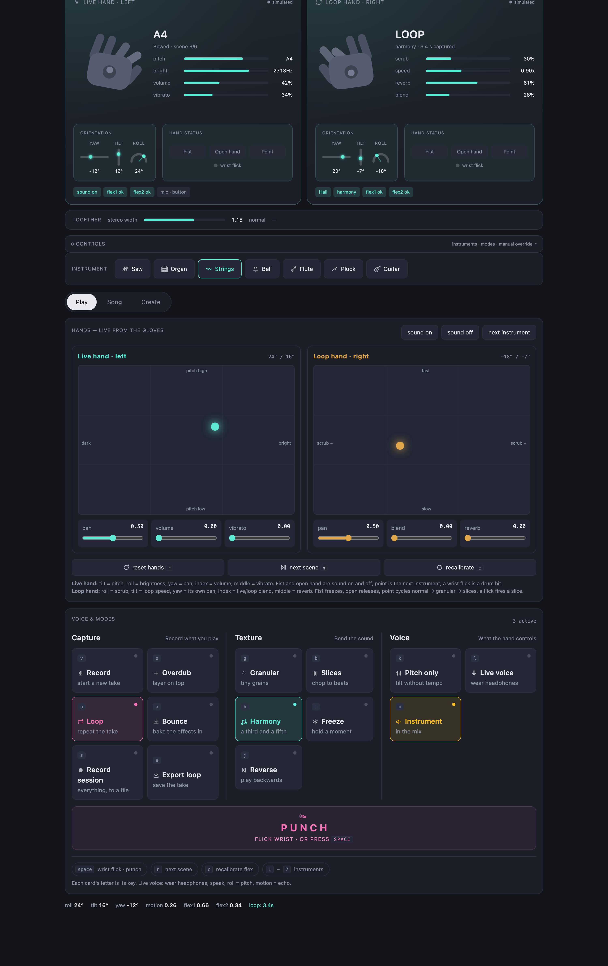
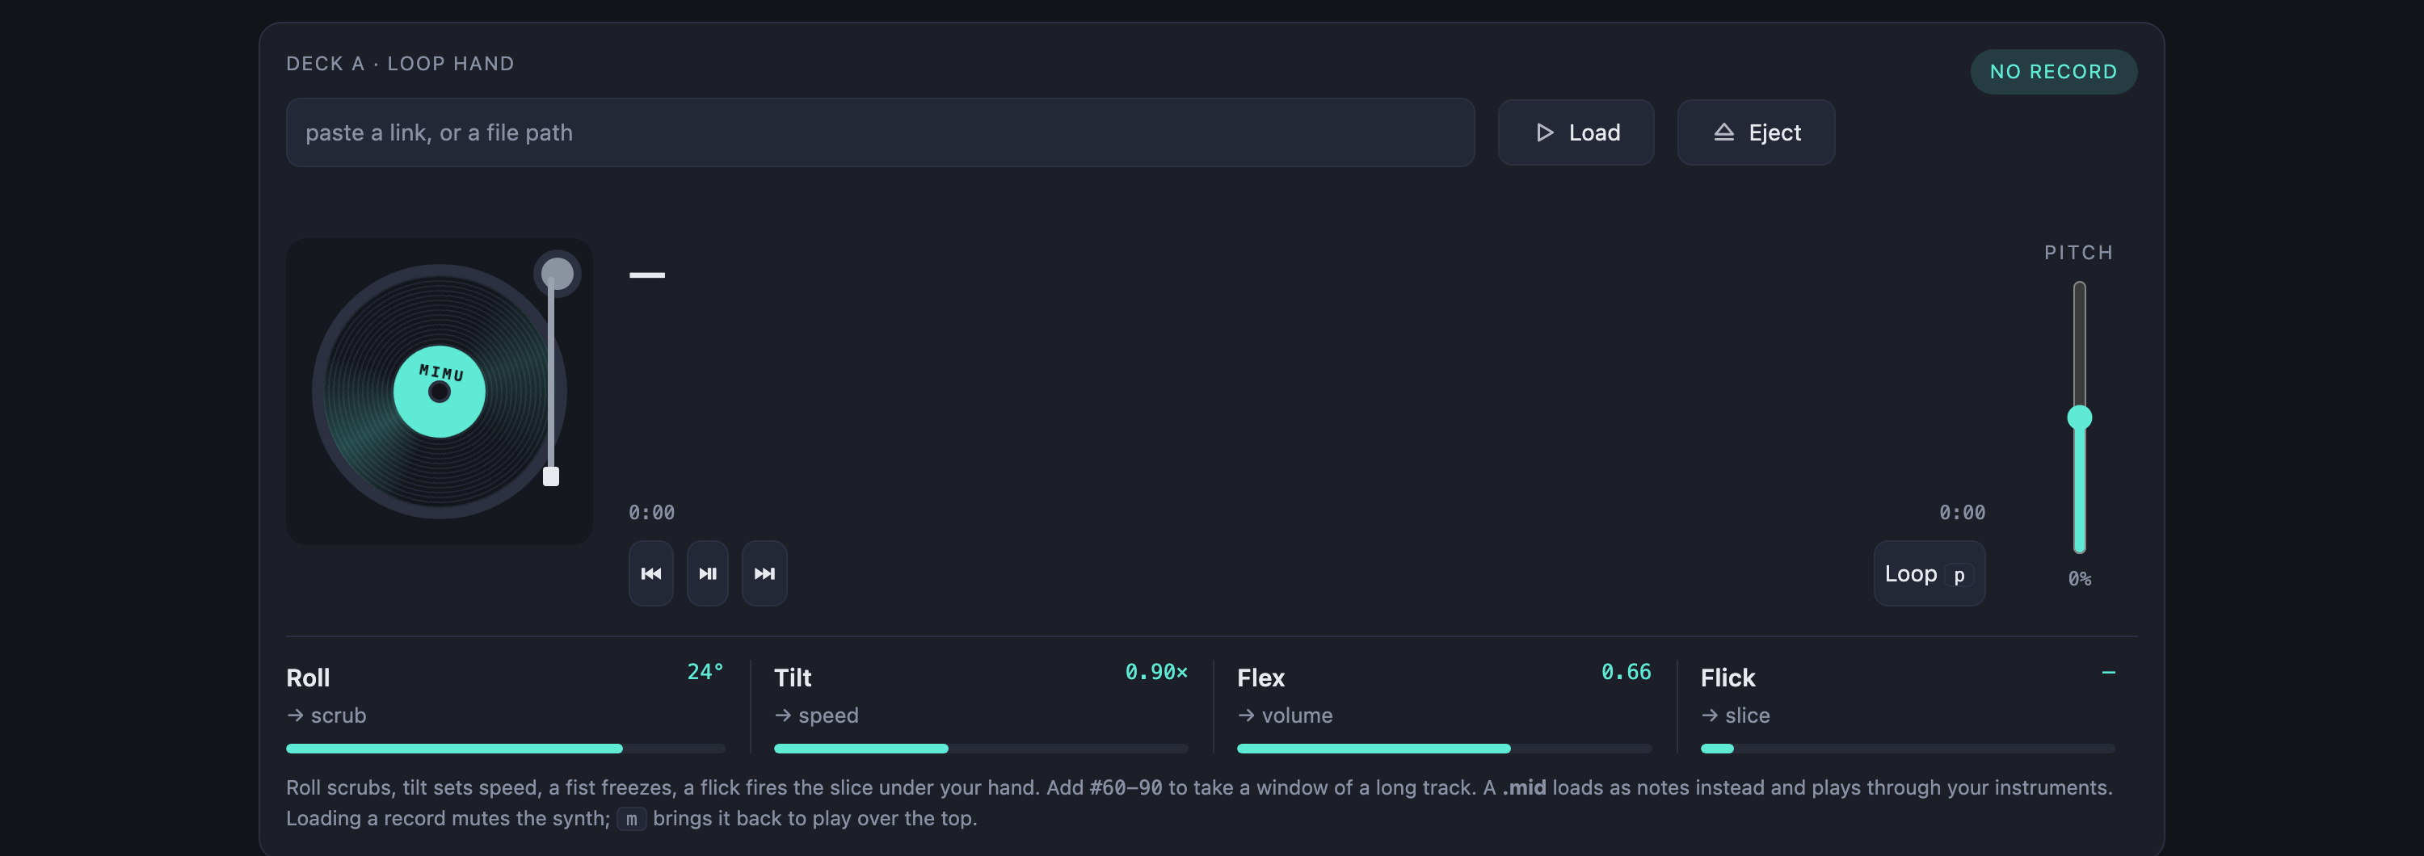
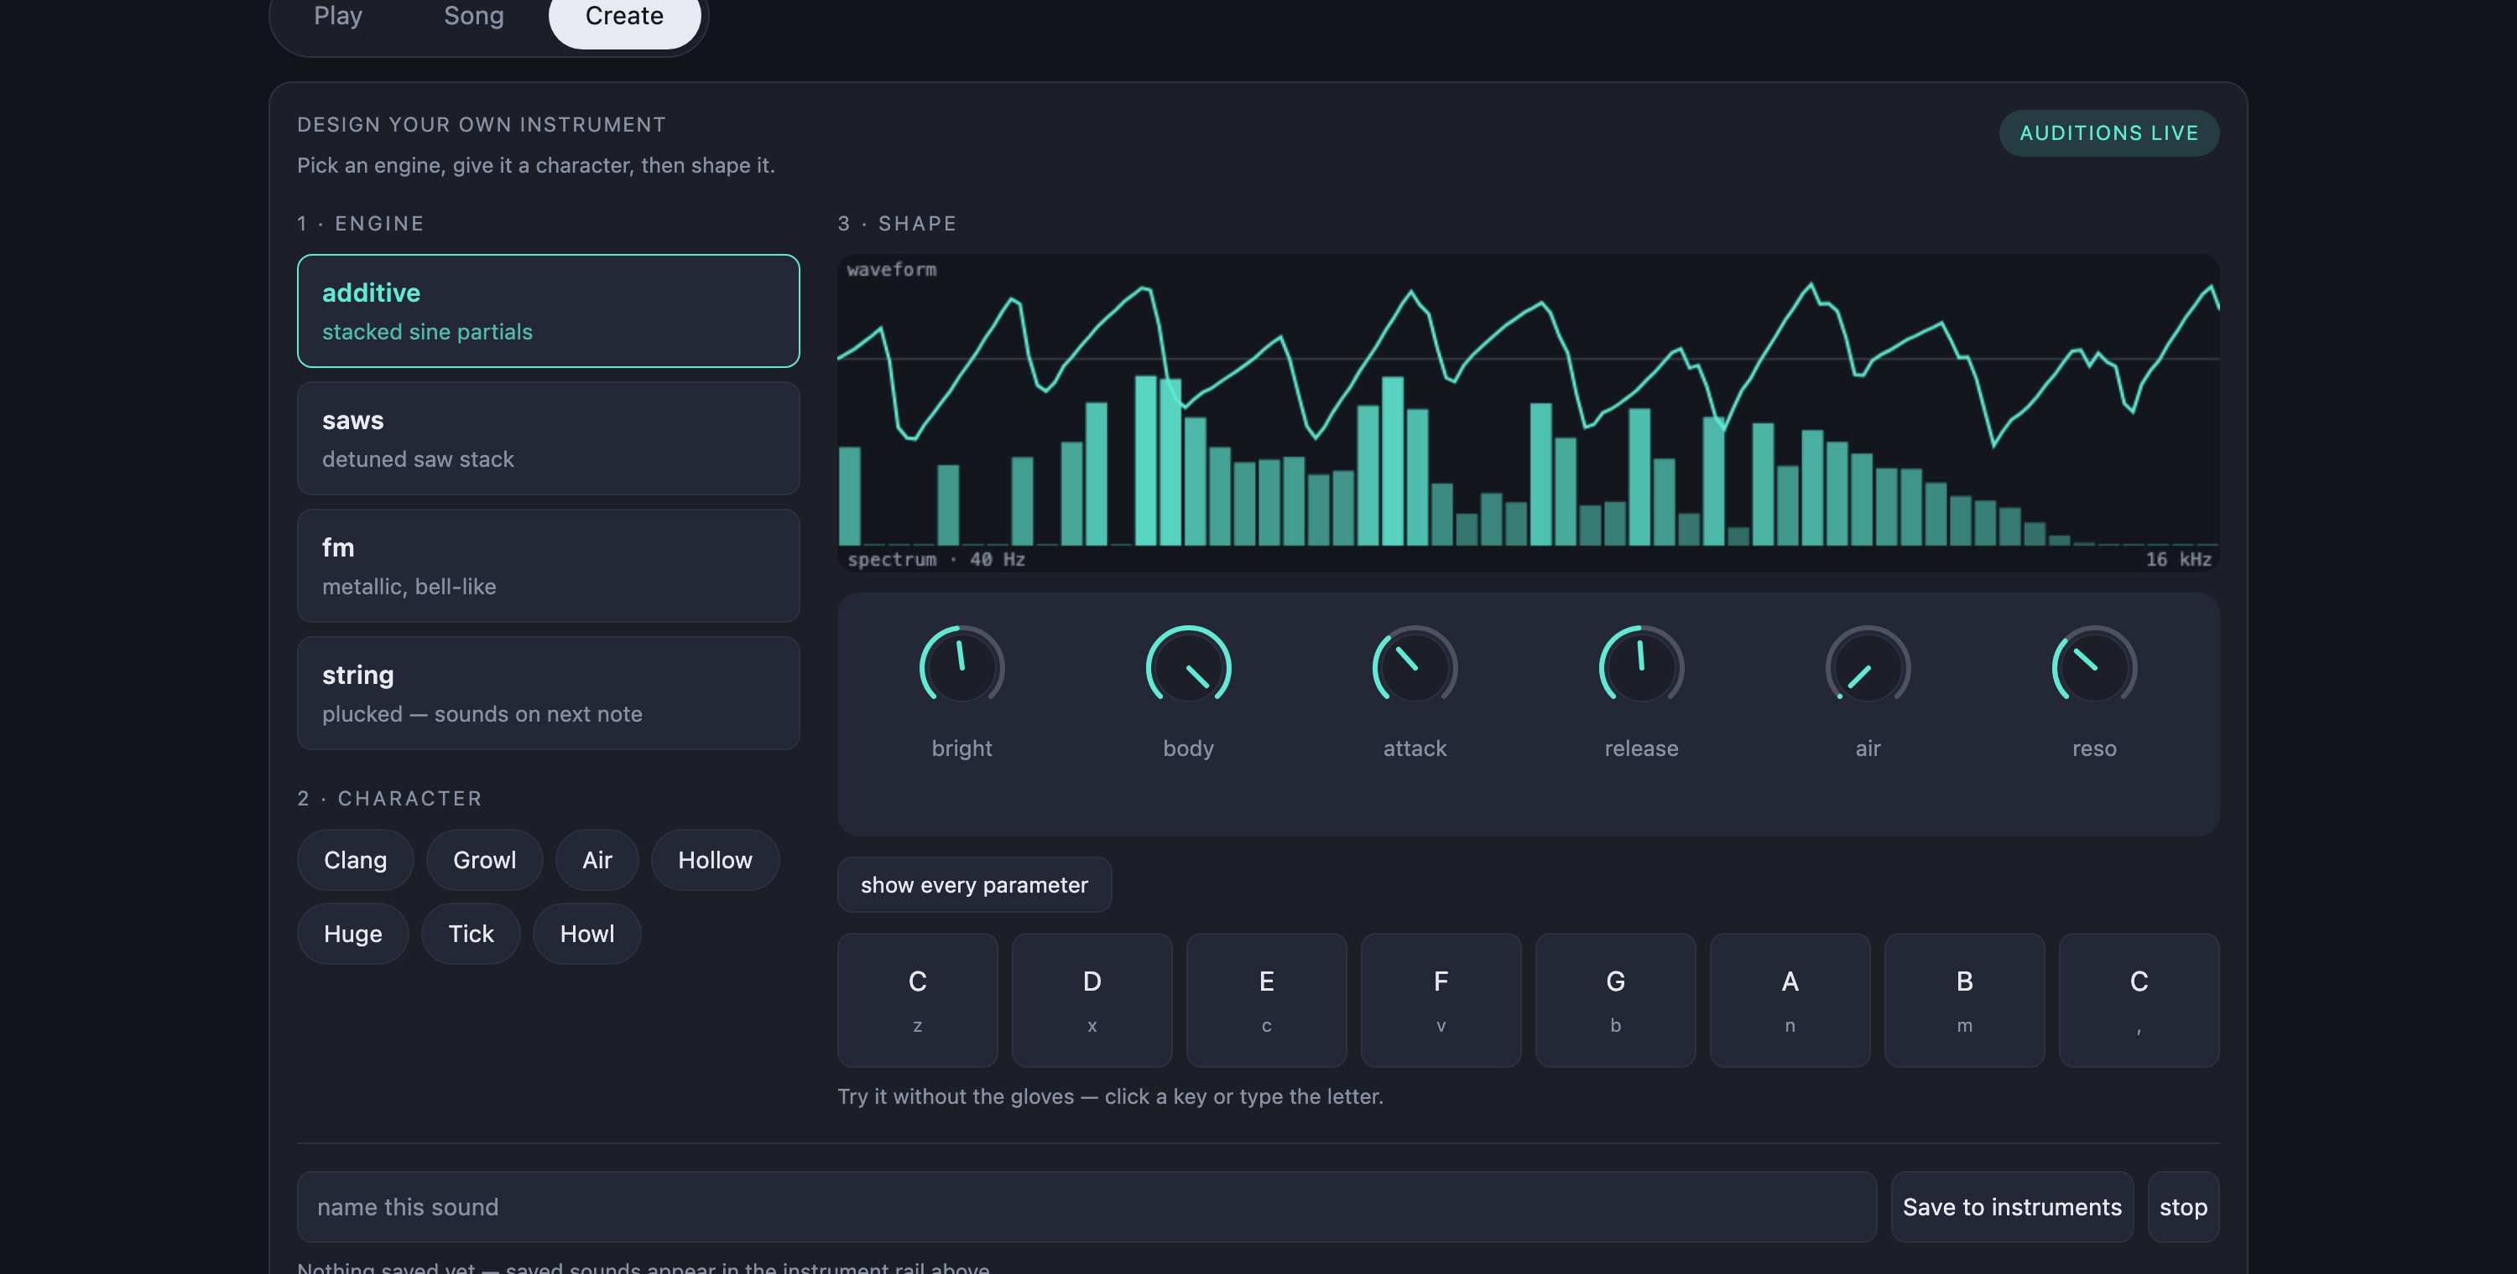
Figure 5. The browser control panel during a live session: the Play tab in full, then the Song tab's deck and the Create tab's instrument designer. The hand cards and the instrument rail stay on screen whichever tab is open.

3.7 Engineering problems and their resolution
This section documents the problems that were discovered during development, because the manner of their discovery is as instructive as their solution. In several cases a subsystem appeared to work and was shown to be defective only when it was measured.

3.7.1 Inertial sensor stalling under Bluetooth load
The most persistent hardware problem was an inertial sensor that stopped reporting after roughly fifteen to twenty seconds of operation, while continuing to acknowledge its own address on the I2C bus. Re-initialisation failed; only a full restart recovered it.
The cause was traced to I2C bus speed. The sensor was being driven at 400 kHz over long breadboard jumper wires whose capacitance was sufficient to corrupt transfers at that rate. Reducing the bus to 100 kHz produced ninety seconds of continuous operation under Bluetooth load with no dropouts at all. The lesson — that a bus speed within specification for the device may still be outside specification for the wiring — generalises well beyond this project.
Because the failure can still occur with marginal wiring, a watchdog was implemented in the firmware. If reports stop arriving, it first re-enables them, then performs a hardware reset of the sensor, and finally restarts the microcontroller. Restarting is the only recovery that has been observed to work in every case, and the firmware escalates to it rather than continuing in a degraded state.

3.7.2 Flex sensor resolution
The flex sensors initially produced unusable, noisy control. Measurement explained why. The sensors vary between approximately 13 and 16 kilohms over their full bending range. In a divider with a 15 kilohm fixed leg, this produces a voltage swing of about 0.17 volts, which corresponds to roughly 212 counts out of the 4095 available from the converter — about five percent of its range. Measured noise on the ESP32's converter was around 50 counts, a quarter of the entire usable signal.
Two corrections were applied. Oversampling sixteen readings per sample reduces random noise by the square root of the sample count, bringing it from about 50 counts to about 13. Calibration was then made adaptive: rather than assuming fixed endpoints, the firmware and host observe the range actually traversed and scale to it, because the resistance of these sensors varies between units and with temperature.
A subsequent regression is worth recording. An attempt to make the calibration respond faster caused the observed range to collapse while a pose was held, so that a fully bent finger was reported as only partially bent. The fix was to widen the range through a median filter and to require a minimum valid span before trusting a reading at all.
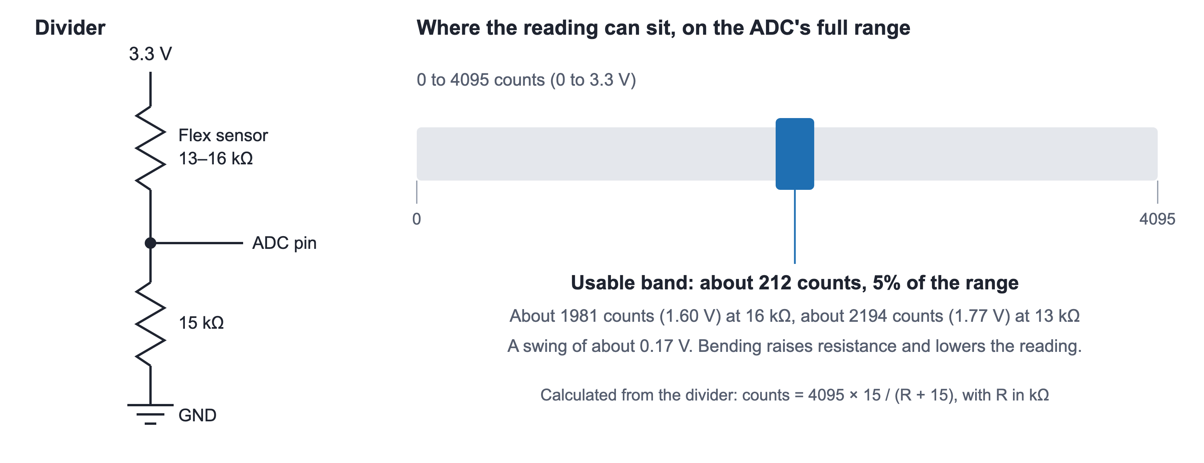
Figure 6. Flex sensor voltage divider and its usable ADC range. Values are calculated from the circuit.

3.7.3 A hardware fault that destroyed the performer's work
One glove developed an intermittent short on the button input. The consequence was far more damaging than the fault itself suggests: each phantom press was interpreted as a recording request, which captured two seconds of ambient room audio and replaced whatever was currently in the loop. A piece of music that had just been loaded could therefore be overwritten by a recording of the speakers playing it back. The measured fault rate was four spurious recordings in twenty-two seconds.
Three protections were added to the firmware, each targeting a different signature of the fault. A button already closed at power-on is treated as shorted and ignored, since nobody powers on a glove while pressing its button. A button held closed for longer than eight seconds is likewise treated as faulty, because no real press lasts that long, and this case additionally mattered because the firmware waits for release and would otherwise wait forever, stopping the orientation stream entirely. Finally, more than three presses within a minute disables the button for the remainder of the session, since a performer does not press a single button that often but a floating input does.
The general principle applied here is that an embedded system should fail in a way that preserves the user's work, and that a plausible hardware fault should be anticipated in software rather than assumed away.

3.7.4 Instrument presets that were not actually different
The instrument designer allows the performer to create new voices by choosing a synthesis engine and adjusting parameters. In testing, the voices produced sounded nearly identical regardless of the settings chosen — a subjective impression that needed to be confirmed before it could be fixed.
The impression was quantified by computing the cosine similarity between the normalised FFT magnitude spectra of pairs of rendered voices. Values near 1.0 indicate spectral near-identity. The measured similarity was 0.98: the voices were, objectively, almost the same sound.
Investigation found two causes. The first was that the designer's default parameters were numerically identical to those of the existing built-in presets, so a user who adjusted only one control heard essentially a built-in voice. The second and more serious cause was architectural: a single filter instance was shared across all voices, so the parameter that most strongly shapes perceived timbre was in practice the same for every design. Giving each voice its own filter reduced the measured similarity from 0.98 to 0.68, and the voices became audibly distinct.
This case is the clearest example in the project of the value of measuring a subjective impression. Without the similarity metric, the first cause would probably have been found and the second — which was the dominant one — would not.
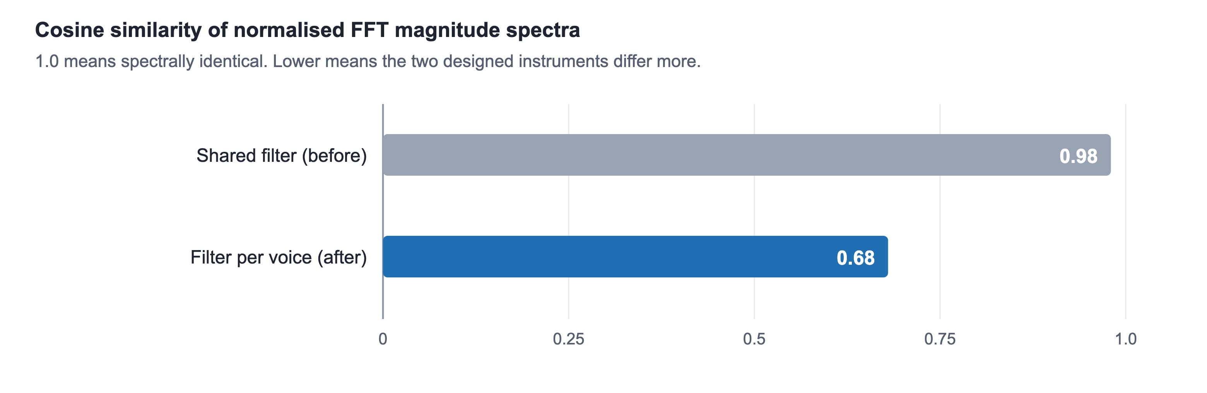
Figure 7. Spectral similarity between designed instruments, before and after the per-voice filter.

3.7.5 Playhead instability from hand tremor
Wrist rotation sets the playback position within a recording. In use, the position would not hold steady: an unavoidable physiological hand tremor of well under a degree was being mapped to an audible jump in playback position. A minimum movement threshold was introduced, calibrated so that it sits above measured hand tremor but below any deliberate movement, together with a short crossfade whenever the position does jump, so that the transition is not heard as a click.

3.7.6 Memory and pin allocation constraints
Two constraints of the ESP32 module affected the design. Audio recording requires a buffer sized to the recording length; with external PSRAM available this permits eight seconds, and without it the buffer must be sized to whatever contiguous internal memory can be spared, yielding roughly two seconds. The buffer is therefore sized at run time from the largest single allocatable block rather than from total free memory, because a fragmented heap reports ample free memory while being unable to satisfy a single large allocation — a distinction that initially produced a buffer of zero length.
Pin allocation also required care. On the module used, two general-purpose pins are connected to the PSRAM and are unavailable when it is enabled, and another pin determines the flash supply voltage at boot, such that driving it incorrectly prevents the board from starting at all. Compile-time assertions were added so that selecting one of these pins for an LED fails the build with an explanatory message rather than producing hardware that does not work for reasons that are difficult to diagnose.

3.8 Timing budget
The responsiveness of the instrument is determined by a chain of contributions, each of which was either chosen or measured.
Stage | Rate or interval | Note
Sensor reports from the IMU | 50 Hz (20 ms) | Higher rates destabilise the sensor's transport
BLE notification interval | 50 Hz | One packet per sensor report
Host control rate | 100 Hz (10 ms) | Gesture values applied to the engine
Audio block | 256 samples at 44.1 kHz | 5.8 ms deadline per block
Control panel update | 10 Hz | Display only; not in the audio path
Table 5. Timing budget of the real-time path.
The audio block size is the critical parameter. Every block of 256 samples must be fully computed within 5.8 milliseconds, and any block that is not completed in time produces an audible click. This deadline is what forces most processing to be vectorised and forbids any file access or network operation inside the audio callback. Operations that cannot meet the deadline — downloading a track, decoding a file, parsing a MIDI file — are performed on separate threads and their results handed to the audio path only when complete.

3.9 Justification of the chosen approach
Three decisions warrant explicit justification.
Bluetooth Low Energy was chosen over a wired connection or Wi-Fi. A cable is unacceptable in a wearable performance instrument. Wi-Fi offers higher bandwidth but much greater power consumption and worse latency determinism. BLE's bandwidth is insufficient for live audio, which is why microphone material is recorded and transferred after the fact rather than streamed — a limitation accepted deliberately in exchange for latency and power behaviour appropriate to the rest of the system.
Python with NumPy was chosen over C or C++ for the host engine. The conventional objection is that an interpreted language cannot meet a hard real-time audio deadline. This is true of sample-by-sample processing and false of vectorised block processing, where the interpreter is entered once per block and the arithmetic executes in compiled library code. The engine comfortably meets its 5.8 millisecond deadline, and the development speed gained was substantial: the synthesis engine, four instrument types, the effects chain and the looper were all developed and repeatedly restructured within the project timeframe.
A self-contained synthesis engine was chosen over emitting MIDI to external software. Emitting MIDI would have been simpler and would have given access to professional instruments. It would also have placed the entire gesture-to-sound path outside the project's control and outside its measurement, and MIDI's own resolution limits would have constrained exactly the continuous expression the project exists to provide. Note that MIDI output was nevertheless implemented as an optional additional output, so the system can drive external software when desired without depending on it.

4. Results and Evaluation

4.1 Final result
The project produced a working two-handed gestural instrument. In its current state the system supports the following.
- Continuous simultaneous control of pitch, brightness, volume, vibrato and stereo position from the live hand through orientation and finger flexion.
- Continuous control of playback position, rate, reverberation, delay and live-to-loop balance from the loop hand.
- Seven built-in instrument voices across four synthesis methods, plus a designer for creating and saving new voices.
- Six performance scenes, each combining an instrument with a musical scale, selectable from the glove.
- Recording from the glove microphone, with the resulting material immediately available for gestural manipulation.
- Loading of external audio, including local files and links, and of MIDI melodies played through the instrument's own voices.
- Granular, slicing and freezing manipulation of recorded material.
- A browser control panel showing both hands, the current state of every mode, and real-time waveform and spectrum displays.
- Fault tolerance for the hardware failure modes described in Section 3.7.

4.2 Evaluation against the success criteria
The project defined four success criteria at proposal stage. Each is assessed below.
Criterion | Status | Evidence
Real-time gesture recognition | Met — 100% | 90 of 90 attempts recognised at the measured sensor noise; nothing fired that was not asked for
Response time adequate for live performance | Met — 36 ms | 20 ms sensor reporting + 10 ms control interval + 5.8 ms audio block
Stability over extended use | Met — no misses | 5,167 consecutive blocks in the heaviest configuration, none over the deadline
Subjective usability | Tested with 3 users | Three first-time users each covered part of the protocol; no hesitations reported, control found quite natural
Table 7. Evaluation against the project's success criteria.

4.2.1 Gesture recognition
Each posture was performed thirty times against the mapping layer itself, with noise added at the level the flex sensors actually produce. That figure is not assumed: Section 3.7.2 measures the divider's usable swing at about 212 of the converter's 4,095 counts and the residual noise after oversampling at about 13 counts, so the noise applied here is 6% of the usable range.
All three postures were recognised in every attempt. The fist and the point gesture, which require a dwell of 0.35 s, scored thirty out of thirty each; the open hand, which requires a full second, also scored thirty out of thirty. Across the ninety attempts nothing fired that had not been asked for, giving an overall recognition rate of 100%.
Recognition alone is only half of the result. The index finger is simultaneously the volume control, so a performer making a swell sweeps it through the entire posture range, and a detector that fires on that is unplayable however well it scores on deliberate gestures. Thirty simulated swells produced no posture events at all, which is what the dead band and the dwell times described in Section 3.3.4 exist to achieve.
Two observations are worth recording, because the first was initially mistaken for a defect. The open hand asks for a full second where the other two ask for a third, and holding it for the shorter time scored zero out of thirty. That dwell is deliberate: an open hand is also what a hand does at rest, and firing on every relaxation would make the instrument unusable. The failure was in performing the gesture, not in detecting it. Second, these are simulated performances rather than human ones. They establish that the detector behaves correctly under realistic noise; they do not replace the user sessions described in Section 4.2.4.
The measurement runs against the mapping and synthesis code itself and needs no glove attached, which is deliberate: a measurement that only runs when the hardware is healthy is one that cannot be repeated. It is reproduced by running python -m tests.measure in the repository.

4.2.2 Latency
The path from a movement to a sound has three fixed costs. The glove reports at 50 Hz, so a reading waits at most 20 ms to be sent; the control loop applies it at 100 Hz, a further 10 ms; and the audio block is 256 samples at 44.1 kHz, which is 5.8 ms. The worst case is therefore 35.8 ms and the typical case roughly half of that, which is inside the range a performer tolerates and an order of magnitude below the point at which an instrument begins to feel detached.
One figure must not be mistaken for latency. The engine smooths control parameters between blocks, so a step change in pitch begins moving after 6 ms and arrives within 90% of its target 87 ms later. That glide is deliberate and is the reason control changes do not click; it describes how the parameter travels, not how long the instrument takes to respond. The two are reported separately for that reason.
This is a calculated budget rather than an end-to-end measurement. The figures above come from the same measurement run that produced the recognition result, and the time taken by the Bluetooth link is not included.

4.2.3 Stability
For an audio instrument, stability means one thing before it means anything else: every block of 256 samples must be computed within 5.8 ms, and a block that misses produces an audible click. The engine was run for thirty seconds of audio in its heaviest configuration, a designed voice over a loop in harmony mode with reverberation and the effect chain engaged.
Across 5,167 consecutive blocks the mean time per block was 0.61 ms and the 99th percentile 1.05 ms, against the 5.8 ms deadline; the worst single block took 3.73 ms. No block missed its deadline and none produced an invalid sample. The margin at the 99th percentile is a factor of 5.5, which is the figure that matters: it is the headroom available for the operating system to interrupt the audio thread without the instrument being heard to stutter.
Hardware stability is a separate matter and is weaker. The inertial sensor watchdog recovers from transport stalls without the performer intervening and the adaptive flex calibration holds across a session, but two faults were found: one flex channel read a constant zero because the flex sensor was damaged, and one inertial sensor at times stopped reporting. The first is a hardware fault; the cause of the second was not fully established.

4.2.4 Subjective usability
A structured testing protocol was prepared for evaluation by users other than the developers. It consists of a sequence of fifteen defined actions, each with an expected observable outcome, covering both hands individually and the combined two-handed gestures, together with a troubleshooting reference. The purpose of a scripted protocol is that it does not require the tester to understand the system, which makes the results meaningful as a usability measure rather than a demonstration.
The protocol was run with three people who had not used the instrument before. The work was divided between them rather than each going through all fifteen steps: one tester processed recorded music, one built up layers, and one covered the remaining actions. No hesitations were reported, and the testers found the control quite natural.
This is a small qualitative sample. No single tester used the whole instrument and no numerical score was collected, so the result indicates that the instrument is approachable rather than establishing it.

4.3 Assessment against the project aim
The aim stated in Section 1.5 was to build and evaluate a two-glove instrument permitting continuous simultaneous control of several sound parameters with latency low enough for live performance. The build objective has been met in full, and in several respects exceeded: the looper, the external audio loading and the instrument designer were not part of the original specification and were added as the system matured.
Three of the four evaluation criteria are now met with reproducible figures: recognition at 100% of ninety attempts under realistic sensor noise, a calculated worst-case latency of 35.8 ms, and no missed audio deadlines across 5,167 consecutive blocks. The measurements are reproducible, since they run against the mapping and synthesis code itself and need no glove attached.
The fourth, subjective usability, was evaluated with three first-time users, each covering part of the protocol in Appendix B. They found the control quite natural, though the sample is small. A damaged flex sensor, an inertial sensor that at times stopped reporting, and two components named in the proposal that were not built are the gap between the project's present state and its stated goals.

4.4 Division of work
Both team members worked on the hardware and the software. Mariam Chodrishvili soldered the gloves, connected the sensors, and modelled and 3D-printed the wrist enclosure. Keso Chikhladze focused mainly on signal processing and on the musical problems of the instrument, and Mariam Chodrishvili also worked on signal processing. The sewing of the gloves, the browser control panel, the gesture mapping, the measurements and this report were done jointly.

5. Conclusion

5.1 Principal aspects of the project
This project set out to show that a gesture-controlled musical instrument of real expressive range can be built from inexpensive, widely available components, and that the limiting factor in such an instrument is not the quality of its sensors but the discipline of its mapping.
Two decisions shaped the outcome more than any others. The first was the choice of an inertial sensor performing fusion on-chip, which eliminated an entire class of filtering and drift problems before they could arise. The second was the decision to make the two hands asymmetric, giving each parameter of the instrument exactly one owner. The second decision cost nothing in hardware and determined, more than any other single choice, whether the instrument was engaging to play.

5.2 Results obtained
A complete working instrument was produced, comprising two sensor gloves, a real-time synthesis and effects engine meeting a 5.8 millisecond block deadline, a live looper with granular, slicing and freezing manipulation, microphone capture on the glove, external audio loading, an instrument designer and a browser control panel. Several engineering defects were identified through measurement and corrected, including a bus speed that destabilised the inertial sensor, a flex sensor arrangement using five percent of its available range, a hardware fault that silently destroyed recorded material, and a designer whose presets were measurably almost identical.

5.3 Knowledge and experience gained
The most valuable lesson of the project concerns the difference between a system that appears to work and one that has been measured. In at least three cases — the flex sensor resolution, the spectral similarity of designed instruments, and the bus speed problem — a subsystem was in use and apparently functional, and only measurement revealed that it was substantially defective. In each case the measurement was simple and could have been performed much earlier.
A second lesson concerns failure modes in systems that hold a user's work. The shorted button was a trivial hardware fault with a severe consequence, because the software had no concept of an implausible input. Designing embedded software to anticipate plausible hardware faults, and to fail in a way that preserves the user's work, proved to be a more valuable principle than any individual technical technique applied in the project.
Technically, the project provided practical experience with real-time constraint satisfaction, embedded sensor integration over I2C and I2S, Bluetooth Low Energy protocol design including the handling of unreliable delivery, digital audio synthesis and effect algorithms, and the design of a mapping layer where engineering correctness and musical judgement both apply and do not always agree.

5.4 Future work
- Extend the user-facing measurements: measured end-to-end latency, and usability testing with more people working through the whole protocol.
- Repair the remaining flex sensor fault and move from hand-wired construction to a small custom circuit board, which would address the mechanical durability limitation identified in Section 2.8.
- Replace the USB power arrangement with an integrated battery and charging module, making the instrument fully untethered.
- Extend the live voice to polyphony, which the synthesis architecture permits but which was not pursued within this project's scope.
- Investigate learned gesture recognition as an alternative to the current threshold-based approach, which would permit performer-specific gestures at the cost of a training step.
- Explore the accessibility application identified in Section 1.7 with users for whom conventional instruments are not playable, which would require collaboration outside the engineering domain.

6. References
References are listed in IEEE style. In-text citations should be inserted throughout the report as square-bracketed numbers corresponding to this list.
[1] K. Karplus and A. Strong, “Digital synthesis of plucked-string and drum timbres,” Computer Music Journal, vol. 7, no. 2, pp. 43–55, 1983.
[2] J. M. Chowning, “The synthesis of complex audio spectra by means of frequency modulation,” Journal of the Audio Engineering Society, vol. 21, no. 7, pp. 526–534, 1973.
[3] M. R. Schroeder, “Natural sounding artificial reverberation,” Journal of the Audio Engineering Society, vol. 10, no. 3, pp. 219–223, 1962.
[4] C. Roads, Microsound. Cambridge, MA, USA: MIT Press, 2001.
[5] J. O. Smith III, Physical Audio Signal Processing. Stanford, CA, USA: W3K Publishing, 2010.
[6] A. Hunt and M. M. Wanderley, “Mapping performer parameters to synthesis engines,” Organised Sound, vol. 7, no. 2, pp. 97–108, 2002.
[7] E. R. Miranda and M. M. Wanderley, New Digital Musical Instruments: Control and Interaction Beyond the Keyboard. Middleton, WI, USA: A-R Editions, 2006.
[8] Mi.Mu Gloves Ltd., “Mi.Mu Gloves.” [Online]. Available: https://mimugloves.com
[9] Bluetooth SIG, Bluetooth Core Specification, Version 5.x. Kirkland, WA, USA: Bluetooth SIG, 2023.
[10] CEVA/Hillcrest Laboratories, BNO08x Datasheet and SH-2 Reference Manual. 2020.
[11] Espressif Systems, ESP32 Technical Reference Manual. Shanghai, China: Espressif Systems, 2023.
[12] C. R. Harris et al., “Array programming with NumPy,” Nature, vol. 585, pp. 357–362, 2020.

7. Appendices

Appendix A. Source code
The complete source code of the project — the ESP32 firmware, the host synthesis engine, the gesture mapping layer and the browser control panel — is available at the repository below.
https://github.com/kethoo/mimu-gloves
The repository is public and requires no account to browse. The default branch, main, holds the version of the system described in this report. The layout is as follows.
- esp32/glove_ble/ — the firmware that runs on each glove: sensor reading, posture detection, audio capture, BLE service and LED behaviour.
- glove/synth.py and glove/layerfx.py — the real-time synthesis and effects engine, including the four voice types, the filter, the reverberation and the looper.
- glove/mapping.py and glove/loop_mapping.py — the gesture mapping layer for the live hand and the loop hand respectively. The asymmetric design described in Section 3.3 is defined here.
- glove/ble_receiver.py — the host side of the Bluetooth link, including connection management, calibration and audio reassembly.
- glove/instruments.py — the instrument designer and its stored voices.
- glove/song.py, glove/melody.py and glove/cover.py — loading of external audio and MIDI material, and backing layers built from a score.
- glove/ui.html — the browser control panel.
- main.py — the entry point, which ties the gloves, the mapping, the engine and the panel together.
- tools/ — helpers for calibration, diagnostics and tone matching, run from the top folder, for example python -m tools.calibrate_flex.
- tests/ — the measurements and tests reported in Chapter 4, for example python -m tests.measure.
- covers/ — song scores ready to play as layers.
- docs/ — images and longer guides.

Appendix B. Gesture reference
A complete gesture reference, suitable for a performer or a tester approaching the instrument for the first time, is reproduced from the testing protocol. It lists for each hand every continuous control, every posture and every button action, followed by the fifteen-step test sequence and a troubleshooting table.
The testing guide is summarised here. It introduces the instrument to a first-time user: two gloves that form one instrument, with the left hand making the sound and the right hand shaping what has been recorded.
Before starting, the tester wears headphones, since the microphone is on the hand and would otherwise pick up the speakers. The gloves are put on with the board on the back of the hand, and each hand is held still for two to three seconds after connecting while the neutral position is captured. Fingers must be fully bent for a posture to register.
Table B1. Gesture reference, summarised from the testing guide.
Gesture | Left hand: makes the sound | Right hand: shapes the recording
Tilt up or down | Note, locked to the scale | Loop speed
Wrist rotation | Brightness (filter) | Position in the recording
Turn left or right | Stereo position | Stereo position
Index finger | Volume | Balance of live and recorded sound
Middle finger | Vibrato depth | Reverb amount
Fist | Sound on | Freeze
Open hand | Sound off | Release the freeze
Point (index straight, middle bent) | Next instrument | Next mode: normal, granular, slices
Wrist flick | Drum hit | Fire a slice of the recording
Button, short press | Next scene | Next effect preset
Button, held | Record a phrase | Record a phrase

With both hands, rotating them relative to each other changes the stereo width, two fists hold everything in a freeze, and two open hands stop the instrument and release the freeze. These two-handed postures are chosen because they are unlikely to happen by accident while playing.
The guide then gives a test scenario of fifteen steps, each stating what should happen. Step 1 connects and calibrates both gloves. Steps 2 to 7 use the left hand: sound on, pitch, volume, brightness, a scene change and sound off. Steps 8 to 13 use the right hand: record a phrase, move through it, freeze, release, change mode and fire a slice. Steps 14 and 15 use both hands together. A tester who sees something different notes it and moves on to the next step.
It closes with a short troubleshooting table covering a glove that does not connect, a hand that freezes on screen because the sensor has stalled, postures that do not register, no sound, feedback from working without headphones, and a recording replaced by a newer one. It also explains the two LEDs on each hand: one for the technical state of the glove, one for what the music is doing.

Appendix C. Hardware reference
Pin assignments, wiring and component connections for both gloves are documented in the project repository alongside the firmware, and are reproduced here.
Table C1. Pin assignments.
Part | Connection
BNO08x inertial sensor | SDA to GPIO21, SCL to GPIO22, RST to GPIO4, ADD to 3V3 (address 0x4B), PS0 and PS1 to GND
Flex sensors | GPIO34 and GPIO35, each from 3V3 through the sensor, with 15 kΩ to GND
INMP441 microphone | SCK to GPIO33, WS to GPIO25, SD to GPIO32, L/R to GND
Button | GPIO18 to GND, using the internal pull-up
Status LED (WS2812B) | DIN to GPIO23, VDD to 3V3
Glove LED (WS2812B) | DIN to GPIO27, VDD to 3V3

Figure C1. Components on one glove and the pins they connect to.

