

**SE4050**

**Deep Learning**

**4th Year, 1st Semester**

**Lab 08**

Submitted to

Sri Lanka Institute of Information Technology

In partial fulfillment of the requirements for the

Bachelor of Science Special Honors Degree in Information Technology

10/04/2024

Question 1

* Markov Decision Process (PolicyIteration) notebook:

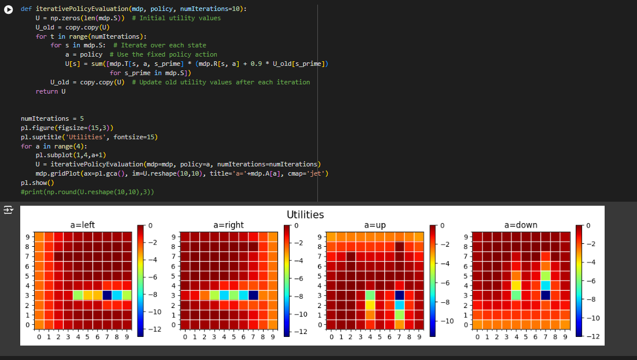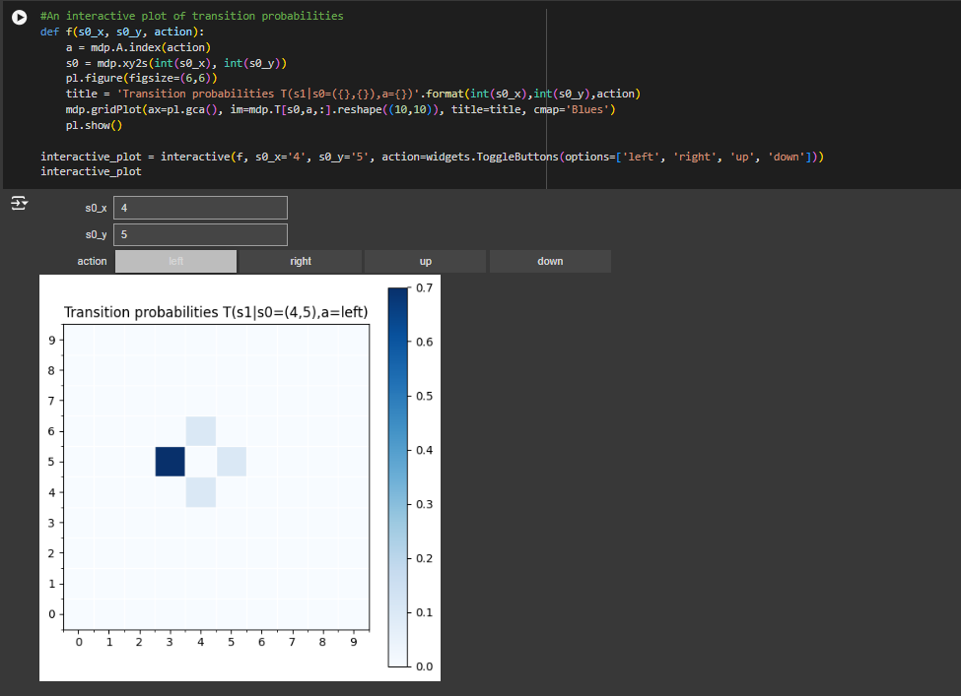

* 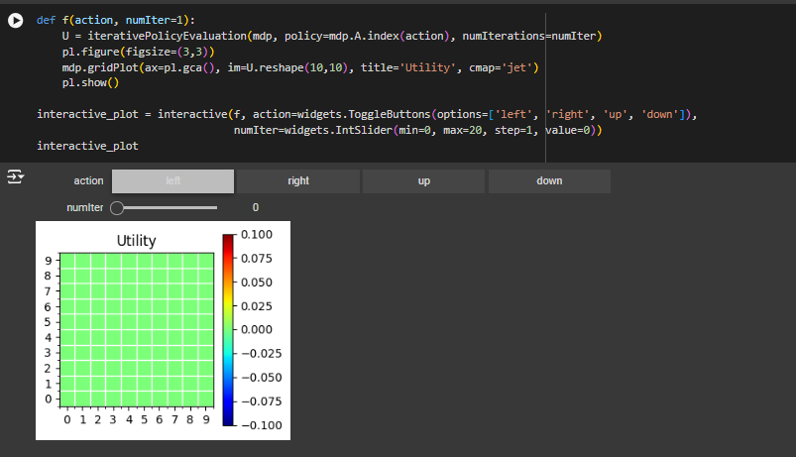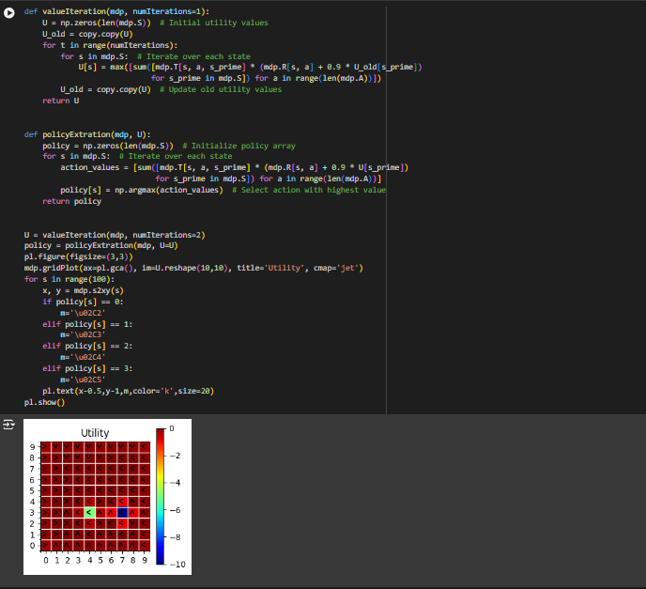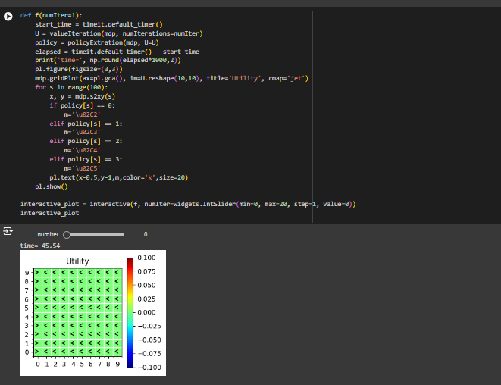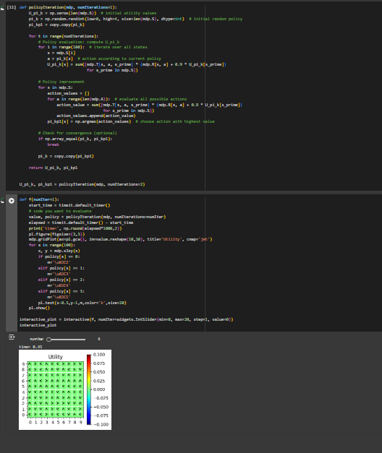
* GridWorld (QLearning) notebook:

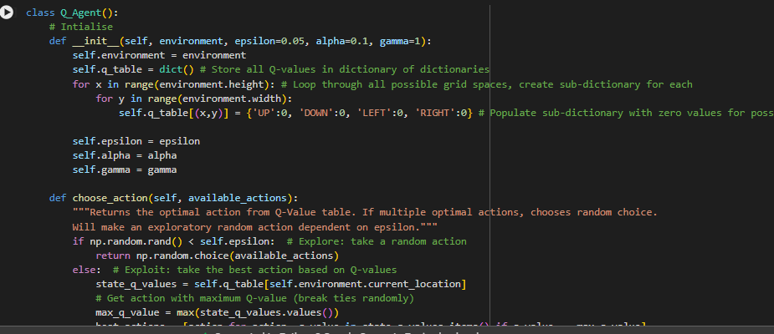

Question 2

2.

* Model-based algorithms can plan and make decisions based on future state and reward predictions because they have access to or have learned a model of the environment.
* Instead of using a model, model-free algorithms learn by doing; they adjust their policies or value functions in response to observable rewards and state transitions.

3.

Question 3



