MCE & Peripherals Reset Strategy

Revisions
- Rev. 1 (BB): Initial Version

Summary
This document describes the approaches taken to mitigate malfunctions in the MCE.

References
[1] MAX6301 +5V, Low-Power μP Supervisory Circuit with Adjustable Reset/Watchdog Datasheet
[2] FDC6303N Digital FET, Dual N-Channel Data Sheet
[3] Clock Card Schematic
[4] Readout Card Schematic
[5] Bias Card Schematic
[6] Address Card Schematic

Acronyms
- AC: Address Card
- ACDCU: AC-to-DC Unit, aka 300V Supply
- BC: Bias Card
- CC: Clock Card
- MCE: Multi-Channel Electronics
- PSU: Power Supply Unit, aka Power Supply Card
- RC: Readout Card
- RTL: Real Time Linux

Terminology
- BRst: A TTL signal in the MCE that is controlled by the PSUC and is distributed over the Bus Backplane to all FPGA-controlled cards. When asserted, this signal causes a reconfiguration of all FPGAs. The Clock Card is reconfigured from its Factory Configuration Device.
- BClr: A TTL signal in the MCE that is controlled by the Clock Card, and is distributed over the Bus Backplane to all FPGA-controlled cards. When asserted, this signal causes a register reset – an asynchronous reset statement in every register process in the FPGA firmware sets the value of the registered output to the specified default. Asserting the BClr signal is akin to asserting the global reset signal in firmware simulations. The results are identical – this is important for reproducing identical starting conditions in hardware as in simulations.

Table of Contents
1. Revisions 1
2. Summary 1
3. References 1
4. Acronyms 1
5. Terminology 1
6. Table of Contents 2
7. Discussion 3
7.1 The FPGA Watchdog Timer 4
7.2 The PSUC Micro-Controller Watchdog Timer 4
7.3 The Voltage Sensors on FPGA-Controlled Cards 4
7.4 The ACDCU Load Sensor 5
7.5 The PSU ‘Cycle Power’ and ‘Cut Power’ Commands 6
7.6 The ACDCU ‘Cycle Power’ and ‘Cut Power’ Commands 6
7.7 The MCE ‘resetmce’ Command 6
7.8 The BRst Button on the PSU Faceplate 6
7.9 The Microcontroller Reset Button on the PSUC 6
7.10 The FPGA Reset Buttons 7

Discussion
There are a variety of ways that the MCE and its peripherals can be reset during operation. Resets can be initiated autonomously by the MCE, by a peripheral, or by an operator. Some resets affect only a part of the system; others affect it in its entirety. A diagram of the MCE and its peripherals is shown below.

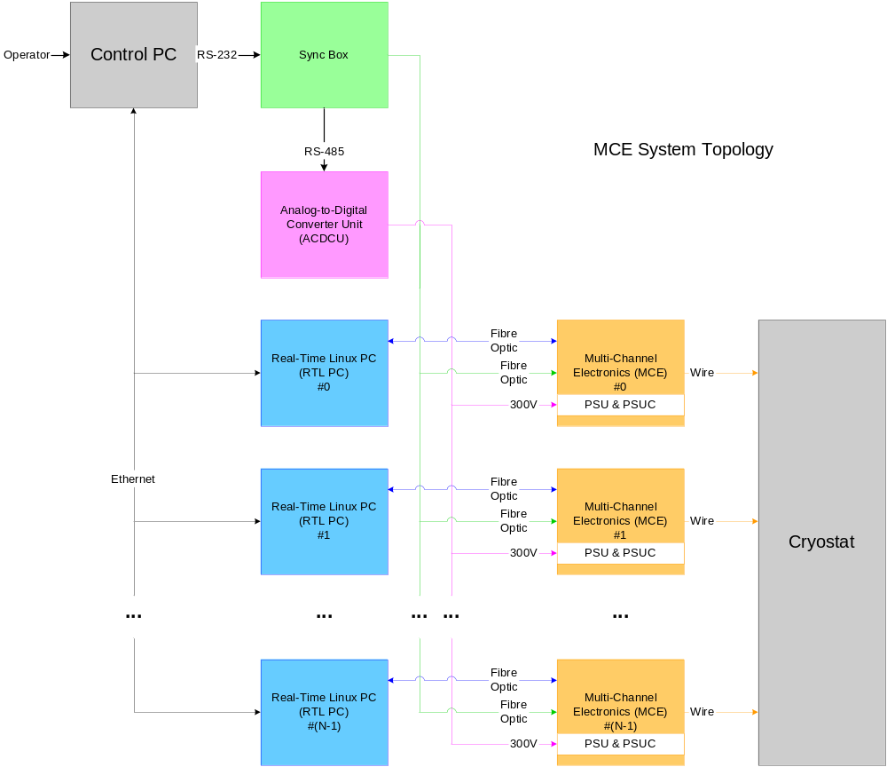
Figure 1. System Hardware Topology of the MCE and its Surrounding Peripherals

The following reset mechanisms have been implemented in the system above:
- Failing to kick the hardware watchdog timers on the MCE FPGA-controlled cards
- Failing to kick the software watchdog timer on the PSUC
- Tripping the hardware voltage sensors on the MCE FPGA-controlled cards
- Tripping the ACDCU load sensor due to an insufficient current draw by the MCE
- Commanding the PSUC to cycle power or cut power to the rest of the MCE
- Commanding the ACDCU to cycle power or cut power to the PSU’s.
- Commanding the MCE to reset, which asserts the BClr signal on the Bus Backplane
- Pressing the BRst button on the PSUC Front Panel button
- Pressing the microcontroller reset button on the PSUC
- Pressing of the FPGA reset button on the FPGA-controlled cards.

Each of these reset mechanisms are discussed in order, below.

The FPGA Watchdog Timer
There is a hardware watchdog timer (MAX6301) on each of the FPGA controlled cards in the MCE (i.e. the Clock Card, Readout Cards, Bias Cards and Address Card). The timeout period of each watchdog timer is determined by a low-leakage ceramic capacitor on board. In general, the value of this capacitor is not the same on all cards. The watchdog timers on all cards can be disabled with a jumper to DGND. Alternatively, a jumper to CONF_DONE disables the watchdog timers during configuration, and enables them in ‘normal mode’ after configuration.

The approximate timeout period on each card is given in the table below:

Card | Control Jumper Designator | Low-Leakage Capacitor Designator | Low-Leakage Capacitor Value (μF) | Watchdog Timeout Period (seconds)
Clock Card | JP1 | C5 | 0.33 | 0.88
Readout Card | JP2 | C190 | 0.33 | 0.88
Bias Card | JP1 | C60 | 0.33 | 0.88
Address Card | JP1 | C35 | 0.01 | 0.026
Table 1. Watchdog Timer Characteristics on a Card-by-Card Basis.
The Watchdog timeout period is calculated using the following formula:

 (1)

Where:
- WTP is the watchdog timeout period, in seconds
- C_{WTP} is the capacitance of the low-leakage ceramic capacitor, in μF

Strategy:
Each card has a FPGA watchdog timer, but only Clock Card’s watchdog timer will be enabled. This is because as long as the Clock Card firmware is functional, the MCE will be responsive to commands that can restore the functionality of an RC, BC or AC. After a watchdog reset occurs on the Clock Card, the reset is reported to the RTL PC in the next command reply.

If a RC, BC or AC freezes, the firmware on the Clock Card is not adversely affected. The reply-packets from the CC to the RTL PC contain information on the status of all cards in the MCE. In this manner, the RTL PC will be informed when the watchdog has reset the firmware on the Clock Card, or when any of the other cards have frozen.

The PSUC Micro-Controller Watchdog Timer
The PSUC is equipped with a software watchdog timer. The watchdog timeout period is between 5-10s. The PSUC software operates as an infinite loop – periodically checking for commands from the Clock Card and servicing them as they arrive. Once a cycle, the watchdog timer is kicked. If the software hangs and the watchdog times out, then the watchdog will move the microprocessor program counter back to the beginning of the infinite loop. Please note that this mechanism is not equivalent to resetting the program counter to zero. The beginning of the infinite loop occurs after a hardware setup routine that drags the microprocessor’s outputs high. As it is, the software watchdog timer avoids changing the current state of the outputs.

Strategy:
The software on the watchdog timer is considered to be simple and robust. Therefore it is not easy to re-program the microcontroller without completely disassembling the PSU. This is why we have limited the effect of software watchdog timer on the PSUC, so that if the software continuously freezes and jumps to be beginning of the infinite loop, it has no impact on the power/ resets in the rest of the MCE.

The Voltage Sensors on FPGA-Controlled Cards
There is a hardware voltage sensor on every FPGA controlled card. When the supply voltage falls below a threshold specified by a voltage divide circuit, the reset line to the FPGA on that card is asserted for at least a period determined by C_{RP}, or until the voltage level once again exceeds the minimum threshold.

The minimum voltage threshold is calculated using the following formula:

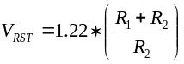 (2)

Where:
- V_{RST} is the minimum voltage threshold, in Volts
- R₁ is the upper resistance of the voltage divider, in Ohms
- R₂ is the lower resistance of the voltage divider, in Ohms

The minimum voltages monitored on each FPGA controlled card are:

Card | Supply Voltage Monitored (V) | R₁ (Ohms) | R₁ Designator | R₂ (Ohms) | R₂ Designator | Minimum Threshold (V)
Clock Card | 1.5VD | 10k | R4 | Zener Diode | D6A
 | 3.3VD | 47k | R7 | 36k | R8 | 2.15
Readout Card | 1.5VD | 10k | R66 | Zener Diode | D2A
 | 3.3VD | 47k | R67 | 36k | R70 | 2.15
Bias Card | 1.5VD | 10k | R19 | Zener Diode | D6A
 | 3.3VD | 47k | R20 | 33k | R23 | 2.08
Address Card | 1.5VD | 10k | R64 | Zener Diode | D29A
 | 3.3VD | 47k | R59 | 36k | R60 | 2.15
Table 2. Supply Voltages Monitored by FPGA-Controlled Cards

The approximate reset period (the amount of time that the reset line is asserted) on each card is given by the table below:

Card | C_{RP} (μF) | C_{RP} Designator | Reset Period (seconds)
Clock Card
Readout Card
Bias Card | 0.01 | C58
Address Card
Table 3. Reset Pulse Characteristics on a Card-by-Card Basis.
The reset period is calculated using the following formula:

 (3)

Where:
- RP is the length of the reset pulse, in seconds
- C_{RP} is the capacitance of the low-leakage ceramic capacitor, in μF

The ACDCU Load Sensor
If the current draw on the ACDCU is not between ? and ? A, the ACDCU shuts down its 300V output. In the case when the MCE subrack is not fully populated, it is likely that the cards present will not draw enough current to reach this range. In this, a cheater plug must be installed on the back of the ACDCU to forcibly enable the outputs.

Strategy:
The reason for this feature is to prevent short-circuit/ open-circuit failures in the MCE from further damaging the subrack. When the ACDCU detects a current draw out of spec, it will automatically shut down its outputs. When a cheater plug is installed, this safeguard is disabled.

The PSU ‘Cycle Power’ and ‘Cut Power’ Commands
The PSU accepts software commands (via the MCE) to either shut down or cycle the power on it’s outputs. The syntax for the commands from a DASDRAMA console command line is:
>rs psu cut_pow 1
>rs psu cycle_pow 1

Strategy:
These commands may be issued by a user, or autonomously by monitoring systems embedded in the MCE firmware or in the RTL software. Both the MCE and RTL have the ability to monitor temperatures, voltages and currents in the MCE. If the MCE or RTL detects an abnormal operating condition, it will cycle the power or cut the power from the PSU to the rest of the subrack. The thresholds set on the Clock Card that trigger autonomous shut down of the MCE are more lenient than the thresholds set on the RTL PCs.

The ACDCU ‘Cycle Power’ and ‘Cut Power’ Commands
The ACDCU accepts software commands (via the Sync Box) that allow the Control PC to either cycle the power or cut the power from the 300V ACDCU to the MCE. The control path is from the Control PC to the Sync Box (RS-232) and then from the Sync Box to the MCE (RS-485).

Strategy:
This interface was added as additional redundancy in case the communications path to the PSU & PSUC had been broken.

The MCE ‘resetmce’ Command
The BClr signal on the MCE Bus Backplane is asserted through the DASDRAMA console command:
>resetmce

In response to this command, a timer process in the Clock Card FPGA asserts the BClr signal on the MCE Bus Backplane for approximately 1 ms. BClr effectively acts as a firmware reset signal – all registers and RAMs in the MCE are reset the default values that are specified by the asynchronous reset statements for each register. However, the timer process that asserts BClr is exempt from any such asynchronous statements to ensure that the signal is asserted for its specified period.

The BRst Button on the PSU Faceplate
The BRst button on the PSU faceplate triggers a reconfiguration of all the FPGAs in the MCE. The Clock Card will be reconfigured from its factory configuration device. The Clock Card FPGA can subsequently be reconfigured from its application configuration device using the ‘config_app’ command, described below.

Strategy:
The BRst signal is connected to the RST_IN pin of the watchdog timer device on each card

The Microcontroller Reset Button on the PSUC
The microcontroller reset button on the PSUC resets the microcontroller program counter to zero. When the program counter goes to zero, the microcontroller executes a hardware setup routine before starting to execute its software. The hardware setup routine causes the microcontroller to assert a ‘high’ logic values on its outputs. This causes the BRst signal on the Bus Backplane to be asserted, and the supply brick outputs on the PSU to be momentarily disabled. In other words, pushing the microcontroller reset button power cycles the MCE.

Strategy:

The FPGA Reset Buttons
The FPGA reset buttons on each card trigger a ??.

Strategy:
The FPGA reset buttons on each card are not accessible when cards are inserted in the MCE. However, they are accessible when cards are on extender cards.

