Monitoring the MCE’s Status

Summary
None at this time

References
None at this time.

Introduction
There are three ways in which status information can be gleaned from the MCE:
- Visually, from the front-panel LEDs on every card in the MCE
- Digitally, via the MCE data-frame header (when taking data)
- Digitally, via a status header included at the beginning of every data file.
- Digitally, via individual command queries issued by the Real Time Linux PC (when not taking data)

Front-Panel LEDs
Each card except the power supply card has a set of three LEDs. Each LED is meant to be interpreted separately – except during configuration when all three are illuminated. Each LED is of a different colour and is marked on the front panel as follows:
- Green
- Yellow
- Red

The LEDs can be driven to one of four states by the firmware when the MCE is not being configured:
- Steady On
- Steady Off
- Slow Blinking (~0.5 Hz)
- Fast Blinking (~2 Hz)

During configuration, all LEDs are driven to the steady “On” state. The following matrix describes the meaning of each LED in each of the four states:

 | Steady On | Steady Off | Slow Blinking | Fast Blinking
Green | Power on | Power off
Yellow | RC: Servo locked  BC: Undefined  AC: Multiplexing  CC: Tx’ing/ Rx’ in | RC: Servo unlocked  BC: Undefined  AC: Not Multiplexing  CC: Not Tx’ing/ Rx’ing
Red | Not configured | Configured |  | Temp/ Voltage Warning
Table 1. LED Definitions

Data Frame Status Block
Each data frame status block is composed of 43 32-bit words included near the beginning of each data packet sent by the MCE to the Real Time Linux PC. The PC extracts information contained in the status block and may take action based on the contents. Data frame status blocks are only included in data packets.

The format of a data packet is as follows:

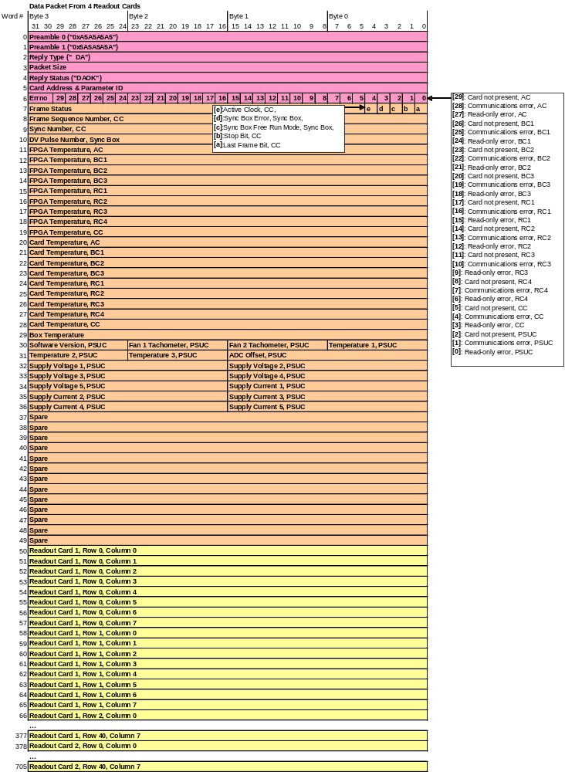
Figure 1. A Data Packet from the MCE to the Real-Time Linux PC.

In Figure 1, the data frame status block is highlighted in orange (words 7 through 49). A descript of all the important status words follows:

Errno Field (Word 6)
The errno field is a word containing 30 useful bits (3 bits per card) that indicate if any communication errors or timeouts have occurred in the MCE. In data packets, only the bits corresponding to Readout Cards can be set. Depending on which bits are set, the MCE will either continue data acquisition or stop. The bits definitions for each card are as follows:
- Card Not Present: When the MCE is reset, the Clock Card assumes that any cards that don’t respond to commands from that time forward are NOT populated. The Clock Card maintains a list of cards that are not populated. In reply packets, only the bits corresponding to cards that were addressed by the command are set.
[card not present = 0] indicates that the corresponding card is populated in the MCE
[card not present = 1] indicates that the corresponding card is NOT populated in the MCE.
- Communications Error: A ‘Communications Error’ bit is set only if the Clock Card has previously received a reply from the corresponding card. In reply packets, only the bits corresponding to cards that were addressed by the command are set.
[communications error = 0] indicates that a CRC error has not occurred in communications.
[communications error = 1] indicates that a CRC error has occurred.
- Read-Only Error: In reply packets, only the bits corresponding to cards that were addressed by the command are set.
[read only error = 0] indicates that a legal command has been send to the MCE
[read only error = 1] indicates that a write command has been sent to a read-only register.

Frame-Status Field (Word 7)
The frame-status field is an amalgam of 5 bits that denote information about the state of the Clock Card and the Sync Box. The bits are labelled as follows:
- Active Clock: indicates the source of the 25 MHz internal clock in the MCE.
[active clock = 0] indicates that the clock signal is sourced from the on-board crystal clock;
[active clock = 1] indicates that the clock signal is sourced the Manchester fibre input.
- Sync Box Error: indicates if an error has occurred on the sync-box.
[sync box error = 0] indicates that no errors have occurred;
[sync box error = 1] indicates that a DV pulse has been received before the sync box has finished sending a DV-packet to the MCE for the previous DV pulse.
- Sync Box Free Run Mode: indicates the source of DV pulses.
[sync box free run mode = 0] indicates that DV pulses are generated by the Sync Box;
[sync box free run mode = 1] indicates that DV pulses are being received by the Sync Box from an external source.
- Stop: indicates if the last data packet is due to a stop command or not. This bit can only be asserted in the last frame of a data sequence.
[stop = 0] in the last data packet of a sequence indicates that the sequence finished normally
[stop = 1] in the last data packet of a sequence indicates that the sequence finished prematurely due to a stop command.
- Last Frame: indicates the last data packet in a sequence.
[last frame = 0] indicates that this data packet is not the last of a sequence
[last frame = 1] indicates that this data packet is the last of a sequence

Frame Sequence Number Field (Word 8)
The frame sequence number field contains a 32-bit number that is incremented in each consecutive data packet from the MCE to the Real-Time Linux PC.

Sync Number Field (Word 9)
The sync number field contains a 32-bit number that is incremented by one every time the row-address multiplexer returns to address zero. In a sequence of data frames, the sync number in two consecutive frames will differ by a value specified by the user called “data_rate.” Monitoring the difference in value between consecutive frames is a good way of confirming that the timing-jitter between frames is 0.

DV Pulse Number Field (Word 10)
The DV pulse number field contains a 32-bit number that is received from the Sync Box in every Manchester packet that requests another data packet from the MCE.

FPGA/ Card/ PSUC Temperature Fields (Words 11 to 31)
FPGA/ Card/ PSUC temperatures are continuously recorded by cards and periodically reported back to the Clock Card. In addition to a card temperature sensor, the power supply card also contains two thermistors that monitor the temperature at two points inside the power supply. Finally, a Box temperature sensor mounted on the MCE backplane is continuously read out by the clock card.

FPGA temperatures are signed 32-bit words from -65°C to 127°C. Card and Box temperatures are signed 32-bit words from -55°C to 85°C. PSUC temperatures are signed 8-bit words from -55°C to 85°C.

Tachometer Fields (Words 30 to 31)
The tachometer values are expressed as integer multiples of a base unit. At this time, the base unit is still to be determined.

Supply Voltage Fields (Words 32 to 34)
The supply voltages are expressed as integer multiples of a base units. At this time, the base units are 10mV and 100mV.

Supply Current Fields (Words 34 to 36)
The supply currents are expressed as integer multiples of a base unit. At this time, the base unit is still to be determined.

Status Command Queries
When the Multi-Channel Electronics are not returning data packets, status information is not directly available because data frame headers are only included in data packets. Thus, the Real Time Linux PC will periodically issue individual commands to the MCE to check its status.

The following commands can be used to monitor the status of the MCE:
- rb sys card_temp
- rb sys fpga_temp
- rb cc box_temp
- rb psc psc_status

Status Header
Starting in Data Acquisition Software version “DAS_010901august06”, a utility has been implemented that collects general MCE status information. This utility parses the mce.xml file for parameters that have the keyword “log=1” and queries the MCE for the values of those parameters. The results are stored to disk. The stored values are refreshed before every data run, and are included at the beginning of every data file. To run the status utility manually, use the command “mcestatus”.

When Should an Alarm Go Off?
The values of the fields outlined above will change during the course of idling or data acquisition, as the temperatures/ currents/ voltages in the MCE vary, and communication errors occur. If any one of these flags exceeds or falls below specified thresholds, it is the responsibility of either the Real Time Linux PC or the MCE to take appropriate action. In these conditions, the PC/ MCE will notify the user and may:
- Allow the MCE to continue operating normally, or
- Stop a data-taking process, and/or
- Shut down the MCE.

The appropriate response of the PC/ MCE will be determined by the severity of the problem. In Figure 2, below, the data frame status block from Figure 1 has been sectioned into two colors. The fields that are highlighted in orange should stop a data-taking process if they reach the values listed within. The fields that are highlighted in red should trigger a power-down if they reach the values listed within.

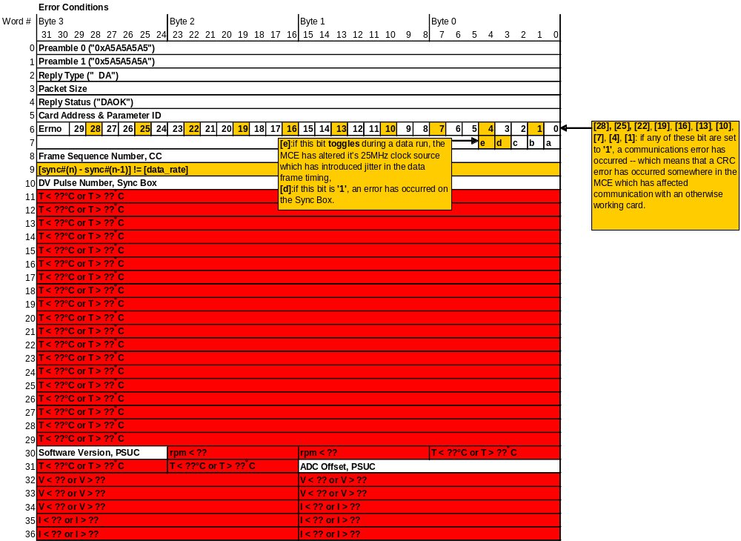
Figure 2. Error conditions that should either cause the data process to stop, or a power-down.

