Monitoring the MCE Status in Real-Time

Summary
None at this time

References
None at this time.

Introduction
There are three ways in which status information can be gleaned from the MCE in real-time:
- Visually, from the front-panel LEDs on every card in the MCE
- Digitally, via the MCE data-frame header (when taking data)
- Digitally, via individual command queries (when not taking data)

Front-Panel LEDs
Each card except the power supply card has a set of three LEDs. Each LED is a different color and is marked on the front panel as follows:
- Green
- Yellow
- Red

The LEDs can be driven to one of four states by the firmware during normal user-mode:
- Steady On
- Steady Off
- Slow Blinking (~0.5 Hz)
- Fast Blinking (~2 Hz)

During configuration-mode, all LEDs are driven to the “steady on” state.

The following matrix describes the meaning of each LED in each of the four states.

 | Steady On | Steady Off | Slow Blinking | Fast Blinking
Green | Power on | Power off |  | Backplane transmission in progress
Yellow | RC: Servo locked  BC: Undefined  AC: Multiplexing | RC: Servo unlocked  BC: Undefined  AC: Not Multiplexing
Red | Configuration completed unsuccessfully | Configuration completed successfully |  | Board/ FPGA temperature visual warning
Table 1. LED Definitions

Data Frame Status Block
Each data frame status block is composed of 43 32-bit words included near the beginning of each data packet sent by the MCE to the Real Tim Linux PC. The PC extracts information contained in the status block and may take action based on the contents. Data frame status blocks are only included in data packets.

The format of a data packet is as follows:

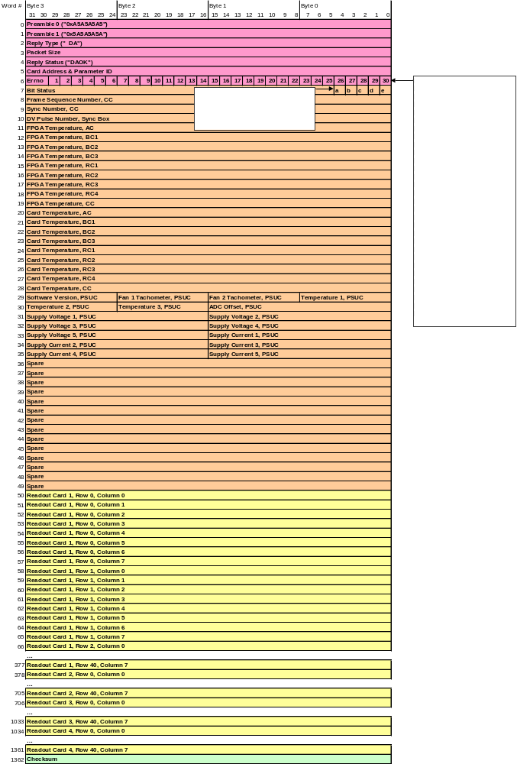
Figure 1. The data packet format from the MCE to the Real-Time Linux PC.

In Figure 1, the data frame status block is highlighted in orange (words 7 through 49). A descript of all the important status words follows:

Errno Field (Word 6)
The errno field is a 32-bit word that indicates if any communication errors or timeouts have occurred in the MCE. Depending on what bits are set, the MCE will either continue data acquisition or stop. The bits are labeled as follows
- Card Not Present:
[card not present = 0] indicates that the corresponding card is populated in the MCE
[card not present = 1] indicates that the corresponding card is not populated.
- Communications Error:
[communications error = 0] indicates that a CRC error has not occurred in communications.
[communications error = 1] indicates that a CRC error has occurred.
- Read-Only Error:
[read only error = 0] indicates that a legal command has been send to the MCE
[read only error = 1] indicates that a write command has been sent to a read-only register.

Bit-Status Field (Word 7)
The bit-status field is an amalgam of 5 bits that denote information about the state of the Clock Card and the Sync Box. The bits are labeled as follows:
- Active Clock: indicates the source of the 25 MHz internal clock in the MCE.
[active clock = 0] indicates that the clock signal is sourced from the on-board crystal clock;
[active clock = 1] indicates that the clock signal is sourced the Manchester fibre input.
- Sync Box Error: indicates if an error has occurred on the sync-box.
[sync box error = 0] indicates that no errors have occurred;
[sync box error = 1] indicates that a DV pulse has been received before the sync box has finished sending a DV-packet to the MCE for the previous DV pulse.
- Sync Box Free Run Mode: indicates the source of DV pulses.
[sync box free run mode = 0] indicates that DV pulses are generated by the Sync Box;
[sync box free run mode = 1] indicates that DV pulses are being received by the Sync Box from an external source.
- Stop: indicates if the last data packet is due to a stop command or not. This bit can only be asserted in the last frame of a data sequence.
[stop = 0] in the last data packet of a sequence indicates that the sequence finished normally
[stop = 1] in the last data packet of a sequence indicates that the sequence finished prematurely due to a stop command.
- Last Frame: indicates the last data packet in a sequence.
[last frame = 0] indicates that this data packet is not the last of a sequence
[last frame = 1] indicates that this data packet is the last of a sequence

Frame Sequence Number Field (Word 8)
The frame sequence number field contains a 32-bit number that is incremented in each consecutive data packet from the MCE to the Real-Time Linux PC.

Sync Number Field (Word 9)
The sync number field contains a 32-bit number that is incremented by one every time the row-address multiplexer returns to address zero. In a sequence of data frames, the sync number in two consecutive frames will differ by a value specified by the user called “data_rate.” Monitoring the difference in value between consecutive frames is a good way of confirming that the timing-jitter between frames is 0.

DV Pulse Number Field (Word 10)
The DV pulse number field contains a 32-bit number that is received from the Sync Box in every Manchester packet that requests another data packet from the MCE.

FPGA/ Card/ PSUC Temperature Fields
FPGA and card temperatures are continuously recorded by each card and periodically reported back to the clock card. In addition to a card temperature sensor, the power supply card also contains two thermistors that monitor the temperature at two points inside the power supply. Finally, a subrack temperature sensor mounted on the backplane is continuously read out by the clock card.

Each temperature reading is rounded to the nearest °C and encoded into a 32-bit or 8-bit, two’s complement, signed binary number.

Tachometer Fields
The tachometer values are expressed as integer multiples of a base unit. At this time, the base unit is still to be determined.

Supply Voltage Fields
The supply voltages are expressed as integer multiples of a base units. At this time, the base units are 10mV and 100mV.

Supply Current Fields
The supply currents are expressed as integer multiples of a base unit. At this time, the base unit is still to be determined.

Status Command Queries
When the Multi-Channel Electronics are not returning data packets, status information is not directly available because data frame headers are only included in data packets. Thus, the Real Time Linux PC will periodically issue individual commands to the MCE to check its status.

The following commands can be used to monitor the status of the MCE:
- rb sys card_temp
- rb sys fpga_temp
- rb psc psc_status

When Should an Alarm Go Off?
The values of the fields outlined above will change during the course of idling or data acquisition, as the temperatures/ currents/ voltages in the MCE vary, and communication errors occur. If any one of these flags exceeds or falls below specified thresholds, it is the responsibility of either the Real Time Linux PC or the MCE to take appropriate action. In these conditions, the PC/ MCE will notify the user and may:
- Allow the MCE to continue operating normally, or
- Stop a data-taking process, and/or
- Shut down the MCE.

The appropriate response of the PC/ MCE will be determined by the severity of the problem. In Figure 2, below, the data frame status block from Figure 1 has been sectioned into two colors. The fields that are highlighted in orange should stop a data-taking process if they reach the values listed within. The fields that are highlighted in red should trigger a power-down if they reach the values listed within.

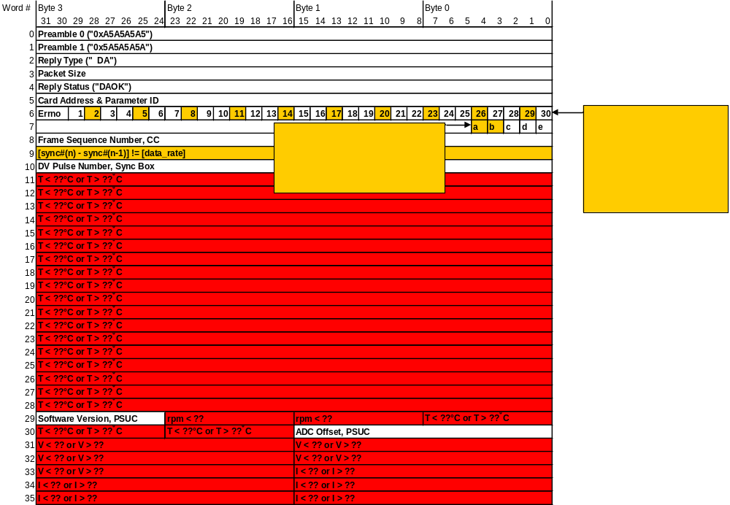
Figure 2. Error conditions that should either cause the data process to stop, or a power-down.

