SCUBA-2 Bus Backplane ISA

Summary
The purpose of this document is to describe the protocol for the communication between SCUBA2 the Clock Card (CC) and all other cards in the Multi-Channel Electronics (MCE). The proposed protocol will be compatible with the one suggested by Gao[4] for communication between the Real-time Linux PCs and Clock Card.

References
[1] SCUBA 2 data acquisition software overview
[3] MCE Firmware Block Diagrams: SC2/ELE/S563/100, SC2/ELE/S563/200, SC2/ELE/S563/201, SC2/ELE/S563/300, SC2/ELE/S563/400, SC2/ELE/S563/500.
[4] SCUBA2 Data Acquisition Software Overview, Xiaofeng Gao, http://www.roe.ac.uk/atc/projects/scuba_two/electronics/pdf_docs/sc2-sof-s200-014-v1.pdf
[5] SCUBA-2 Data Acquisition to Data Processing Interface, Dennis Kelly, http://www.roe.ac.uk/atc/projects/scuba_two/software/pdf_docs/sc2-sof-s200-008rev.pdf

Introduction
In the MCE, the CC will act as the master card, and all other cards will be slaves. In other words, all communication sequences over LVDS will be initiated by the CC. The CC will send instructions on a multi-tapped LVDS line over the Bus Backplane (BB) to the other cards, and will wait for their replies on dedicated point-to-point lines. For the purpose of BB communication, a simple well-defined Instruction-Set Architecture (ISA) will be implemented. This ISA will exist internally to the MCE. However, this protocol is compatible with the one that has been tabled by Gao. The focus this BB ISA is to provide a simple, short, byte-aligned, error-free instruction set that is easily implemented. This ISA will contain instructions that have a direct correspondence with operations initiated by the Real-Time Linux PC’s (RTL PC), and instructions that will be used for internal operations which the RTL PC’s need not know about.

Instructions
CC will initiate all communication with other cards using instructions, and wait for replies to each instruction issued. The generalized instruction format is shown below.

Figure 1. BB Instruction Format

All instructions issued over the bus backplane will be generated by the CC, and will be byte-aligned. Instructions will be transmitted MSB-first. Each coloured background in the figure above designates a field that may appear in an instruction. Each character in the coloured background corresponds to a bit. The fields are:

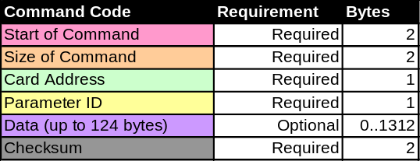
Figure 2. BB Instruction Fields

As noted in the figure 2, some fields are labelled as ‘Optional’. Optional fields are included in the ISA so that when timing is critical, short instructions can be issued and parsed quickly. All instruction fields are discussed below (refer to Figure 1 to identify each field):

‘Start of Command’: This field is required, and is 2 bytes long. It will indicate to a Command_FSM that a new instruction is incoming. The ‘Start of Command’ field will allow the Command_FSM to recover if it has lost lock on previous instructions. The ‘Start of Command’ field will be a constant value, but it will not be a uniquely-occurring value in the Bus Backplane communications. Two bytes will suffice, and in combination with the ‘Size of Command’ field, prompt recovery is possible from errors where a byte has been dropped. Detection will work this way: if a Command_FSM looses lock on instructions, then at some point thereafter, it will receive what it thinks is a ‘Start of Command’ field that doesn't contain the expected constant value. Recovery will include responding with an error message.

Usage example: In all instructions, the ‘Start of Command’ field will appear as ‘0xAAAA’.

‘Size of Command’: This field is required, and is 2 bytes long. It is a measure (in bytes) of the length of data included with a particular instruction. 2 bytes are enough to allow an instruction to theoretically include up to 2¹⁶-1 bytes of data. However, the largest packet of data will be a quarter-frame of data (1312 bytes) transmitted from a single Readout Cards to the Clock Card. If no data are included, ‘Size of Command’ will be ‘0x0000’. Note that required fields (Start of Command, Size of Command, Parameter ID, Checksum) do not figure in the Size of Command field.

The Size of Command field will tell Command_FSM blocks how long an expected instruction will be, so that they know when to expect the beginning of the next instruction.

Usage example: Size of Command = ‘0x0110’ means that the optional fields of the instruction are 272 bytes long.

‘Parameter ID’: This field is required, and is 1 byte long. This field will allow the Instruction Set to support up to 255 different Parameter IDs. A list of all parameter ID’s is shown below:

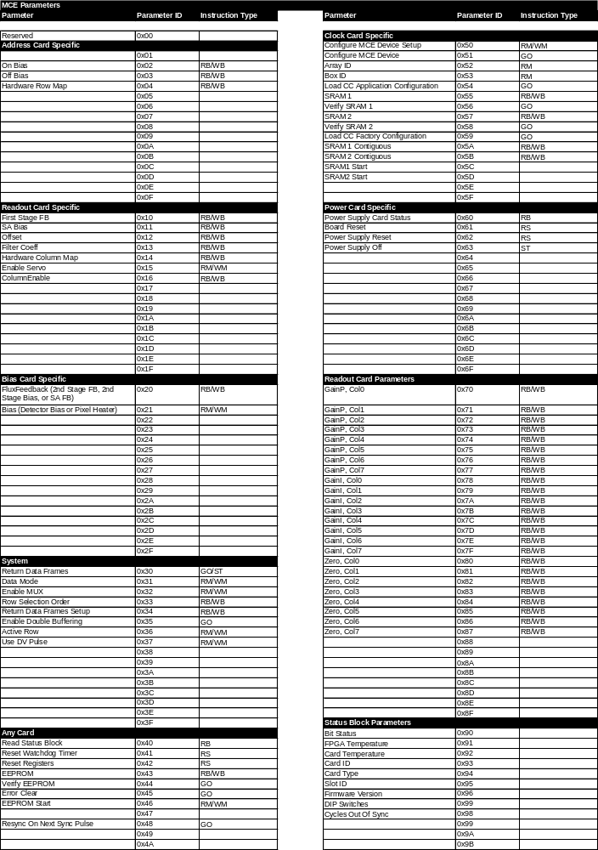
Figure 3. Accessible Parameters in the MCE
Each ‘Parameter ID’ represents a command that can be issued by the RTLPCs or the Clock Card.

Usage example: ‘0x10’ Parameter ID is associated with ‘1st Stage FB’.

‘Card Address’: This field is required, and is 1 byte long.

Some parameters with the same ‘Parameter ID’ exist on several cards in the MCE (i.e. the Watchdog Timer exists on every card). In these cases, the ‘Card Address’ field will be used to target the Watchdog Timer on a specific card, if need be.

If this field is included in an instruction, the instruction will only affect the card(s) that it targets. The possible field-values are:

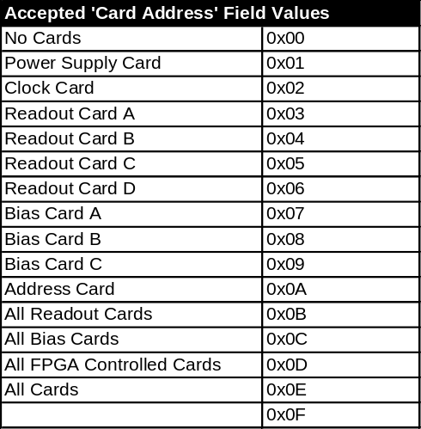
Figure 4. Accepted ‘Card Address’ Field Values

Usage example: ‘0x0D’: this instruction targets all cards in a subrack, except the Power Supply Card.

‘Data’: This field may not be required, and can theoretically be up to 2¹⁶-2 bytes long. The data field will be used to send data and operating parameters to/from cards within the MCE.

‘Checksum’: This field is required, and is 2 bytes long. Each bit in the ‘Checksum’ will be calculated using a CRC16 generator block.

If transmission error rates are below an agreed-upon level, then this field may not be included in the final version of the Bus Backplane Instruction Set. If the ‘Checksum’ field is not included in the Bus Backplane Instruction Set, then the maximum instruction length will be reduced to 2¹⁶+3 bytes.

Instruction Types
As in Gao’s protocol, there will be five types of instruction operations in the BB ISA. They are:
- ‘Block Read Memory’
- ‘Block Write Memory’
- ‘Start Application’: starts a process
- ‘Stop Application’: stops a process
- ‘Reset’: reset a system

Some instructions of type (a, b) form pairs, as some do in (c, d). Instructions that form pairs will have identical ‘Parameter ID’ fields. For example, both the ‘Read Row 'On' Value’ and the ‘Write Row 'On' Value’ instructions in the BB ISA have the same ‘Parameter ID’ (‘0x02’). Two paired instructions will be differentiated by the number of parameters that are passed along the Bus Backplane. For example, the ‘Block Read’ instruction requires no data parameters, whereas the paired ‘Block Write’ instruction requires new parameter values. Generally speaking, a ‘Block Write’ instruction will always require more parameters than it’s paired ‘Block Read’ instruction. It will be easy to differentiate between paired instructions by the value of the ‘Size of Command’ field included. The instruction decoder on every card will differentiate between paired instructions by knowing what the expected length of each instruction is.

Instruction pairs of the (c) “Start” and (d) “Stop” varieties will also have identical “Parameter ID” fields, but will include a mandatory data parameter that will determine whether the instruction is a “Start” or “Stop”. In this case, these instructions will be differentiated by using reserved values for parameters that are included in the instruction. Please see the BB ISA spreadsheet for examples.

Please note that there are a few instructions that are issued by the RTL computers which may not be seen over the bus backplane. For example, a request to ‘Download Configuration Data’ will be received from the fibre optic link and parsed by the CC, but not be passed on over the BB.

Agreement between the Bus Backplane Instruction Set and Gao’s Instruction Set
As mentioned, the Bus Backplane Instruction Set and Gao’s instruction set are completely compatible. The correspondence between fields is shown below:

Figure 5. Correspondance between Gao’s PCI Interface Protocol and the Bus Backplane Instruction Set.

The figure above indicates that only Gao’s “Card Address” and “Data” fields will contain information that is useful to the MCE. Each of these fields will be large enough hold the range of values that the MCE requires. This correspondence scheme will require Gao’s “Card Address” field to grow to 8 bits, and his “Memory Address” field to shrink to 24 bits from the sizes proposed in [4].

Replies
Replies to instructions will follow the same rules as instructions. The only major difference is in format, where replies will include and additional field called ‘Success/Fail’.
Figure 6. Bus Backplane Reply Format
‘Success/Fail’ is one byte long, and is required. It will provide a means for a replying card to communicate a reason for an error to the Clock Card.

Status Block
Near the beginning of each frame, a block of data containing status information pertaining to the MCE will be included. This block will be 11 x 32 bits, and will allow the RTLPCs to monitor the state of the MCE during data acquisition. The RTLPCs will not explicitly request this information during data acquisition because of the requirement on the system that there be no more than one instruction from the RTLPCs in flight at any instant: during data acquisition, an instruction will be in flight during the duration of the data acquisition cycle. Instead, status information will be included in every data header, at a rate of 200 Hz in science mode, although the data may be time averaged to a frequency much lower than this. The format of the header is shown below.

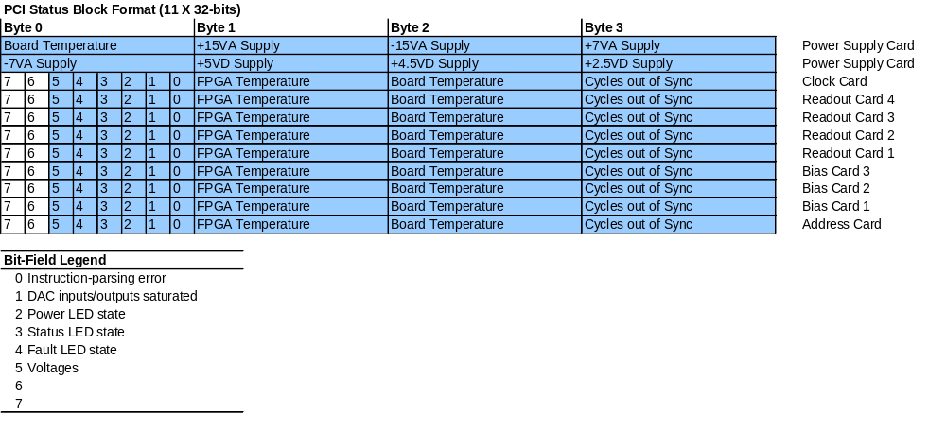
Figure 7. Format and Content of the Status Block in Data Frames.

