MCE User’s Guide

Revisions
- Rev. 1 (BB): Initial Version

Summary
This document describes common user scenarios, from configuring the MCE FPGAs to setting up the MCE and peripherals (i.e. Sync Box) to communicate with each other.

References
[1] SCUBA2-das-engineer-user-manual.doc
[2] InstrDscr.doc

Table of Contents
1. Revisions 1
2. Summary 1
3. References 1
4. Table of Contents 1
5. Introduction 2
6. Commanding the MCE through a Linux PC 3
6.1 Starting Data Acquisition Software (DAS) Environment 3
6.2 MCE Commands and Scripts 3
6.3 Known MCE Fibre Optic Communications Bug 3
7. Synchronizing MCE’s with a Sync Box 4
8. Using the Dedicated DV-Pulse Fibre Input to the MCE 5
9. Data Collection While Stepping the TES Bias 6
10. Upgrading MCE Firmware 10
10.1 Automatic Update Using a CDF File 10
10.2 Manual Update Using the Quartus II Programmer 11
10.3 Updating Firmware Using the RTL PC 16
11. Appendix: Quartus Software 17
11.1 Reinstalling the Quartus II Programmer 17
11.2 Reinstalling the ByteBlaster/USB-Blaster Cable Drivers 21

Introduction
None at this time.

Commanding the MCE through a Linux PC
Be sure that the MCE and Real Time Linux PC are linked with a duplex fibre-optic cable. Power on the MCE, and configure the MCE with the correct firmware (see the section called “Upgrading MCE Firmware”).

The MCE is controlled via commands issued from a Real Time Linux PC through the “Data Acquisition Software” environment. Please refer to [1] and [2] for detailed descriptions of the communications protocol and the command set in this environment.

Starting Data Acquisition Software (DAS) Environment
To start the DAS environment:
- Log on to your Real Time Linux PC as “mce”
- Open a shell window and type:
>cd das
>source dassetup
>startdas mce
>set_directory
- To command the MCE in Verbose mode, type:
>mcedebug 1

MCE Commands and Scripts
You can read and write MCE parameters by individual commands (“mcecmd”) or by running a batch files that contain multiple commands (“mcebatchgo”). For a list of individual MCE commands (including syntax), refer to [2].
To run a batch file create a file that contains a list of commands and then execute the batch file by calling “mcebatchgo.” This batch file has to be under directory pointed by $USRCONFIGDIR. A set of sample batch files are provided in a directory called: ~mce/ubcscripts. A set of plot programs for the data from some of the scripts are provided in a directory called ~mce/idl_pro.

For example, you may create a batch file called “temp.bat” that contains the following commands:

rb rc3 offset
wb sys row_len 64

To run the batch file, type:
>mcebatchgo <cmd> <data> <temp.bat>

where:
- mcebatchgo: is the name of the DAS utility that executes a batch file
- <cmd>: is the name of the file that logs outgoing commands and incoming replies
- <data>: is the name of the datafile that the data frames will be stored (if any)
- <temp.bat>: is the name of the batch file.

Known MCE Fibre Optic Communications Bug
If the MCE is uncommunicative to commands, re-configure the MCE from Quartus and then issue any command to test whether communications have been established (you may have to reconfigure several times before communication is established). This is a known issue that is related to fibre-optic communications between the Real Time Linux PC and the MCE.

Synchronizing MCE’s with a Sync Box
Sync Boxes are used to synchronize up to 8 MCE’s with each other. A Sync Box communicates with MCE’s over 8 fibre-optic channels and with a PC over RS-232. When configured properly, the Sync Box sends a continuous stream of communication containing:
- DV pulses,
- Sync pulses and a
- 25 MHz clock.

The MCE can be configured to use any combination of these.

To set up a Sync Box and MCE’s for communication with each other:
- Open communication with the Sync Box via an RS-232 connection. If communicating from a windows machine, use HyperTerminal; from a Linux machine use minicom. Be sure that the RS-232 terminal adds line feeds after carriage returns (in minicom: <ctrl>+<a>, <a>), and echoes characters (in minicom: <ctrl>+<a>, <z>).
- After connecting to the Sync Box via RS-232, you can type “help” to view the Sync Box’s valid commands and “?” to view the Sync box’s current status.
- For communication between the Sync Box and MCE to succeed, there are two parameters in each that must correspond to each other. The Sync Box “rl” parameter value must be exactly half the value of the MCE “row_len” parameter. This is because the Sync Box is clocked at half the speed of the MCE. Also be sure that the Sync Box “nr” parameter value matches the MCE’s “row_num” value.
- To configure the MCE to use DV/ Sync/ Clock from the Sync Box, use the following commands:
>w cc use_dv <dv_source>
>w cc use_sync <sync_source>
>w cc select_clk <clk_source>

Where:
- <dv_source> = 0 configures the MCE to use internal DV pulses generated at a rate of “data_rate”; = 1 configures the MCE to source pulses from the DV input (labelled DV-IN on the Clock Card faceplate); = 2 configures the MCE to source pulses from the Sync Box input (labelled SYNC-IN on the Clock Card faceplate.) If the MCE is configured to use DV pulses from a fibre source that is faulty/ non-existent, then a request for data will time out.
- <sync_source> = 0 configures the MCE to use internal Sync pulses; = 2 configures the MCE to source pulses from the Sync Box input (labelled SYNC-IN on the Clock Card faceplate.) If the MCE is configured to use Sync pulses from a faulty/ non-existent fibre source, the MCE will be in an unpredictable state.
- <clk_source> = 0 configures the MCE to use the internal crystal clock; = 1 configures the MCE to use the Manchester clock received from the Sync Box input (labelled SYNC-IN on the Clock Card faceplate). If a command to switch the MCE over to a faulty/ non-existent fibre input, the MCE will not switch. Also, if a fibre input fails while the MCE is sourcing it’s clock from that connection, it will automatically switch to it’s internal clock.

Using the Dedicated DV-Pulse Fibre Input to the MCE
For lack of a Sync Box, the MCE can be configured to return data on the falling edges of raw DV pulses from the fibre-optic DV-pulse input on the Clock Card faceplate. To configure the MCE to use raw DV pulses, use the following command:
>w cc use_dv 1

Now query the MCE for data using any data acquisition script (i.e. mceframetest), and the MCE will return the number data frames as you specified – each frame in response to a DV pulses it received. When the MCE as completed the data run, it will ignore all subsequent DV pulses it receives.

Data Collection While Stepping the TES Bias
This feature of the MCE allows a user to specify the period and amplitude of a square wave applied to the TES Bias inputs, while collecting data.

TES Bias toggle commands are internally scheduled and issued by the Clock Card. Four parameters control the attributes of the TES square wave:
>w cc tes_tgl_max <high value>
>w cc tes_tgl_min <low value>
>w cc tes_tgl_rate <n>
>w cc tes_tgl_en <mode>

Where:
- <high value> and <low value> are numbers between 0 and 65535.
- <n> is the number of frame periods between a switch in the TES Bias level (note that this is a measure of the half-period of the square wave!). To ensure that the phase shift between data packets and TES bias toggling remains constant, be sure to choose <n> as a multiple of <data_rate>. Note that the phase difference between data collection and TES Bias switching may not be the same from one data run to the next, but it will be constant within a data run.
- <mode> = 0 means TES Bias toggling is disabled, =1 mean TES Bias toggling is enabled.

To enable these commands, add the following lines to your mce.xml file, in the section for the Clock Card, and restart DAS:
<tes_tgl_en ParId="0xA3" Type="int" Count="1" />
<tes_tgl_max ParId="0xA4" Type="int" Count="1" />
<tes_tgl_min ParId="0xA5" Type="int" Count="1" />
<tes_tgl_rate ParId="0xA6" Type="int" Count="1" />

In data packets returned to the Real-Time Linux PC, one of the bits in the status header indicates the level of the TES Bias square wave. The bit is set to “1” if the TES Bias level was high while the data packet was collected, or “0” if the level was low while the data packet was collected.

The effect of the parameters discussed above is shown in a generic timing diagram of the TES Bias output, below. The diagram is for the case where TES Bias toggling has been enabled (i.e. a “w cc tes_tgl_en 1” command has been issued to the MCE).

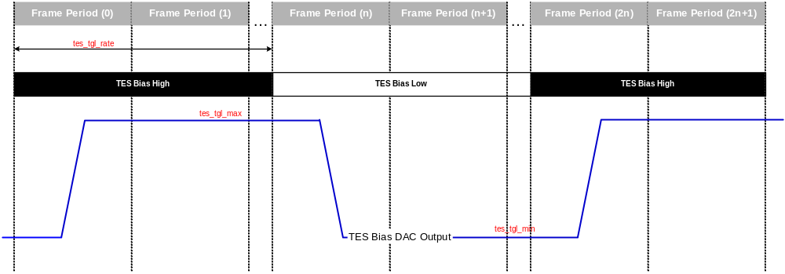
Figure 1. A Timing Diagram for TES Bias Square Wave.

If the tes_bias_rate is an integer multiple of the data_rate, then the phase shift between edges of the square wave and data packets will be constant during a data run. However, the phase shift will vary between data runs because the MCE does not enforce timing between the two processes. However, the MCE does enforce the timing of the data packets – internal commands will never cause jitter in the data samples. This can be verified by taking the difference between the sync numbers of consecutive data packets, and confirming that the difference is constant during a data run.

The internal mechanism for ensuring zero-jitter works like this:
- When the TES Bias toggling is enabled, all other internal housekeeping commands are disabled to ensure the correct timing of the TES Bias commands.
- If the TES Bias toggling is enabled in the middle of a data run, it will not interfere with the timing of data commands. The issue of the first TES toggling command will be delayed until immediately after a ret_dat command. The timing is shown below. This is the easiest way of controlling the phase difference between data frames and bias toggling.
- Conversely, if a data run is started while TES Bias toggling is enabled, then the timing of TES Bias toggle commands is adjusted so that the toggle commands are issued immediately after the ret_dat commands.

Here are some scope captures that show the rise and fall times of the TES Bias signal. Note that the following four screen captures are taken by looking at the output of the TES Bias signal with a active probe (one lead grounded, the other lead measuring a signal) and an oscilloscope. It should be noted that the rise and fall time of the TES Bias is much faster when connected to the cryostat because of the cable characteristics.

Assuming that you have:
Row Length = 100 clock cycles
Number of Rows = 33 rows
Data Period = 38

The internal MCE clock runs at 50 MHz.

Thus,
Multiplexing Rate = 50MHz/(100*33) = 15,152 Hz
Frame Period = 66 us
Data Rate = 50 MHz /(100*33*38) = 398.72 Hz
Data Period = 2508 us

When the MCE is DV-triggering off the Sync Box, it reacts in the same way as if it were triggering off of internal DV pulses. The steps in square waves at the outputs of the Bias Card DACs occur:

2044 us before next data packet (if collecting data from 1 Readout Card)
1912 us before next data packet (if collecting data from 4 Readout Cards)

Please note the slightly revised numbers wrt to my last email.

When the MCE is in busy with a data run, it will only issue an internal command (like the square wave steps) immediately following the processing of a data packet. Also, it will issue at most one internal command per data packet. This way, internal commands don't take up too much of the time between data packets. You sort of have to be careful, though, not to crank up your data rate too high, otherwise internal commands will start interfering with the timing of data packets. Also, note that this timing might be different for other registers.

Internal square wave commands are issued immediately after the Clock Card is finished processing a data frame, and the value of the square wave that is applied is reported out in the next data frame header. Data frames are collected at the start of a new Frame Period. The timing of this breaks down as follows:

Please note that these values are the time between applying the Bias Step at the DAC, and when data from the last row of the multiplexer is collected. The time between the application of the Bias Step at the DAC and the collection of the first row of data would be about [66us - (20 ns * sample_dly)] = ~64 us less than this, because the rows are multiplexed in time, and there is a sample delay from the start of each row dwell period.

The key thing to recognize is that if you set your bias step period equal to an integer multiple of your data period, then you ensure that the amount of time between when the step value is applied and when the next data packet is collected remains constant.

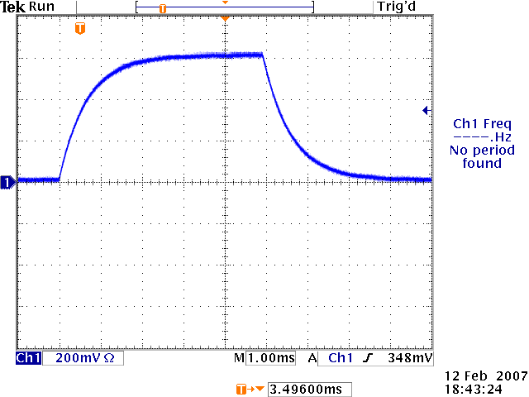
Figure 2. Rise and Fall Time of TES Bias between 0 and 16000

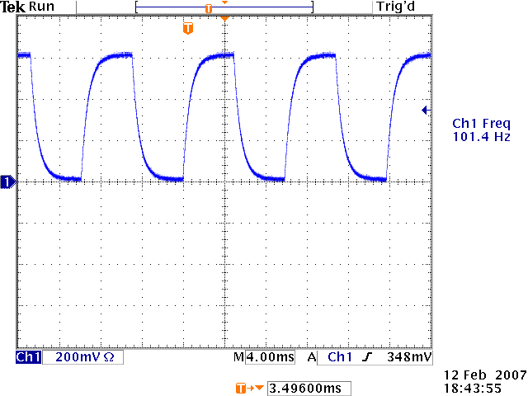
Figure 3. row_len = 128, num_rows = 41, tes_tgl_rate = 47 yields a 101Hz TES Bias square wave.

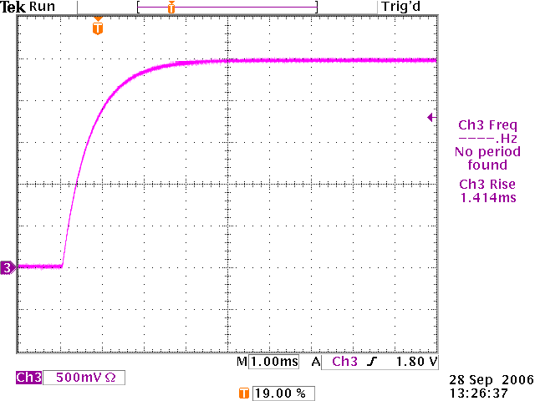
Figure 4. Rise Time of the TES Bias DAC Output, from 0 to 64000.

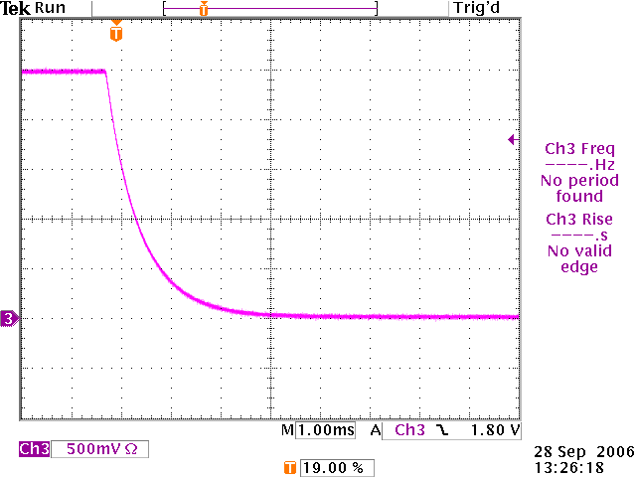
Figure 5. Fall Time of the TES Bias DAC Output, from 64000 to 0.

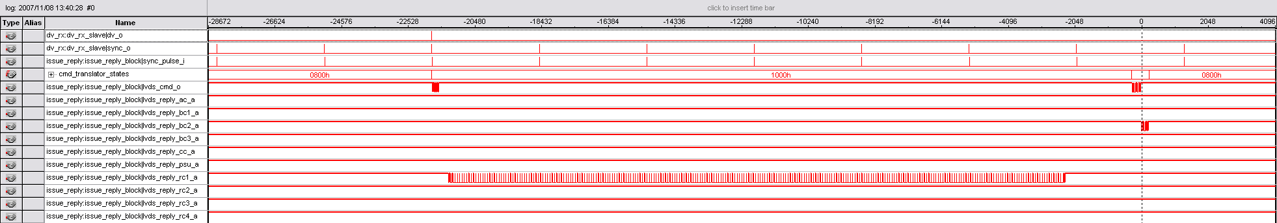
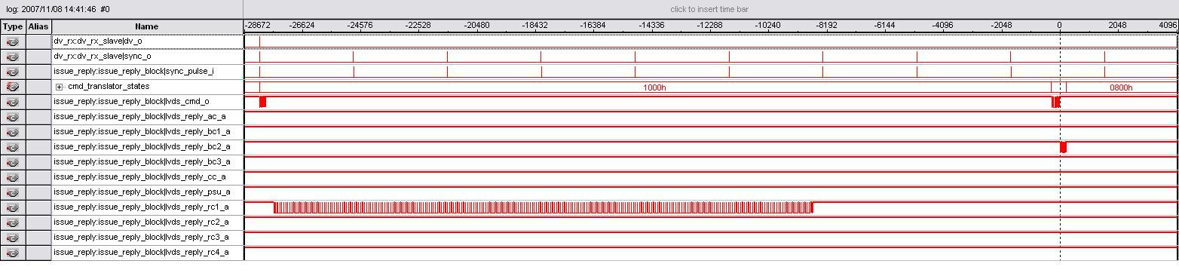
Figure 6. The two images above were taking during data collection from one Readout Card and 4 Readout Cards respectively. Please note that the Bias Card 2 Bias is not applied until the sync pulse following the Bias command, which triggered a response from Bias Card 2. For more information, please see the two .stp files called mce_response_2_dv_rc1.stp and mce_response_2_dv_rcs.stp

Upgrading MCE Firmware
This section describes how to load firmware into the MCE. We currently support two methods of updating firmware; both involve using the Quartus II Programmer software. A third method of updating firmware, using the RTL PC, is not currently supported. With the Quartus Programmer, one can use a CDF file that automatically selects each card’s firmware (recommended), or one can load the firmware manually by individually choosing what firmware goes into each card. CDF files can be obtained from the UBC firmware engineering team.

Automatic Update Using a CDF File
Note: In order to use a CDF file, your MCE subrack must be fully populated (all cards must be plugged in). Otherwise, the programmer will report an error.

- Start the Quartus Programmer by selecting Start ➔ Altera ➔ Quartus II 4.2sp1 Programmer. If you did not install into the “Altera” program folder, substitute the correct folder name above.

Verify that the correct programming hardware is selected. If “No Hardware” is displayed in the top left-hand corner, click on Hardware Setup. Otherwise, proceed to Step 3.

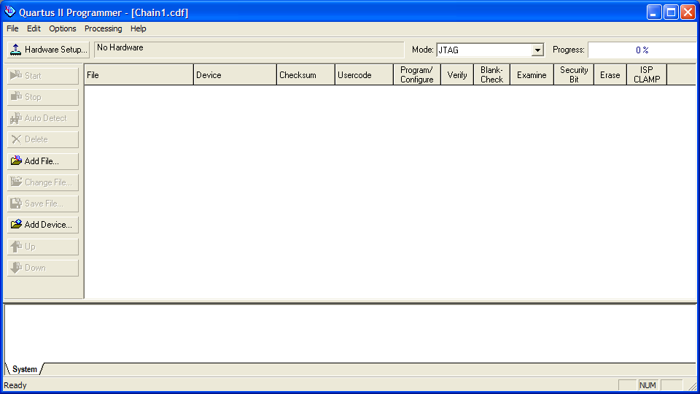

- Double-click on “ByteBlaster” or “USB-Blaster” under “Available hardware items” to select the programming hardware. If no such device is available, verify that the Altera ByteBlaster or Altera USB-Blaster driver has been installed on the system. Click Close. You should now see “ByteBlaster” or “USB-Blaster” in the top left-hand corner.

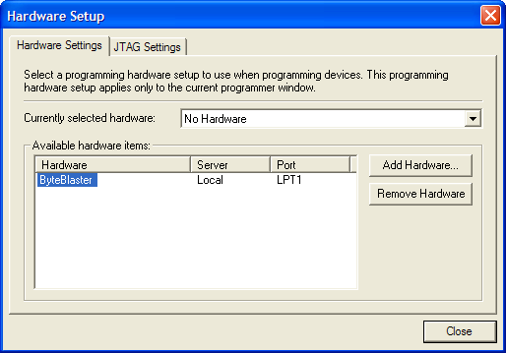

- Click on File ➔ Open… and browse to the directory containing the CDF file. Select the CDF file and click Open.

- Click Start to begin the firmware update process.

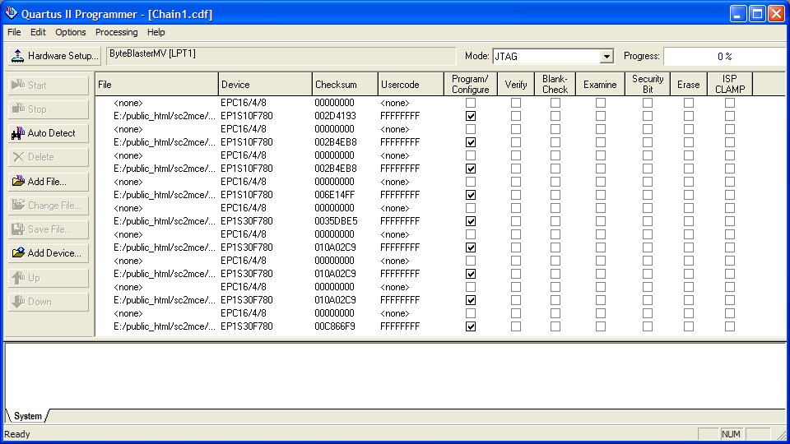

- Upon successful completion, the status messages at the bottom will appear in green at the bottom of the window. If there is a problem, error messages will be displayed in red. Refer to the troubleshooting guide for assistance.

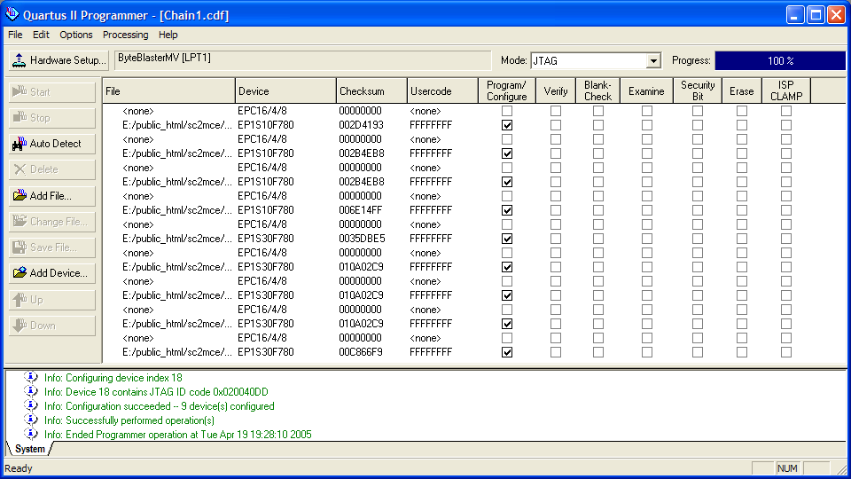

Manual Update Using the Quartus II Programmer
Note: In order to program the clock card’s Factory configuration device, put the clock card on an extender card and connect the programming cable to the JTAG header (header P2).

- Start the Quartus Programmer by selecting Start ➔ Altera ➔ Quartus II 4.2sp1 Programmer. If you did not install into the “Altera” program folder, substitute the correct folder name above.

Verify that the correct programming hardware is selected. If “No Hardware” is displayed in the top left-hand corner, click on Hardware Setup. Otherwise, proceed to Step 3.

- Double-click on “ByteBlaster” or “USB-Blaster” under “Available hardware items” to select the programming hardware. If no such device is available, verify that the Altera ByteBlaster or Altera USB-Blaster driver has been installed on the system. Click Close. You should now see “ByteBlaster” or “USB-Blaster” in the top left-hand corner.

- Click Auto Detect. In the list of devices that appears, each card in the MCE appears as a group of two devices, consisting of one “EPC16/4/8” configuration device and one “EP1Sxx” FPGA device. Furthermore, each card is listed in order from MCE slot 1 (address card) at the top of the list to MCE slot 9 (clock card) at the bottom.

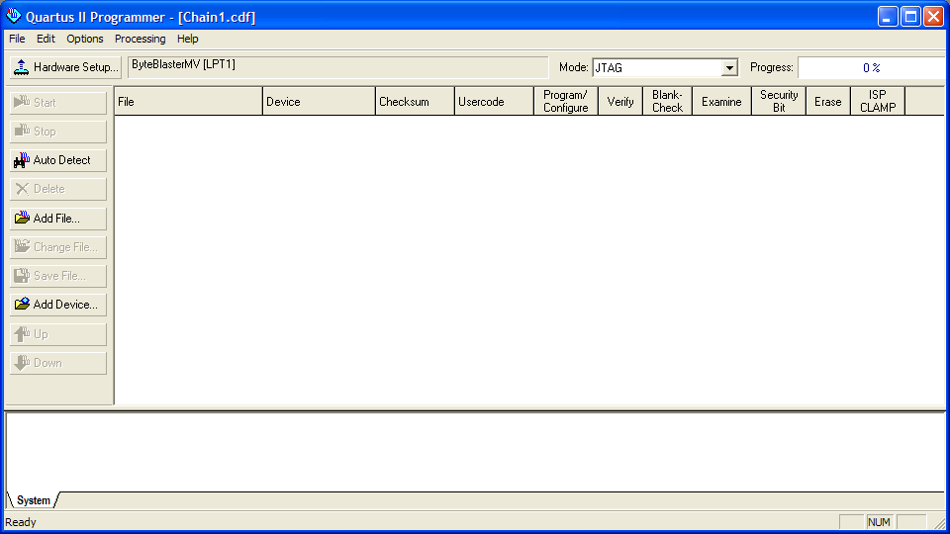

- If you are programming the FPGAs, double click on the “<none>” beside each EP1Sxx device that you wish to program and select the appropriate programming file. FPGA programming files have file extension .sof.

If you are programming the configuration devices, double click on the “<none>” beside each EPC16/4/8 device that you wish to program and select the appropriate programming file. Configuration device programming files have file extension .pof

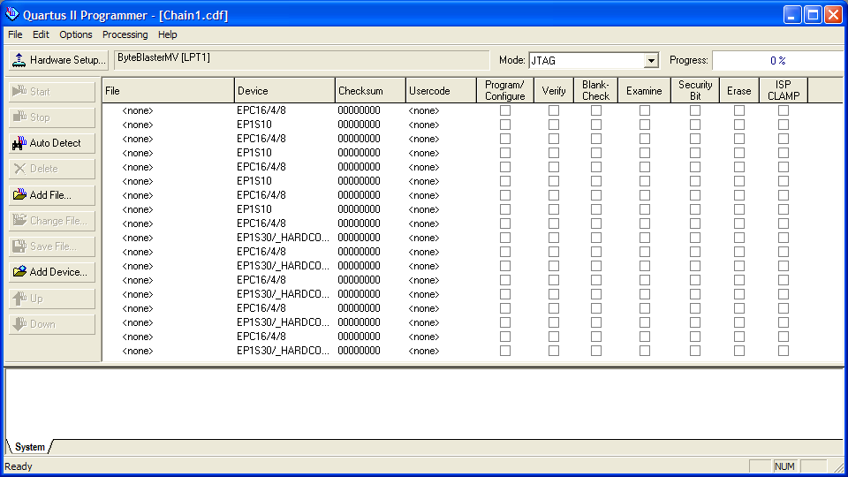

- Put a checkmark in each box under “Program/Configure” corresponding to the FPGA or configuration device that you selected in Step 4.

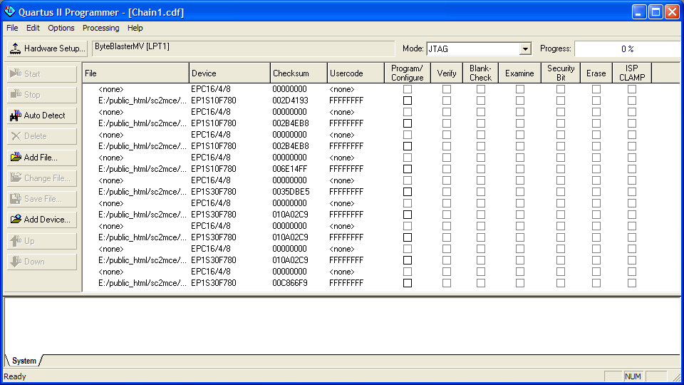

- If you are programming configuration devices, you will need to tell the Quartus Programmer to trigger an automatic reconfiguration of the FPGAs after the configuration devices have been loaded. To enable this, click on Options ➔ Initiate Configuration After Programming.

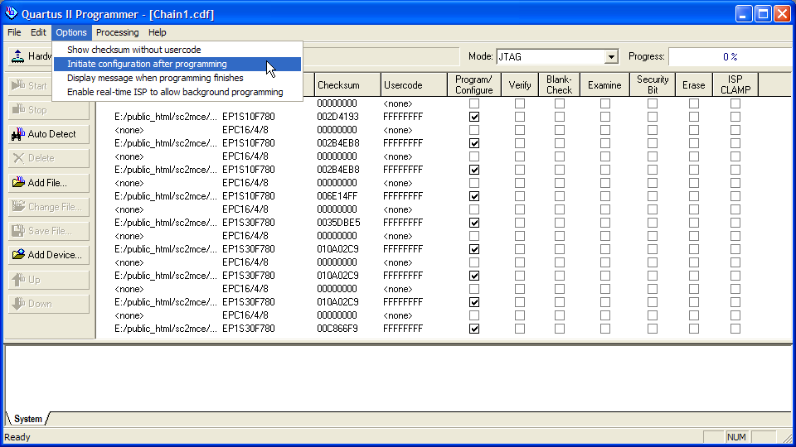

- Click Start to begin the firmware update process.

- Upon successful completion, the status messages at the bottom will appear in green at the bottom of the window. If there is a problem, error messages will be displayed in red. Refer to the troubleshooting guide for assistance.

Updating Firmware Using the RTL PC
Updating the firmware using the RTL PC via the fibre-optic link is not supported as of yet. This document will be updated when this functionality comes online.

Appendix: Quartus Software
This section describes how to reinstall the software and drivers required for loading the MCE firmware.

Reinstalling the Quartus II Programmer
- Uninstall the existing software by clicking on Start ➔ All Programs ➔ Altera ➔ Quartus II Programmer and SignalTap Uninstall, Repair or Modify. Select Remove and click Next.

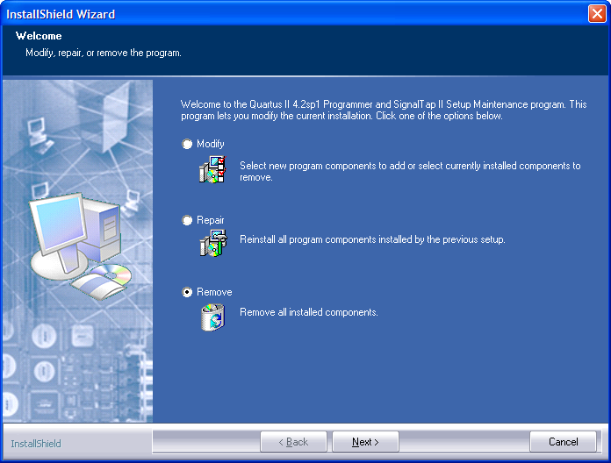

Note: If this does not work, try using the Add/Remove Programs wizard from the Windows Control Panel. You can also attempt to reinstall the Programmer on top of the old installation without removing it first.

- Click OK to remove the Quartus II Programmer from your system. When prompted, click Finish to complete the uninstall.

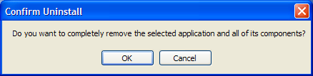

- Download the Quartus II Programmer, version 4.2 SP1, from the following location:

http://www.physics.ubc.ca/~scuba2/sc2mce/system/sys_fw/quartus2programmer.exe

- Double-click on the downloaded file to start the installation program. Click Next.

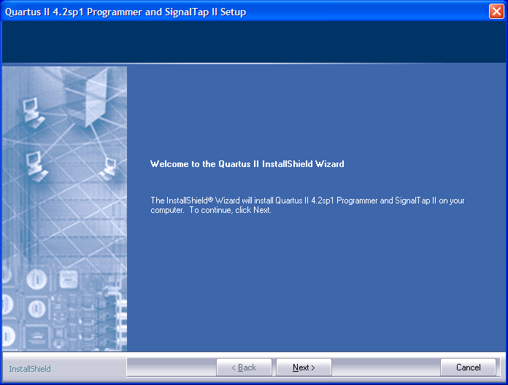

- Select “I accept the terms of the license agreement” then click Next.

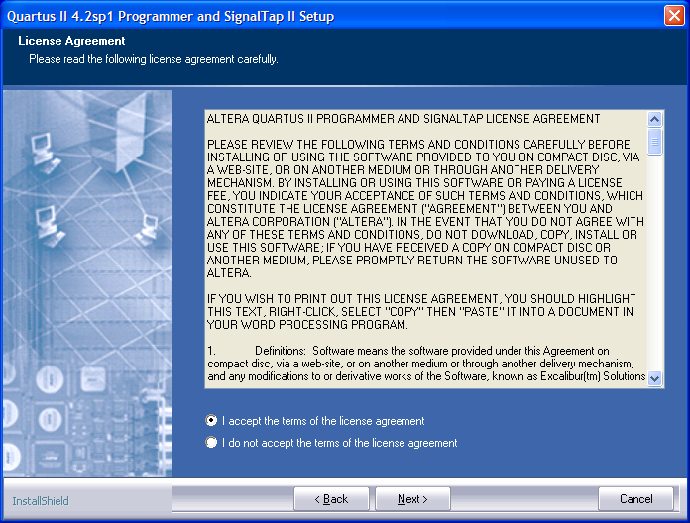

- Enter your information in the appropriate fields then click Next.

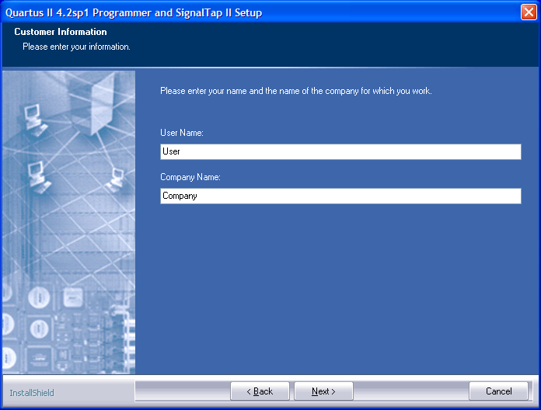

- Click Next if you agree to install the programmer in the indicated location. Otherwise, select a different directory then click Next.

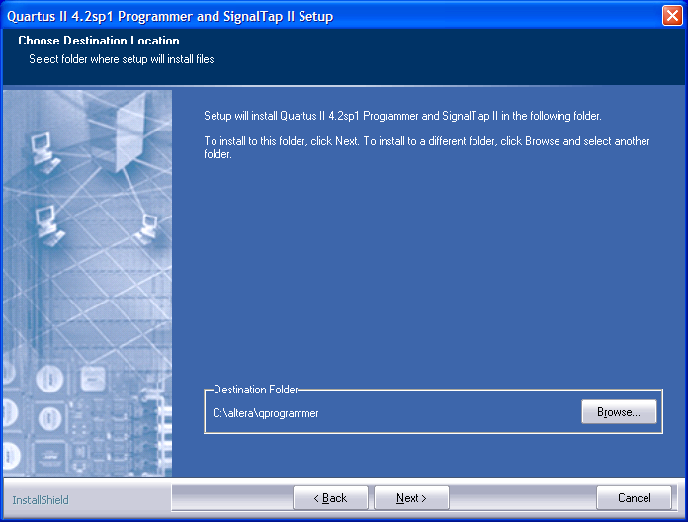

- Click Next to install both the Programmer and SignalTap II.

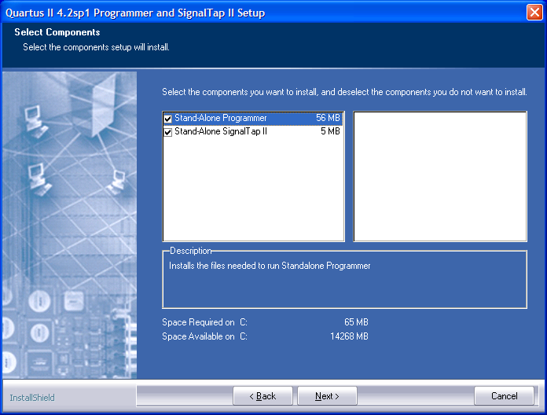

- Click Next if you agree to the default program folder name. Otherwise, choose a different name then click Next.

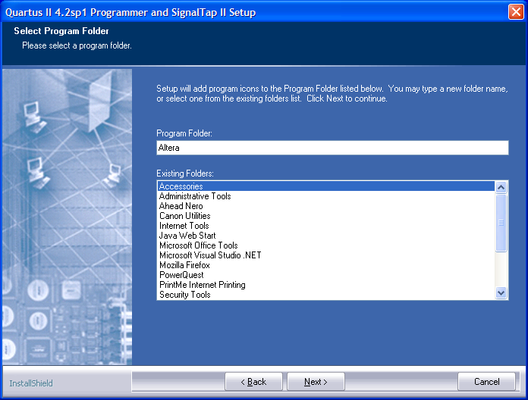

- Click Next to accept the settings and start installation. If you disagree with any of the settings, click Back until you arrive at the appropriate page and then make your corrections.

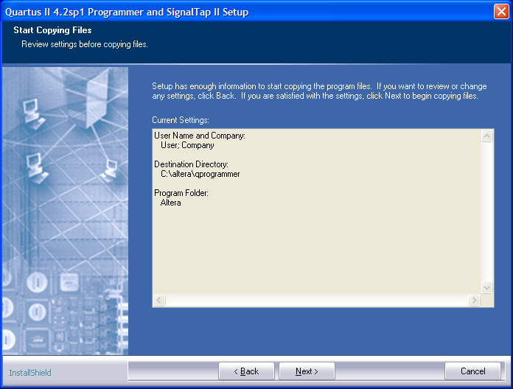

- The stand-alone programmer does not require licensing, so installation is complete. Click Finish.

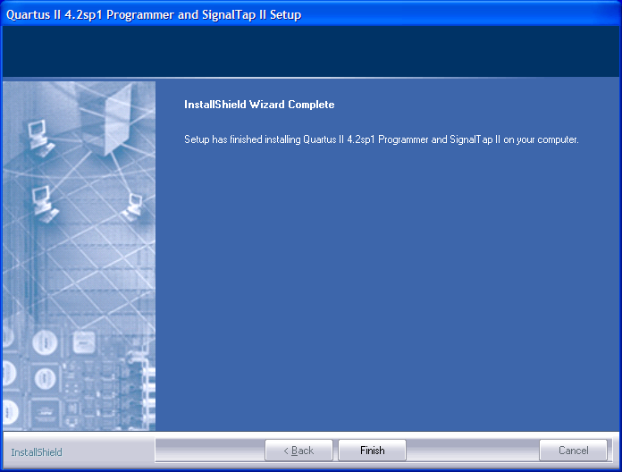

Reinstalling the ByteBlaster/USB-Blaster Cable Drivers
- Download the ByteBlaster and USB-Blaster driver files from the following location: http://www.physics.ubc.ca/~scuba2/sc2mce/system/sys_fw/drivers.zip

- Extract the files. Note the location of the extracted files.

- Open the Windows Control Panel. Open the Add Hardware Wizard. In Windows XP, you may have to click on “Switch to Classic View” in order to see the “Add Hardware” icon.

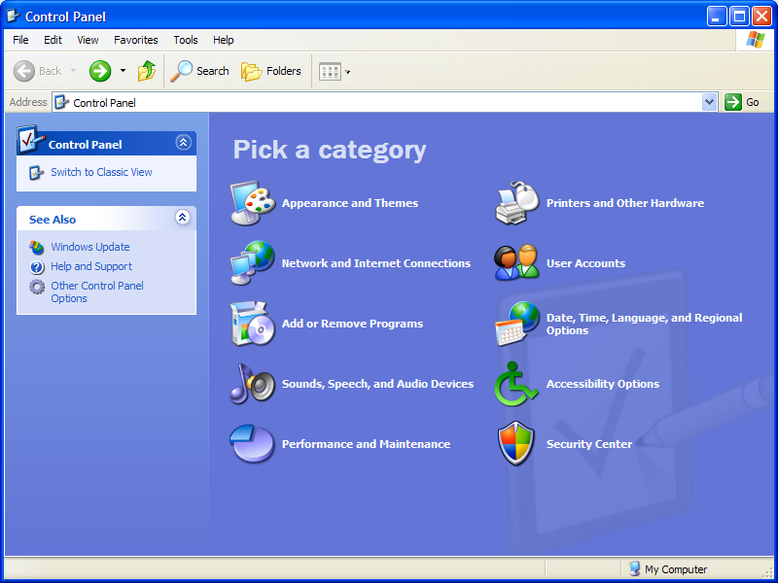

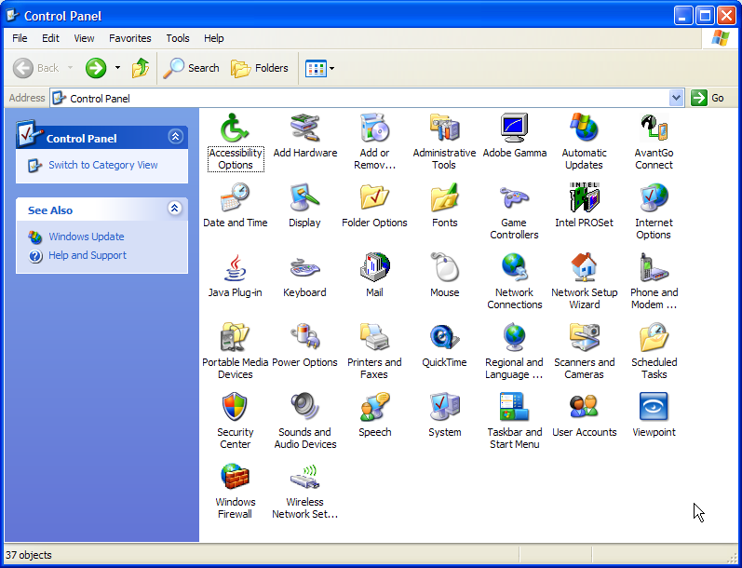

- Click Next.

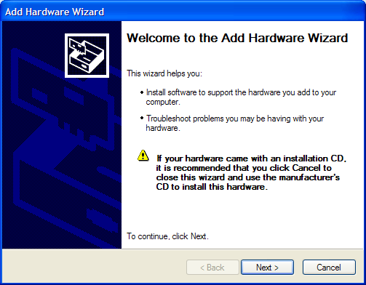

- Select “Yes, I have already connected the hardware” then click Next.

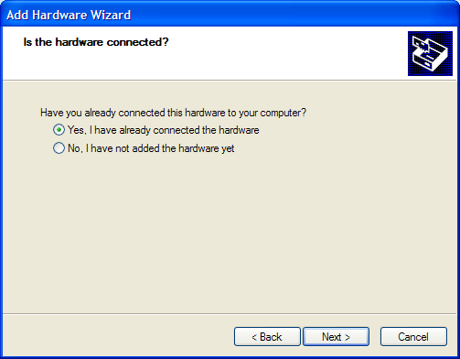

- Scroll down and select “Add a new hardware device” then click Next.

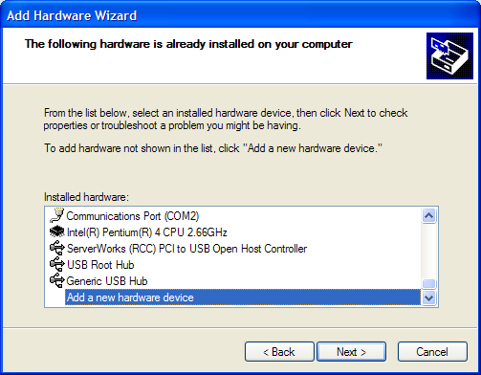

- Select “Install the hardware that I manually select from a list (Advanced)” then click Next.

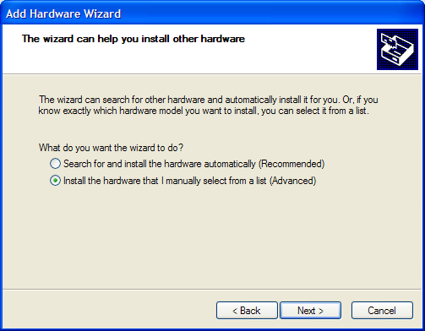

- Scroll down and select “Sound, video and game controllers” then click Next.

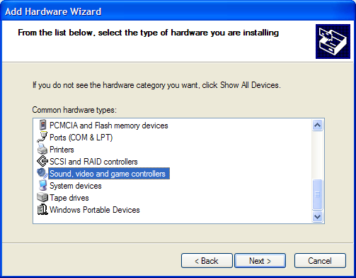

- Click on Have Disk.

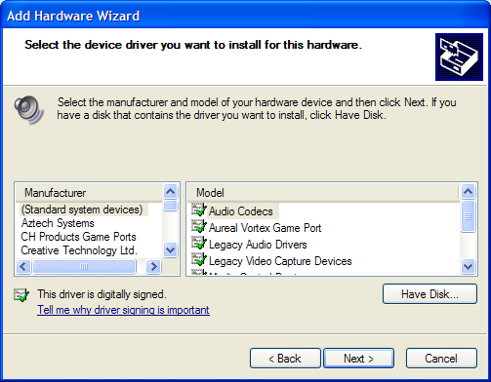

- Browse to the folders in which you extracted the drivers. If you are installing a ByteBlasterMV, browse to the /byteblaster subdirectory. Otherwise, browse to the /usbblaster subdirectory. Click OK. If a warning appears, click Continue Anyway.

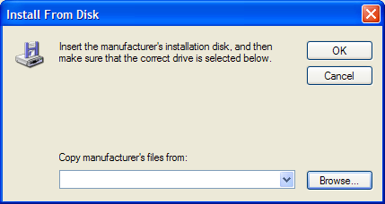

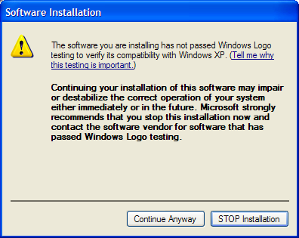

- Select Altera ByteBlaster or Altera USB-Blaster (depending on which one you are installing) then click Next.

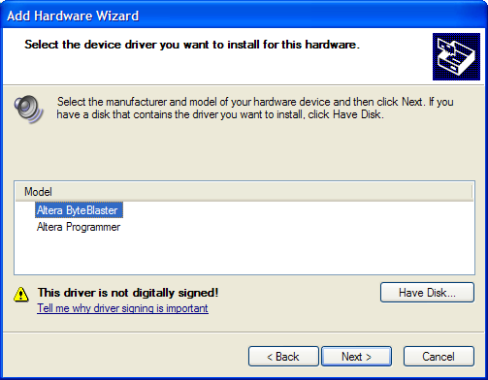

- Click Next to begin installation. If a warning appears, click Continue Anyway.

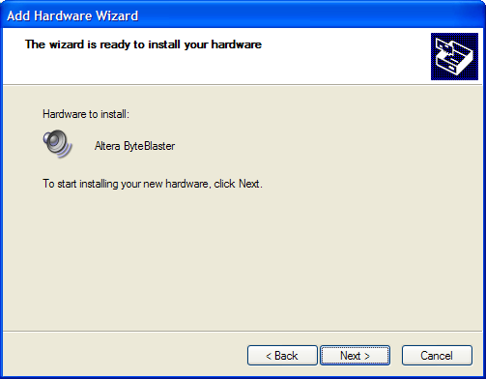

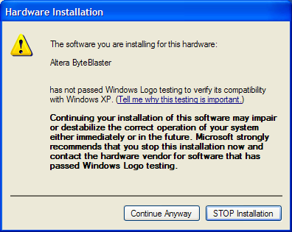

- Click Finish. Reboot the PC to complete the installation.

