Monitoring MCE Status

Revision History
Rev.1: [BB] Initial revision.

Summary
This document describes the different ways there are of monitoring the MCE status both visually and digitally while it is in various operating conditions (i.e. idle, taking data, etc.).

References
None at this time.

Table of Contents
1. Revision History 1
2. Summary 1
3. References 1
4. Table of Contents 1
5. Introduction 2
6. The Front-Panel LEDs 3
7. The Errno Word 4
8. The Housekeeping Block 6
8.1 Errno Words (10, 20, 30 and 38) 7
8.2 Frame-Status Word (6) 7
8.3 Frame Sequence Number Word (7) 7
8.4 Sync Number Word (8) 8
8.5 DV-Pulse Number Word (9) 8
8.6 FPGA/ Card/ PSUC Temperature Words (11-19, 21-29, 31, 32, 39) 8
8.7 Supply Voltage Words (33-35) 8
8.8 Supply Current Words (35-37) 8
9. Periodic Status Queries 9
10. The MCE Status Block 10

Introduction
There are several ways to glean status information from the MCE:
- Visually, from the front-panel LEDs on every card in the MCE
- Digitally, from the Errno word in every reply from the MCE
- Digitally, from the housekeeping block in data packets
- Digitally, from the MCE status block maintained by the Real Time Linux PC
- Digitally, from periodic status commands issued by the Real Time Linux PC (while MCE is idle)

The Front-Panel LEDs
Every card has a set of three LEDs on its front panel. Each LED is a different colour (except for the Power Supply Card) and is labelled on the front panel as follows:
- Green
- Yellow
- Red

During configuration, the Red LED is illuminated and the Green and Yellow LEDs are off.

During operation, the LEDs are driven either on or off by the firmware. The following table describes the meaning of each LED state during operation:

 | On | Off
Green | RC: Card powered  BC: Card powered  AC: Card powered  CC: Card powered  PSU: Outputs powered | RC: Card powered  BC: Card powered  AC: Card powered  CC: Card powered  PSU: Outputs powered
Yellow | RC: Servo unlocked  BC: --  AC: Not multiplexing  CC: Factory Mode  PSU: (LED not populated) | RC: Servo locked  BC: --  AC: Multiplexing  CC: Application Mode  PSU: (LED not populated)
Red | RC: --  BC: --  AC: --  CC: --  PSU: Clock Card communications timeout or PSU reset has occurred. | RC: --  BC: --  AC: --  CC: --  PSU: No errors
Table 1. LED States during operation (not configuration).

The Errno Word
An Errno word is at index 4 of every reply packet sent from the MCE to the Real Time Linux PC (see Figure 1, below). The Errno word contains 31 bits of useful information indicating whether any communication errors, timeouts or resets have occurred in the MCE since the last time a command was executed.

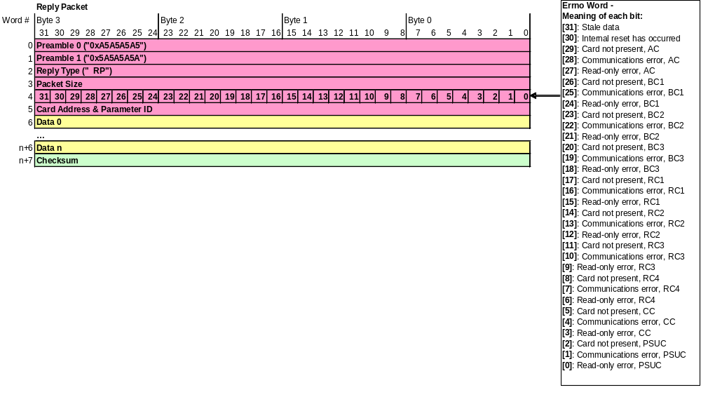
Figure 1. A standard MCE Reply Packet (not a Data Packet). The header is red, the data block is yellow and the checksum is green.

The Errno word contains five types of bits:
- Stale Data (bit 31):
[0]: indicates new data.
[1]: indicates stale data, i.e. that the data have not been updated since the last reply packet.

In all reply packets (including data packets) the ‘Stale Data’ bit in the fourth word will always be ‘0’.

In data packets, the story is slightly different. There are additional Errno words at indexes 10, 20, 30 and 38. The housekeeping data that each Errno word corresponds to may not be refreshed in every data packet. In this case, the ‘Stale Data’ bit will be ‘1’. The timescale for updating housekeeping data is once every few seconds. If housekeeping data remain stale during an entire data run, it means that there isn’t enough time between data packets for the MCE to issue housekeeping commands. By reducing the data rate, one can increase the time between data packets and allow the MCE to issue housekeeping commands.

- Reset Has Occurred (bit 30):
[0]: indicates that the MCE has not been reset since the last reply placket.
[1]: indicates that the MCE was reset since the last reply packet and that the state of the MCE may have changed.

If an internal reset occurs during a data run, the MCE will forget that it was in the middle of a data run, and it will stop returning data packets. After timing out, the Real Time Linux PC should close off its data process.

- Card Not Present (bits 29, 26, 23, 20, 17, 14, 11, 8, 5 and 2):
[0]: indicates that the corresponding card is populated in the MCE
[1]: indicates that the corresponding card is NOT populated in the MCE.

When the MCE is reset, the Clock Card assumes that any cards that don’t respond to commands from that time forward are NOT populated. The Clock Card maintains a list of cards that are not populated. If a card responds at any time after a reset, it is removed from the list.

There is a “Card Not Present” bit for every card in the MCE, but only the bits corresponding to cards that were addressed by the command will be set. In this case, dummy data words (0xFFFFFFFF) are inserted at the data indexes that correspond to the cards that are not populated. The same is true for the “Communications Error” bits and “Read-Only Error” bits, described below.

- Communications Error (bits 28, 25, 22, 19, 16, 13, 10, 7, 4 and 1):
[0]: indicates that NO CRC errors have occurred in the MCE.
[1]: indicates that a CRC error occurred in the MCE.

- Read-Only Error (bits 27, 24, 21, 18, 15, 12, 9, 6, 3 and 0):
[0]: indicates that a legal command was issued.
[1]: indicates that an illegal command was issued, i.e. a write command was sent to a read-only register.

The Housekeeping Block
The data-packet housekeeping block (highlighted in orange, in Figure 1, below) consists of forty-three 32-bit words near the beginning of every data packet sent by the MCE to a Real Time Linux PC. The PC extracts the information contained in the housekeeping block and may or may not take action based on the contents. In addition, the complete housekeeping block is stored to disk with the data. The full contents of a data packet, including the housekeeping block, are shown below:

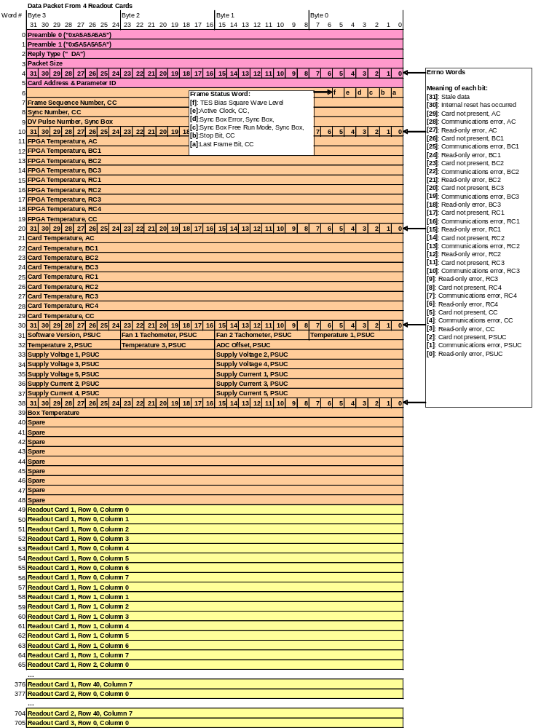
Figure 2. A Data Packet from the MCE to a Real-Time Linux PC. The header is in red, the housekeeping block is in orange, the data block is in yellow and the checksum is in green.
The status words in every data packet are described below:

Errno Words (10, 20, 30 and 38)
In data packets, the Errno words at indexes 10, 20, 30 and 38 correspond to the four different housekeeping commands that are used to collect the information in the housekeeping block. For example, the Errno word at index 10 is from the “rb sys fpga_temp” housekeeping command that populates indexes 11 to 19, and so on. See section 7 for more information on the meaning of each bit.

Frame-Status Word (6)
The frame-status word is a made up of 6 bits that denote the current state of the MCE and the Sync Box. The bits are labelled as follows:
- TES Bias Square Wave Level (bit ‘f’):
[0]: indicates that the TES Bias Square Wave level is currently low.
[1]: indicates that the TES Bias Square Wave level is currently high.

During a data run it is possible to enable an internal MCE process that outputs a square wave on the TES Bias lines into the Cryostat. The frequency, high and low values of the square wave are commandable parameters, and by varying them in locked-mode, the electrical time constants of the detectors can be measured.

If the TES Bias square wave is enabled, this bit will switch as the level of the wave switches. If the square wave is not enabled, this bit does not mean anything.

If the TES Bias square wave is enabled, internal housekeeping commands are disabled to ensure the correct timing of the TES Bias commands.

- Active Clock (bit ‘e’):
[0]: indicates that the clock signal is sourced from the 25MHz crystal clock on the Clock Card
[1]: indicates that the clock signal is sourced from the Manchester fibre input.

If the value of this bit changes between successive replies, the source of the MCE clock has changed. If this occurs during a data run, there may be some data jitter between this data frame and its predecessor and successor.

- Sync Box Error (bit ‘d’):
[0]: indicates that no unexpected events occurred while transmitting the previous DV packet.
[1]: indicates that a DV pulse was received while transmitting the previous DV-packet to the MCE. That DV-pulse was skipped by the Sync Box and no data packet was returned by the MCE for it. There will be a gap in the data stream.

- Sync Box Free Run Mode (bit ‘c’):
[0]: indicates that the DV pulse was generated by the Sync Box.
[1]: indicates that the DV pulse was sourced from external DV input to the Sync Box.

- Stop (bit ‘b’):
[0]: Indicates that NO stop commands have been received.
[1]: Indicates that a stop command was received.

During a data run, if a STOP command is sent to the MCE, it will halt the run and set this bit in the last data packet that it returns to the Real Time Linux PC. The Stop bit is only set if the Last Frame bit is also set. See below.

- Last Frame (bit ‘a’):
[0]: Indicates that more data packets are to be returned.
[1]: Indicates the last packet of a data run.

Frame Sequence Number Word (7)
The frame sequence number is a 32-bit unsigned integer that is incremented in each consecutive data packet of a data run.

During a data run, if there is a missing frame sequence number between two consecutive frames, then a data packet was lost by the MCE or PC.

Sync Number Word (8)
The sync number is a 32-bit unsigned integer that is incremented every time the row-address multiplexer returns to address zero. The difference between the sync numbers of consecutive data packets indicates how many frame periods elapsed between. Monitoring this difference in consecutive data packets of a data run is a good way of measuring the data jitter.

If the MCE is receiving timing information from the Sync Box, it should source its clock from the Sync Box input to avoid problems related to small drifts between the Sync Box clock and the MCE clock that could introduce data jitter.

DV-Pulse Number Word (9)
The DV-pulse number is a 32-bit unsigned integer that is received from the Sync Box every time that it requests another data packet from the MCE.

If the MCE is not sourcing DV-packets from the Sync Box, the value in this field has no meaning. If the MCE is sourcing DV-packets from the Sync Box, and if there is a missing DV-pulse number, then the MCE skipped a DV-pulse issued by the Sync Box. No data packet was returned for that pulse. This may occur if the Sync Box data rate is too high for the MCE to keep up with.

FPGA/ Card/ PSUC Temperature Words (11-19, 21-29, 31, 32, 39)
Temperatures are continuously recorded by every one of the MCE’s cards and polled periodically by the Clock Card. All cards except the Power Supply Control Card monitor their ambient air temperature (also called “Card Temperature”) and the FPGA temperature. In addition, the Clock Card records the MCE Box Temperature – between the backplanes and the cryostat mounting plate. The Power Supply Control Card measures ambient air temperatures at different locations in the Power Supply.

FPGA temperatures are signed 32-bit words from -65°C to 127°C. Card and Box temperatures are signed 32-bit words between -55°C and 85°C. PSUC temperatures are signed 8-bit words between -55°C and 85°C.

Supply Voltage Words (33-35)
The supply voltages are expressed as integer multiples of different base units. At this time, the base units are still to be determined.

Supply Current Words (35-37)
The supply currents are expressed as integer multiples of a base unit. At this time, the base unit is still to be determined.

Periodic Status Queries
When the MCE are not returning data packets, status information can not be gleaned from the data frame housekeeping block. Thus, the Real Time Linux PC should periodically issue the following commands to the MCE to monitor its status:
- rb sys card_temp
- rb sys fpga_temp
- rb psc psc_status
- rb cc box_temp

The MCE Status Block
In Data Acquisition Software version “DAS_010901august06” and greater, a utility has been implemented that collects general MCE status information. This utility parses the “mce.xml” file for parameters to query and asks the MCE for the values of those parameters. The results are stored to disk. The stored values are refreshed before every data run, and are included at the beginning of every data file. To run the status utility manually, use the command “mcestatus”.

