SQL server:
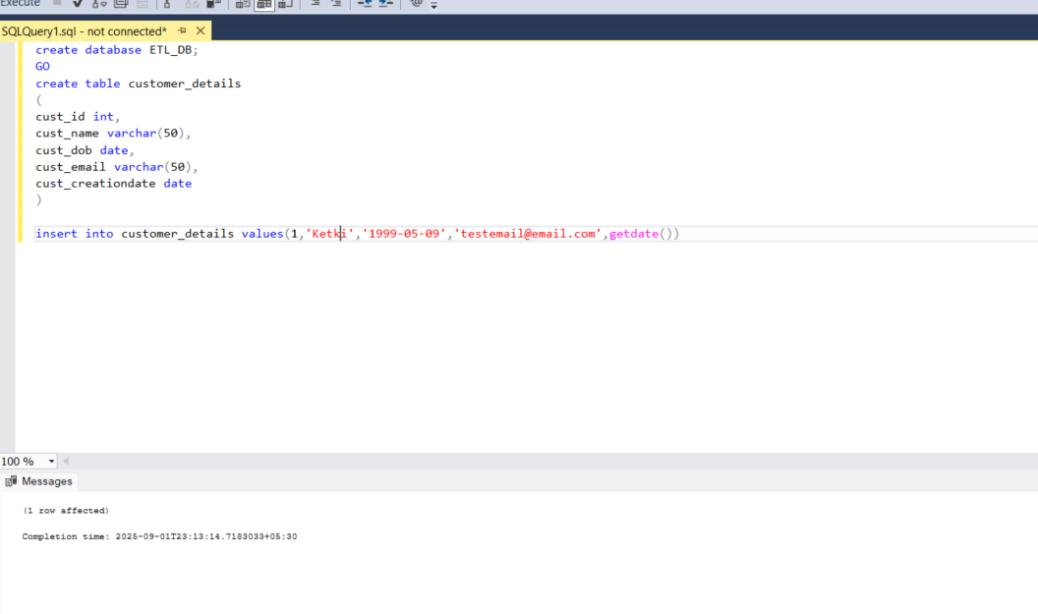
Successful data transfer
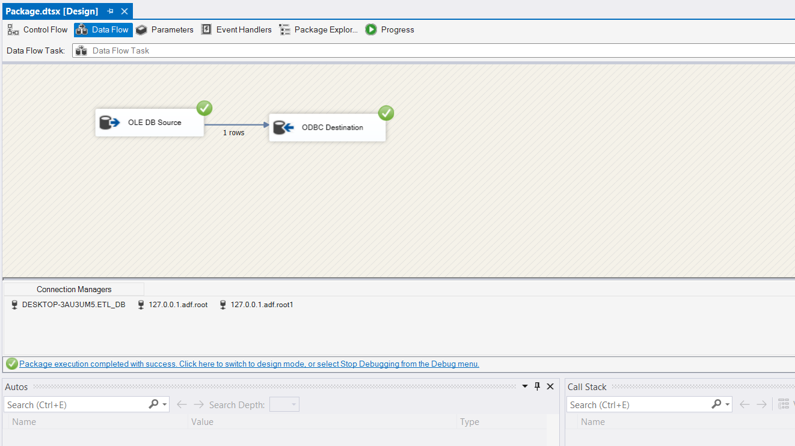

Mysql server after migration:

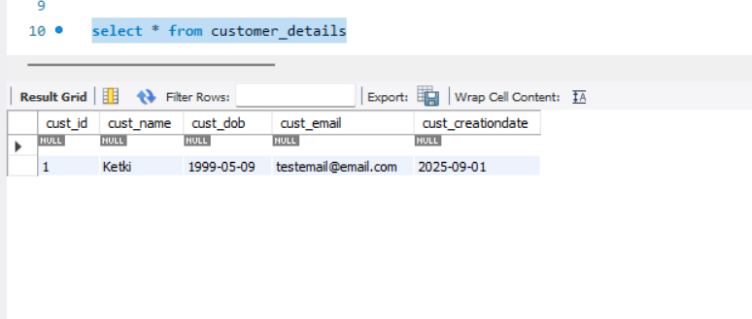

SQL server script:
create database ETL_DB;
GO
create table customer_details
(
cust_id int,
cust_name varchar(50),
cust_dob date,
cust_email varchar(50),
cust_creationdate date
)

insert into customer_details values(1,'Ketki','1999-05-09','testemail@email.com',getdate())

My sql server:
select * from customer_details;

