- CSV file present in Azure Blob storage
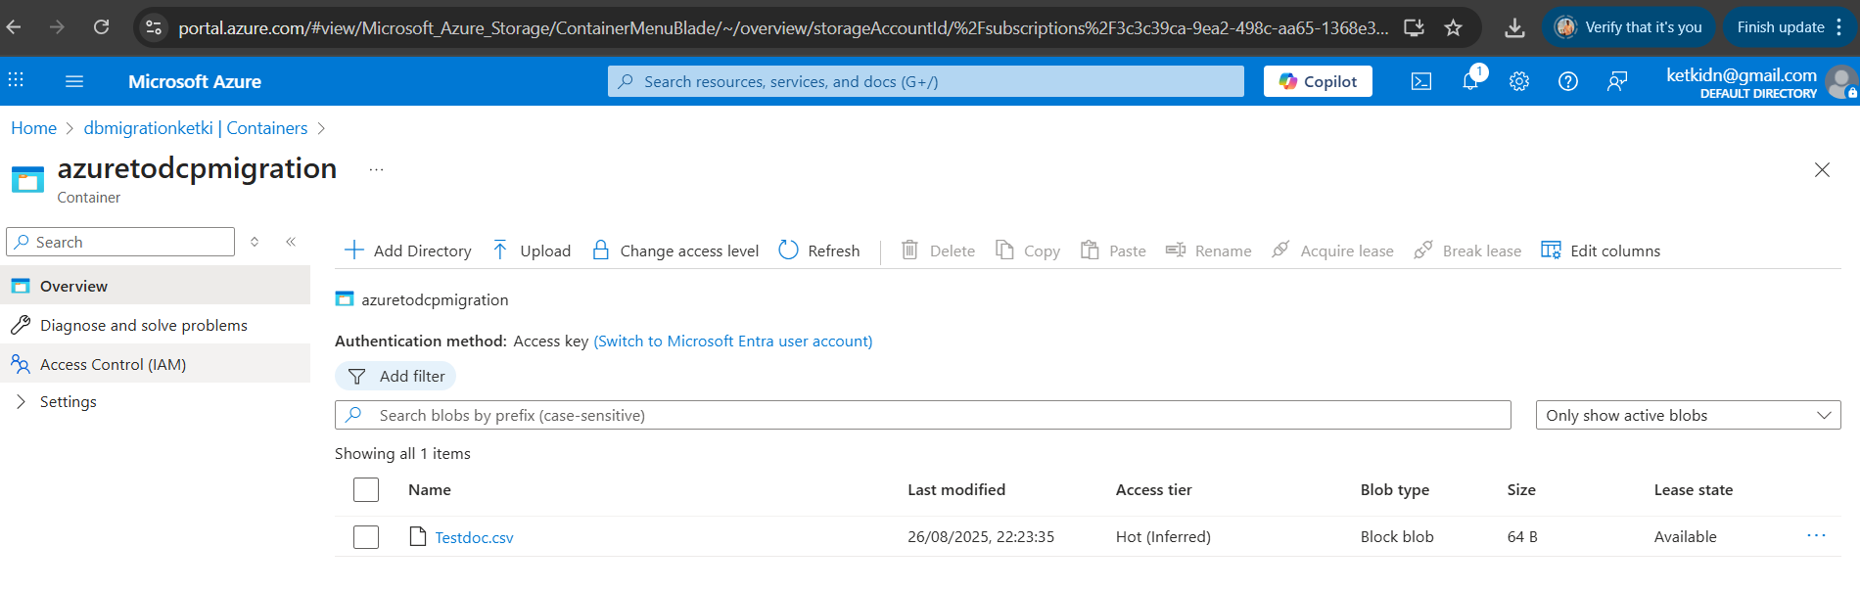

Steps Performed:
Use GCP Storage Transfer Service
- Directly connect Azure Blob Storage → GCS.
- Steps:
  - In GCP Console → Storage → Transfer Service.
  - Create a transfer job → Source: Azure Blob → Destination: GCS bucket.
  - Provide Azure Storage account name & key.
  - Run job (one-time or scheduled).
- After job run CSV file transferred to Google Cloud bucket.
