- Created Fivetran account.
- Added Source connecter as BigQuery
- Added Destination connector as Redshift
Note: created Serverless- new workgroup and enabled public access. Also confirmed VPC-Route table-Internet gateway connection is proper.
In internet gateway inbound rules add custom TCP connection for 5439 port.
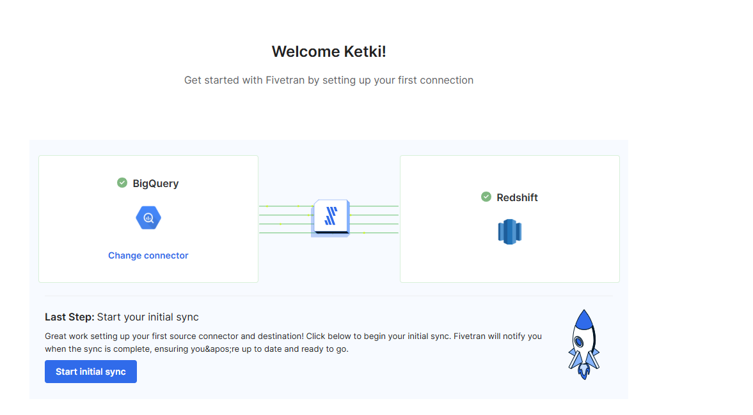
- Data present in Bigquery.
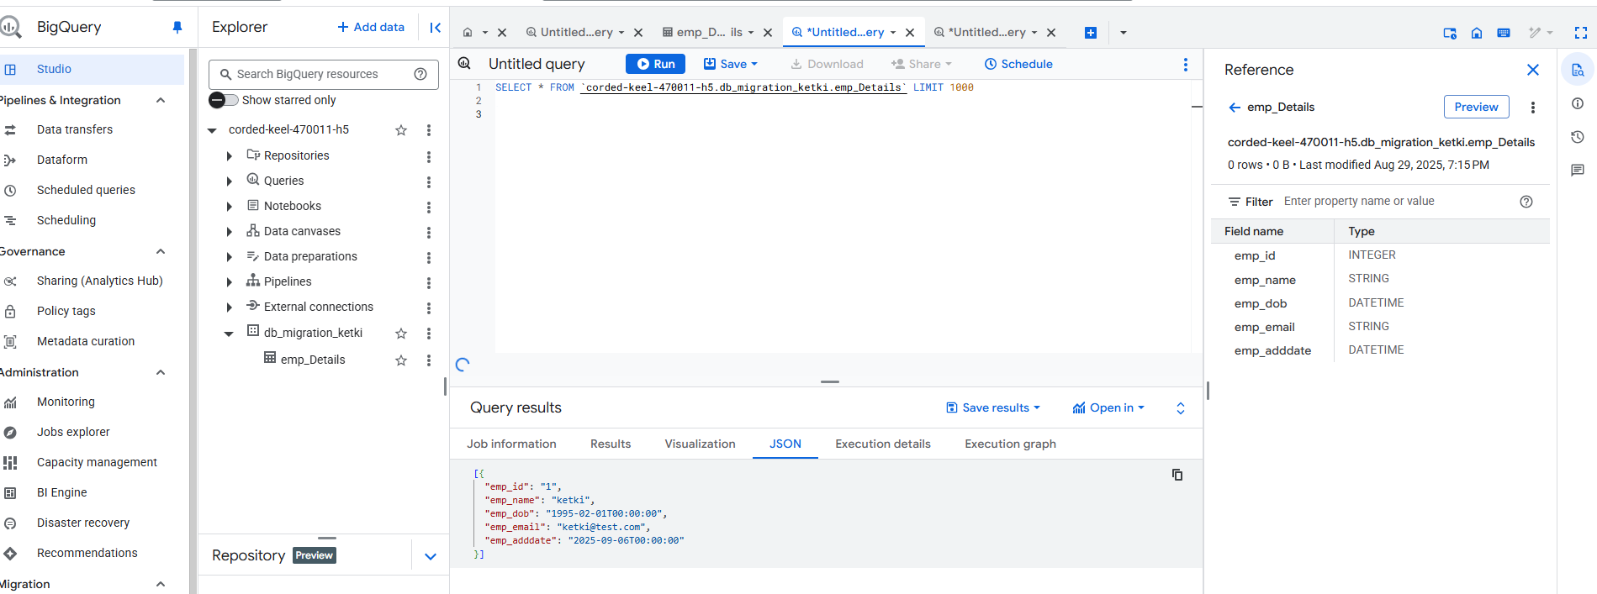

- When first run the sync encountered error of permission denied.
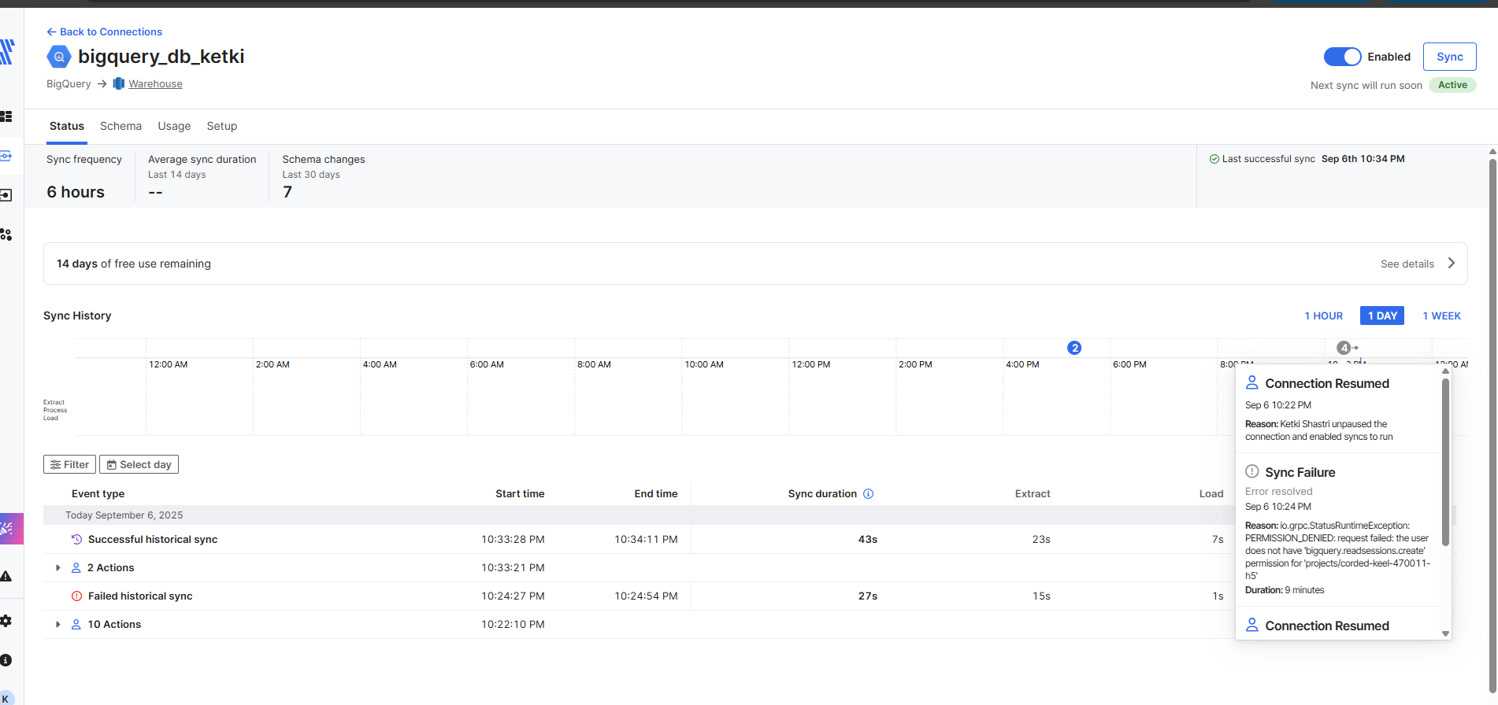

- Added BigQuery Read Session User role in IAM in GCP.
Note: Listed Bigquery roles in below screenshots are required too.
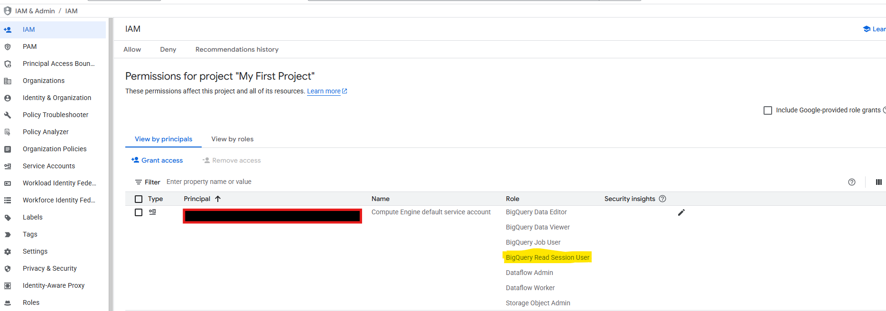

- After that run was successful.
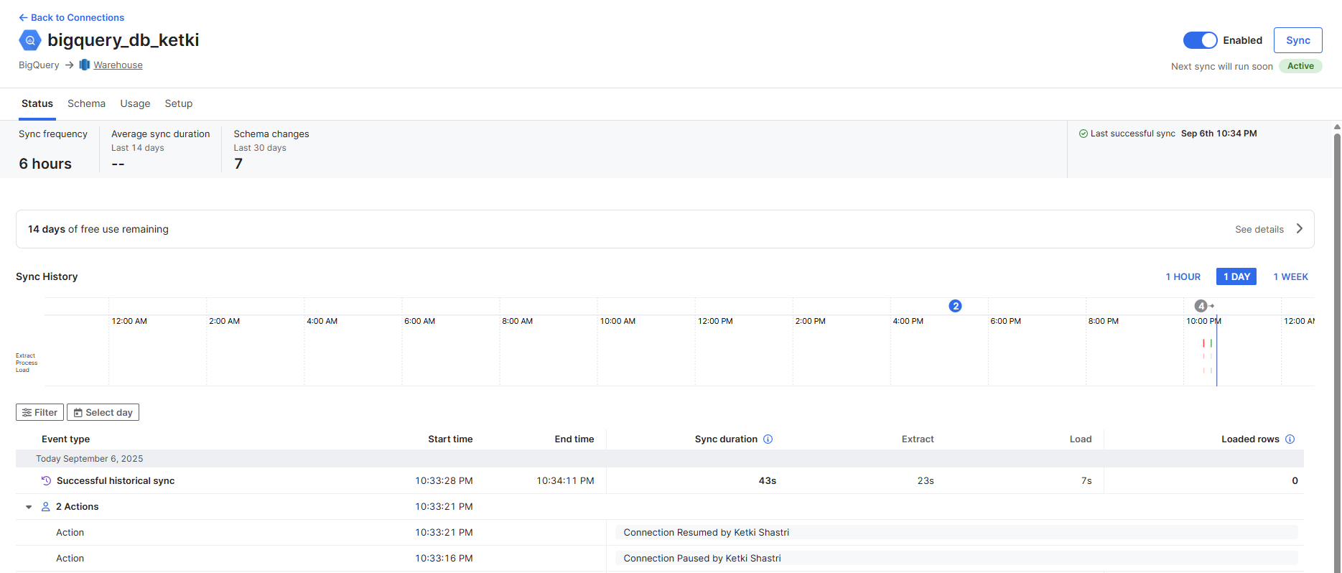
- Checked in Redshift and table with data is created.
