**Part1 : For SQL server to Azure SQL server Migration through SSMS**

1. Create SQL Database Server on Azure

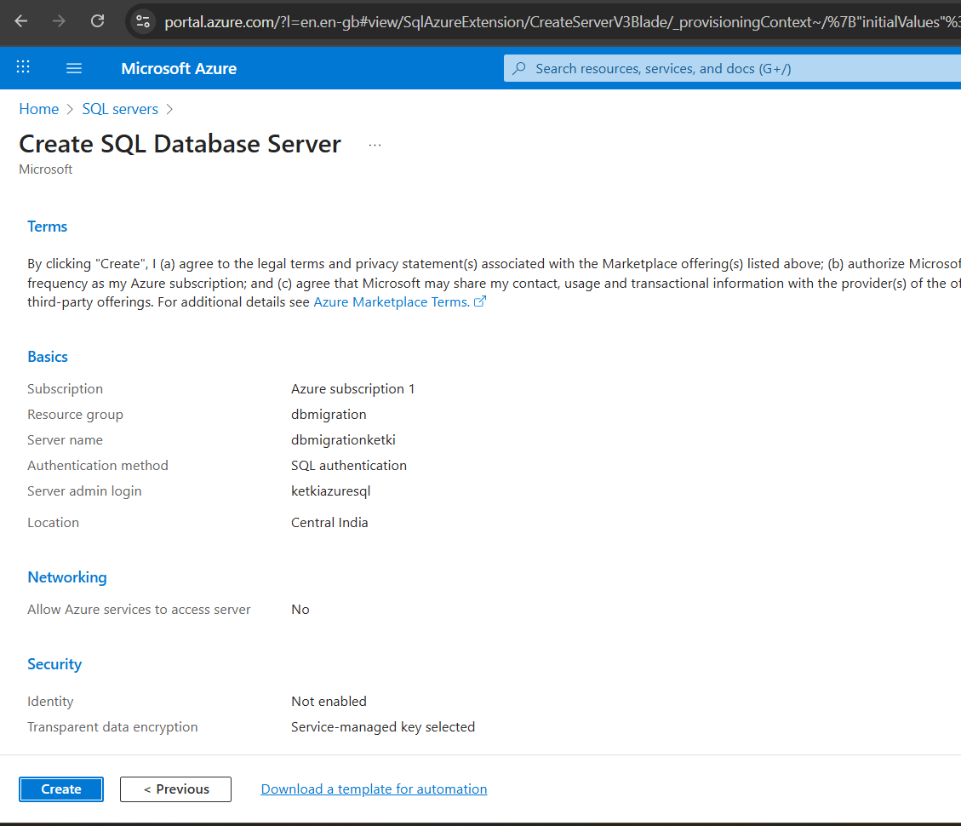

1. Create Database in SQL server

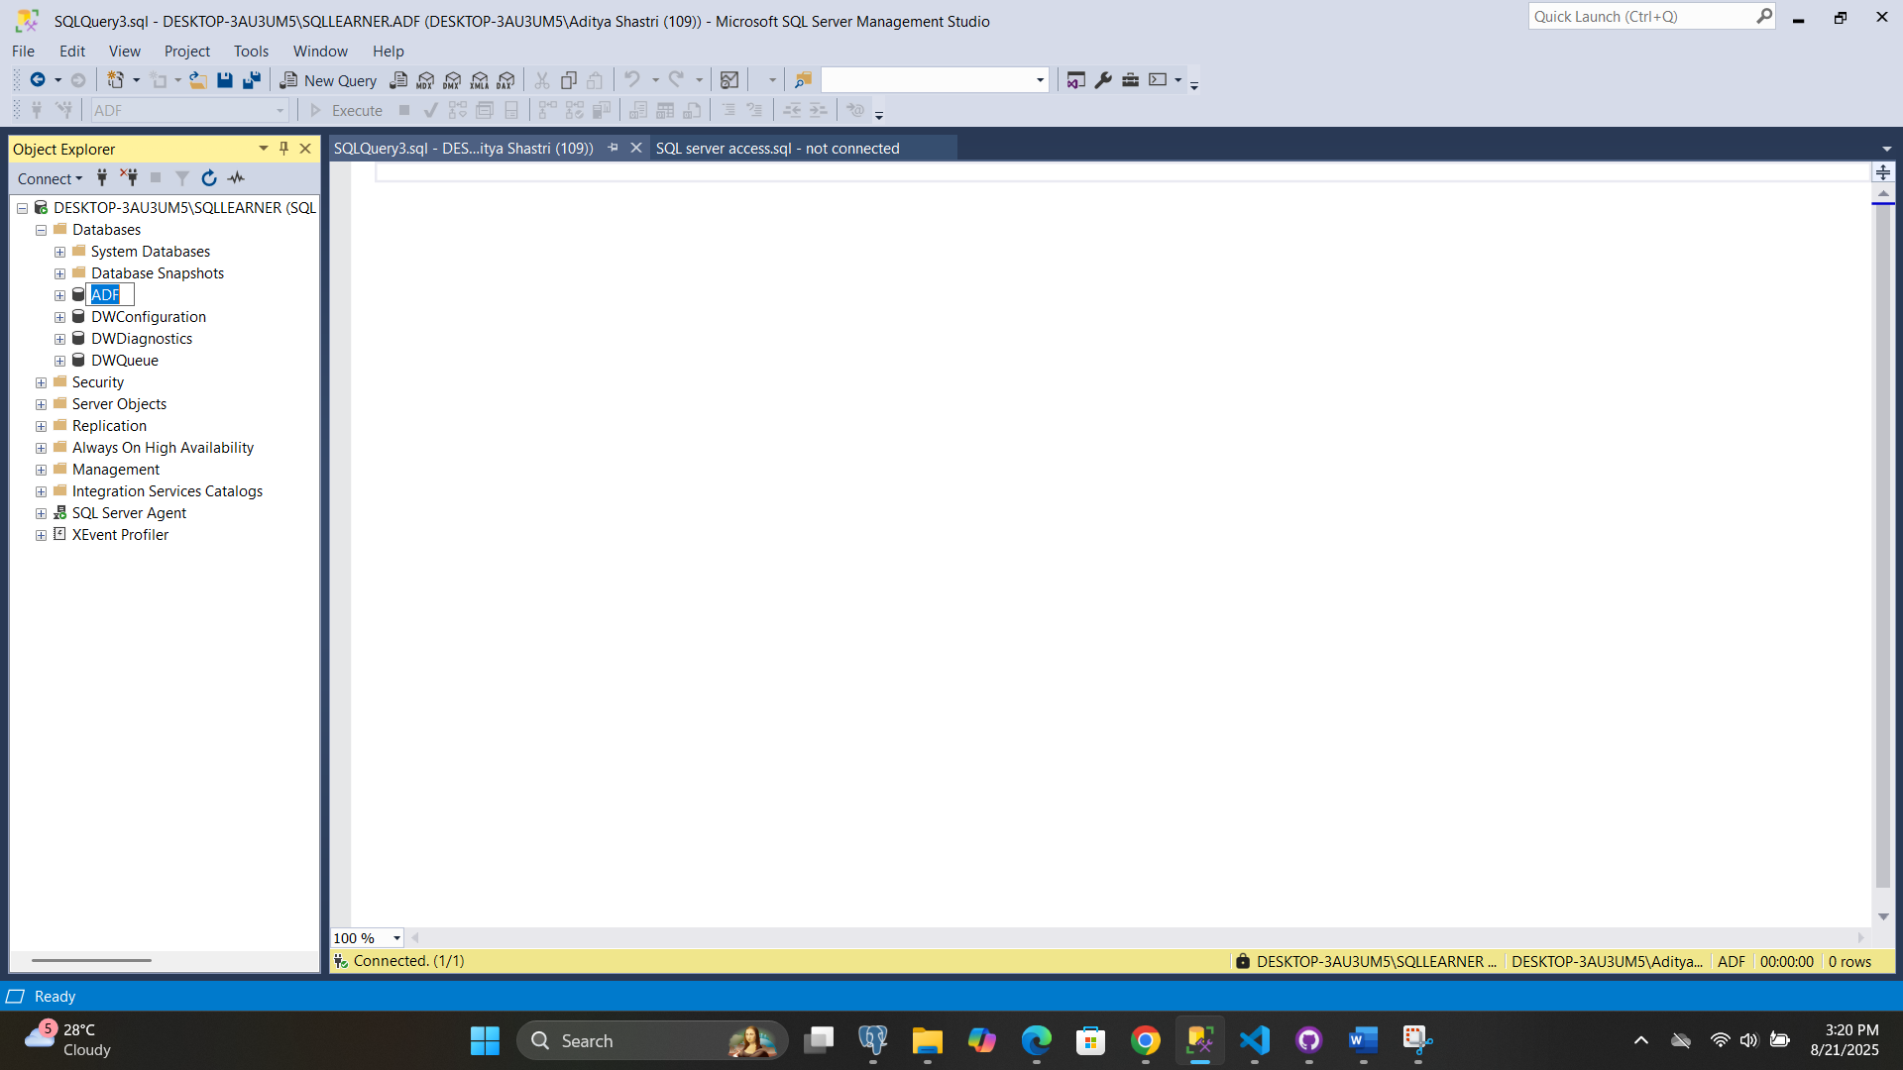

1. Using SSMS set connection SOURCE and TARGET to migrate data.

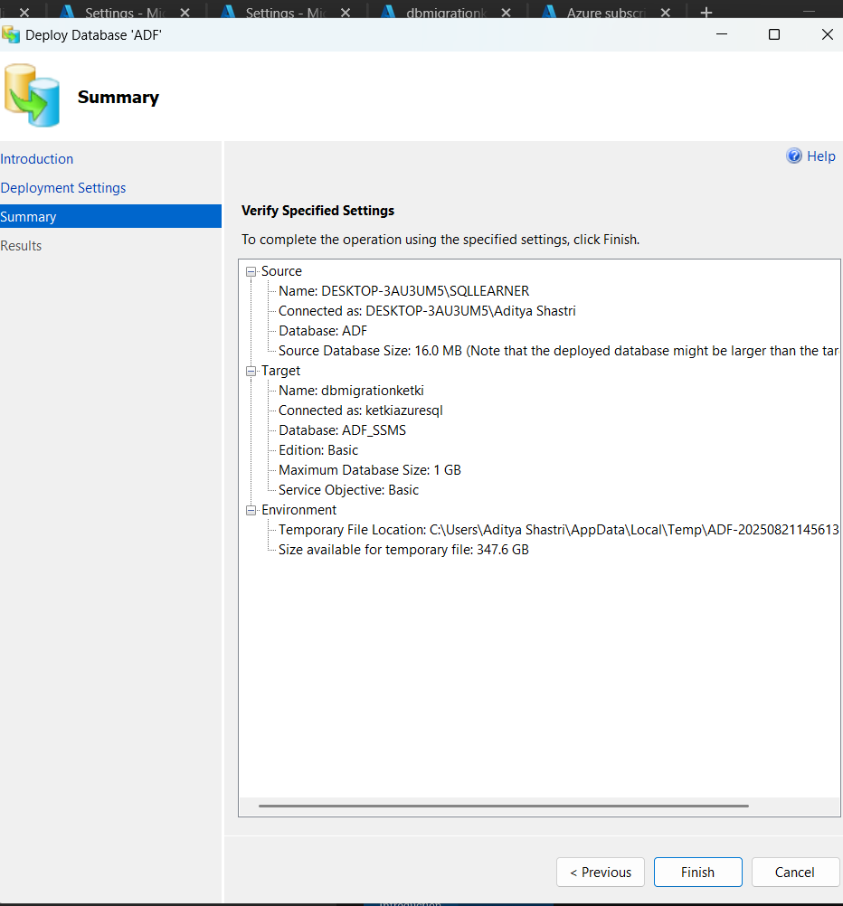

1. It runs successfully

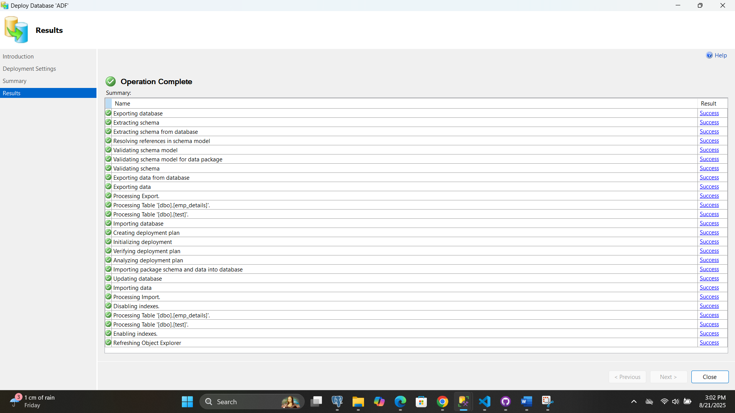

1. Now can see database from on-prem server to cloud

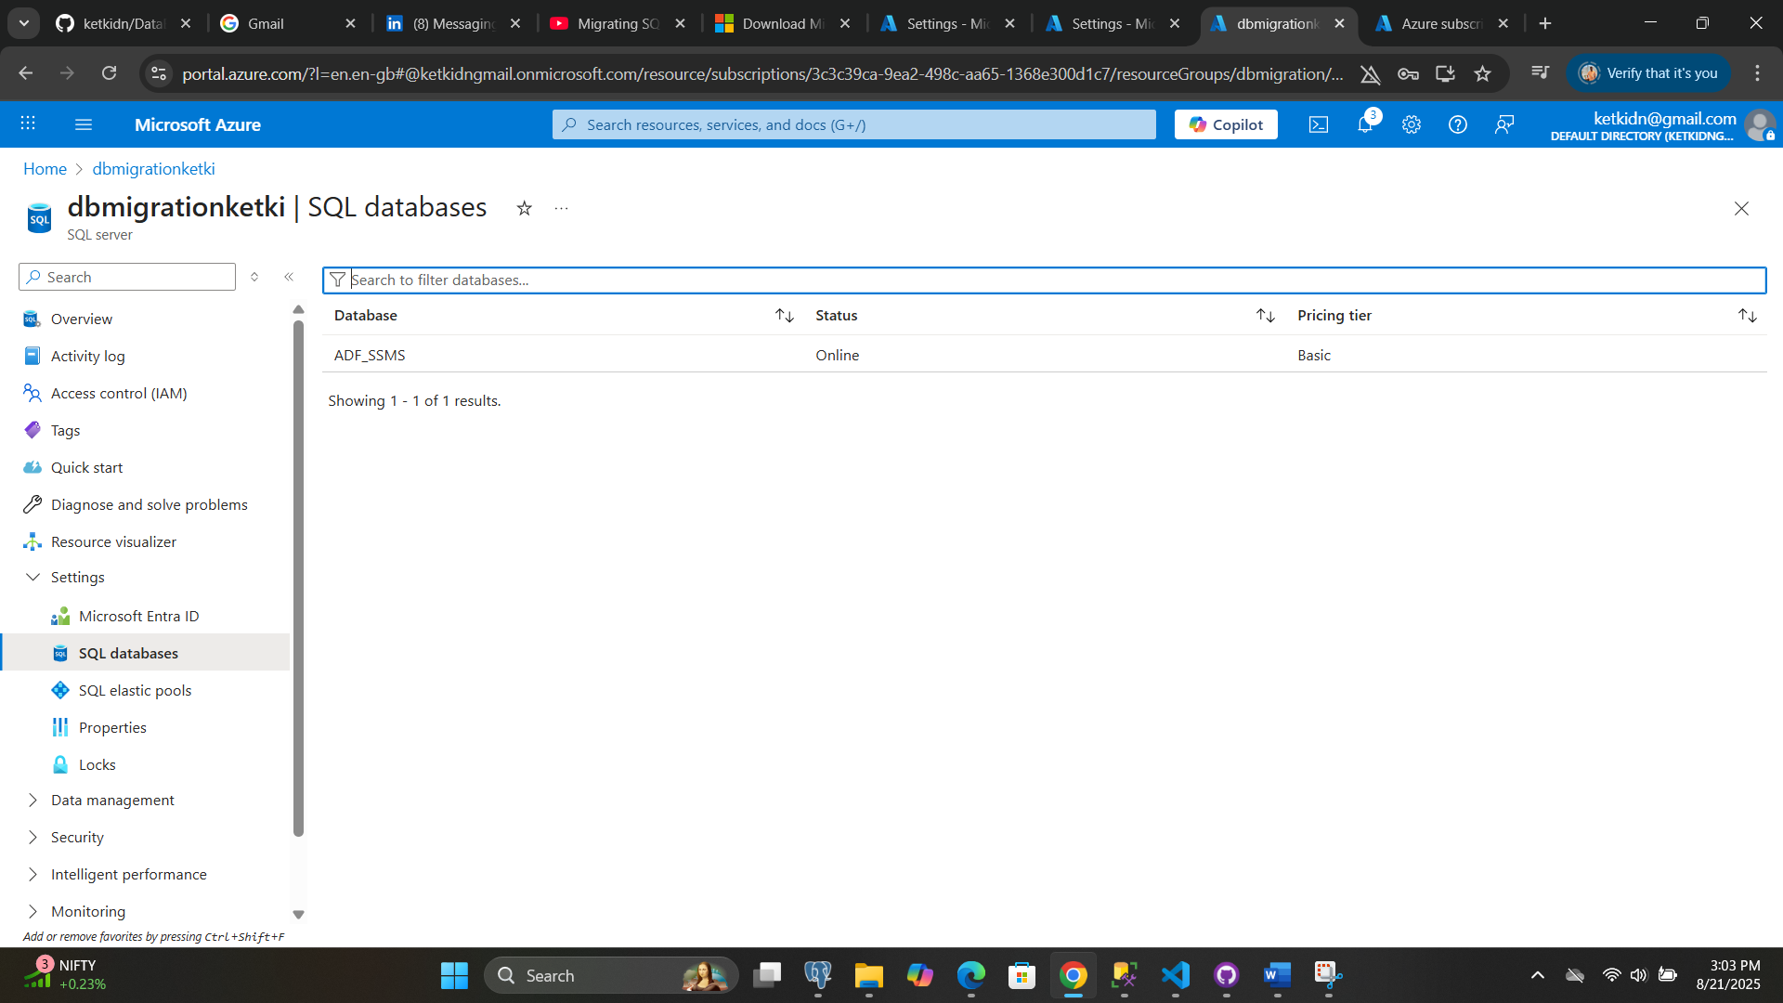

**Part 2: For Azure SQL daily database Sync**

1. Create Data Sync Group

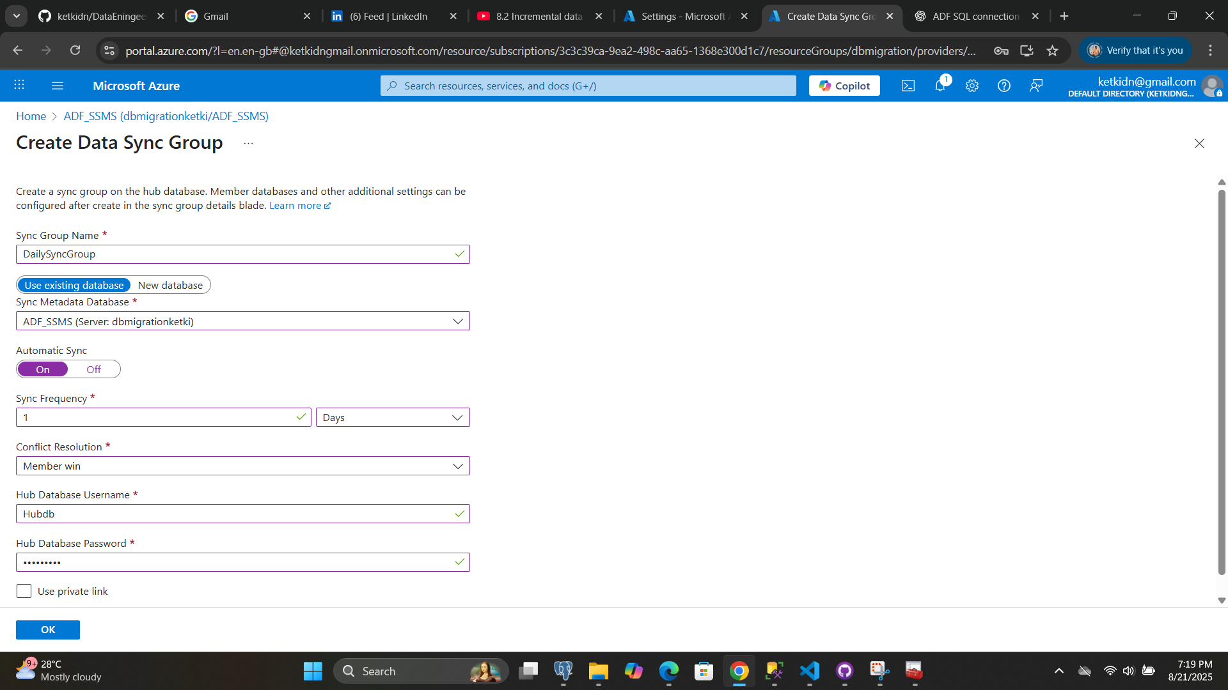

1. Create Microsoft SQL Data Sync Agent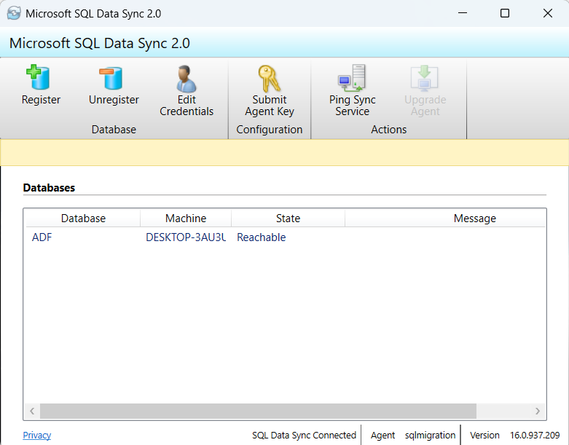
2. Add Sync Group and Sync Agent

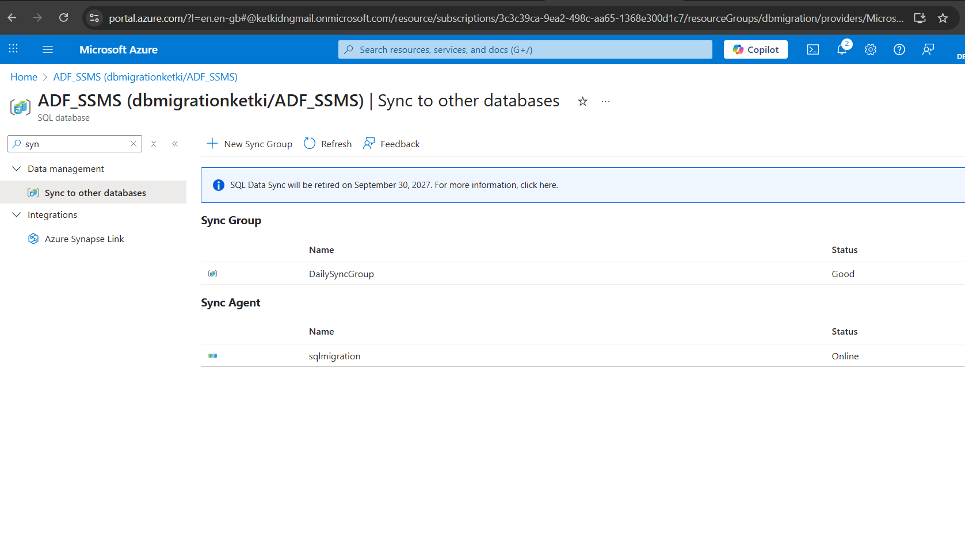

1. Databases connected successfully and can view tables.

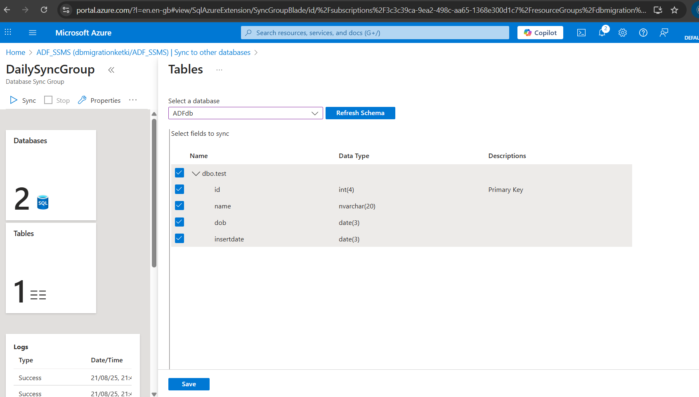

1. On SYNC run able to see data transfer from On-prem server to cloud.

Inserted 1 row in SQL server ADF database

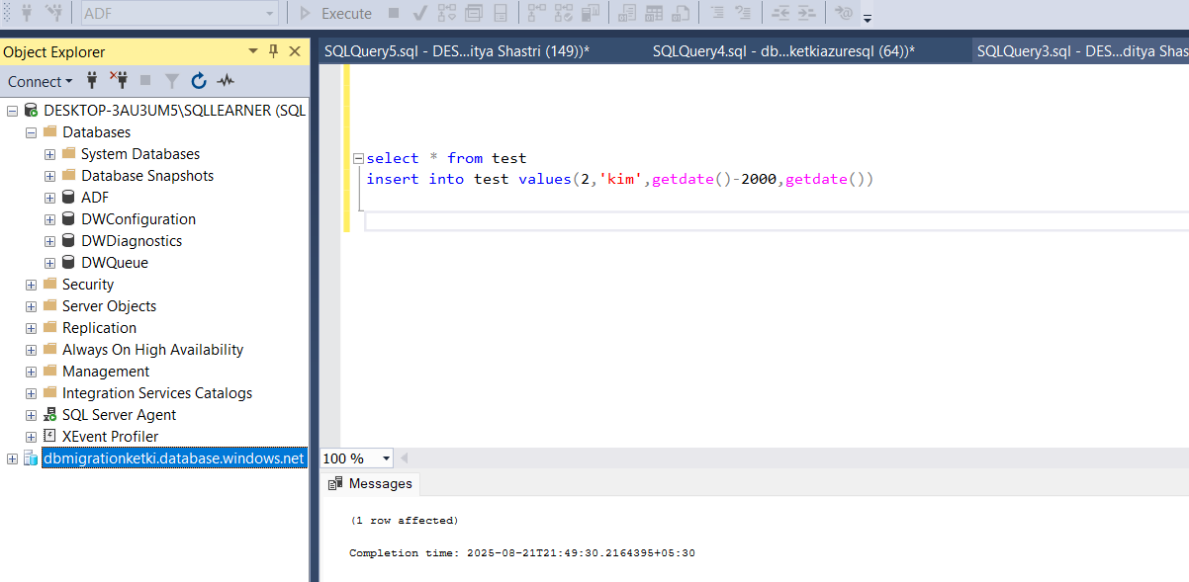

1. Run the SYNC in Azure successfully

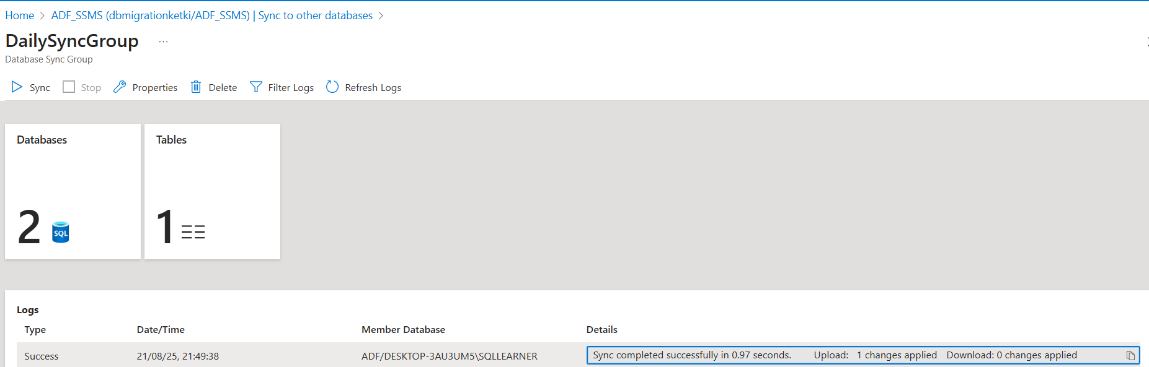

1. Now can see the same data in Azure DB as well

