Live Data — Azure CLI Design (az iot ops live-data)
Status: Draft for review
Author: Ketki Naik
Scope: The IT-admin CLI surface that enables, verifies, and disables Live Data for an AIO instance.

1. Overview
This document covers the IT-admin CLI (az iot ops live-data) that enables, verifies, and disables the shared, instance-level infrastructure required for Live Data. (The OT-facing session experience in DOE is out of scope here.)
The CLI is imperative — it reads live Azure state and converges it to the desired configuration. It does not deploy Bicep/ARM templates, and it does not create any per-session Dataflow Graph or 1P transforms (those belong to DOE).

2. Command design
A new command group az iot ops live-data with three commands:
Command | Purpose
az iot ops live-data enable | Provision & configure the shared Live Data infrastructure for an AIO instance.
az iot ops live-data show | Report the Live Data configuration and resource status (or lack thereof).
az iot ops live-data disable | Tear down the instance-specific Live Data infrastructure.

3. What each command does (CLI-side behavior)

3.1 enable
Converges the following resources across three domains (Event Grid, ADR namespace, AIO instance), plus role assignments. All steps are idempotent — re-running adds to shared resources without overwriting unrelated entries.
Resources created / configured:
Each item is tagged Created (a net-new resource the CLI provisions) or Configured (an existing resource the CLI modifies). Every item is implemented in this CLI codebase as an imperative create-or-update call.
- Event Grid — topic space — Created. Wildcard template aio/observability/#. Concrete session topics take the form aio/observability/{scopeId}/{assetName}/{topicPath}, where scopeId is the AIO instance name.
- AIO — dedicated Dataflow Profile — Created. instanceCount = 1, distinct from the default profile so Live Data graphs are isolated and profile-wide changes do not restart unrelated dataflows.
- AIO — EG Dataflow Endpoint — Created. MQTT, managed-identity auth, pointing at the customer’s Event Grid namespace. Uses a system-assigned identity by default; a user-assigned identity may be supplied.
- ADR namespace link — Configured (existing namespace PATCHed) via properties.observability:
  - properties.outboundIdentity = SystemAssigned (default) or UserAssigned. For SystemAssigned, the namespace’s system-assigned identity is enabled if not already present.
  - properties.observability.endpoints[<customLocationId>] = { endpointType: "Microsoft.EventGrid/namespaces", address, scopeId, resourceId }.
  - properties.observability.enabled = true.
- Role assignments — Created. The scope is selectable via --ra-scope (default namespace):
  - AIO instance identity → EventGrid TopicSpaces Publisher
  - ADR namespace identity (SAMI/UAMI) → EventGrid TopicSpaces Subscriber
- The scope choice also determines whether the roles survive disable (see §3.2):
  - --ra-scope namespace (default) — scoped to the EG namespace. Durable: the assignment survives enable/disable cycles, so a privileged admin can grant it once and less-privileged IT admins can then run routine enable/disable with --skip-role-assignments (no roleAssignments/write needed each cycle).
  - --ra-scope topic-space — scoped to the topic-space resource (least privilege). Removed together with the topic space on disable, so each enable re-creates the assignment (requires roleAssignments/write).
No Event Grid permission bindings are created: both the publisher (AIO instance) and subscriber (ADR namespace) authenticate with Microsoft Entra ID (managed identity), and EG client groups / permission bindings apply only to the certificate-client auth model.

Resource naming
Resource names are deterministic so show and disable can recompute them without storing any state. The AIO-instance-scoped resources (dataflow profile and EG dataflow endpoint) use fixed names — they are unique within their instance, and DOE must reference them by exact name when creating the per-session Dataflow Graph, so they must be predictable. The EG topic space lives in the shared Event Grid namespace (which may serve multiple instances), so it carries an instance-derived hash8 suffix to stay globally unique; DOE does not reference it by name (it publishes to the topic path aio/observability/{scopeId}/...).
hash8 is the first 8 hex characters of the SHA-256 hex digest of the AIO instance’s ARM resource ID — i.e. sha256(instance_resource_id.encode("utf8")).hexdigest()[:8].
Resource | Scope | Name
Dataflow profile | AIO instance | live-data-profile
EG dataflow endpoint | AIO instance | live-data-endpoint
EG topic space | shared EG namespace | live-data-ts-{hash8}

Enable flow
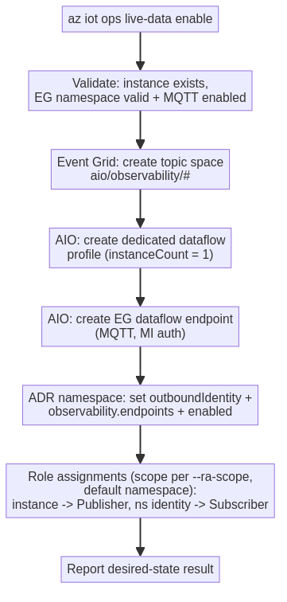

Staged enablement (new system-assigned identity)
When the ADR namespace’s system-assigned identity does not yet exist (or has not yet been granted the Subscriber role), a single enabled=true write is unsafe — the identity’s principal is only created during the update, and role-assignment propagation is eventually consistent. In that case the CLI stages the enablement:
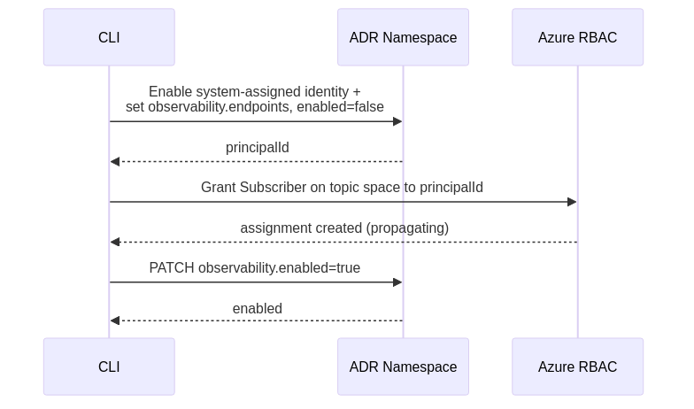
A one-call enabled=true is used only when the selected identity already exists and already holds the Subscriber role (an existing namespace SAMI or a pre-authorized UAMI).

3.2 disable
Tears down the instance-specific Live Data infrastructure. Whether the role assignments are removed depends on the --ra-scope chosen at enable time (see §3.1): namespace-scoped roles (default) are preserved; topic-space-scoped roles are removed together with the topic space.
Order matters — latch first, then teardown:
- Latch → drain: set properties.observability.enabled = false. This is the canonical ADR drain signal; active sessions end and no new sessions can start. (Removing an endpoint alone does not drain — sessions retain their endpoint snapshot.)
- Tear down instance-specific resources:
  - AIO: dedicated Dataflow Profile (this also deletes any associated Dataflow Graphs — by design) and the EG Dataflow Endpoint.
  - Event Grid: topic space.
  - ADR namespace: remove the observability.endpoints[<customLocationId>] entry.
- Role assignments: namespace-scoped assignments (default) are preserved; topic-space-scoped assignments are removed together with the topic space in step 2 (nothing is left orphaned).
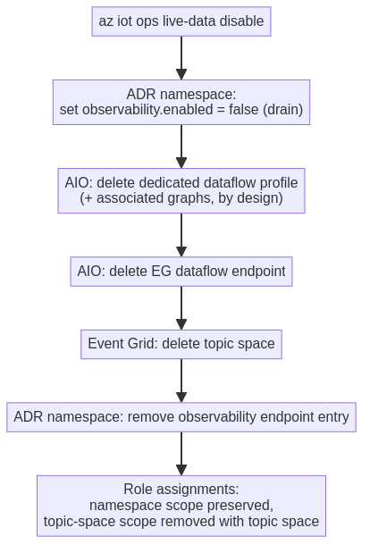

3.3 show
Reads live Azure state and reports a single, easy-to-scan view of whether Live Data is configured. Proposed output:
- Enabled state (observability.enabled)
- Observability endpoint(s) on the ADR namespace
- Event Grid topic space existence
- AIO dedicated dataflow profile + EG dataflow endpoint existence
- Provisioning status for deployed resources
- A top-level enabled rollup (true only when all pieces are present)

4. Command parameters

enable
Parameter | Required | Default | Notes
--instance / -i / -n | Yes | — | AIO instance name
--resource-group / -g | Yes | — | Instance resource group
--eg-resource-id | Yes | — | Event Grid namespace ARM resource Id
--mi-user-assigned | No | System-assigned MI | UAMI resource Id for the EG dataflow endpoint / outbound identity
--ra-scope | No | namespace | Role-assignment scope: namespace (durable, preserved on disable) or topic-space (least privilege, removed on disable)
--adr-role-ids | No | EG TopicSpaces Subscriber | Override role(s) for the ADR namespace identity
--ops-role-ids | No | EG TopicSpaces Publisher | Override role(s) for the AIO instance identity
--skip-role-assignments | No | off | Skip role assignments
--no-progress | No | off | Suppress progress UI

show
Parameter | Required | Notes
--instance / -i / -n | Yes | AIO instance name
--resource-group / -g | Yes | Instance resource group
--no-progress | No | Suppress progress UI

disable
Parameter | Required | Notes
--instance / -i / -n | Yes | AIO instance name
--resource-group / -g | Yes | Instance resource group
--yes / -y | No | Skip the confirmation prompt
--no-progress | No | Suppress progress UI

Examples
# Enable Live Data (system-assigned identity, default roles)
az iot ops live-data enable \
--instance myInstance -g myResourceGroup \
--eg-resource-id /subscriptions/00000000-0000-0000-0000-000000000000/resourceGroups/egRg/providers/Microsoft.EventGrid/namespaces/myEventGrid
# Enable using a user-assigned managed identity for outbound auth
az iot ops live-data enable \
--instance myInstance -g myResourceGroup \
--eg-resource-id /subscriptions/00000000-0000-0000-0000-000000000000/resourceGroups/egRg/providers/Microsoft.EventGrid/namespaces/myEventGrid \
--mi-user-assigned /subscriptions/00000000-0000-0000-0000-000000000000/resourceGroups/idRg/providers/Microsoft.ManagedIdentity/userAssignedIdentities/myUami
# Enable but skip role assignments (grant them separately)
az iot ops live-data enable \
--instance myInstance -g myResourceGroup \
--eg-resource-id /subscriptions/00000000-0000-0000-0000-000000000000/resourceGroups/egRg/providers/Microsoft.EventGrid/namespaces/myEventGrid \
--skip-role-assignments
# Enable with custom role-definition GUIDs
az iot ops live-data enable \
--instance myInstance -g myResourceGroup \
--eg-resource-id /subscriptions/00000000-0000-0000-0000-000000000000/resourceGroups/egRg/providers/Microsoft.EventGrid/namespaces/myEventGrid \
--adr-role-ids 4b0f2fd7-60b4-4eca-896f-4435034f8bf5 \
--ops-role-ids a12b0b94-b317-4dcd-84a8-502ce99884c6
# Enable with least-privilege, topic-space-scoped role assignments
# (roles are removed with the topic space on disable)
az iot ops live-data enable \
--instance myInstance -g myResourceGroup \
--eg-resource-id /subscriptions/00000000-0000-0000-0000-000000000000/resourceGroups/egRg/providers/Microsoft.EventGrid/namespaces/myEventGrid \
--ra-scope topic-space
# Verify the Live Data configuration and resource status
az iot ops live-data show --instance myInstance -g myResourceGroup
# Disable Live Data (prompts for confirmation)
az iot ops live-data disable --instance myInstance -g myResourceGroup
# Disable without the confirmation prompt
az iot ops live-data disable --instance myInstance -g myResourceGroup --yes

5. mgmt-actions vs live-data
Live Data is the second “outer loop” feature after management-actions and follows the same enable / show / disable pattern, but keeps its resources logically separate (its own observability bag and dedicated resources) so the two can be governed independently. The shared Event Grid / ADR / role-assignment logic will be extracted into a common module used by both command groups. The table below summarizes the differences.
Aspect | mgmt-actions | live-data
Commands | enable / disable / show / execute | enable / disable / show
ADR property bag | properties.management.endpoints | properties.observability (enabled + endpoints)
Enable latch | none | observability.enabled (true on enable, false on disable)
ADR identity | top-level system-assigned identity | properties.outboundIdentity (SAMI or UAMI)
EG topic space | actions/requests\|responses/{scope}/# | aio/observability/#
Dataflow profile | default (overridable via --dataflow-profile) | dedicated — live-data-profile, instanceCount = 1
Dataflow graph | created by CLI (request graph + response dataflow) | none — DOE creates the per-session graph
Transforms | graph rules engine | none (DOE owns session transforms)
Role assignments | Publisher + Subscriber to both principals | split: instance → Publisher, ns identity → Subscriber
Role scope | EG namespace | selectable via --ra-scope — namespace (default) or topic space (least privilege)

6. Dependencies & open items
- ADR SDK regen (coding-phase): the vendored deviceregistrymgmt client is pinned to api-version 2026-04-01, which does not know observability. It must be regenerated against 2026-11-02-preview before the CLI can read/write the bag. The contract is confirmed stable by ADR.
- Timeline: the parent Live Data feature targets 2Wk05 (Aug 23 – Sep 5) for DOE integration; ADR deployment is not yet scheduled. CLI end-to-end testing depends on a deployed 2026-11-02-preview endpoint / region availability (regional feature filter).
- Confirmed contract references: azure-rest-api-specs-pr @ release-adr-development → specification/deviceregistry/resource-manager/Microsoft.DeviceRegistry/preview/2026-11-02-preview/deviceregistry.json and DeviceRegistry.Management/namespaces.tsp.

