

Microprocessors
Project

Lesson : Microprocessors
Teacher : V.Tenentes
Team : 5V ( X.Ketoglou , V.Kontotoli )
University of Ioannina
2019

Table of Contents

1.0 Introduction……………………………………………………………3
2.0 Hardware………………………………………………………………4
2.1 SUD50P06..……………………………………………………...5
2.2 L7805..…………………………………………………………...6
2.3 PIC18F27K42……………………………………………………6
2.4 CH340E………………………………………………………….7
2.5 LT3081…………………………………………………………..8
2.6AD5272…………………………………………………………..9
2.7 MCP6281 & LM77054…………………………………………10
3.0 Firmware……………………………………………………………...11
3.1 Configuration………………………………………………………..11
3.2 Watchdog Timer
3.3 Timer 0
3.4 Analog to Digital
3.5 Universal Asynchronous Receiver-Transmitter
3.6 Inter-Intergrated Circuit (I²C)
4.0 Software
5.0 References

1.0 Introduction
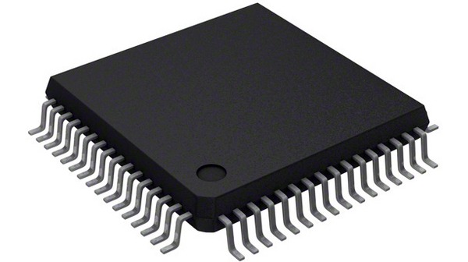

The basic idea behind this project is to power other devices and adjust the voltage until the voltage reach a level that the device is not working properly.
In this project for the Microprocessors lesson we build a mini power supply which the voltage is adjustable.To be more specific we implement a circuit that can handle an input voltage from 6.5V-35V and can output a maximum of 5V with 5mV step.The heart of this project is the microcontroller,we decide to use the PIC18F27K42 microcontroller from Microchip.The MCU can handle the output voltage of a voltage regulator and monitor the output voltage and current at real time.To do all this the MCU must be commanded somehow,so we make a PC program which is the interface between the user and the microcontroller.With this program the user can set the output voltage from 0V-5V with 5mV step and can monitor the voltage and current at real time,if the user want he can limit the current,when the current reach at limit a buzzer will ring and the voltage will be set automatically to 0V.
To implement this project we use Altium Designer as a CAD tool to build the circuit.The hardware components that was used it is explained later in this document.After the hardware we implemented the firmware part of the microcontroller,to do this we use the XC8 compiler along with MPLAB X IDE from Microchip and of course embedded C as programming language.
To load the firmware to the microcontroller we use PICKit 3 programmer.
At the end we build the software part of the project for the PC,for this we decide to use the Python as programming language due to the flexibility and the easiness it is offer.

2.0 Hardware


The hardware of this project includes a PIC18F277K42 as a microcontroller,a SUD50P06 P-Channel MOSFET,a L7805 voltage regulator,a CH340E USB to serial chip,a AD5272 variable resistor chip,a MCP6281 amplifier,a LM7705 nevative voltage regulator and the main LT3081 variable voltage regulator and different values of capacitors and resistors.At the next sections of this chapter we will introduce every one chip and how it is operate at the project circuit.

2.1 SUD50P06
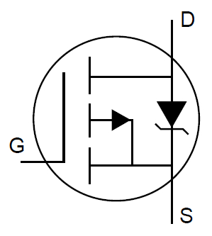

The SUD50P06 is a P-Channel MOSFET.It is used at the beginning of the circuit and its purpose is to protect the circuit from inverse polarity currents.It is often phenomenon for a user to connect the energy source that a device needs to operate vice versa.To prevent the circuit to be burned from such phenomenons we use a P-Channel MOSFET which can handle a maximum Vds of -60V which is far more from the recommended value we suggest.In normal operation (when the connection of energy source is correct) the Drain of the MOSFET is connected to positive terminal of energy source,the Gate is connected to the negative terminal of the energy source and because we use a P-Channel we will have an energy flow from Drain to Source.Otherwise the Drain is connected to the negative terminal and the Gate to the positive terminal and no energy flow through the circuit.Mathematically the Vds must be >= Vgs-Vt for the transitor to be fully on.We add and a led next to the MOSFET so we can see when we have power at the circuit.

2.2 L7805

The L7805 is a stable voltage regulator.It can handle up to 35V as an input and always produce a stable 5V output.We use this regulator so the MCU can operate independently from the voltage level of the energy source (35V max input).This circuit need two capacitors to work normally,one at the input and one at the output.

2.3 PIC18F27K42
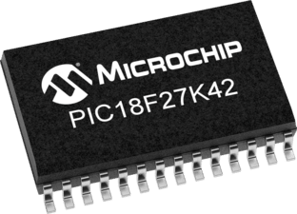

The heart of this project is the microcontroller.For our project we use an MCU from Microchip advanced 8-bit family (PIC18).The PIC18F27K42 is the heart of this project,is an 8-bit microcontroller with 128KB program flash memory,8KB of SRAM,it operates from 2.3V-5.5V and it can run up to 64MHz.It includes a lot of peripherals circuits but for this project we will only use the interrupt controller,the PPS module,the watchdog timer,the timer 0,the UART,the I2C and the ADC.This microcontroller needs pull-up resistors and a capacitor at MCLR pin as the datasheet recommend to work properly.Additionaly we will use two pull up resistors at RBO,RB1 pins which will be our communicate pins for I2C protocol,RB0 is the SDA so data can flow through this pin and RB1 is the SCL for clock syncronization.The RB3 pin it is used to reset the AD5272 in case something go wrong and the chip is not respond,the RB4 and RB5 read the voltages from LT3081 output and the differential amplifier MCP6281 respectively.The RC6 and RC7 are the RX and TX respectively and are used to to communicate with the PC.A buzzer is connected at RA1 pin and can be set to ring from user when a current limit is exceeded.At last a led is flashing from RA0 pin to indicate that the microprocessor is fully functional and working.To program with the firmaware we make this microcontroller we use the PICKit 3 programmer and the RB6,RB7 needed for this job as clock and data pins.

2.4 CH340E


This IC is a simple converter.It converts the differential USB signals from PC to TTL serial signals for the microcontroller.The microcontroller can communicate only via UART because it does not include a USB peripheral so it can understand the USB signals directly.The MCU can communicate only at TTL levels and this converter make this conversion for the MCU.

2.5 LT3081
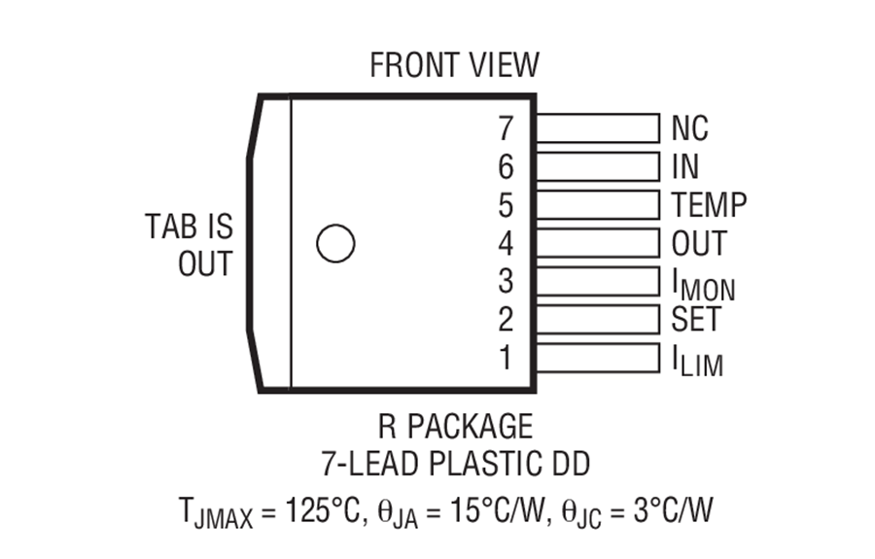
The LT3081 is a variable regulator with a lot of features.It has six active pins and one inactive.This pins are for input,output,voltage set,current set,current monitor and internal temperature.For this project we use only the voltage set pin,the current monitor pin and off course the input,output pins of the regulator.The minimum voltage for the regulator at this project is 6.5V and the maximum 35V.The output it varies from 0V-5V.To set the output voltage a resistor must be connected from voltage set pin to the ground.The value of the resistor affects the output voltage,according to the mathematical type from data sheet of the regulator :
Vout = 50μΑ*Rset .
The resistor in this project is set from AD5272 variable resistor chip which can be commanded from the MCU.
At last the current monitor pin produces a voltage drop across a resistance which measured and amplified by MCP6281 amplifier and send to MCU for reading.

2.6 AD5272
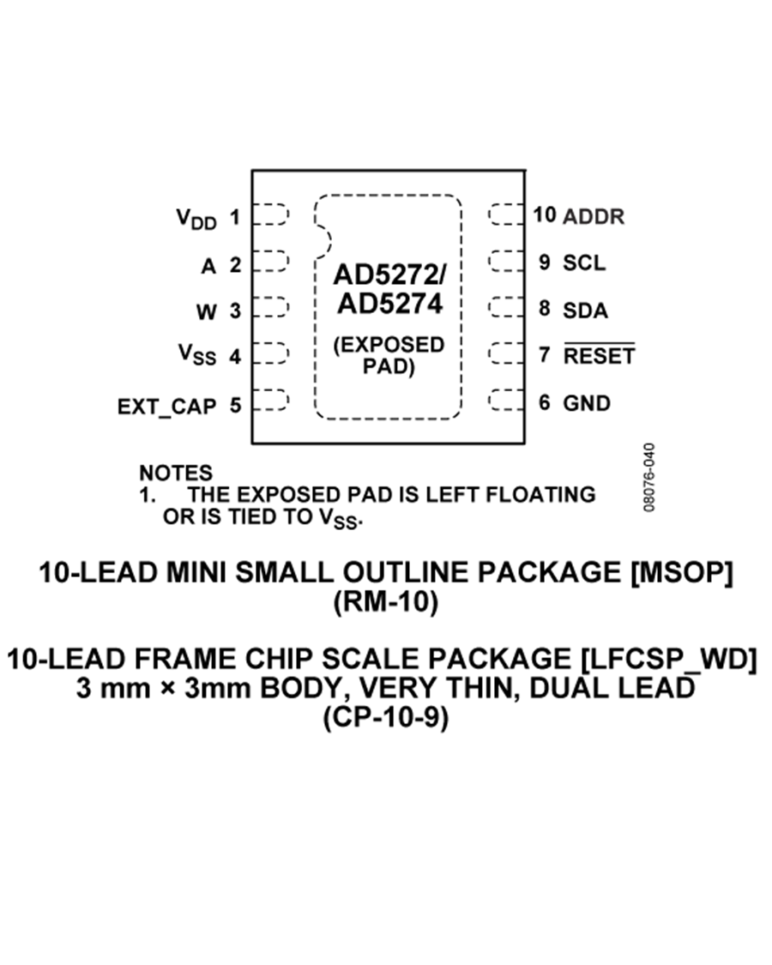

The AD5272 is a variable resistor chip,it can communicate via I2C with the MCU and set the appropriate resistor according to the communication.It is 100KΩ and 1023 steps,this means that can set a resistor from 0Ω to 100KΩ with 97,75Ω step.So if we want the LT3081 to output 3.3V we must set a 3.3V/50μΑ = 66ΚΩ resistor.But the closest value that can be set is 675*97.75 = 65981,25Ω (66KΩ/97.75 = 675,19).In some cases we will have such an errors but is small and does not affect the reasons of this project.

2.7 MCP6281 & LM7705
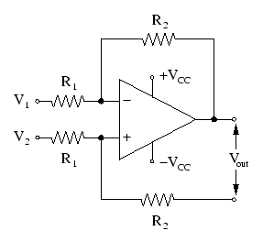

The MCP6281 plays the role of a simple differential amplifier.The current monitor pin of the LT3081 sources a small current across a resistance which voltage drop is measured by the amplifier and amplified by G=R2/R1= 4.9.The MCU measure that voltage and send it to PC.From there the software of the PC which know that the voltage is amplified by 4.9 factor and the resistor which is measured is 1KΩ it can easily find the real voltage drop across the resistance via Ohm law and last the real current flow through this resistor.At last but not least this current according to the manual of LT3081 is 1/5000 of the current flow through the load.So with this way the real current can be measured.A common problem in amplifiers is that if the V- pin isn’t tied to a negative voltage source it always give something as output because the ground is never at 0V at real.This problem is known a zero cross problem and the solution here is given from LM7705 negative voltage regulator which source a voltage of -0.232V.This negative voltage is enough for the amplifier to produce a real 0V when no voltage drop exist at the measured resistor.

3.0 Firmware

