Automated Visual Defect Detection with CNNs
Model Comparison Report & Reflection
Industry context: Manufacturing Quality Control — Casting Products

Module: Deep Learning with Artificial Neural Networks
Student: [Your name]
Student number: [Your number]
Date: [Submission date]
Notebook: defect_detection_pytorch.ipynb

✎ SAMPLE REPORT. Yellow-highlighted notes mark places to replace with your own words and experience. The brief requires a personal, original reflection. Delete every note before submitting.

Contents
Contents 2
1. Executive Summary 3
2. Business Context and Success Criteria 3
3. Data Preparation and Exploration 3
4. Phase 1 — Baseline CNN from Scratch 5
4.1 Architecture and training 5
4.2 Baseline results (test set, threshold 0.5) 5
4.3 Phase 1 — Key lessons and reflection 5
5. Phase 2 — Improving on the Baseline 7
5.1 Options considered and justification 7
5.2 Shared improvements (Candidates A and B) 7
5.3 Candidate A — Regularised CNN (2.35 M params) 7
5.4 Candidate B — ResNet18 transfer learning (11.18 M params) 8
5.5 Model selection and threshold tuning (validation only) 8
6. Head-to-Head Comparison (Same Test Set, 715 Images) 10
6.1 Improvement over the baseline (threshold 0.5) 10
6.2 Discussion 11
7. Deployment Considerations 12
7.1 Inference latency 12
7.2 Error analysis 12
7.3 Explainability (Grad-CAM) 12
7.4 Recommended production setup 13
8. Key Lessons and Reflection 14
8.1 On the approach I chose 14
8.2 On the learning journey 14
8.3 What I would do next 14
9. Limitations 14
10. Conclusion 14
References 15

1. Executive Summary
This report compares three convolutional neural networks built to flag defective submersible-pump impeller castings automatically on a production line. The business goal is to minimise false negatives (defective parts reaching customers) while keeping false positives low enough that the line isn't flooded with manual re-checks.
 | Baseline CNN | Selected: Cand A (Regularised CNN)
Test recall (defective) | 0.9912 | 0.9978
Test precision | 1.0000 | 1.0000
Missed defects (of 453) | 4 | 1
False alarms (of 262) | 0 | 0
CPU latency / image | 3.5 ms | 21.6 ms

- Result: The improved model cuts missed defects by 75 % (4 → 1) with zero false alarms on the same held-out test set.
- Key insight: Higher input resolution plus label-preserving augmentation and regularisation mattered more than a bigger or pre-trained network. ResNet18 transfer learning matched the selected model but is ~5× larger.
- Recommendation: Deploy Candidate A at the validation-tuned threshold of 0.204, with a manual-review band for uncertain scores.

2. Business Context and Success Criteria
Manual inspection by line workers is slow, inconsistent and expensive at scale. An automated visual inspection system has to meet three criteria:
- Catch defects: Very high recall on the Defective class. A missed defect leads to warranty claims, reputational damage and possibly safety issues.
- Few false alarms: A false alarm costs a manual re-check. That's tolerable, but too many would defeat the purpose of automation.
- Real-time inference: The model must run at line speed on modest hardware.
Because of this cost asymmetry, recall is the headline metric, precision measures the re-check burden, and accuracy alone would be misleading.

3. Data Preparation and Exploration
Dataset: the Kaggle “Casting Product Image Data” (real-life industrial dataset). I used the casting_data version (300×300 top-down images with an official train/test split) because it is larger than the raw 512×512 set and its fixed test split makes results comparable.
Split | Images | OK | Defective | Defective share
Train | 5,638 | — | — | 56.7 %
Validation (15 % of train, stratified) | 995 | 431 | 564 | 56.7 %
Test (official, untouched until final evaluation) | 715 | 262 | 453 | 63.4 %

- Grayscale: Images were loaded as single-channel grayscale because colour carries no information under the consistent lighting.
- Small defects: Defects such as blow holes, pinholes, burrs and edge chips are often small and local, which argues against aggressive down-sampling.
- Normalisation: Pixel mean/std (0.564 / 0.237) were computed on the training split only, to avoid leakage.
- Test-set discipline: The validation set drives early stopping, model selection and threshold tuning. The test set is used exactly once.
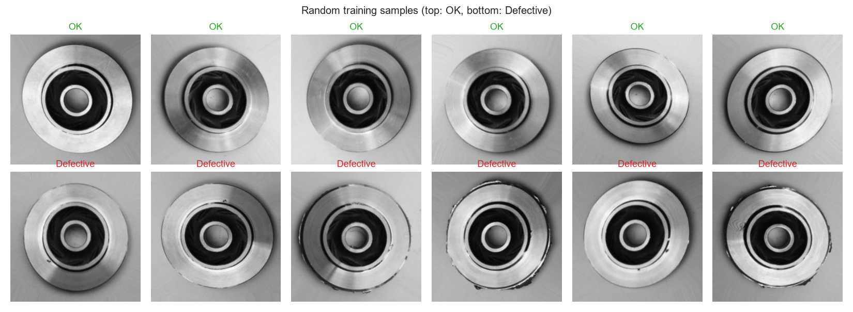
Figure 1 – Random training samples (top: OK, bottom: Defective)

4. Phase 1 — Baseline CNN from Scratch

4.1 Architecture and training
- Input: 128×128 grayscale input.
- Feature extractor: 4 × [Conv 3×3 → ReLU → MaxPool 2×2] with 32 → 64 → 128 → 128 filters.
- Classifier: Flatten → Dense(128) → Dropout(0.5) → Dense(1) logit. 1.29 M trainable parameters.
- Training: AdamW (lr 1e-3, no weight decay), one-cycle schedule, BCE-with-logits loss, batch 64, up to 20 epochs with early stopping (patience 5) on validation loss. No batch-norm and no augmentation, so this is deliberately a simple reference point.
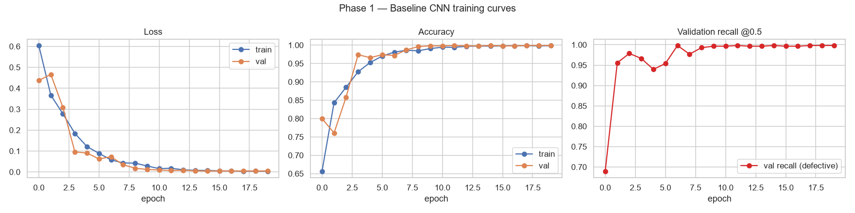
Figure 2 – Baseline training curves (loss, accuracy, validation recall)

4.2 Baseline results (test set, threshold 0.5)
Accuracy | Precision | Recall | F1 | ROC-AUC | TN | FP | FN | TP
0.9944 | 1.0000 | 0.9912 | 0.9956 | 1.0000 | 262 | 0 | 4 | 449

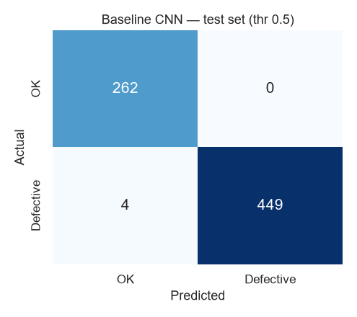
Figure 3 – Baseline confusion matrix (test set)

4.3 Phase 1 — Key lessons and reflection
- A strong baseline sets a high bar. The simple CNN already reached 99.1 % recall with no false alarms. The dataset is highly learnable, so any improvement would be measured in single images.
- The training curves corrected my assumption. I expected over-fitting, but validation loss kept falling alongside training loss (best 0.0045 at epoch 15). The real limitation was resolution: at 128 px, pinholes shrink to a few pixels.
- All errors were false negatives. Precision was never the constraint. Every baseline error was a missed defect, so further work should focus on recall.
- The default threshold is arbitrary. A 0.5 threshold ignores that a missed defect costs far more than a false alarm.
✎ Add your own experience here. What surprised you? What went wrong while setting it up (data paths, memory, GPU)? What did you learn about CNNs from building one from scratch?

5. Phase 2 — Improving on the Baseline

5.1 Options considered and justification
I chose techniques based on the baseline diagnosis (resolution, lack of augmentation, arbitrary threshold) rather than defaulting to the largest model.
Option | Pros | Cons | Decision
A. Regularised scratch CNN (224 px, BatchNorm, GAP head, weight decay, augmentation) | Small and fast; no external weights; isolates the effect of resolution + regularisation | Must learn all features from ~5.6k images | Tried
B. ResNet18 transfer learning (ImageNet, full fine-tune) | Pre-trained edge/texture filters; fast convergence; light enough for edge devices | ImageNet ≠ grayscale metal; 11 M params | Tried
Bigger backbones (ResNet50, EfficientNet, ViT) | Higher potential ceiling | 2–8× slower; little headroom left; harder edge deployment | Rejected
Class re-weighting / oversampling | Handles imbalance | Imbalance is mild and favours the positive class; threshold tuning is more transparent | Rejected
Anomaly detection (train on OK only) | Useful when defects are rare | Plenty of labelled defects available, so supervised learning is stronger | Rejected
Extensive hyper-parameter search | Squeezes extra points | Expensive; risks over-fitting the validation set | Light manual tuning only

5.2 Shared improvements (Candidates A and B)
- Augmentation: Rotations by multiples of 90° and flips. These preserve the label because the impeller is rotationally symmetric.
- ±15° rotation, ±10 % zoom and ±5 % shift simulate positioning tolerance on the conveyor.
- ±15 % brightness/contrast jitter simulates lighting drift.
- Resolution: 224×224 input, so small defects keep more pixels.
- Fair comparison: Same splits, loss, early-stopping rule and metric code as the baseline. The winner is picked on validation, then its threshold is tuned on validation, and only then is it scored on test.

5.3 Candidate A — Regularised CNN (2.35 M params)
5 × [Conv–BN–ReLU–Conv–BN–ReLU–MaxPool] (32→64→128→256→256) → GlobalAvgPool → Dropout(0.3) → Linear(1). AdamW (lr 2e-3, weight decay 1e-4), up to 25 epochs, patience 7. It trained all 25 epochs in 570 s (best validation loss 0.0034). Validation loss spiked in epochs 2 and 8, most likely because of the high peak learning rate combined with BatchNorm. Early stopping on the best checkpoint absorbed the spikes.
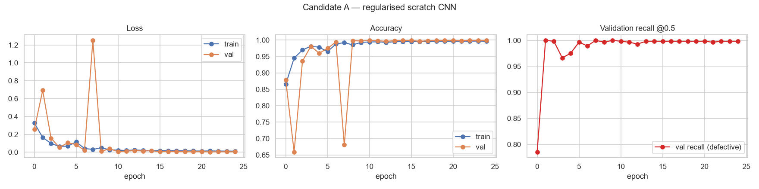
Figure 4 – Candidate A training curves

5.4 Candidate B — ResNet18 transfer learning (11.18 M params)
ImageNet weights. Grayscale is replicated to 3 channels with ImageNet normalisation, and the head is replaced by Dropout(0.3) → Linear(1). Discriminative learning rates: 3e-4 for the backbone and 3e-3 for the head. It reached 99.1 % validation accuracy after one epoch and early-stopped after 11 epochs (149 s, best validation loss 0.0067).
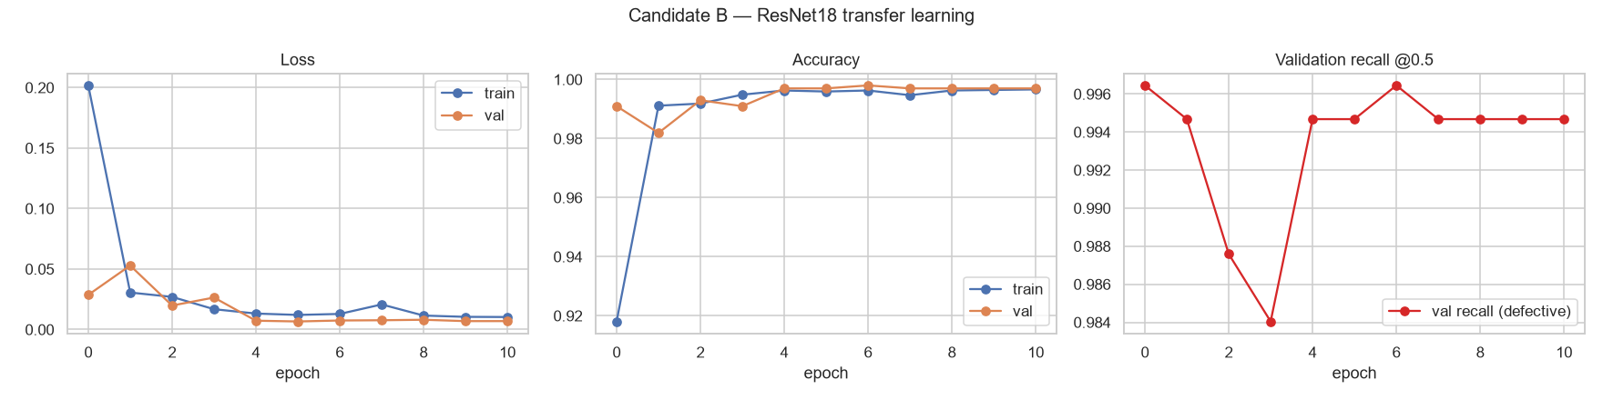
Figure 5 – Candidate B training curves

5.5 Model selection and threshold tuning (validation only)
Model | Accuracy | Recall | F1 | ROC-AUC | FN | FP | Tuned threshold
Baseline CNN | 0.9990 | 0.9982 | 0.9991 | 0.99999 | 1 | 0 | 0.580
Cand A: Regularised CNN | 0.9980 | 0.9965 | 0.9982 | 1.00000 | 2 | 0 | 0.204
Cand B: ResNet18 TL | 0.9970 | 0.9947 | 0.9973 | 0.99997 | 3 | 0 | 0.314

Selection rule: highest validation ROC-AUC, with F1 as the tie-break, so Candidate A was selected. The margin is extremely thin, though: all three models are effectively tied on validation, and the baseline actually has the best validation F1.
Threshold rule: take the highest-precision threshold that still reaches ≥ 99.5 % validation recall. This makes the FN/FP business trade-off explicit.
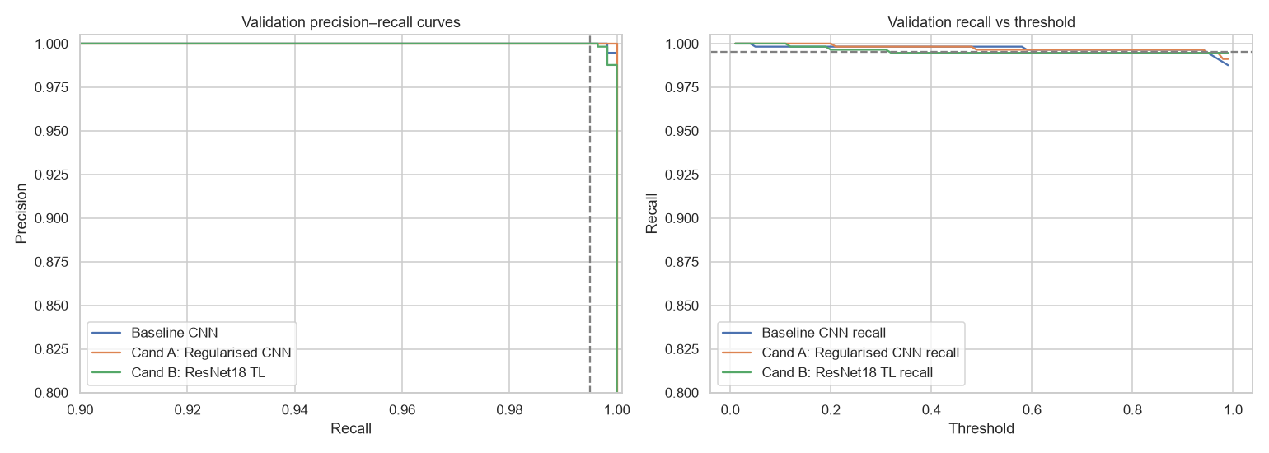
Figure 6 – Validation precision–recall curves and recall vs threshold

6. Head-to-Head Comparison (Same Test Set, 715 Images)
Model | Threshold | Accuracy | Precision | Recall | F1 | FN | FP
Baseline CNN | 0.50 | 0.9944 | 1.0000 | 0.9912 | 0.9956 | 4 | 0
Baseline CNN | tuned 0.580 | 0.9930 | 1.0000 | 0.9890 | 0.9945 | 5 | 0
Cand A: Regularised CNN | 0.50 | 0.9986 | 1.0000 | 0.9978 | 0.9989 | 1 | 0
Cand A: Regularised CNN | tuned 0.204 | 0.9986 | 1.0000 | 0.9978 | 0.9989 | 1 | 0
Cand B: ResNet18 TL | 0.50 | 0.9972 | 1.0000 | 0.9956 | 0.9978 | 2 | 0
Cand B: ResNet18 TL | tuned 0.314 | 0.9986 | 1.0000 | 0.9978 | 0.9989 | 1 | 0

6.1 Improvement over the baseline (threshold 0.5)
Metric | Baseline | Candidate A | Change
Accuracy | 0.9944 | 0.9986 | +0.42 pp
Precision | 1.0000 | 1.0000 | 0
Recall | 0.9912 | 0.9978 | +0.66 pp
F1 | 0.9956 | 0.9989 | +0.33 pp
Missed defects | 4 | 1 | −3 (−75 %)

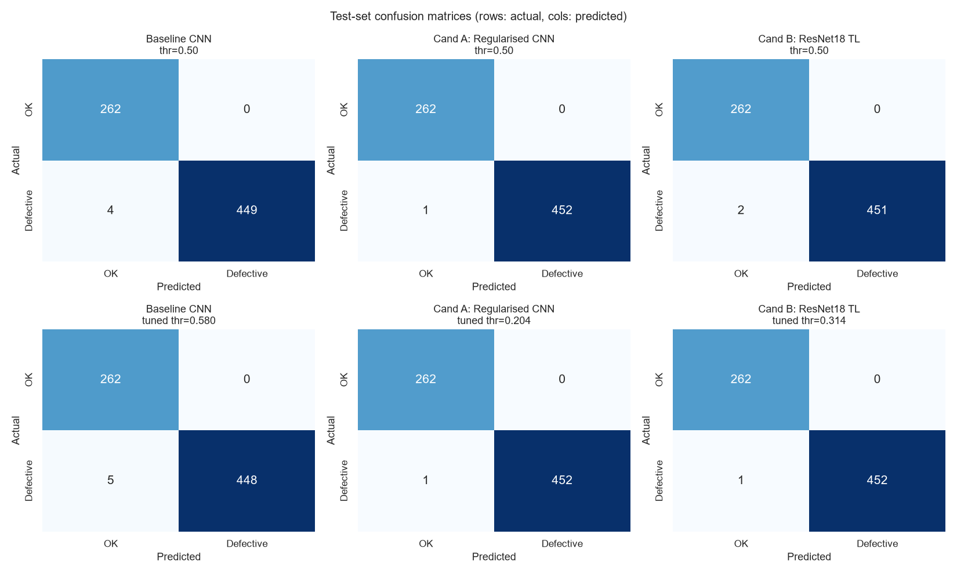
Figure 7 – Test confusion matrices: threshold 0.5 (top) and validation-tuned (bottom)
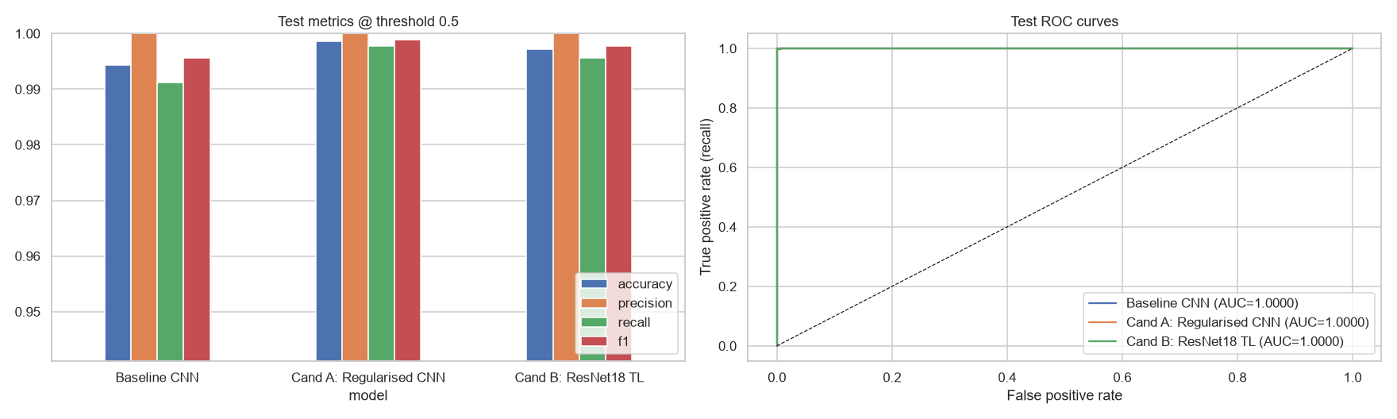
Figure 8 – Test metrics at threshold 0.5 and ROC curves

6.2 Discussion
- Precision was never the constraint. No model produced a single false alarm on the test set. Every remaining error is a missed defect.
- Threshold tuning can backfire. The baseline's tuned threshold (0.58) raised its misses from 4 to 5. A threshold tuned on ~564 validation defects is noisy and does not always transfer.
- Ranking is near-perfect. Test ROC-AUC is ≥ 0.99998 for all models. They rank images almost perfectly, so the remaining errors are about where the threshold sits.
- A vs B is a tie on metrics. At their tuned thresholds A and B tie exactly (1 FN, 0 FP). A wins at 0.5 and is ~5× smaller, so it is preferred.

7. Deployment Considerations

7.1 Inference latency
Model | Params (M) | CPU ms / image | GPU ms / image (RTX 4050 Laptop)
Baseline CNN | 1.29 | 3.52 | 2.33
Cand A: Regularised CNN | 2.35 | 21.56 | 4.39
Cand B: ResNet18 TL | 11.18 | 19.36 | 4.61

All models run in under 25 ms per image on CPU (> 40 parts/s), which is comfortably real-time. Candidate A is slower on CPU than ResNet18 despite having 5× fewer parameters. It runs double convolutions at full 224 px resolution, while ResNet18's stem downsamples 4× immediately. Compute (FLOPs), not parameter count, drives latency.

7.2 Error analysis
At its tuned threshold, the selected model makes one error: a missed defect with p(defective) = 0.107. The defect is not visually obvious at 224 px, which points to either a very subtle defect or a possible labelling issue. It's worth inspecting at full resolution.
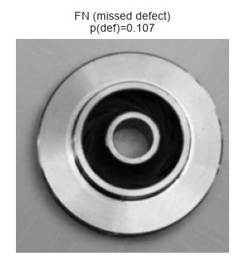
Figure 9 – The only remaining test error (false negative)

7.3 Explainability (Grad-CAM)
Grad-CAM on the last convolutional block shows which regions drove a “defective” decision. Attention mostly falls on the outer rim and edge chips where the visible defects are, which is evidence that the model uses the defect rather than background artefacts. One example shows diffuse attention, which warrants monitoring.
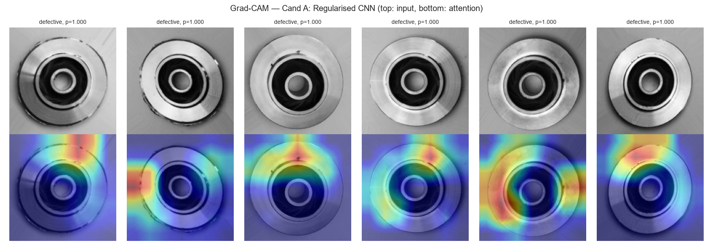
Figure 10 – Grad-CAM for Candidate A (top: input, bottom: attention)

7.4 Recommended production setup
- Reject: Automatically reject parts with p ≥ 0.5.
- Review band: Send parts with 0.05 ≤ p < 0.5 to manual inspection (the only miss scored 0.107).
- Pass: Pass parts with p < 0.05.
- Monitor: Log every prediction. Track recall on audited samples and the false-alarm rate per shift and line.
- Retrain: Retrain when lighting, camera or product changes. Re-validate on fresh line images.

8. Key Lessons and Reflection
✎ This section must be in your own words. The points below are a starting skeleton drawn from the results. Rewrite them around your own experience: what you tried, what failed, what you'd do differently.

8.1 On the approach I chose
- Diagnose before you scale. Most of the gain came from higher resolution (128 → 224 px) and label-preserving augmentation, not from a fancier architecture.
- Let the evidence correct you. My assumption of over-fitting was wrong. The training curves showed the model was resolution-limited.
- Transfer learning is fast but not always necessary. ResNet18 converged in one epoch, but on this narrow, consistent domain a well-regularised scratch model matched it at a fifth of the size.
- The threshold is a business decision. Choosing the operating point on validation for a recall target turns an arbitrary 0.5 into an explicit cost trade-off. It is noisy with few borderline cases, though.
- Report differences honestly. A 1-error difference is 0.22 pp of recall. Honest reporting means acknowledging that the models are close and justifying the choice on size, simplicity and speed too.

8.2 On the learning journey
✎ Describe your own journey. For example: moving from the TensorFlow notebook to PyTorch and why; memory or GPU problems you solved; what you understood better about convolution, pooling, batch-norm or augmentation; what you would try next.

8.3 What I would do next
- Repeat training with several seeds or cross-validation to get confidence intervals on recall.
- Validate on fresh images from a real line (different lighting and camera) before deployment.
- Try an explicit cost-weighted loss and compare it with threshold tuning.
- Quantise or export the model (ONNX / TorchScript) for an edge device and measure latency there.

9. Limitations
- Small test set: 453 defective images is too few to separate models reliably at > 99.5 % recall.
- Possible near-duplicates: The dataset author augmented the casting_data images, so train and test may share near-copies, which inflates scores.
- Single run: Results come from one training run (seed 42), and GPU nondeterminism can shift individual errors.

10. Conclusion
A regularised CNN trained from scratch at 224 px, with label-preserving augmentation and a validation-tuned threshold, reduced missed defects from 4 to 1 on the held-out test set with zero false alarms. It meets real-time latency on CPU. It matches a ResNet18 transfer-learning model at a fifth of the size, and is recommended for deployment with a manual-review band and production monitoring.

References
- Ravirajsinh45 (2020). Casting Product Image Data for Quality Inspection. Kaggle. https://www.kaggle.com/datasets/ravirajsinh45/real-life-industrial-dataset-of-casting-product
- He, K., Zhang, X., Ren, S. & Sun, J. (2016). Deep Residual Learning for Image Recognition. CVPR. https://arxiv.org/abs/1512.03385
- Selvaraju, R. R. et al. (2017). Grad-CAM: Visual Explanations from Deep Networks via Gradient-based Localization. ICCV. https://arxiv.org/abs/1610.02391
- Smith, L. N. (2018). A disciplined approach to neural network hyper-parameters (one-cycle policy). https://arxiv.org/abs/1803.09820
- PyTorch documentation. https://pytorch.org/docs
✎ Acknowledge any other resources you used, including AI tools, as the brief requires.

